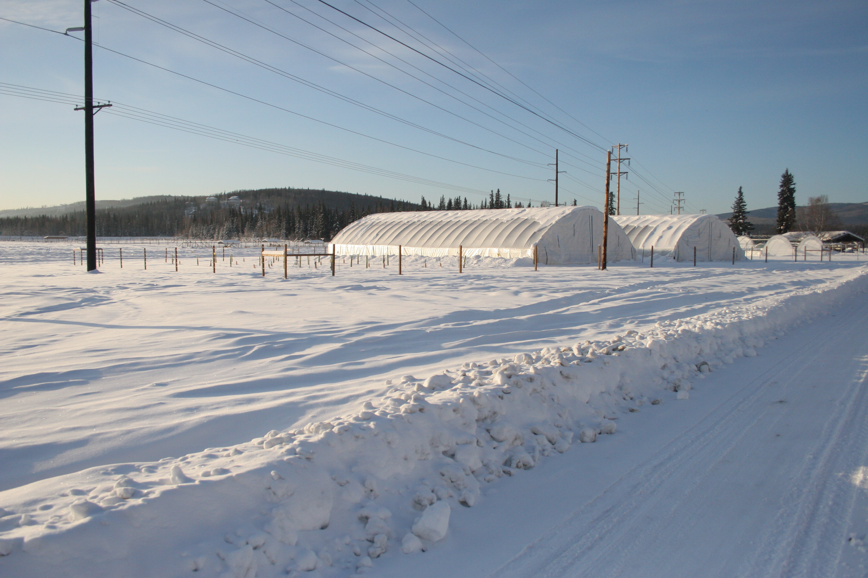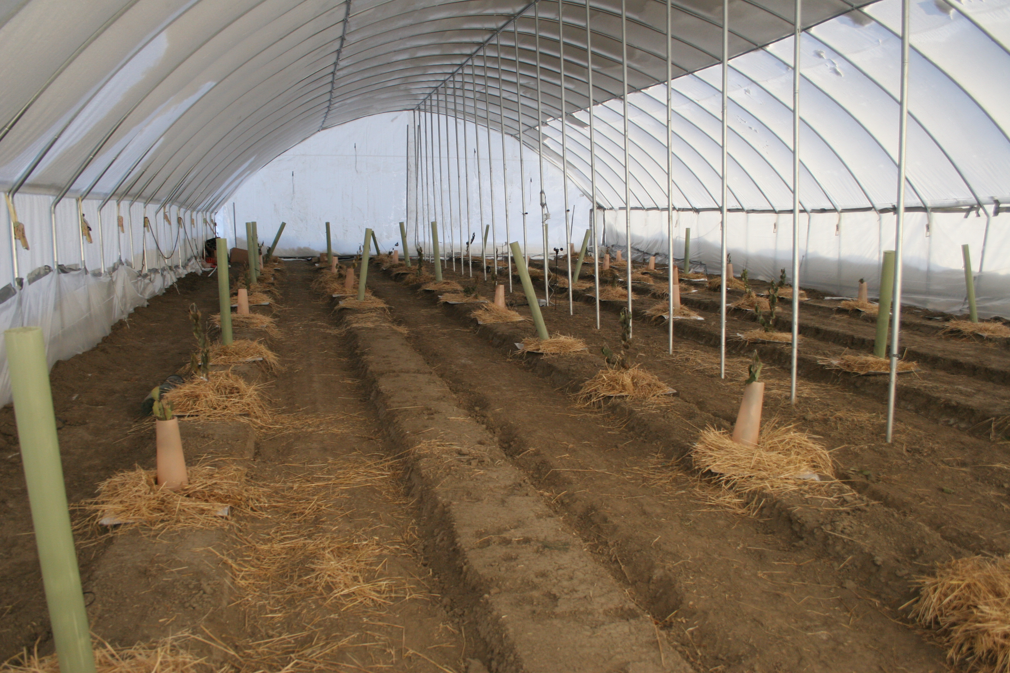

Figure 5. High tunnels and exterior plots in the winter and inside a tunnel with trees prepared for the winter.