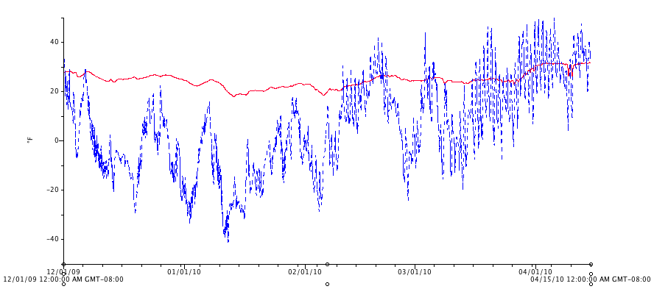

Figure 13. Soil (red) and air (blue) temperatures for the exterior plot during the 2009/2010 winter (December through April).