**Photo captions from Help Ourselves Project Black Farmers Distribution and Education Programs**



Help Ourselves Project “People Play with Dirt Program” hosted at the 9 acre Alhambra Organic Farm in Atco, NJ- October 10, 2010

October 10, 2010, HOP and participating children and parents visited the Alhambra Organic Farm in Atco, NJ. This Solar Powered organic farm is owned and operated by a Black farmer by the name of Charles Glenn-El. The kids had an opportunity to get samples of fresh vegetables, learn how solar powered energy works, see deer tracks, and see composting in action.

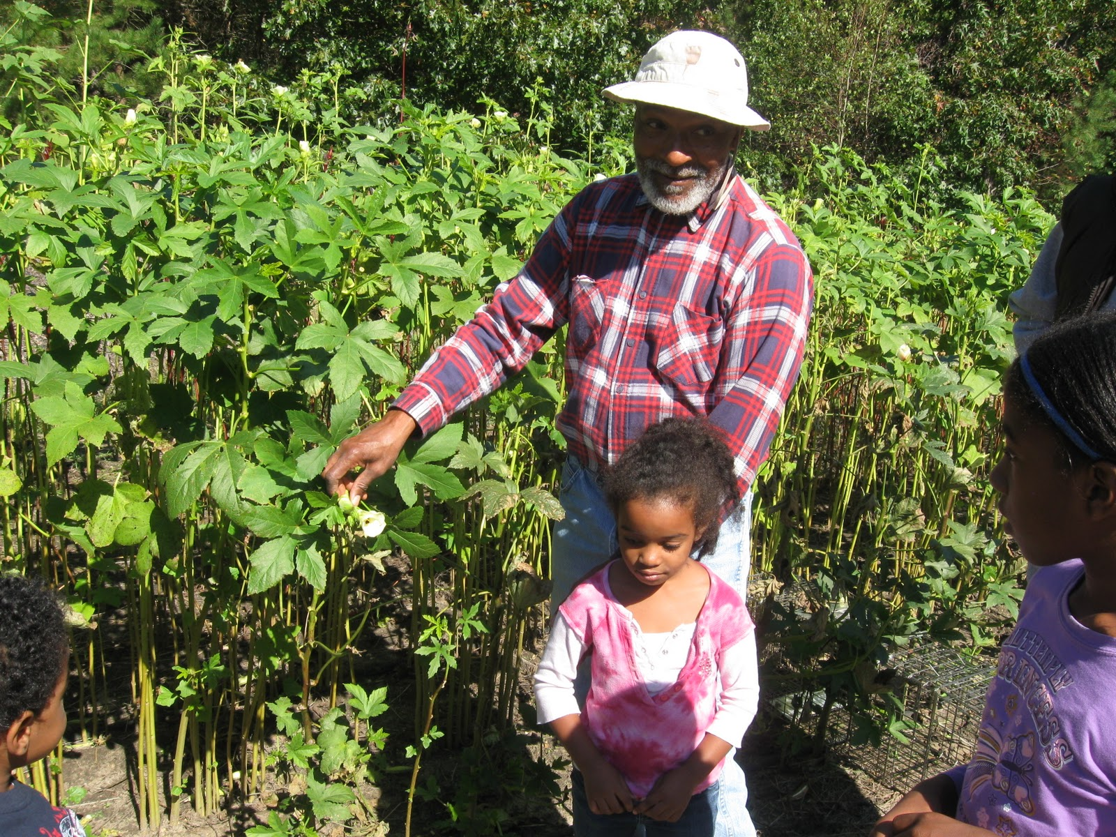

Alhambra Organic Farms farmer, Mr. Glenn-El showing his okra crop to the children in the “People play with dirt program (October 10, 2010).



Children on a tractor at the Al-Hambra Farms hosting the “People Play with Dirt Program” in Aatco, NJ (October 10, 2010).



Mr. Glenn-El showing his 4200 Kw solar array operating on his farm in Aatco, NJ (October 10, 2010).

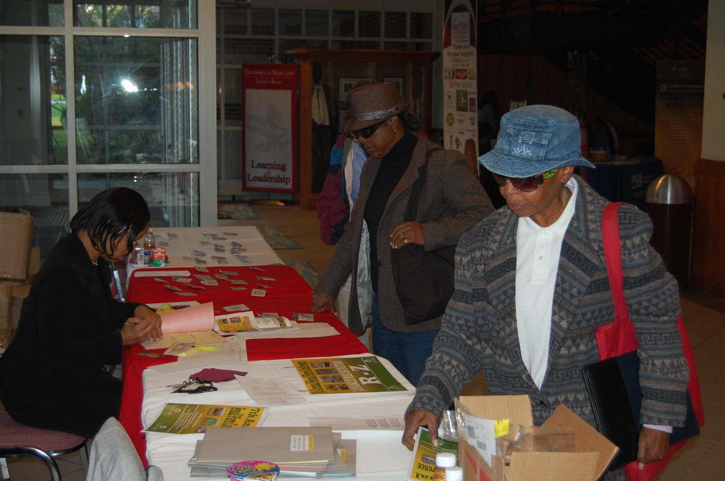

Farm owner of Mt Pleasant Farms, Ms. Paulette Green and business partner Donna Dear, at the 2010 University of Maryland Eastern Shore Small Farms Conference in Princess Anne, MD.

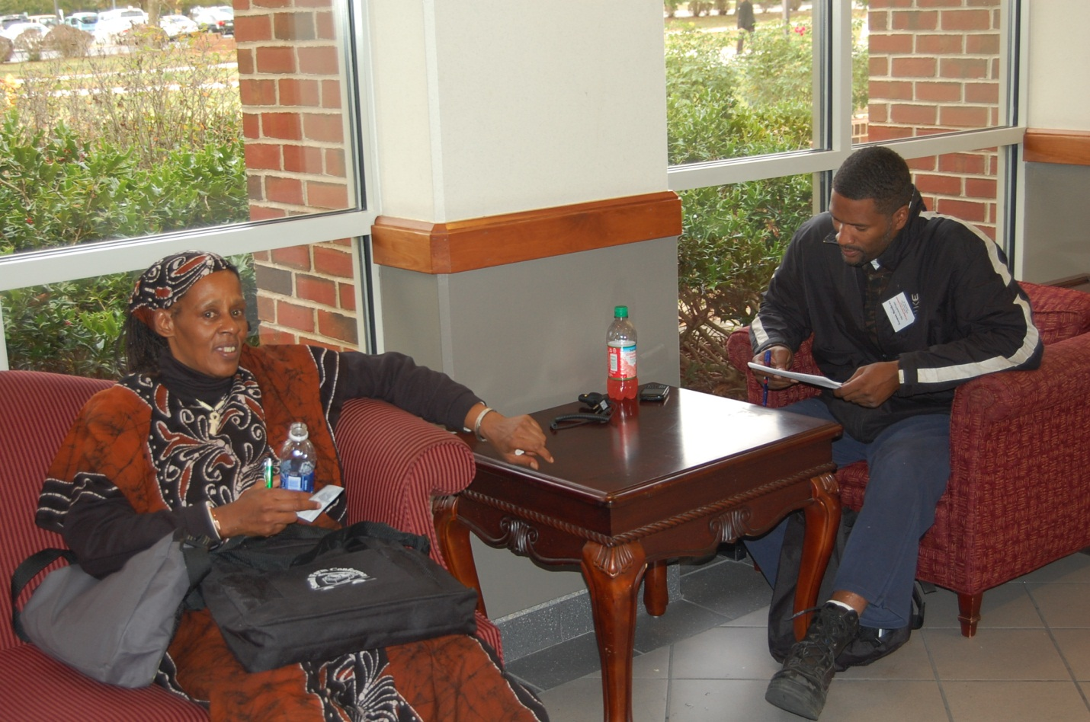

Help Ourselves Project, Project Coordinator, Gladys McMichael, and HOP staff member, Norman Matthews at the 2010 UMES Small farms conference taking a break from networking.

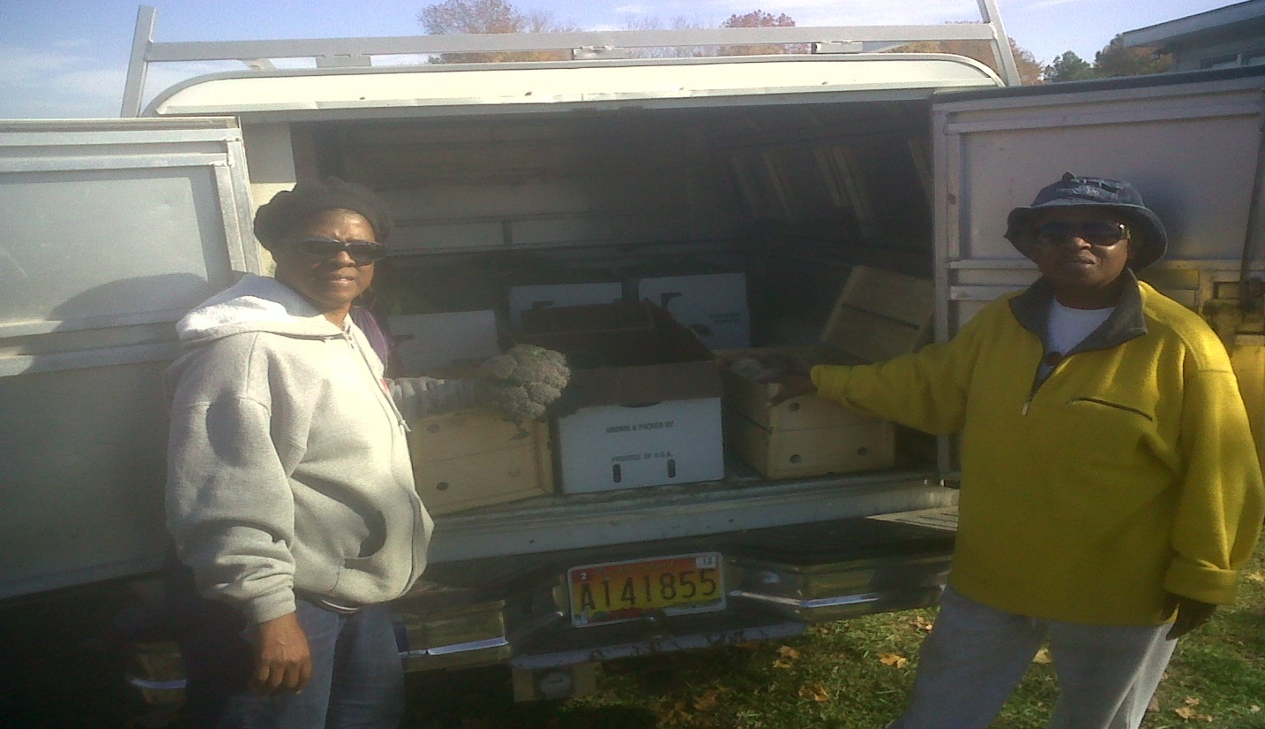

Produce was picked up by HOP in November and December of 2010 at Ms. Green’s *Mt Pleasant Acres* 100+ acre farm in Preston, MD. This year was HOP’s proof of concept year.

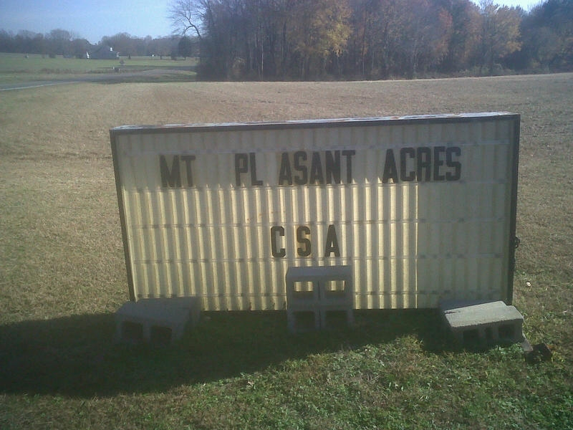

Mt Pleasant Acres sign in 2010, Preston, MD.

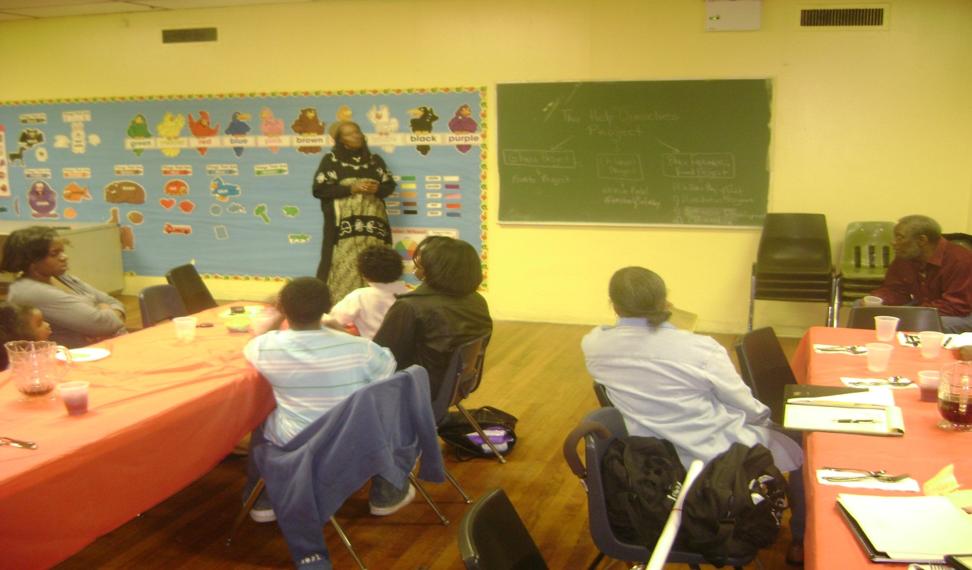

HOP Project Director, Gladys McMichael, giving a presentation in March 2011 at the HOP Partnership meeting in Philadelphia, PA. Farmers in attendance were Ms. Donna Dear and Ms. Paulette Greene.

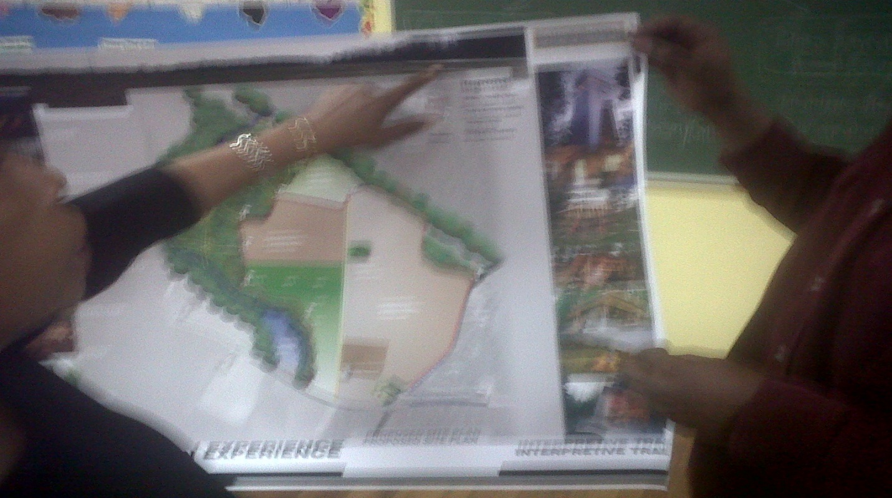

Ms. Paulette Greene, displaying a map of her farm to participants with the help of HOP co-director, Deke Jones, at the HOP Partnership meeting in Philadelphia, PA (March 2011).

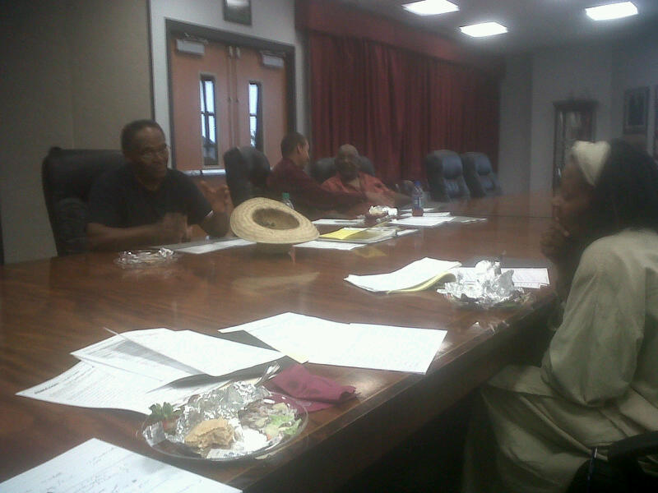

HOP Project Director, Gladys McMichael, talking with owner of Ballard Farms, Ken Ballard (Princess Anne, MD) at the HOP-MD farmers’ partnership meeting hosted at UMES in June 2011. Also in attendance was farmer, James Dickerson owner of Half-Acres Farms.

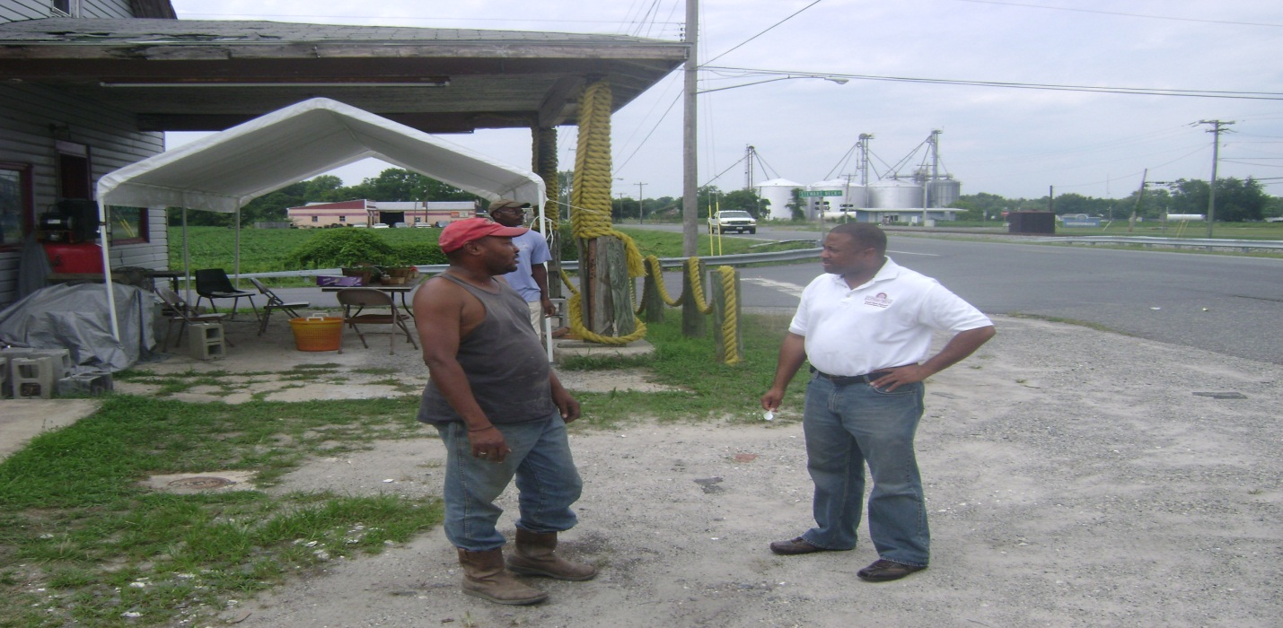

UMES Small Farms Coordinator, Barren Rogers (right), talking with a farm worker of the Ballard Farm in July 2011. HOP was present to make a pickup of summer produce from the Ballard Farm in Princess Ann, MD. This year (2011) was HOP’s pilot year for their food distribution outreach program.

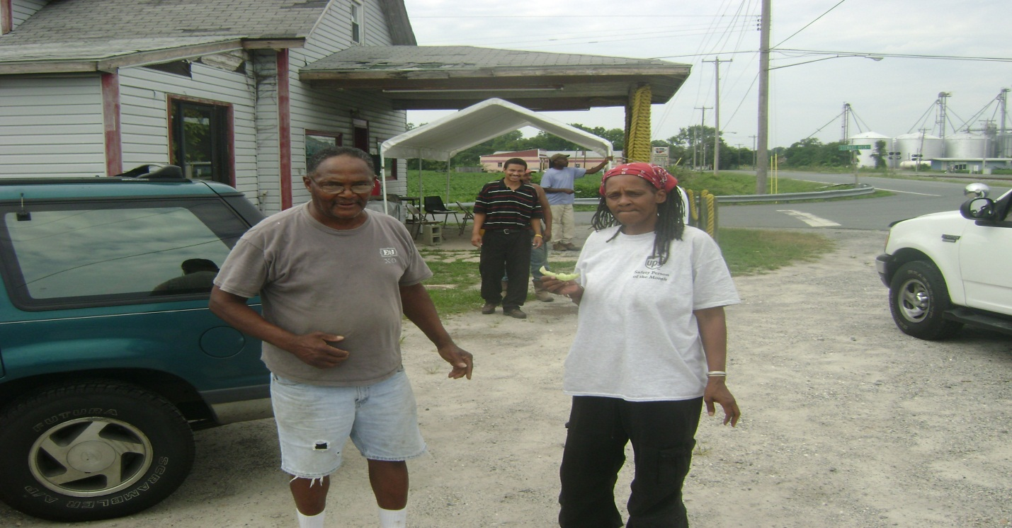

HOP Project Director, Gladys McMichael, sampling Ballard Farm’s Honey Dew while standing with farm owner, Ken Ballard, at one of the grounds of the Ballard Farm in July 2011. HOP was present to make a pickup of summer produce from the Ballard Farm in Princess Ann, MD.

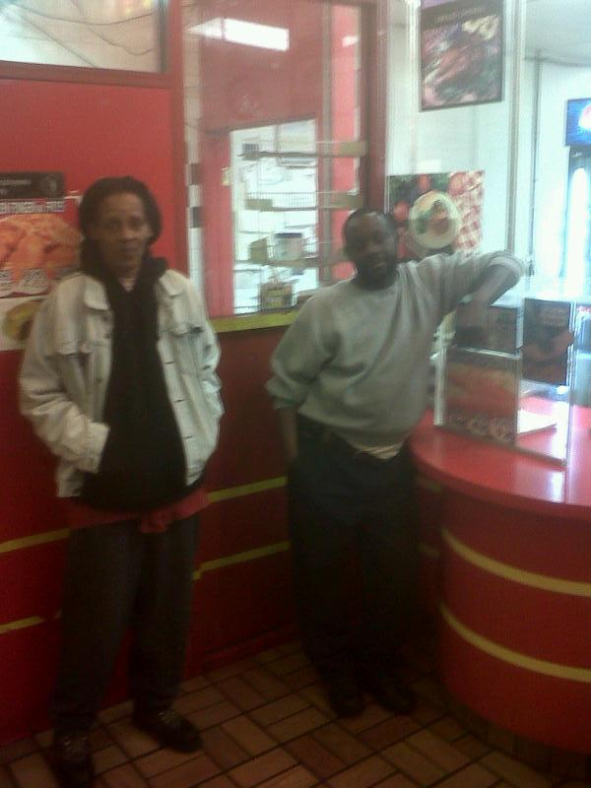

Help Ourselves Project Director, Gladys McMichael at Medina Crown restaurant in Philadelphia standing with food distribution outreach recipient, Seck Ishmael, owner of Medina Crown Restaurant at 304 South 52nd Street in Philadelphia, PA. Medina Crown purchased a case of Collard Greens and a 50lb bag of large Onions in December 2011 from the HOP distribution outreach team at terminal prices. Medina Crown was very pleased with the price and the quality of the produce that came from the Mt Pleasant Acres farm.

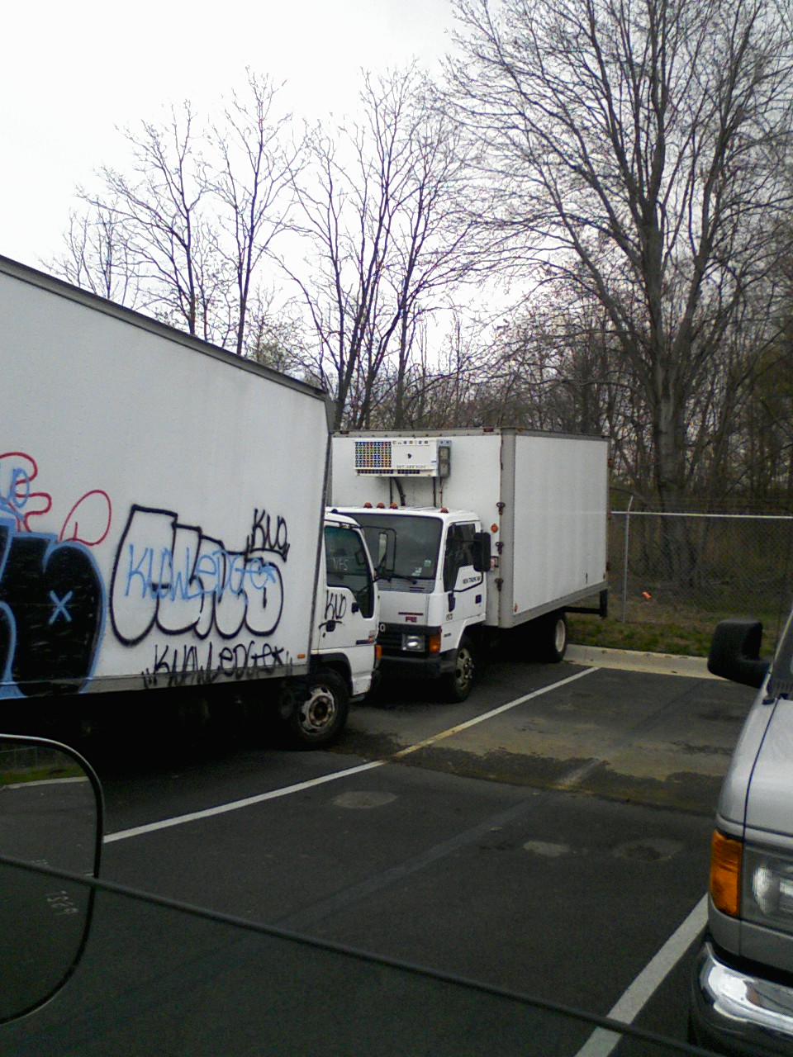

Help Ourselves Project recently purchased a 14’ refrigerated truck (rear) that will deliver larger volumes of produce from its partnering farms in the MD area into the Philadelphia, PA region for the 2012 crop season. HOP views 2012 as a trial year for its food distribution outreach program.