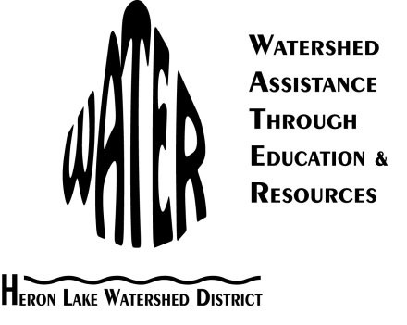**Heron Lake Watershed District Cover Crop Demonstration Project**

**RESEARCH**

### This demonstration project will build upon previous work done through different grant foundations including the Sustainable Agriculture Research and Education Program. Our project results will allow farmers within the HLWD and southwest Minnesota to gain knowledge and understanding of cover crops and their ability to be used locally. Data will show farmers that cover crops are a useful management tool for their own farm’s sustainability.

### This project will deliver the following: soil samples, coverage data, and water quality monitoring data. Tillage transects, infiltration measurements, plant tissue tests, and soil samples will be taken at the cover crop fields and control fields for comparison in the spring of 2012 and the spring of 2013 to gauge cover crop success. Tillage transects measure field residue and are useful for gauging erosion and sediment runoff. Analysis will also be done to determine phosphorus, potassium, zinc, and pH (potential of hydrogen) levels. Infiltration measurements will be taken to establish water absorption rates. And plant tissue tests will be conducted by Extended Ag to analyze the nutrient levels in the plants all of which is helpful information that will be put into newsletters and newspaper articles promoting the project.

### Evaluation of this project will be done by HLWD staff. Success will be defined as implementation of a cover crop, developing and distributing a newsletter and newspaper articles about the project, and hosting a field day to demonstrate the cover crop project.

Through past projects, the HLWD has found a high level of community cooperation and support. Watershed residents are interested in improving water quality and protecting native habitat through financially competitive farming methods.

**OUTREACH**

Landowners and operators are more receptive to installing water quality improvement practices on their property when they have first-hand information about their effectiveness in the HLWD. The HLWD would host a field day at the demonstration site during the fall of 2012. The HLWD staff would be responsible for field day organization. The resource technician and district administrator would be responsible for drafting a newsletter highlighting the project and informing the public about the field day.

In addition to the SARE website, data and results from this project will also be shared on the HLWD website (<http://www.hlwdonline.org/hlwd/>).

This project will build civic aptitude by improving institutional capacity for water stewardships, encourage collaborative relationships, and create new norms for water management by encouraging citizens to take personal responsibility for the water moving across their property. This project will encourage different choices at a local level that will improve water quality. The HLWD will provide local communities with a sense of ownership in relation to water quality problems and solutions and encourage citizens to lead change rather than act as passive participants.

**EVALUATION**

The results of this project will be evaluated through soil samples, infiltration measurements, plant tissue tests, and tillage transects taken before the cover crop is established in the spring of 2012 and after the cover crop is destroyed in the spring of 2013. Desirable outcomes include successfully establishing 40 acres of cover crop in the 2012 growing season and providing farmers and service providers with information about the results of the cover crop project through a field day, newspaper article, and HLWD newsletter.

The Cover Crop Demonstration Project will compare field residue amounts and nitrogen levels in the cover crop field and the control field. Both fields are comparable in size, soil type, elevation, and slope. Farm profitability will be measured by calculating the cost of seeding and establishing the cover crop versus the reduction in nitrogen application costs. The results of the soil samples, infiltration measurements, plant tissue tests, and tillage transects will show how beneficial cover crops are to the environment. Nitrogen application rates compared to aerial seeding costs will show how this project affects farm profitability.

### Through past projects, the HLWD has found a high level of community cooperation and support. Watershed residents are interested in improving water quality and protecting native habitat through financially competitive farming methods. HLWD has worked together with local landowners to install over 26,030 acres of filter strip, waterway, terrace, and wetland restoration best management practices (BMPs) and 310 structural BMPs including rock inlets, rain gardens, wildlife ponds, septic systems, and water and sediment control basins. The HLWD also holds well-attended semi-annual public educational workshops.

The HLWD will highlight the progress and finding of the cover crop demonstration site in one newsletter distributed to 3,400 residents, conservationists, and legislators. This newsletter will be sent before the field day to highlight the upcoming event and progress of the Cover Crop Demonstration Project.