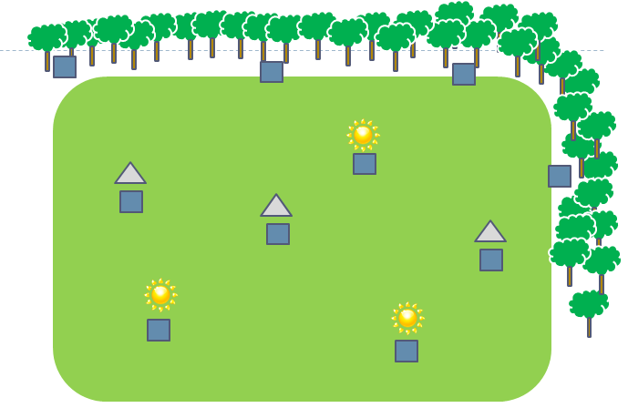
Figure 15. Diagram of a watermelon field in the 2012 study. Blue boxes indicate quads (four colonies). Those along the edge received a natural shaded treatment, while the quads in the middle either received a shade structure (denoted by a triangle) or full sun treatment (denoted by the sun symbol).

