**Farmland Access Info Night & Farmer/Landowner Mixer**

March 2015

**AGENDA**

6:00pm **Registration**

6:05pm **Welcome and Introduction of Service Providers**

*Amanda Littleton, Cheshire County Conservation District*

6:30pm **Case Study** – Farmer and Non-Farming Landowner discusses leasing relationship

*Facilitator: Kathy Ruhf, Land For Good, Farmer: Larry Britton, Landowner: Juliana Stevens*

6:45pm **Asking the Right Questions** – Small group discussion

7:00pm **Mixer** with beer tasting from Belgian Mare Brewery of Alstead NH.

This is an opportunity to talk to service providers and other farmers and landowners.

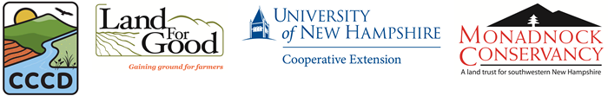

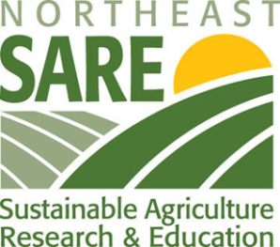

This project is supported by the Northeast Sustainable Agriculture Research and Education (SARE) program. SARE is a program of the National Institute of Food and Agriculture, U.s. Department of Agriculture.