Design Narrative for Three-Wheeled Machine with Furrow Guidance

INTRODUCTION
The original prototype of the three wheeled machine utilizing furrow guidance was an older machine that had started out life as a tobacco harvesting aid, was later converted for use as a tomato harvesting aid, and that had the front part of the frame rebuilt in 2012 prior to it being outfitted with narrow front wheels and guidance arms for utilizing furrow guidance. That first prototype was used for two growing seasons with good results. The original tobacco harvesting aid had been designed and fabricated with the major objective of being low-cost, simple mechanization that could benefit smaller growers without having to have the economics of scale to justify the cost. That same objective was foremost in consideration when the older machine was retrofitted for implementation of the furrow guidance system.
As part of the Southern SARE-funded on-farm research project, a new prototype was designed and built in 2015. The new prototype uses the same basic configuration as the original prototype, with a single drive wheel in the rear and widely-spaced steered wheels in front that straddle two vegetable rows, adjustable width front wheel spacing, an electric lift on one side (with Cat. 0 three point hitch), and mechanical steering that allows feedback from the guidance arms so that the furrows created by the narrow front wheels can be used for precision guidance of the machine for repeated operations over the same rows. The new design kept the basic configuration of the original prototype, as well as the primary objective of being low-cost and relatively simple mechanization, while incorporating a few improvements. The main improvements were higher frame clearance (both for crops, and to allow implements to extend under the center beam of the frame), adjustable row spacing in 3 inch increments (accomplished with a series of drilled holes in the sliding tubes used for the front part of the frame), and the use of the front part of the frame as the toolbar for mounting the lift and operator seat.
In keeping with the original inspiration of low-cost, simple mechanization to benefit smaller growers, a specific objective of the SARE project was to post the design plans and specifications for the three-wheeled machine utilizing furrow guidance on-line so that growers could build the machine themselves, or hire someone else to do it. Accordingly, what follows is a narrative of the design of the second prototype of the machine, with references (and links) to design drawings and a spreadsheet of materials and parts.
As is unfortunately often the case with minimally-funded experimental mechanization development work, much of the actual design of the new prototype was done “real-time” in the machine shop, as pieces were being welded together under the gun to get the machine in the field for seasonal crop production. Also, all of the machine drawings were done by undergraduate Biosystems and Agricultural Engineering students. So, it was difficult to come up with the kind of definitive design plans that would be needed for standardized, for-hire fabrication by a machine shop. For example, welding instructions are not given on these drawings. In some cases, photos are used in lieu of actual machine drawings, and in all cases substantial explanation is needed to explain how and why things were done. In many cases, we have realized things that we would have done differently if we were to build another machine, so the narrative attempts to point these things out.
Despite these shortcomings in the design plans, as well as in the actual design of the machine, it is hoped that these design plans can be useful for someone who actually wants to build a machine that utilizes furrow guidance. The furrow guidance concept has only had very limited trials during three growing seasons, with two iterations of somewhat crudely-developed experimental prototypes. But the concept is so simple but potentially so useful and adaptable that we want very much to get it out there, in the hands of innovative growers, who can figure out ways to improve the design of the machine. We hope that by posting these design plans on-line, an open source development process can be initiated that will contribute to improvements and/or new applications for the furrow guidance concept and machine system.

PRECAUTIONS AND DISCLAIMER
This design narrative describes a small-scale, three-wheeled powered prime-mover for agricultural operations that has been built and was used for one growing season. The furrow guidance concept was tested for two previous seasons using an older prototype of the three-wheeled machine. Use of the furrow guidance concept entails an interaction between powered machinery and human actions/operations that is somewhat novel for agricultural production. We have found this machine system to be safe and reliable in our three years of work with it, but there are hazards inherent with the use of powered machinery, and operators should exercise caution and vigilance at all times with the use of this and all powered machinery. The wide stance and relatively low profile of this machine makes it very stable as far the potential to overturn, but care should be taken not to drive over rough terrain or to let wheels drop into holes. This machine system is intended for use on moderate slopes (< 5%). The only braking method provided in this design is on the transaxle itself (not on the wheels), and the brakes should not be relied on for downhill braking at higher slopes, either running or parking. The furrow guidance capabilities make it possible for the operator to be off the machine, doing things related to the machine operation. Such off-machine activities should never be done in front of the machine or in front of any part of the machine when it is moving, and should not be done out of range of a lever or any other means of disengaging the movement of the machine.
This design narrative has been posted on-line as an aid for people wanting to build a machine for themselves. It should be noted, however, that these are not complete design plans, as explained in the introduction section, and that there is no means of control over materials and methods used for fabrication and subsequent operation by anyone using these plans or any equipment resulting from the use of these plans. Therefore, anyone using these plans must agree to hold harmless the University of Kentucky and its employees, and Southern SARE, against any and all liability, loss, damage, expense, claims and demands of any kind arising from the use of these plans.

DESIGN PLANS
Design drawings have been created for the three-wheeled machine itself, the main clamp for attaching to the front part of the frame, and for a mast and toolbar used for mounting implements to the Cat. 0 three-point hitch. The list of design drawings is given separately in Table 1: “Design Drawings for Three-Wheeled Machine with Furrow Guidance.” In the table are links to PDF’s of each of the separate design drawings. Links to each drawing are also given within the text of this design narrative. The design drawings are organized using a numbering system of capital letters A through E for the main assemblies, followed by a dash and number for parts and sub-assemblies, and a second dash and number for sub-assembly parts in some cases. As shown in Figure 1, the letter A is for the main frame of the machine, B is for steered wheel frame assembly, C is for the guidance arm mount assembly, D is for the drive train, and E is for drawings related to mounting things (lift and seat bracket, implements) to the frame. Many photos of the machines and implements are also included in the text of the design narrative and referenced for explaining various aspects of the design.

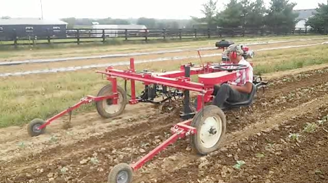
D. Drive Train
E-1. Front Frame Hanger Clamp
Three-Point Hitch Lift
Operator
C. Guidance Arm Mount Assembly
B. Steered Wheel Frame Assembly
A. Main Frame
Figure 1. Three-wheeled machine with furrow guidance.

Main Frame (A)
The main frame (drawing A) is welded together from square and rectangular tubing to form a “T” configuration, with the front part of the frame (A-1) for mounting the two steered wheels, and the rear part of the frame (A-2) for mounting the drive components including the engine, the drive wheel, and the transaxle. The two sections of the rear frame are connected by a short section of 3” x 6” steel tubing, and then this rear part is connected to the front frame by a single beam of 3” x 6” steel tubing. Note that a different design could be used for connecting the rear and front frame sections, but the center beam (or beams) has to be narrow enough so that there is no interference from the lift mounted on the right, or passenger, side of the machine. The main frame, in conjunction with the steered wheel frame assembly (B) and the wheels that were used, gives a ground clearance under the front frame (A-1) of approximately 30”.
Front Frame
The front frame (A-1) is made from 3” square tubing, thin walled (3/16”), sized so that 2.5” square tubing used for the steered wheel frame assembly will slide inside of it. Note that the fit is likely to be tight because of interference from the welding bead inside the tubing, so it may be necessary to file down part of that welding bead, or cut some grove on the outside of the inner sliding tube (B-2-1), to get the tube-in-tube assembly to slide easily enough. The front frame piece has a series of holes drilled in it that are dimensioned to work in conjunction with a series of holes drilled in the 2.5” inner tube of the tube-in-tube assembly, to give standardized incremental row spacings of 36” to 48” in 3” increments. The holes are actually spaced 1.5” apart to give a standardized spacing for mounting the three-point hitch lift in 1.5” increments (for centering the three-point hitch over the row). The length of the front frame, and the distance from the ends of the frame to the holes, are dimensioned in conjunction with the dimensions of the sliding tube (B-2-1) of the steered wheel frame assembly, to give the desired row spacing increments based on the steered wheel mounting used in this design. If a different mounting design is used, the dimensions for the front frame and drilled holes should be adjusted accordingly.
An additional detail of the front frame is holes drilled diagonally in the square tubing section. These holes are used for welding ½” nuts in place for using bolts as set screws for holding the inner sliding tube assemblies (B-2) fixed rigidly in the front frame.
Rear Frame
The rear frame (A-2) is welded together from 2” square tubing. The tubing is cut at precise angles to give a diagonal configuration for maximizing the frame strength for the mounting of the drive wheel. The frame configuration and size was dictated by the engine and transaxle that we used. The frame configuration and size should be adjusted accordingly if a different engine and/or transaxle is used. Note that the complexity of fabrication of the rear frame could be reduced if the frame were rectangular (eliminating the odd angular cuts), but such a change may reduce the frame strength. The machine has not been used enough for us to have the experience to know if such a reduction in strength would be a problem.

Steered Wheel Frame Assembly (B)
The drawing of the steered wheel frame assembly (B) shows the front part of the main frame (A) with the inner sliding tube assembly (B-2, that fits inside the front frame 3” square tubing) attached to the axle fork frame for mounting the steered wheels (B-1), and the steering box assembly (B-3). The steered wheel frame assembly encompasses the mounting of the widely-spaced front steered wheels (straddling two rows) and the mechanical steering system that is a key component of the furrow guidance system. It shows the bearing placements for the axle fork frame assembly and for the steering shaft, the hubs for mounting the steered wheels, and the steering connector arms for the steering tie rod (B-1-4).
Axle Fork Frame Assembly
The axle fork frame assembly (B-1) is made from 2” square tubing and incorporates a hub extension (B-1-5) for mounting the hubs for the steered wheels and kingpins (B-1-1) for the steering pivots. The tubing for the axle fork (B-1-3) and the other components are sized and dimensioned so that the wheels that we used (4.00/15SL; see Parts List Spreadsheet) are exactly in-line vertically with the steering pivot, which is key to the furrow guidance. Note that the kingpin (B-1-1) for the fork frame assembly on the operator’s side may need a key way for the steering sprocket (key way not shown on drawing). Note also that the hub extension that was used (B-1-5) was intended to give maximum welding surface for the shaft of the hub for mounting the steered wheels (1500 lb hubs; see Parts List Spreadsheet) . This piece required complicated fabrication that would be expensive to hire done. In retrospect, we believe that the hub shaft could have been satisfactorily welded directly to the axle fork (B-1-3).
Steering Connector Arms
Not shown in the axle fork frame assembly drawing (B-1), but visible in the photo in Figure 2, is the steering connector arm (B-1-4). These arms are used to connect the two axle fork frame assemblies via a steering tie rod (see below) so they turn in tandem when the steering wheel on the driver’s side is turned. The arms were designed with an angle (70°) to give the best configuration for steering between the two front steered wheels for the range of steering operation and wheel spacings used. Also, they were fabricated with two 90° bends, as can be seen in Figure 2, to offset the steering tie rod upward to maximize the ground clearance below the front of the main frame. Fabrication could be simplified by making the steering connector arms straight (without the bends), at the sacrifice of a few inches of ground clearance. The steering connector arms were welded to the horizontal square tubing member of the axle fork (B-1-3), with placement so that a line through the center of the steering connector arm passes through the center of rotation of the axle fork frame assembly kingpin (B-1-1).

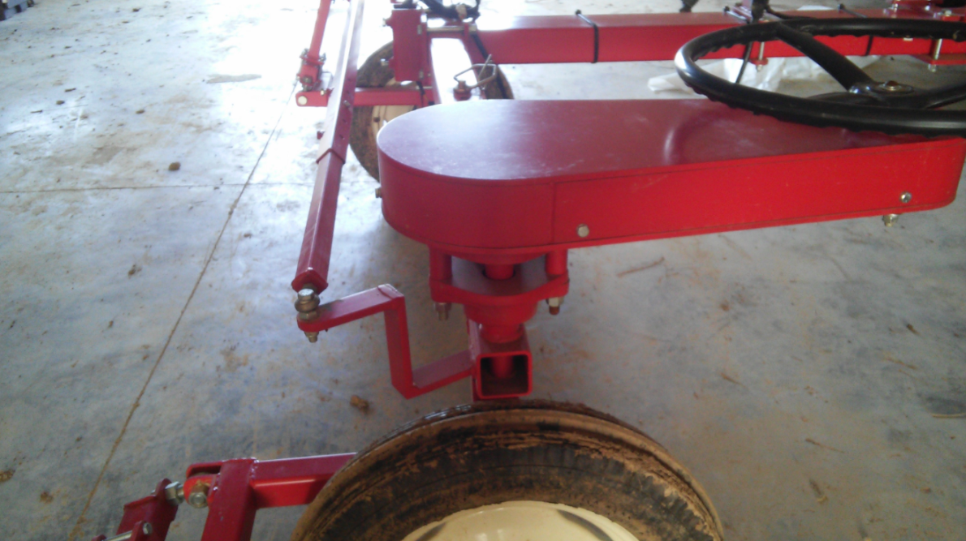
Figure 2. Steering connector arm and steering tie rod.

Steering Tie Rod
The steering tie rod can be seen in Figure 2. No drawings were done of the tie rod, but an explanation of its design is fairly straight forward. The main section of the tie rod was made from a 60” length of 1.25” square tubing (1/16 wall thickness). Inserted into each end of the main section are 32” lengths of 1” square tubing with the ends capped. The capped ends were drilled and tapped for tie rod ends (3/4"-16 right-hand male shank, 3/4" ball ID, 1-3/4" L thread; see Parts List Spreadsheet). The outer section of tubing had holes drilled into the corners and nuts welded on for set screws, as can be seen in Figure 1. Once the front wheels were properly aligned with the guidance arms exactly parallel, a hole was drilled through the outer and inner sections for square tubing so a bolt could be inserted as a pin. Additional holes were drilled in the outer section of square tubing at 3” intervals, so the proper alignment of the guidance arms could be maintained at the standardized incremental row spacings of 36” to 48” in 3” increments.
Inner Sliding Tube Assembly
As referenced under the narrative for the main frame, the inner sliding tube assembly (B-2) is made from 2.5” square tubing designed to slide inside the front frame. The square tubing (B-2-1) has a series of drilled holes 3” apart designed to work in conjunction with a series of holes in the front frame to give exact 3” increments in row spacing for the machine. Shaped plates (B-2-2) welded to the ends of the tubing are for mounting the bearings for the kingpin of the axle fork frame assembly (B-1). Note that these plates require more complex/expensive fabrication. We believe that the fabrication complexity could be reduced by simply mounting the bearings directly to the square tubing. If this change is made, bearing mount holes will need to be drilled in the tubing, and the dimension of the tubing adjusted accordingly to give the same placement of the axle fork frame assembly.
Steering Box Assembly
Steering for this machine is accomplished using a steering wheel controlling the pivoting of the steered wheels through a chain-and-sprocket drive. This type of steering is key to the furrow guidance concept, as it allows feedback from the guidance arms following the furrows to be fed back through the steering system to move both steered wheels as needed to stay on the furrows. Note that this type of feedback will not work with gear boxes used with other types of mechanical steering systems. The steering wheel is located approximately 17” from the center of rotation of the pivot of the left (or driver’s side) steered wheel, in a position within easy reach of someone sitting in the operator seat, depending on its mounting location. The steering box assembly (B-3) was initially designed to allow adjustable positioning of its angle – hence the extensive set of holes positioned around the kingpin hole on the steering box bottom plate (B-3-1). In the steered wheel frame assembly (B), the steering box assembly is shown angled diagonally back from the steering kingpin, but in practice, we have only used the steering box assembly in one location, straight back from the king pin (at a right angle to the front frame, as shown in Figure 2). Drilling only a single set of holes would reduce the fabrication complexity of the steering box bottom plate significantly. Note that no design instructions are given in B-3 for the band welded between the steering box top plate (B-3-2) and bottom plate (B-3-1). This band was cut and bent to fit the plates “in real time” as it was being fabricated.
As shown in the steered wheel frame assembly (B), the larger end of the steering box assembly (B-3) is connected to the inner sliding tube assembly (B-2) using the mounting bolts for the bearings for the kingpin of the axle fork frame assembly (B-1). The sprocket at this end is 10T 3/4 bore 40P (see Parts List Spreadsheet). At the other end, a pair of bearings (3/4 2-bolt UCFL207-20, see Parts List Spreadsheet) is bolted to either side of the steering box bottom plate (B-3-2) for mounting the steering shaft for the steering wheel (B-4). The sprocket at this end is 40T 1.25 bore 40P (See Parts List Spreadsheet). A fairly inexpensive steering wheel was used (Replacement, Massey Ferguson keyed hub; See Parts List Spreadsheet), but it should be noted that this steering wheel required a tapered shaft, necessitating additional machining complexity. It would probably be worthwhile to investigate moderate-priced alternatives in steering wheel s that would not require a tapered shaft.

Guidance Arm Mount Assembly (C)
The guidance arm mount assembly (C) is for mounting the furrow guidance arms out in front of the front steered wheels. The assembly bolts onto the vertical section of the axle fork (B-1-3) via four-bolt clamping plates, as shown in Figure 3. The clamping plates allow the position of the assembly to be adjusted up and down as needed. The guidance arm (C-3) mounts on the guidance arm pivot (C-2), positioned so that the guidance arm is centered in line with the steered wheel. The guidance arm pivot (C-2) mounts on the guidance arm mount (C-1) using two steering tie rod ends (3/4"-16 right-hand male shank, 3/4" ball ID, 1-3/4" L thread; see Parts List Spreadsheet) that make the alignment of the furrow guidance arms adjustable, an important feature for precisely aligning the guidance arms in-line with the steered wheels for precise following of the furrows. The mounting of the guidance arm pivot on the guidance arm mount via the steering tie rod ends is shown from above in Figure 4. At the end of the guidance arm, the guidance wheel is bolted on, as shown in Figure 5. The wheel used was a 4.10/3.50 pneumatic tire and rim (See Parts List Spreadsheet).

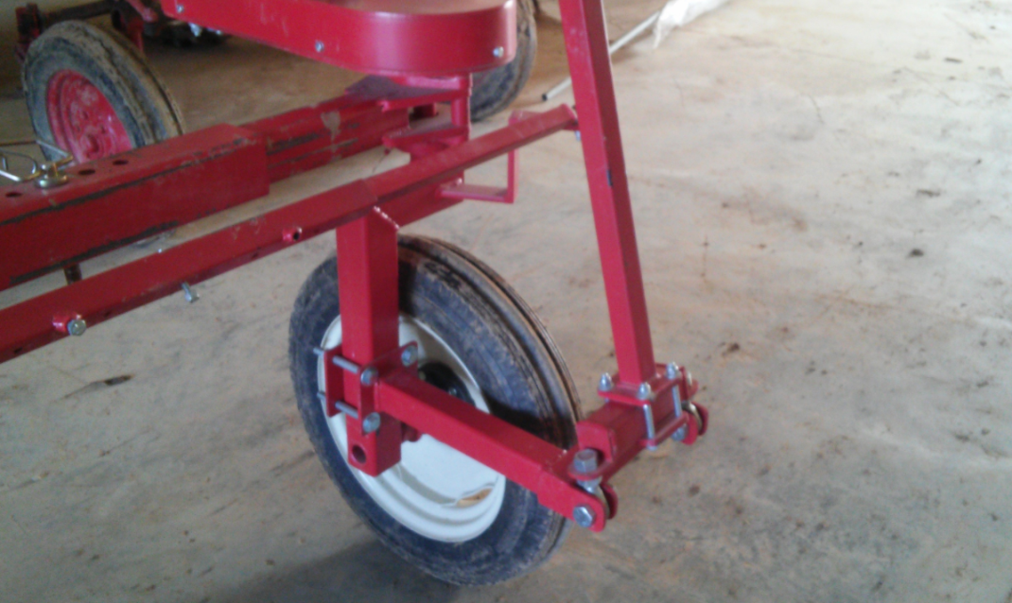
Figure 3. Four-bolt clamps for mounting the guidance arm mount assembly on the axle front fork assembly.

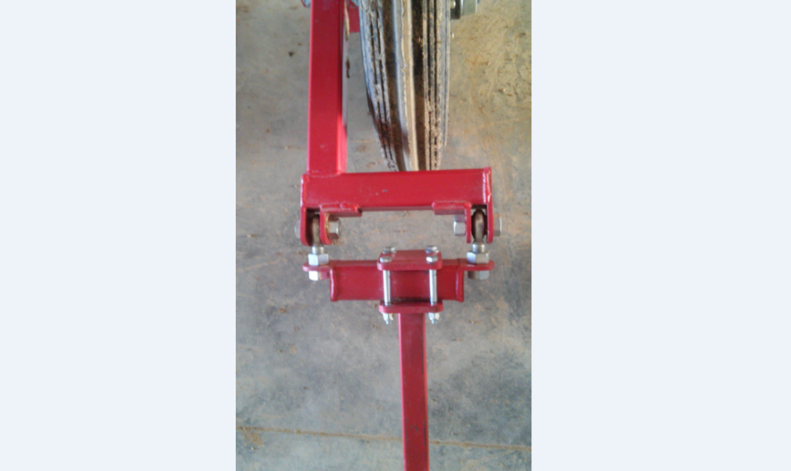
Figure 4. Guidance arm pivot mounted on the guidance arm via the steering tie rod ends.

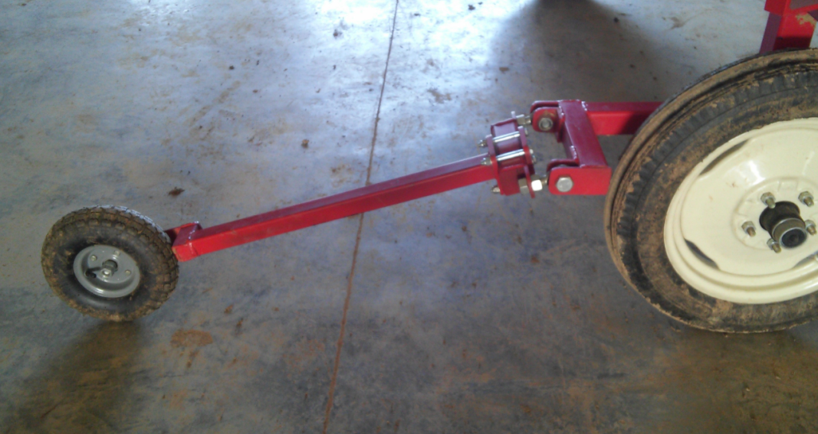
Figure 5. Guidance wheel on the end of the guidance arm.

Drive Train (D)
The main components of the drive train for this machine, some of which can be seen in Figure 6, are as follows: engine, transaxle, V-belt drive from the engine to the transaxle, rear wheel, double chain drive from the transaxle to the rear wheel, idler clutch for engaging/disengaging the V-belt drive, and the idler clutch control.

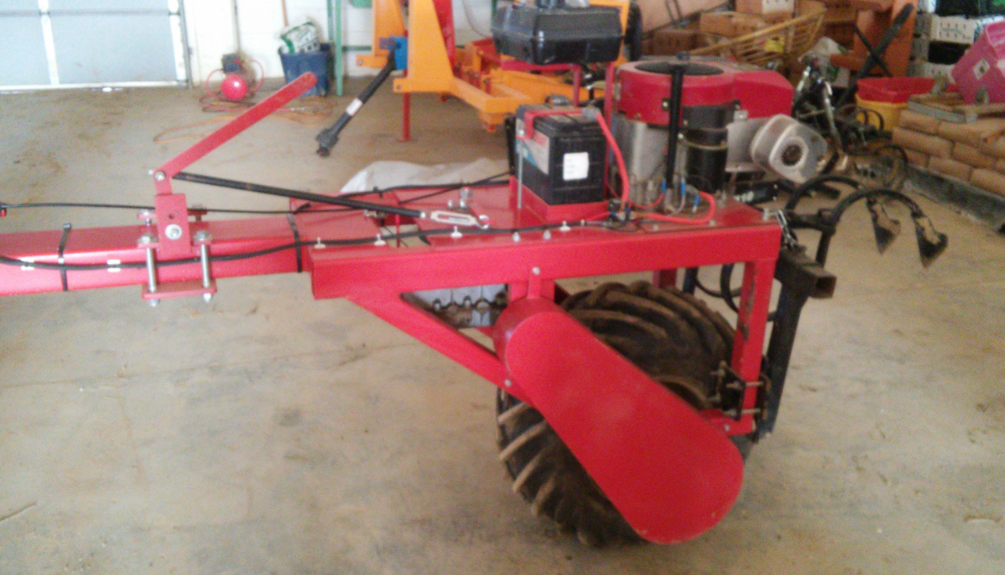
Figure 6. Drive train for three wheeled machine.

Engine
The engine used for this machine was a 15.5 hp Briggs and Stratton, Model # 28N787 (See Parts List Spreadsheet). This is a vertical shaft engine with electric start. The mounting plate (D-1) for the engine bolts on top of the main frame (A). Note that the same basic configuration and design for the engine mounting plate, and for holes for bolting the mounting plate to the main frame, can be used for different engines, with appropriate adjustments made for the hole patterns, dimensions, etc. Most engines of similar power output and configuration should work for the machine. The engine had to be set up for a gas tank and wired for electric starting with a solenoid valve, a battery, and an ignition switch (See Figure 6). The specifics for this are not being presented, as the actual details of how to do it will vary depending on the engine and other components used. The battery box we used is shown in D-3.
Transaxle
The transaxle that we used was chosen because of its ready availability at a very low cost. These transaxles (Peerless transaxle; See Parts List Spreadsheet) are a type used for some riding lawnmowers that have been available through surplus outlets. They have a vertical shaft on top for the input from the engine, horizontal output shafts to both sides, and the control in front. The schematic for the particular transaxle that we used is at Link for Peerless Transaxle mst-203-568. The transaxle has three forward speeds (speed reduction ratios of 47.5 to 1, 30.9 to 1, and 15.2 to 1) and one reverse (47.5 to 1). The design of the main frame was dictated in part by the configuration and size of the transaxle and the requirement to position the input shaft to line up with the output shaft of the engine for the V-belt drive. Spacers were machined and used to lower the transaxle mounting 2.50” below the upper horizontal section of rectangular tubing of the rear part of the main frame (A, A-2) so that the pulley on the input shaft of the transaxle would line up with the pulley on the output shaft of the engine (see Figure 7). The control lever for changing gears/speeds, seen in Figure 8, extends above the main frame and is operated by moving the lever horizontally.

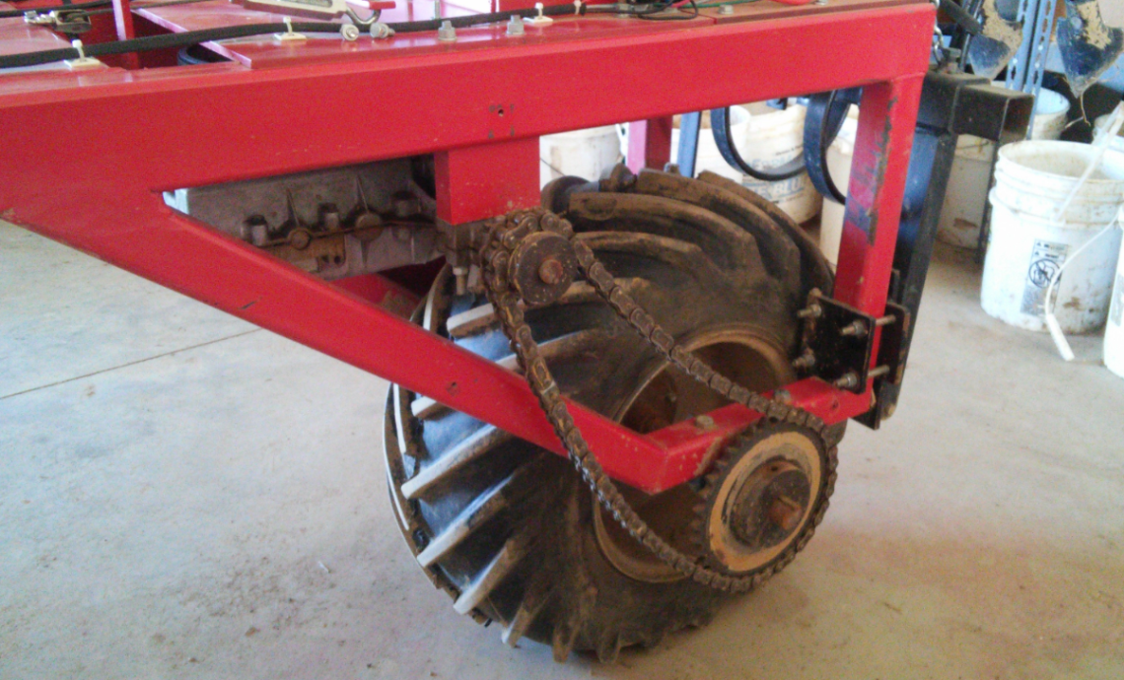
Figure 7. Chain drive on one side of the drive wheel shown with the safety shield off.

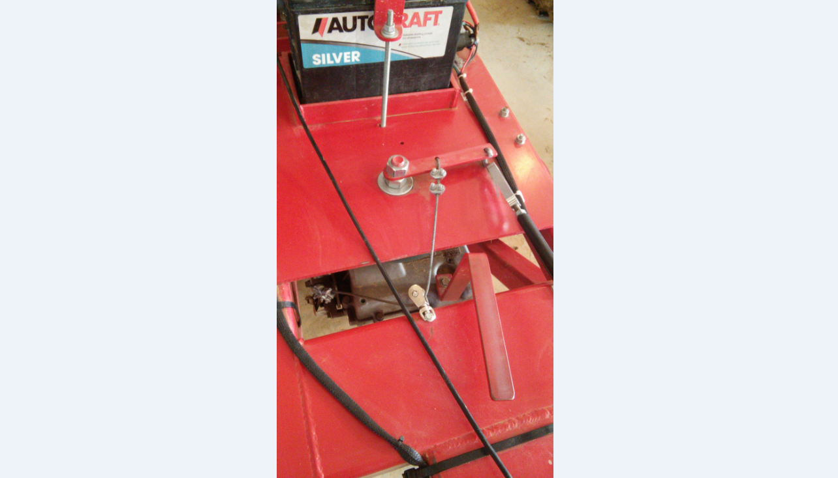
Figure 8. Transaxle and idler clutch control levers shown from above.

V-Belt Drive from the Engine to the Transaxle
The V-belt drive is located underneath the engine mounting plate (D-1) and clutch lever mounting plate (D-2) (See Figure 9). Note that the hole pattern near the edges of the clutch lever mounting plate (D-2) is for bolting the plate on top of the main frame, using the same bolts that mount the transaxle below the main frame. The single hole is for the idler clutch for engaging/disengaging the V-belt drive (more on that in the Idler Clutch for Engaging/Disengaging the V-Belt Drive section). The pulleys used for the V-belt drive were 3.75 O.D. 1 bore 1 groove at the transaxle, and 7.75 O.D. 5/8 bore 1 groove at the engine (See Parts List Spreadsheet). The V-belt was 5/8” x 57” (See Parts List Spreadsheet). The pulleys were sized to give the desired ground speeds in conjunction with the chain drive sprocket sizes, the drive wheel size, the engine speed, and the transaxle speed reduction ratios. The approximate ground speeds at an engine speed of 2500 rpm were 0.45 mph, 0.91 mph, and 1.4 mph.

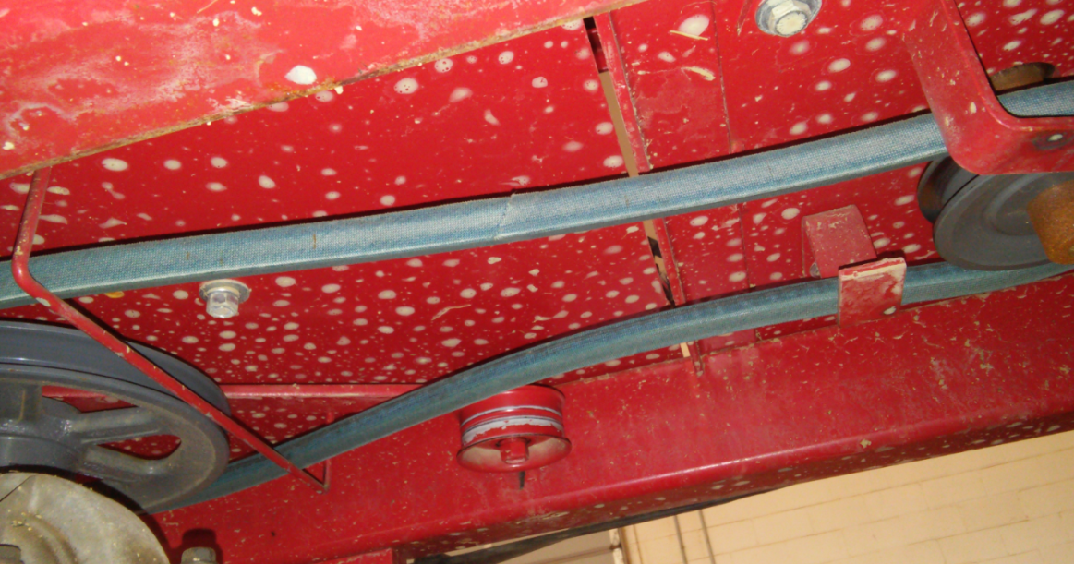
Figure 9. Idler clutch.

Note that these ground speeds are appropriate for most field operations conducted with the three-wheeled machine using furrow guidance, and the slowest speed is particularly important for various manual operations conducted while the operator is seated on the machine. However, the maximum speed is a bit slow for moving the machine longer distances (i.e. a “road gear”). A possible way to achieve faster speeds without considerably more expensive drive train components could be to have a double V-belt drive with two pairs of pulleys with different speed reduction ratios. While a potentially economical way to achieve a wider range of speed ratios, such an arrangement would add considerably to the complexity of the idler clutches and associated controls that would be required.
Rear Wheel
The rear wheel used was 26x12.00-12NHS. This particular wheel and mounting hub was surplus from other research/machine development work, so it was available to us at no cost (and consequently, there is no source information for it given in the Parts List Spreadsheet). The shaft for the rear wheel was mounted with pillow block bearings (1-1/4 UPC206-20; See Parts List Spreadsheet) bolted to the bottom of the rear part of the main frame (A), as can be distinguished in Figure 7 (although the view of the bearing is obscured by the sprocket). Note that this size wheel is readily available, but there may be some question as to the type hub of available at a reasonable cost for mounting this size wheel on the shaft. The shaft used, and any required machine work like for keyways, will depend on the hub and sprocket used, so specifications for it are not presented.
Double Chain Drive from the Transaxle to the Rear Wheel
The chain drive on one side of the drive wheel is shown in Figure 7 with the safety shield off. The sprocket at the transaxle is 12T 3/4 bore 60P, and the one at the wheel shaft is 35T 1-1/4 bore 60P (See Parts List Spreadsheet). The 60P chain that we used had 76 links (See Parts List Spreadsheet). The safety shield for the chain drive used the same basic configuration as the steering box (B-3), but without the bottom plate and the holes. The dimensions for center distance and radii for the safety shield were adjusted appropriately from that of the steering box assembly (19” instead of 17.58” for the center distance, radius of 5.5” instead of 5” at the small end, and radius of 8.5” instead of 8” at the large end). The safety shield has small tabs welded on to it for bolting the safety shield directly to the main frame using threaded holes in the main frame, as seen in Figure 10. The tabs can be welded on to the safety shield, and the mounting holes drilled into the main frame, after the safety shield has been fabricated.

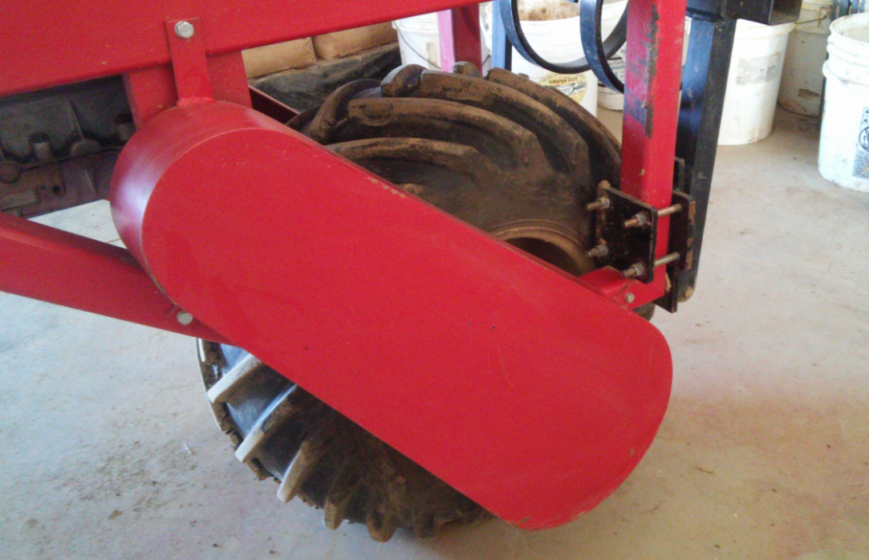
Figure 10. Safety shield with tabs, bolted onto frame.

Idler Clutch for Engaging/Disengaging the V-belt Drive
The idler pulley (See Parts List Spreadsheet) is attached to the end of an arm located below the clutch lever mounting plate, as shown in Figure 9. This arm pivots in a hole in the clutch lever mounting plate (D-2). In our design, the arm is made of ¼” x 1” steel plate, and the center distance from the lever pivot to the idler is 10”. However, the entire V-belt drive and idler clutch arrangement had to be worked out “real-time” in the machine shop as the machine was being assembled, and it required a lot of trial and error to get it to work right. Because of the vertical shaft arrangement with the engine and transaxle that we used, the V-belt drive was in the horizontal plane, and it was difficult to get the correct combination of V-belt length, V-belt support hangers, and tension in the belt and idler so that the V-belt stayed on the pulleys but engaged and disengaged the transaxle as desired. Given the challenges and the trial and error nature of getting the V-belt drive to work correctly, we will not present further specifics of the idler clutch arrangement that we used. Some of the support hangers that we ended up using can be seen in Figure 9.
Since the V-belt drive is in the horizontal plane, as explained above, the idler has to swing in the horizontal plane. Accordingly, a lever arm above the clutch lever mounting plate has to swing in the horizontal plane to swing the idler into position to tension the V-belt to engage the drive, as can be seen in Figure 8. The arrangement for this lever was especially challenging because we needed to be able assemble the idler clutch arrangement while providing needed adjustability in the angular position of the lever. Accordingly, we had to use a large bolt with a nut tightened down to hold the lever in the desired position. This arrangement allowed us to get the idler clutch to work properly through trial and error, but occasionally the nut would work loose after long periods of operating in the field. A different arrangement that would hold the angular position of the lever fixed, while retaining the required assembly/disassembly capability, would be a good improvement. We will not present the specifics of this part of the idler clutch arrangement either.
Lever Control for Engaging the Idler Clutch
The control for engaging the idler clutch was also very challenging. We wanted a lever control that would engage the transaxle (and hence the movement the machine) when pushed forward over center but that would spring up to disengage the transaxle with a very easy upward nudge. At the same time, we needed the same lever to brake the transaxle, and hence brake the movement of the machine, when pushed back. We felt that the lever control should be in the vertical plane for the most suitable ergonomic characteristics for safe operation, i.e. to make it the simplest and most natural motion for disengaging the machine quickly when desired, with further motion in the same direction to brake the machine. To meet these requirements, the movement of the control lever in the vertical plane had to translate to a movement of the idler lever arm in the horizontal plane, and the linkage had to be rigid to apply pressure for braking when it was pushed back. The lever control that moves in the vertical plane can be seen in Figure 6, and the transition from the vertical movement to the horizontal movement of the idler clutch arm can be seen in Figure 8. The rigid linkage is made out of 3/8” steel tubing, with a turnbuckle at one end for adjustability for the trial and error needed to get it to work. To accomplish braking, an arrangement of flexible steel cable and small pulleys was used to apply the needed pressure for moving the plate that functions to brake the transaxle, as can be seen in Figure 8. As with the idler clutch arrangement, given the challenges of making this control arrangement work, we will not present specifics of the design that we used.

Mounting to the Machine (E)
In keeping with the overall objective for this machine system of being low-cost and relatively simple mechanization, the set ups used for mounting things on the machine were kept simple and standardized as much as possible. This principle was applied to the brackets for mounting things on the front part of the main frame and to the toolbars and masts used for implements attached to the Category 0 three-point hitch, both of which are described below. It should be noted that the configuration of the machine, with its wide stance (and hence good stability) and simple tubular frame, lends itself to mounting various other things, in various ways, to the frame. Two applications in particular that come to mind are platforms or surfaces for storage (like flats of plants for transplanting, harvest bins, etc.) and overhead shade. These and other mounting applications are left to future machine users to devise. Hopefully such improvements and new applications will be shared for continued improvement of the system.
Mounting to the Front Frame
As mentioned previously, the front frame of the machine serves as a toolbar for mounting the three-point hitch lift system and the operator seat. The same clamp is used for mounting the bracket for three-point hitch lift on one side of the machine (the “passenger” side) and the bracket for the seat on the other side (the “driver” side), as can be seen in Figure 1. This front frame hanger clamp (E-1) was made from a short section 2.5” square tubing welded to a 3/8” plate with holes drilled for a four-bolt clamping plate set up for bolting it to the front part of the main frame. The 2.5” square tubing is sized so that 2” square tubing can slide inside for mounting the T-bracket that holds the lift or the seat.
An additional feature of the hanger clamp is a horizontal tab in back, centered with a hole drilled through it. This tab holds the hanger clamp above the frame, “hanging” it from the frame, making it easier to adjust its position and tighten the bolts for clamping it in place. The hole drilled in the tab is sized and located so the clamp’s position can be standardized with the adjustable row spacing of the machine at 3” increments, with a pin through this hole and the holes drilled in the front frame (A-1) and the inner sliding tube (B-2-1) (referenced in earlier sections). This feature is important for centering the three-point hitch exactly halfway between the centers of the drive wheel and the steered wheel (the row spacing). Note that the hanging clamp can still be bolted in place without centering it on the row using the pin, as might be the case for positioning the seat bracket on the driver’s side of the machine. Figure 11 shows the front frame hanger clamp in place, supporting the three-point hitch lift (pinned through the frame so the lift is centered over the row).

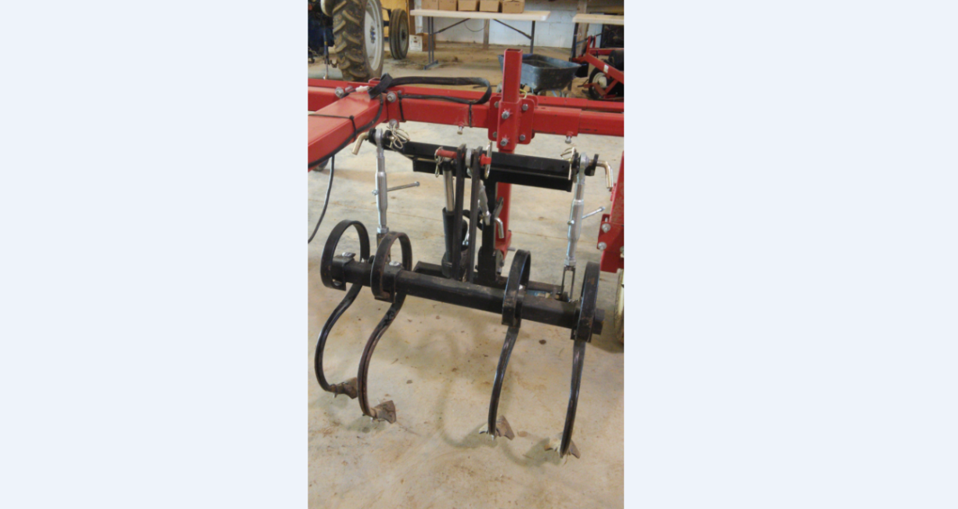
Figure 11. Front frame hanger clamp in place, supporting the three point hitch lift.

The holes drilled in the hanging bracket tab and in the front frame and inner sliding tube are sized for use with a 5/8” pin, which happens to be the standard size pin used for mounting implements to the Cat. 0 three point hitch. This makes it easy and relatively inexpensive to purchase the needed pins (rather than fabricating something). Note that we used a grinder to file down a slight taper on these pins to make it easier to insert the pins when attempting to line up three different machine parts (the hanging clamp, the front frame, and the inner sliding tube).
The bolts used for the four-bolt clamping plate were ½” diameter. Note that the heads of these bolts could be welded to the plate to hold them rigid to the plate. This arrangement might make it easier to position the hanger clamp, and it would allow the nuts to be tightened with only a single tool.
The T-bracket, shown in Figure 12, consists of a 24” section of 2” square tubing welded at a right angle to a 6” long section of 2.5” square tubing. The 2” tubing part of the T-bracket slides vertically into the 2.5” tubing of the front frame hanger clamp (E-1) referenced in the section above. The 2.5” tubing section of the T-bracket is sized for 2” square tubing, used for mounting either the lift or a frame for the operator seat, to slide into it. This 2” tubing, which is secured in place with set screws in the 2.5” tubing part of the T-bracket, serves as a frame for mounting the lift on the passenger side and the seat and foot rest on the driver’s side. Note that the length of the vertical section of the T-bracket is dictated by the machine height, to maximum the adjustability for positioning the seat or lift as low to the ground as desired, while allowing the T-bracket to be inserted into the hanger bracket without having to take the hanger bracket off of the front frame (or having to jack up the machine).

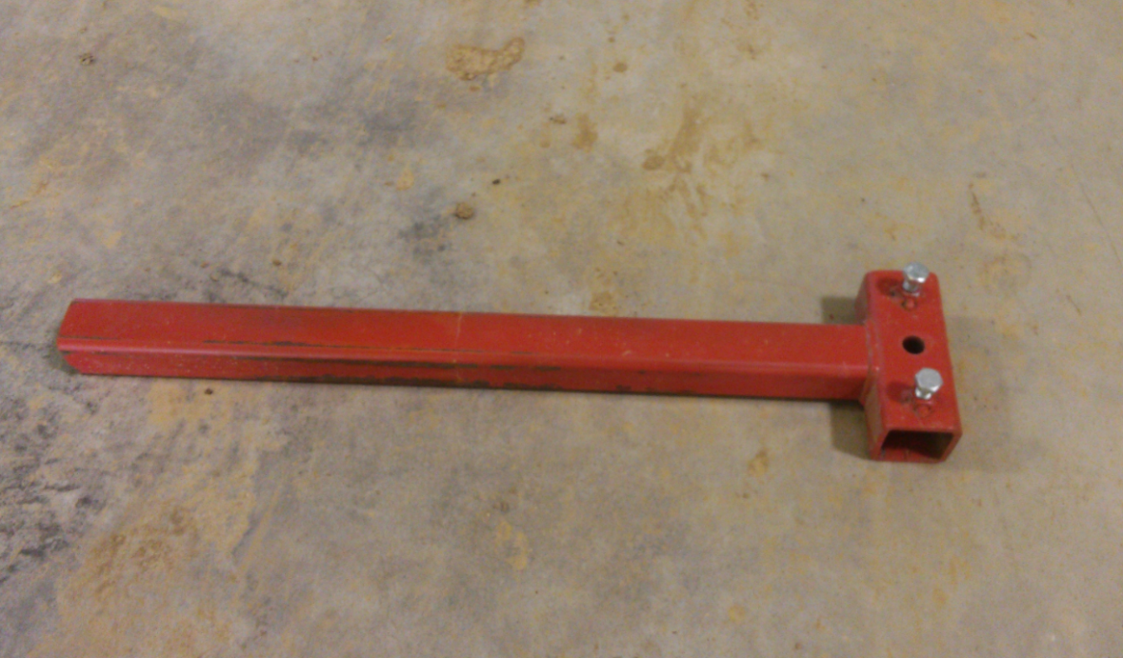
Figure 12. T-bracket that mounts in front frame hanger clamp.

Implement Mounting
One of the benefits of the small scale of this machine system is that most of the implements are small and light enough that one person can lift and maneuver them into place for mounting on the three-point hitch. With the Category 0 three-point hitch system, the toolbars and mounting brackets are fairly simple and light weight, and therefore relatively easy to fabricate. A standardized toolbar for mounting implements can be made from a section of 2” square tubing as the toolbar, with mast parts welded to 2.5” square tubing sections that slide over the 2” tubing, as shown in the implement mast assembly (E-2). The mast parts (upper, E-2-1; and lower, E-2-2) are secured to the toolbar with set screws. This arrangement, with the mast parts that slide onto the toolbar, gives good flexibility and allows mast parts to be slid off the toolbar for mounting various implement parts onto the toolbar. However, the toolbar is so short that it does not leave very much room for mounting anything else. The implement seen in Figure 11 has an alternative toolbar and mast assembly with mast parts that are welded into place. This assembly is simpler and cheaper to fabricate, and leaves more space on the toolbar, but it has less flexibility. Note that with either arrangement, additional toolbars may need to be mounted back from the mast assembly, to have sufficient room for positioning tools as needed. A cultivator with this double toolbar arrangement is shown in Figure 13.

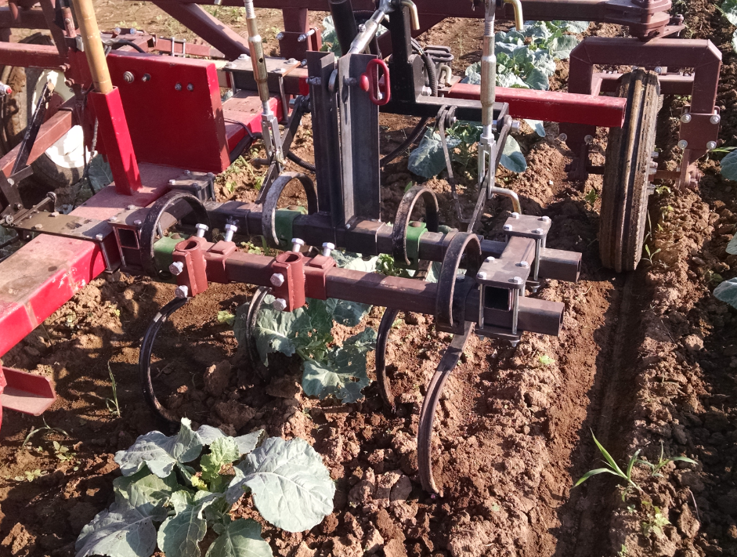
Figure 13. Two toolbar implement arrangement.

Various Implements (F)
Various implements have been put together, using the basic toolbar/mast assembly, for accomplishing a range of field operations.
Drip-Tape Layer
Perhaps the most critical implement is the drip-tape layer, as it is the basis for the use of the three wheeled machine with furrow guidance for bare ground production with buried drip tape. The drip-tape layer that we put together for the second prototype is shown in Figure 14. We put this implement together using the standard toolbar/mast assembly (E-2). A digging shoe with drip-tape laying tube attached is mounted underneath the toolbar, and a reel for the drip tape is mounted above. A double loop of heavy chain is used for bringing dirt back in and filling in the furrow created by the digging shoe. The drip tape reel was purchased from Martin’s Produce Supply in Liberty, KY (See Parts List Spreadsheet). It is sold as a replacement part or attachment for a smaller-scale raised-bed plastic layer that this company sells. The kit that was purchased also comes with a drip-tape laying tube, but that tube is fairly large (2” outer diameter), as it is designed to be used with a raised-bed plastic layer that moves a lot of soil to form the raised bed. For our application, we felt like it would be important for drip-tape laying shoe to be as narrow as possible so that much less soil was required to fill in the furrow created by the drip-tape laying shoe. So we made our own drip-tape laying tube by bending a section of steel conduit (approximately 1.13” O.D.) and securing it to the rear of the digging shoe. The digging shoe that we used was sold as a replacement box blade shank (18” long, 4 hole; see Parts List Spreadsheet). A closer view of the drip tape tube and digging shoe is shown in Figure 15. Note that sheet metal pieces were welded between the tube and the digging shoe to make a smooth wall between the two to reduce drag and the potential for soil to build up in that space.

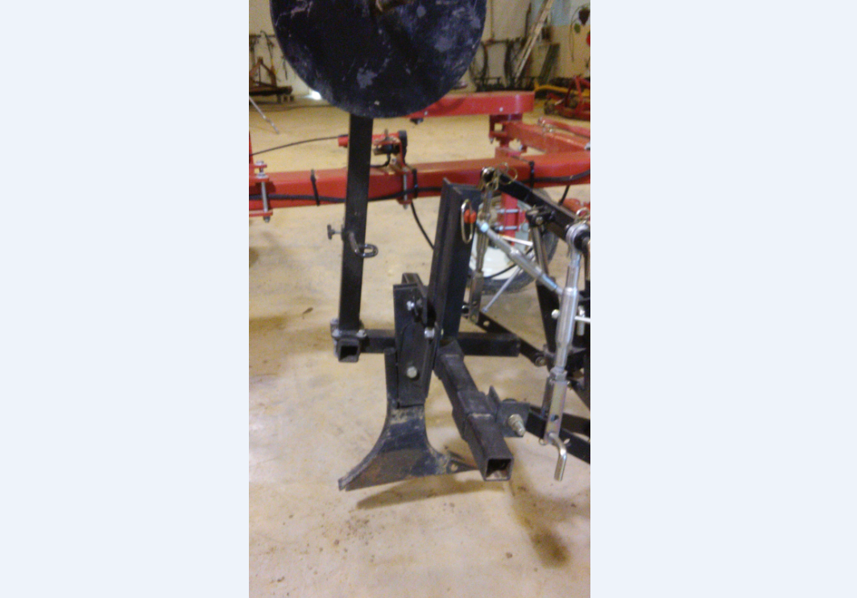
Figure 14. Drip tape layer for three-wheeled machine.

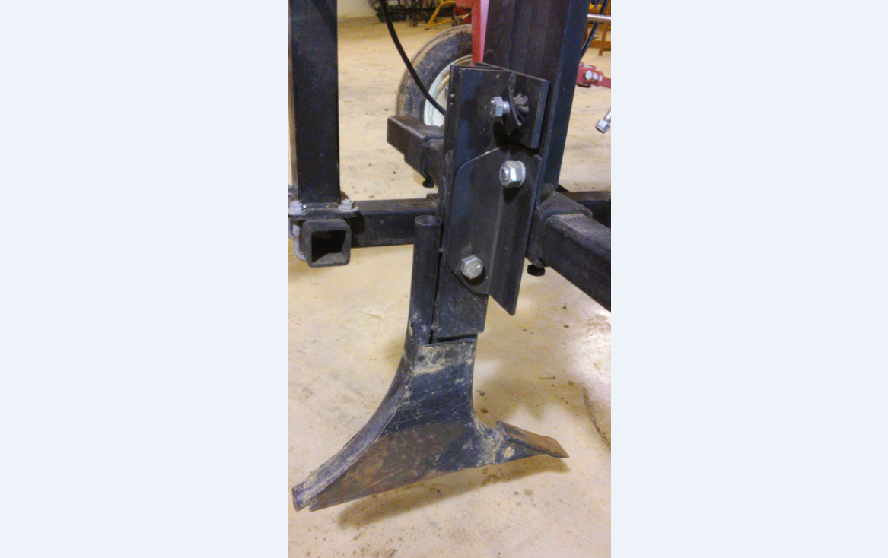
Figure 15. Drip tape tube and digging shoe.

The drip-tape layer has worked very well for us. Using the electric lift, it is very easy to control the depth when laying drip tape. The overall configuration of the machine, which has the operator down low close to operation, with a clear view of the implement, contributes to the ease of control as well. We have tended to lay the drip tape relatively deep, 4”-5”, but it may be beneficial for some crops to lay it shallower so that not as much water is needed from the drip tape to wet the surface and upper root zone of the plants. It would be good to check out this possibility.
Potato Planter
The drip-tape layer can be used for planting potato seed pieces by outfitting it with a planting tube for dropping the potato seed pieces in the furrow above the drip tape, in front of the closing chains. Figure 16 shows the planting tube attached to the drip-tape layer. The 3” PVC planting tube is held in place by a bracket bolted to the digging shoe. It is notched out at the bottom to nestle over the end of the bent drip-tape tube, as shown in Figure 17. It has a 30° elbow so the planting tube can extend to a position for the operator on the other side of the machine to very easily and efficiently drop the potato seed pieces into it. Figure 18 shows the older machine with the operator in position for planting potatoes. It also gives an indication of the type of arrangements that can be made for storing containers (for potato seed pieces in this case) on the machine. With this set up, laying drip tape and planting potatoes in a single pass is a one-person operation. After the machine is driven through the field once just to make the initial guidance furrow (without laying drip tape), all the rest of the passes with the machine can be made using furrow guidance for steering, so that the operator is freed up for dropping the seed pieces into the planting tube.

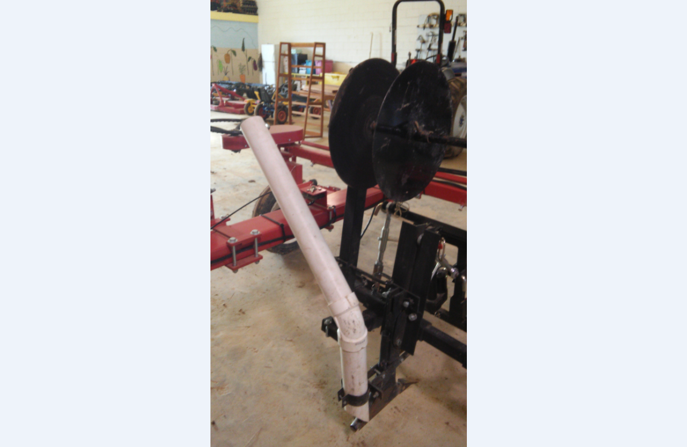
Figure 16. PVC tube attached to drip tape layer for planting potatoes.

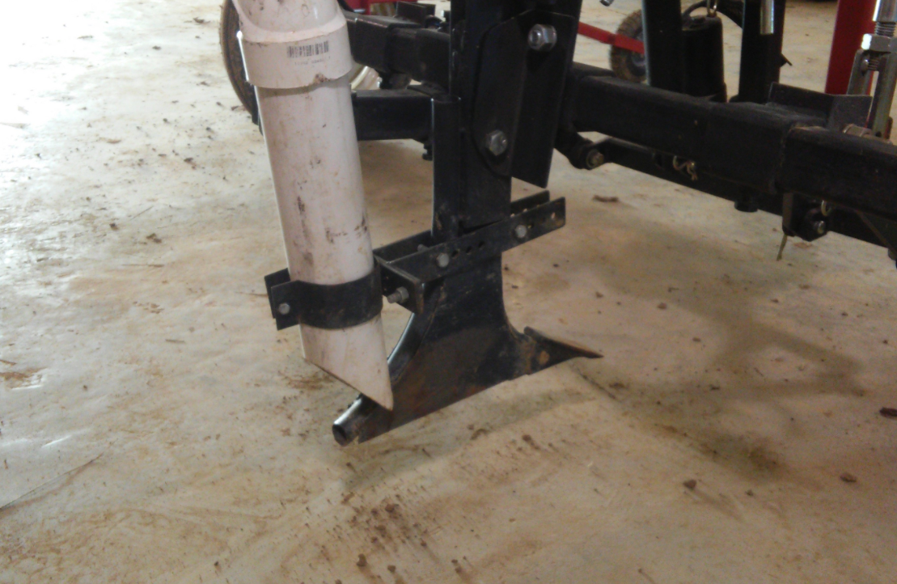
Figure 17. Planting tube bolted to digging shoe .

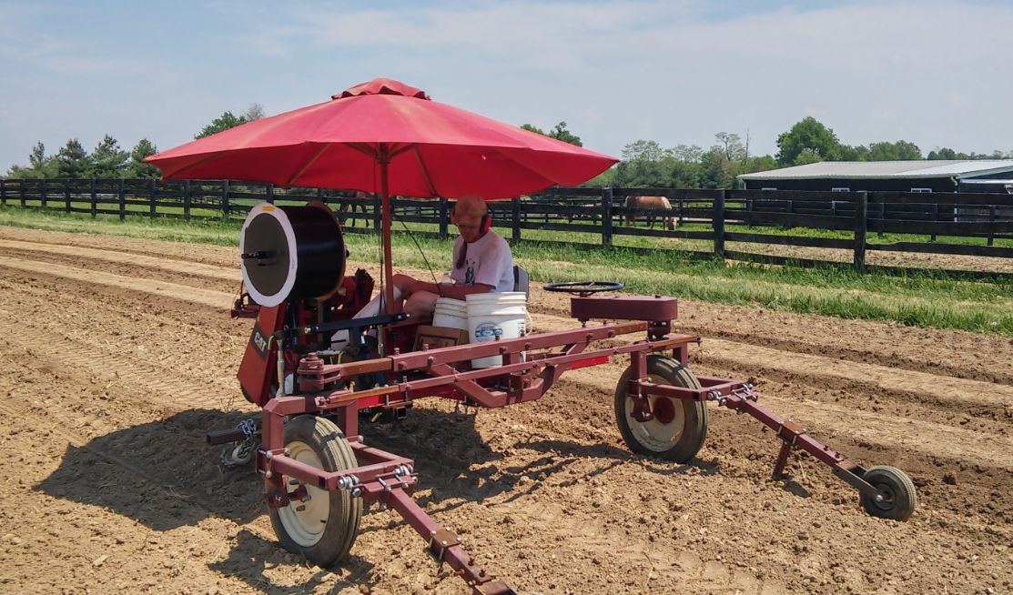
Figure 18. Planting potatoes from the first prototype of the three-wheeled machine.

We have tried this set up for potatoes with the seed pieces dropped directly on top of the drip tape laid 4”-5” deep, with a hilling operation done some weeks later following several cultivations (after the potatoes have grown sufficiently for soil to be hilled around the plants). There are other possibilities that may be better for a potato crop. In particular, it may make it easier to dig potatoes later in the season if the potatoes are grown in more of a raised bed. It could work to make a raised bed in an initial operation, and then use the drip-tape layer with potato planting tube in a subsequent operation. However, this scenario could make cultivating more difficult (more on that to come).
Hilling Disks
Shown in Figure 19 is the implement mast assembly (E-2) with 16” hilling disks mounted on it (See Parts List Spreadsheet). Note that because of the spacing of the brackets for the mast on the toolbar, the spacing of the hilling disks was constrained. This is a case where a second toolbar might be needed for more flexibility in tool spacing. This is the arrangement that has been used for hilling potatoes. We think it could also be used for making raised beds, but we have not tried that out.

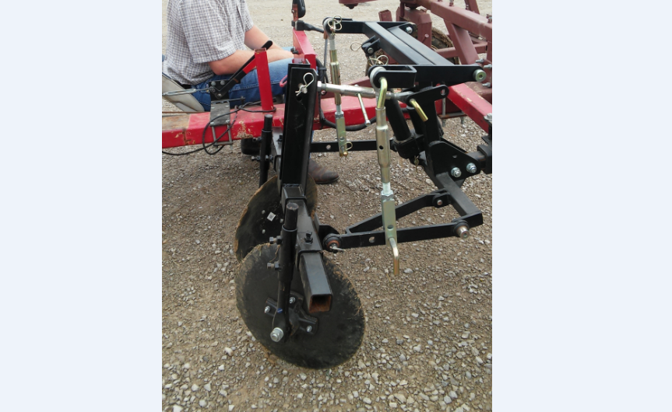
Figure 19. Implement mast assembly with hilling disks.

Seeders
An arrangement for mounting seeders can be especially useful for crops that are direct-seeded. We have used such an arrangement both for mounting older model Planet Junior seeders, as shown in Figure 20, and for mounting the more recently-popular Jang seeders, as shown in Figure 21. In both cases, two seeders were mounted centered over the row, for planting in double rows on 11” spacing (need to check this). In the case of the Planet Junior seeders, the units included the frame work for mounting on the original toolbar and that allows the seeders to float on with the ground surface. In this case, a bracket had to be fabricated for mounting the existing seeder frame work to our toolbar/mast assembly. In the case of the Jang seeders, the seeders available were hand-push units, so we devised some simple linkages that allowed the seeders to float with the ground surface, and added an arrangement for chains that raise the seeders off the ground when the electric lift is raised. It should be possible to devise similar arrangements for other seeders.

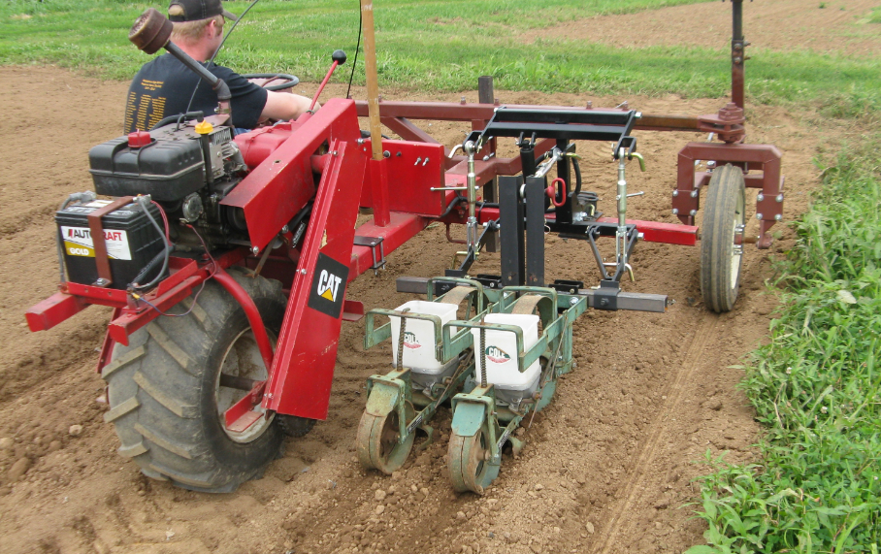
Figure 20. Planet Junior seeders mounted on implement mast assembly.

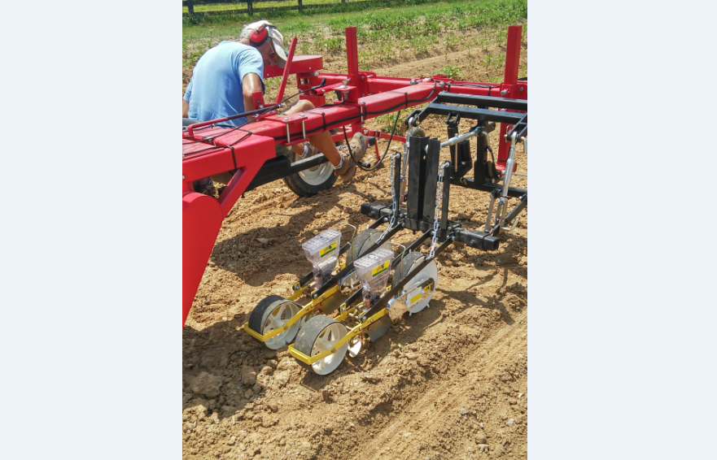
Figure 21. Jang seeders mounted on implement mast assembly.

Cultivators
The only cultivation tools we have tried with the furrow guidance system are Danish S-tines with shovels attached to the end. A double toolbar arrangement (used with the older machine) is shown in Figure 13. Note that there are two additional brackets on the second toolbar, for tools with vertical round shanks, which are not being used. Shown in Figure 22 is a single toolbar arrangement used with an electric-powered fertilizer drop box (powered off the machine battery) with drop tubes rigged up to side-dress fertilizer in front of the two inner shovels. Various other arrangements for cultivating tools are possible. The only other arrangement we have tried is with a single S-tine centered on the toolbar. A centered cultivating tool may be of possible use for cultivating between double rows of direct-seeded crops, although at 11” spacing it is pretty tight. We used the centered cultivating tool for marking the center of the row for transplanting operations.

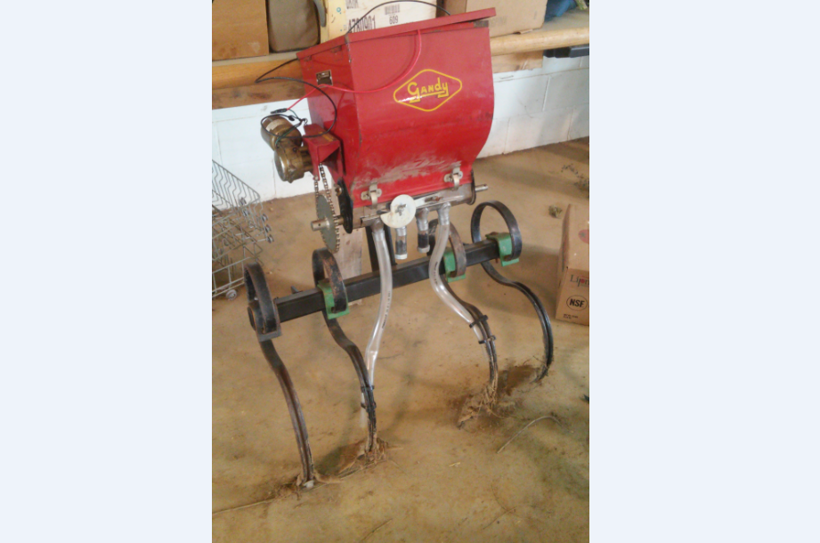
Figure 22. Danish S-tine cultivators mounted on a single toolbar, with electric-powered fertilizer drop box.

Shown in Figure 23 is a rear-mounted toolbar with Danish S-tine cultivators for cultivating behind the central drive wheel (on the older machine). This cultivation tool is needed to cultivate for weeds in the track of the drive wheel because of the constraints to extending the toolbar far enough to the center of the machine (where the drive wheel is) to cultivate that area. This toolbar pivots down from bolts through the rear of the frame, with the cultivation shovels riding along the surface of the soil with pressure only from gravity. The toolbar must be raised manually at the ends of the row in order to turn the machine around. This same rear cultivation tool used with the new machine can be seen in Figure 5, with the toolbar raised up as needed for turns at the ends of the rows.

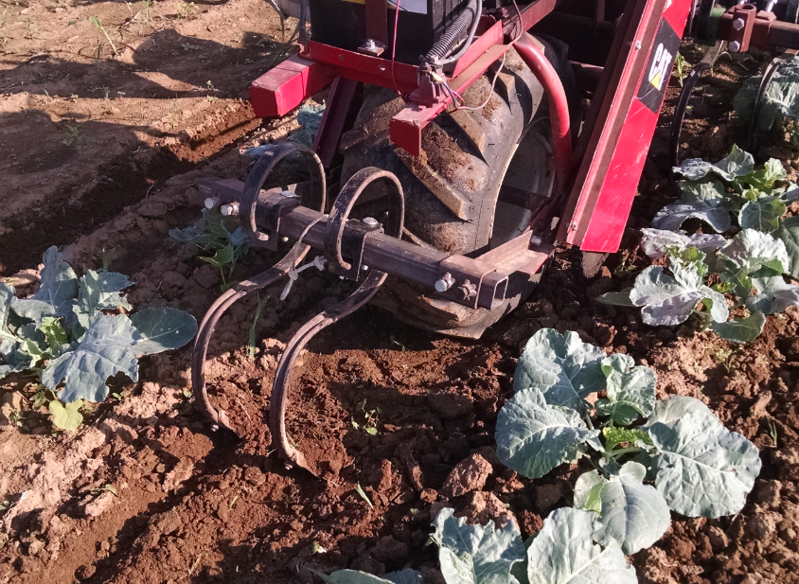
Figure 23. Rear-mounted toolbar with Danish S-tine cultivators for cultivating behind the central drive wheel.

Furrow Reforming
The furrows used for guidance with this machine system are initially created when the narrow front wheels are driven through loose soil. Due to rainfall and wind, furrow quality can deteriorate over time, jeopardizing the reliability of machine tracking. This problem is easily solved by re-plowing the furrows every time the machine is used, utilizing furrow reforming shovels mounted on the guidance arms. Figure 24 shows the operator-side guidance arm with the furrow reforming shovel mounted on it. The shovel is the same as those that we used for the Danish S-tine cultivators. The shovel is bolted to a vertical shank welded at an angle to a 4-bolt clamping plate that is clamped onto the guidance arm, as shown. The depth that the shovel digs is adjusted by moving it up or down along the guidance arm.

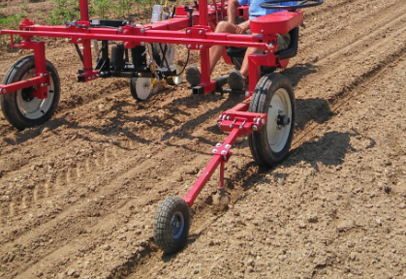
Figure 24. Furrow reforming shovel mounted on operator-side guidance arm.

