Fig. 1. Crop value of different cultivars grown under organic production in Charleston, SC 2014.
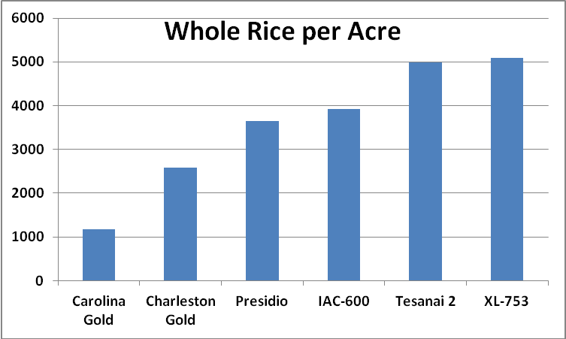
Whole rice per acre = (field yield x whole milling yield/100), amount of whole milled rice produced per acre. IAC 600 is purple bran rice and is presented as whole brown rice per acre.

