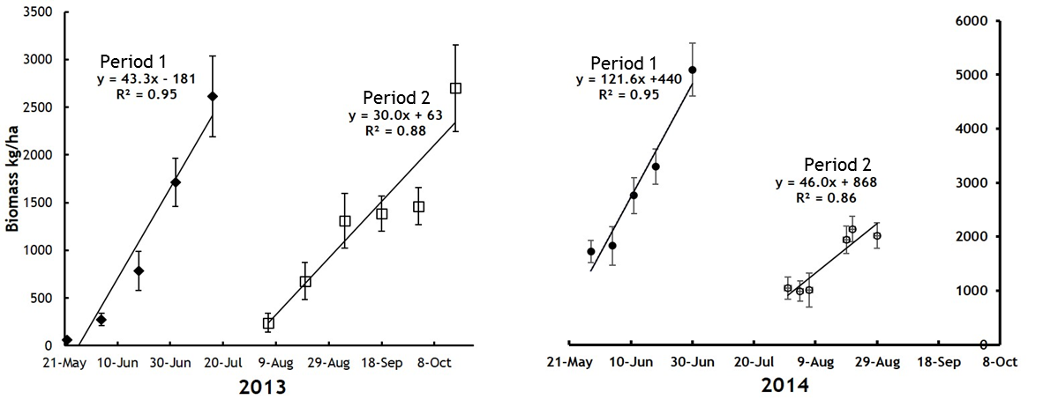
Figure 1. Growth trends of dry matter (biomass) during early (Period 1) and late summer (Period 2) of 2013 and 2014.

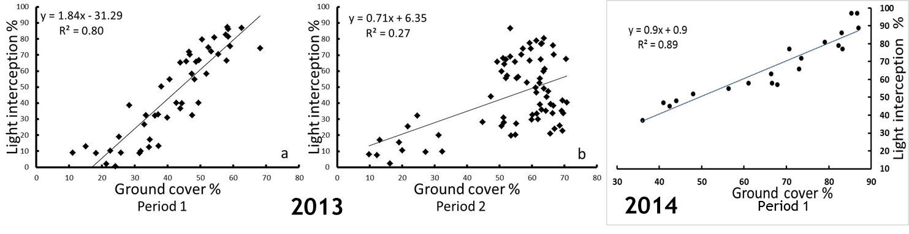
Figure 2. Light interception (%) in relation to ground cover (%) for both periods in 2013 and Period 1 only in 2014.
Figure 3. Average daily gain (ADG) of cattle liveweight during three grazing periods in 2014 and the season-long mean (Final). West (red) symbolizes the grass-only treatment, and East (black) symbolizes the grass-alfalfa treatment.

