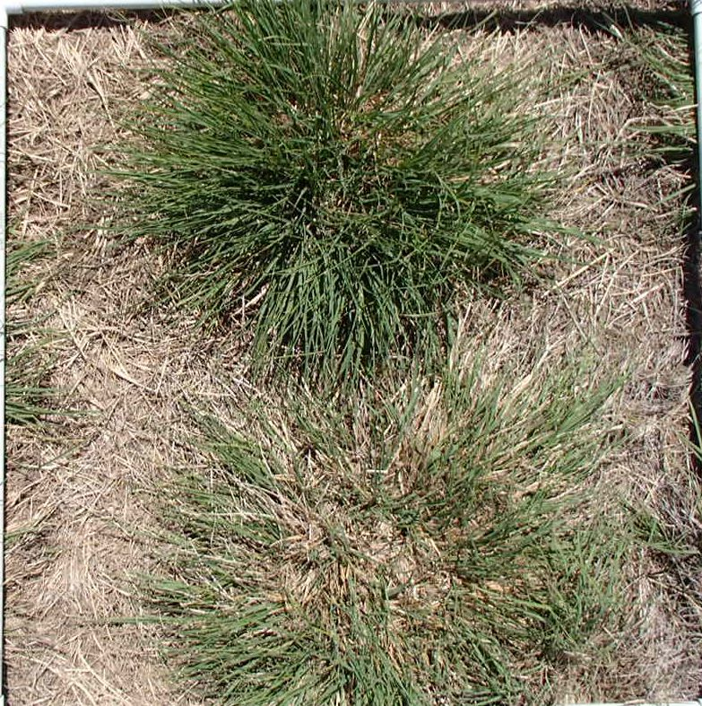

Figure 1. Example digital photograph of WW-B.Dahl bluestem in 1 m² area.
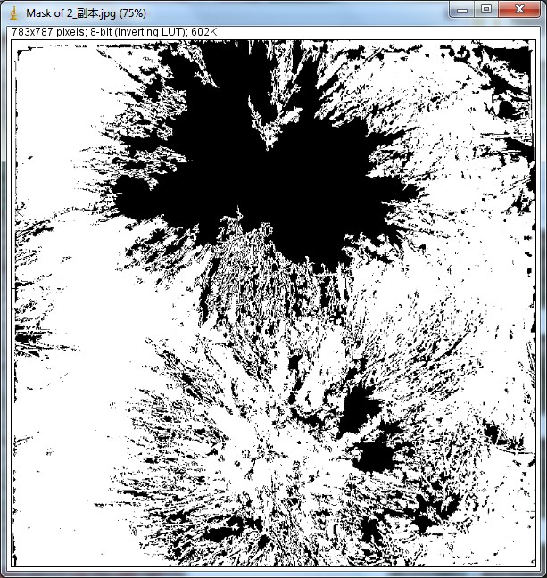

Figure 2. Digitization of photograph and conversion of green leaf area
to percent ground cover using ImageJ software, in this case 30.7%.
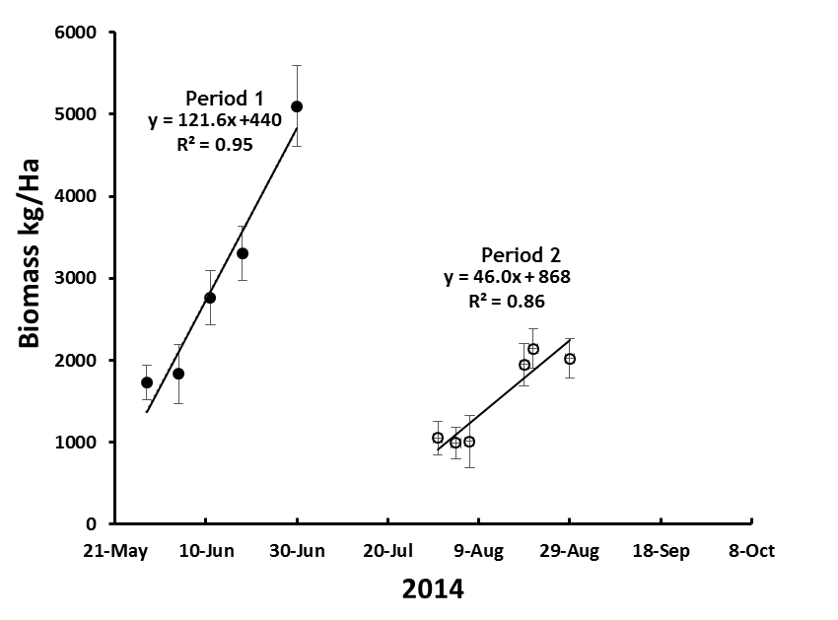
Figure 3. Linear growth trends during two growth cycles in 2014
regressed on days. The x-coefficients indicate daily growth rates of
121.6 kg/ha in Period 1 and 46 kg/ha in Period 2.
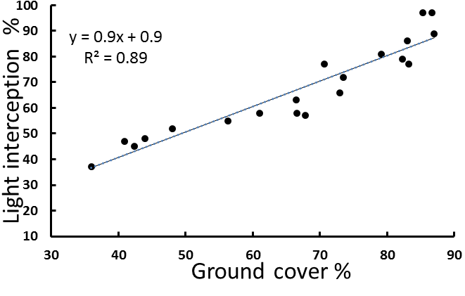
Figure 4. Linear relationship between percent light interception
percent ground cover, as determined using image analysis.
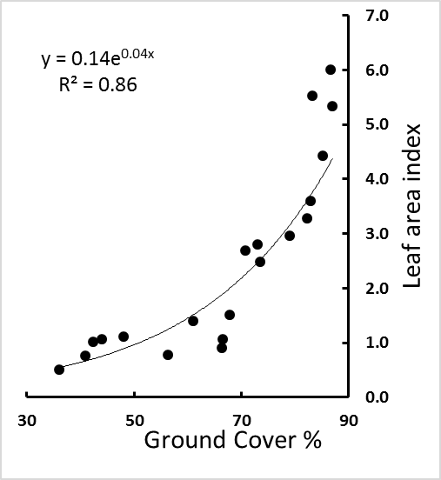
Figure 5. Relationship between leaf area index and
percent ground cover using image analysis.

