Table 1. Soil properties from soil in the upper 0-20 cm of under-vine rows after the second year of under-vine cover crop establishment in the late fall of 2013 in a Riesling vineyard in the Finger Lakes, NY. Treatment abbreviations: BW: Buckwheat; CHI: Chicory; CON; glyphosate sprayed control.
Treatment |  | pH | Buffer pH | Organic Matter (%) | Wet Aggregate Stability
BW |  | 6.05 | 6.44 | 3.39 | 32.5
CHI |  | 6.05 | 6.46 | 3.34 | 39.1
CON |  | 6.08 | 6.45 | 3.36 | 39.3

Table 2: Morgan extractable nutrient content from soil in the upper 0-20 cm of under-vine rows. Samples were collected in the second year of under-vine cover crop establishment in the late fall of 2013 in a Riesling vineyard in the Finger Lakes, NY. Treatment abbreviations: BW: Buckwheat; CHI: Chicory; CON; glyphosate sprayed control.
Treatment |  | NO₃ (ppm) | P (ppm) | K (ppm) | Ca (ppm) | Mg (ppm) | Al (ppm) | Fe (ppm) | Mn (ppm) | Zn (ppm)
BW |  | 4.7 | 2.2 | 114.9 | 830.5 | 106.7 | 7.1 | 0.8 | 8.2 | 1.8
CHI |  | 4.1 | 2.5 | 118.6 | 792.7 | 118.0 | 5.0 | 0.6 | 7.7 | 0.9
CON |  | 5.3 | 2.1 | 115.4 | 736.0 | 106.3 | 6.2 | 0.8 | 7.2 | 1.8

Table 3: Yield, pruning weight, and Ravaz index from a Riesling vineyard under-vine cover crop experiment in the Finger Lakes, NY in 2013 and 2014. NY. Treatment abbreviations: BW: Buckwheat; CHI: Chicory; CON; glyphosate sprayed control.
Treatment |  | 2013 Yield (kg/vine) | 2013 Pruning Weight (kg/vine) | 2013 Ravaz Index (Yield/ Pruning Weight) | 2014 Yield (kg/vine) | 2014 Pruning Weight (kg/vine) | 2014 Ravaz Index (Yield/ Pruning Weight)
BW |  | 7.46 | 1.24 | 6.28 | 7.46 | 1.24 | 6.28
CHI |  | 5.52 | 0.84 | 7.49 | 5.52 | 0.84 | 7.49
CON |  | 7.57 | 1.16 | 7.2 | 7.57 | 1.16 | 7.2

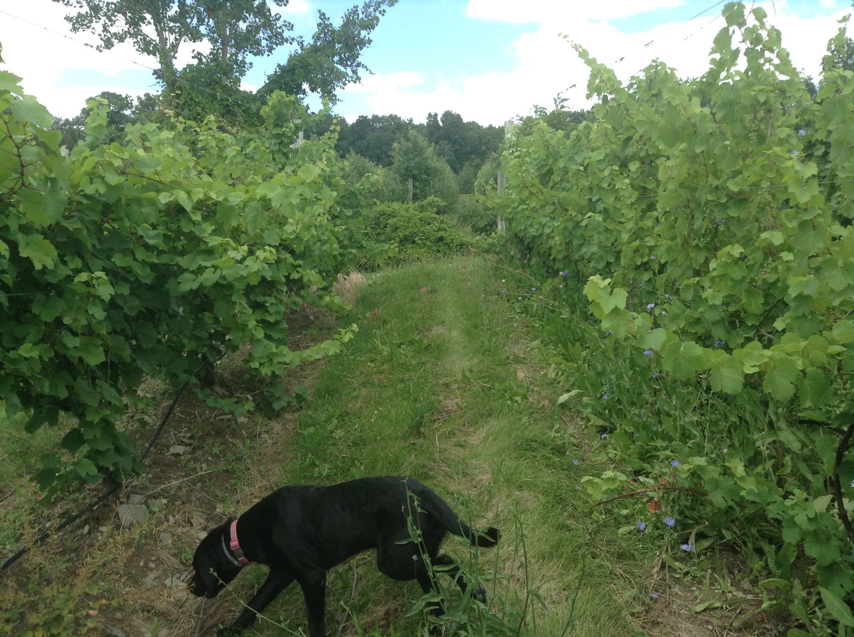
Figure 1: glyphosate plots on left, chicory plots on right. Note reduced vine size in chicory, and that chicory stalks are growing up into the fruiting zone of the vine.

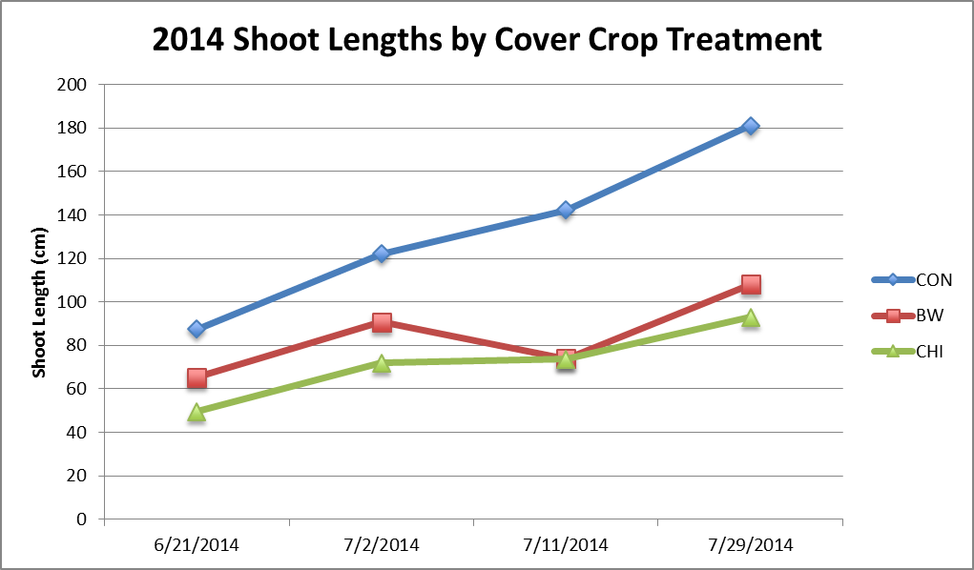
Figure 2: Shoot lengths in 2014 under-vine cover crop study. CON = control (glyphosate), BW = buckwheat, CHI = chicory.

