Mapping brown marmorated stink bug and landscapes that influence their populations

BACKGROUND
The brown marmorated stink bug (BMSB), Halymorpha halys (Stål), is an invasive pest of multiple fruit and vegetable crops in the mid-Atlantic region that has caused significant reductions in crop yield. It is native to China, Korea and Japan and was first found in the United States in Allentown, Pennsylvania in 1996. Since then, populations have been found in multiple states in the mid-Atlantic region, Midwest, and West Coast. In New Jersey, the stink bug was first caught in 1999 in a black light trap. On peach farms, exact numbers of brown marmorated stink bug damage have not been assessed, but growers in PA and MD have estimated upwards of 50%-60% crop loss in recent years.

Because of high levels of stink bugs and losses of fruit, growers have increased their frequency of insecticide treatments. There have been some changes in laws that have led to the increased use of “reduced-risk insecticides”. Reduced-risk insecticides are less toxic, but applications may be more frequent and ineffective against the stink bug. Knowing where and when the stink bugs come from would help focus the control of the stink bugs. A focused approach would likely be cheaper and be friendlier towards the environment by targeting only parts of orchards that have higher stink bug populations at the right time of the season when fruit is most vulnerable.

Brown marmorated stink bug are expected to travel into tree fruit orchards from the outside. They typically spend the winter time in warmer environments such as between the bark of dead trees and the tree trunk or in human-made structures. They move into agricultural fields in the beginning of an agricultural season and begin laying eggs to start a new generation of stink bugs. Brown marmorated stink bugs are also polyphagous, which means that they can feed on many different host plants. This allows them to travel between multiple host plants easily.

GIS (Geographical information systems) is a useful tool that can be used to answer many of our questions in the scientific field. It covers a wide range of subjects, from making and interpreting maps to gathering data to build these maps. Maps can be used to tell a story, or even directly answer questions through the use of statistics. The goal of this research is to develop a management strategy based on the distributions of brown marmorated stink bug in peach orchards by using GIS software as a tool.

AUDIENCE
Students in grades 5-8

Meets COMMON CORE standards
English Language Arts: RI5.1, RI5.2, RI5.3, RI5.4, RI5.5, SL5.1d, SL5.2, SL6.1, SL6.2, RST6-8.1, RST6-8.2, RST6-8.3, RST6-8.4, RST6-8.7, SL7.1, SL7.2, SL8.1, SL8.2
Mathematics: 5.G.A.2, 6.SP.B.5.A, 7.SP.A.1, 8.SP.A.1

TOTAL TIME: 70 minutes

LEARNING OBJECTIVES
- Activate prior knowledge of insects and spark interest in entomology using specimens, live and dead.
- Understand background of brown marmorated stink bug and how to read population maps and graphs
- Learn how to interpret maps that have been developed to display changes in brown marmorated stink bug populations
- Create maps with data provided and make conclusions about how to apply the knowledge gained from the maps to develop a pest management program

MATERIALS
Insect specimens (live and dead), computer; projector; projector screen; Mapping Brown Marmorated Stink Bug powerpoint presentation; flip chart or whiteboard, transparency slide paper (one sheet per student); colored permanent markers

HANDOUTS (One packet per three students)
Map 1, Map 2, Population Curve, Unmarked Map, Sample Data, Sample Map 1, Sample Map 2, Sample Map 3

DISPLAY AND DISCUSS INSECT SPECIMENS (20 minutes)
Display insects pinned in their boxes as well as live insects. Explain that the term “entomology” refers to the study of insects. Review common characteristics of insects, i.e. six legs, exoskeleton, three main body parts (head, thorax, abdomen). Activate prior knowledge by engaging students in a discussion about insects. Sample questions include:
- What kind of insects have you seen before?
- Do you have a favorite insect? Why is it your favorite?
- What importance do you think that insects have to society?

If insect specimens include a brown marmorated stink bug, point out distinguishing characteristics, e.g. brown and black patterns on abdomen and antennae (see slide 2 of the Mapping Brown Marmorated Stink Bug powerpoint presentation for more information).

MINI LECTURE (10 MINUTES)
Use slides 1-15 of Mapping Brown Marmorated Stink Bug powerpoint presentation to present background information on the brown marmorated stink bug, the research being conducted at Rutgers, and an explanation of how to understand population maps and graphs. The script for presentation is included in the slide notes.

INTERPRETING POPULATION MAPS AND GRAPHS (15 MINUTES)
Organize students into groups of three. Pass out one packet of handouts to each group. Give students two minutes in small groups to compare Map 1 to Map 2, referring to the legend to identify where stink bugs are most concentrated on the field. Write the following questions on a whiteboard or flip chart to guide their comparison of Map 1 and Map 2:
- Are stink bugs distributed randomly throughout the field or are they clumped? How can you tell?
- Where are the highest concentration of stink bugs in the field?

Spend three minutes having small groups report out their findings. Then have students place the Population Curve handout next to Map 1 and Map 2. Initiate a 10-minute whole group discussion about how the graph corresponds to the two maps and how to use the graph to understand changes in stink bug populations from July to September. Guiding questions include:
- How does the Population Curve handout correspond to the two maps?
- What were the populations like at the beginning of July and the end of August? When did the population of stink bugs reach its highest level?
- Why do you think there is a higher number of stink bugs on 8/23 than 7/19? What factors might be contributing to this change in population level?
- Where do you think you would find the most amount of damage to peaches in the field?

Notes for facilitator: The data from Map 1 (7/19) show that there is a random assortment of the population of stink bugs in the field on that date. The data from Map 2 (8/23) show that there is a large population of stink bugs in the middle of the field on that date. The highest concentration of stink bugs is apparent in Map 2, in the middle row. The population curve shows that there was a lower population of stink bugs in July than in August, with peak population between 8/13 and 8/27. (The actual date of highest population numbers is 8/23.) The change in stink bug arrangement and population is most likely because the peaches in this location were the ripest in the field at the time.

MAPPING DATA AND APPLYING KNOWLEDGE (25 MINUTES)
Pass out three sheets of transparency slide paper to each group. Have students look at the Sample Data alongside the Unmarked Map. Show them how the trees and rows on the Unmarked Map sheet correspond to the Sample Data sheet; for example, Row 1, Tree 4, has 15 Adult stink bugs, 9 stings, and 0 ripening days. Explain to students how a legend can be created to represent a set of data, also known as a “layer.” In Sample Map 1, the legend shows that green represents populations of less than 10 stink bugs, yellow populations between 10 to 50 stink bugs, and red populations above 50 stink bugs. Each “layer” of data gets its own legend. Review legends for Sample Map 2 and Sample Map 3. (Note to facilitator: The “layers” in this activity refer to the three sets of data on the Sample Data handout: number of adults, number of stings, and ripening days. This explanation should take no more than 3 minutes.)

Direct students to create their own legend for each “layer” of data in the Sample Data handout. They can be as imaginative as they like, e.g. shapes, patterns, faces, etc. Each transparency slide paper will be used to represent a “layer” of data. Once groups have created a legend for each “layer” of data, instruct the students to lay a sheet of transparency slide paper over the Unmarked Map. Have them use the legend they created for number of adult stink bugs to mark the corresponding circles on the map. Repeat this exercise with the other two sheets of transparency slide paper so that each “layer” of data is on a separate sheet, i.e. one sheet represents number of adults, one sheet number of stings, one sheet number of ripening days. (Note to facilitator: Allot about 10 minutes total for this portion of the activity.)

After students have made their maps of each “layer” on the transparency slide paper, instruct them to overlay the transparency for number of adult stink bugs and the transparency for number of stings on the Unmarked Map. Ask if they see any relationship between the number of adults and number of stings; students should observe that the locations with the higher populations of adults correspond to the locations with the most stings. Instruct students to overlay the transparencies in different combinations and discuss in small groups what relationships may exist between the three “layers” of data. (Note to facilitator: Allot 7 minutes total for this portion of the activity.)

Have students share out to the whole group some of the conclusions they have made based on the maps they created. Explain to students that researchers of brown marmorated stink bug combine the “layers” of data to target when and where they should implement pest management measures such as insecticide sprays. Conclude with the following questions:
- Based on the maps, what suggestions can you make for the best locations to concentrate pest control efforts?
- What have you learned about the usefulness of maps for studying insects?

TAKE HOME MESSAGE
Brown marmorated stink bugs, and most other insects are distributed through space in different spatial patterns. Landscape factors will have differing influences on stink bug distribution in a peach orchard. Basically, it’s important to take the context of the area around a study area into account when looking at populations.

Population curve

Map 1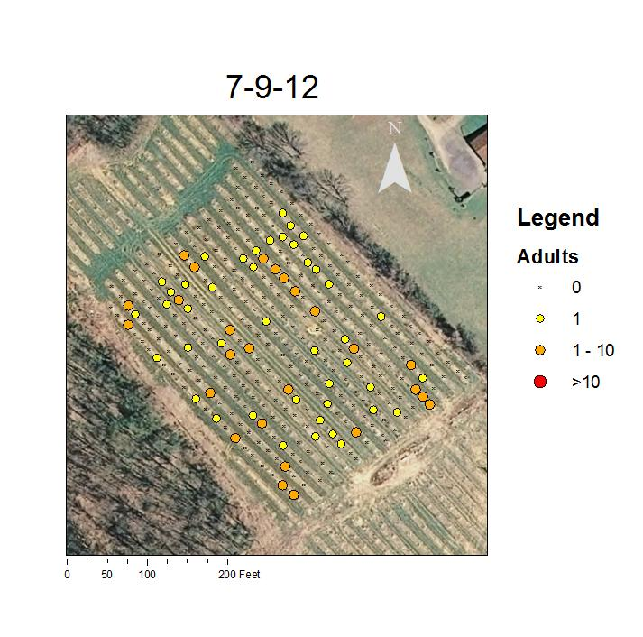Map 2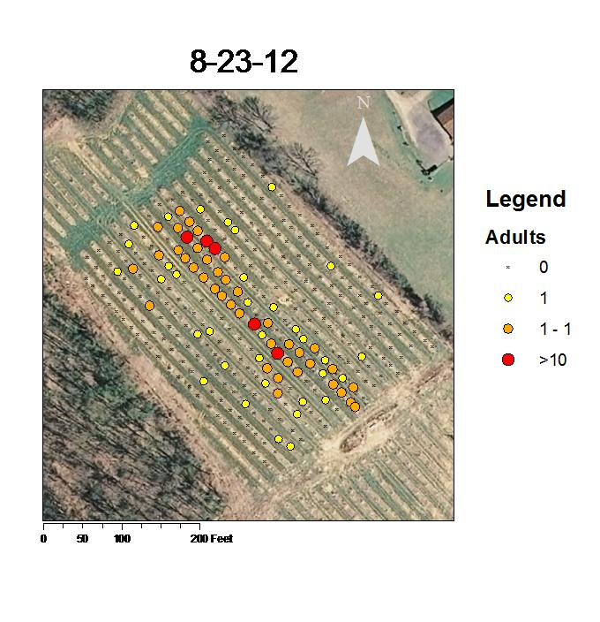

Unmarked Map

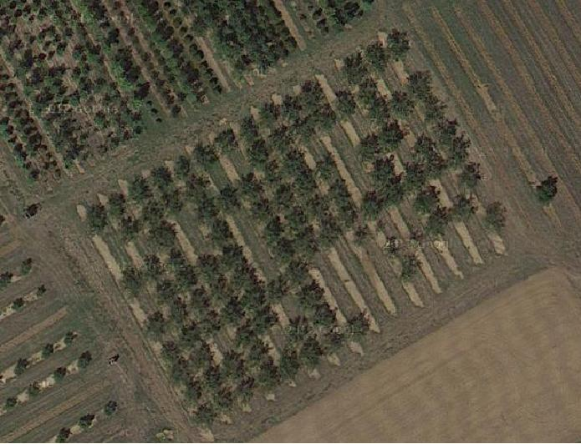
10
9
6
8
7
4
5
3
2
1
Tree
Row
14
15
13
12
11
10
9
8
7
6
5
4
3
2
1

Sample Data

Row | Tree | # of Adults | # of stings | Ripening days | Row | Tree | # of Adults | # of stings | Ripening days
1 | 1 | 20 | 10 | 0 | 4 | 1 | 23 | 10 | 0
1 | 2 |  |  |  | 4 | 2 | 30 | 15 | 0
1 | 3 |  |  |  | 4 | 3
1 | 4 | 15 | 9 | 0 | 4 | 4
1 | 5 |  |  |  | 4 | 5 | 2 | 3 | 0
1 | 6 | 0 | 0 | 14 | 4 | 6 | 0 | 0 | 14
1 | 7 | 0 | 1 | 14 | 4 | 7 | 0 | 0 | 14
1 | 8 | 2 | 0 | 14 | 4 | 8 | 0 | 0 | 14
1 | 9 | 0 | 0 | 28 | 4 | 9 | 0 | 0 | 28
1 | 10 | 0 | 0 | 28 | 4 | 10 | 0 | 0 | 28
2 | 1 | 15 | 9 | 0 | 5 | 1 | 17 | 13 | 0
2 | 2 | 13 | 9 | 0 | 5 | 2 | 25 | 10 | 0
2 | 3 |  |  |  | 5 | 3 | 10 | 5 | 0
2 | 4 | 100 | 30 | 0 | 5 | 4 | 6 | 3 | 0
2 | 5 | 1 | 0 | 0 | 5 | 5 | 5 | 2 | 0
2 | 6 | 0 | 0 | 14 | 5 | 6 | 0 | 1 | 14
2 | 7 | 0 | 0 | 14 | 5 | 7 | 0 | 0 | 14
2 | 8 | 0 | 5 | 14 | 5 | 8 | 0 | 0 | 14
2 | 9 | 0 | 0 | 28 | 5 | 9
2 | 10 | 1 | 0 | 28 | 5 | 10 | 0 | 0 | 28
3 | 1 | 21 | 11 | 0
3 | 2 | 10 | 8 | 0
3 | 3 | 5 | 2 | 0
3 | 4 | 4 | 1 | 0
3 | 5 | 2 | 1 | 0
3 | 6 | 0 | 0 | 14
3 | 7 | 0 | 0 | 14
3 | 8
3 | 9 | 0 | 0 | 28
3 | 10 | 0 | 0 | 28

Sample Map 1 (Number of Adult stink bugs)

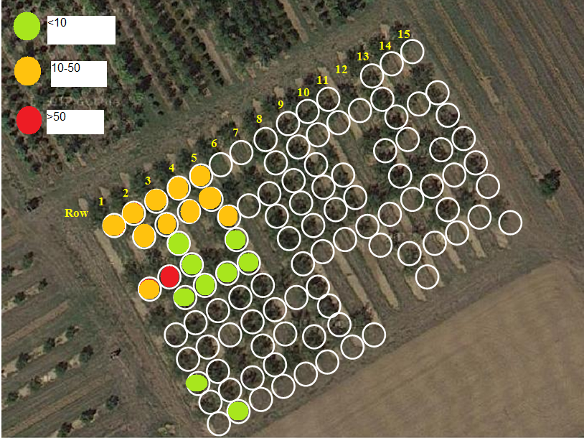

Sample Map 2 (Number of stings)

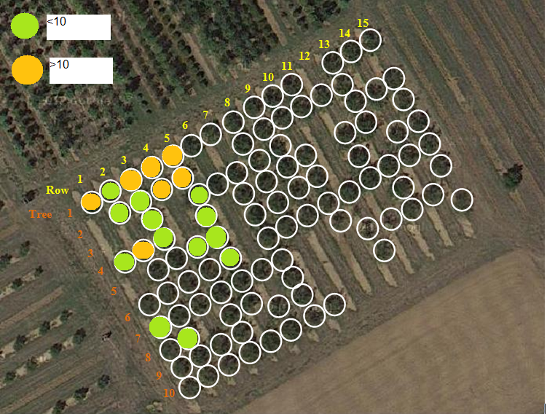

Sample Map 3 (Ripening days)

