a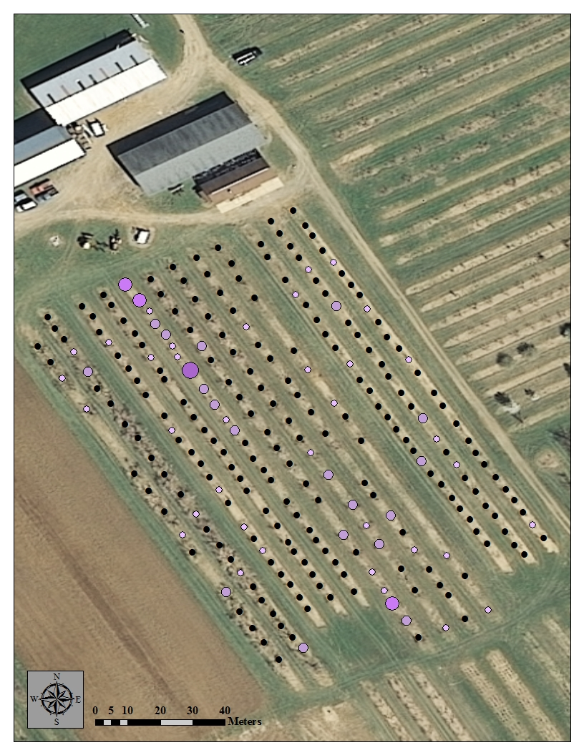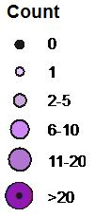
b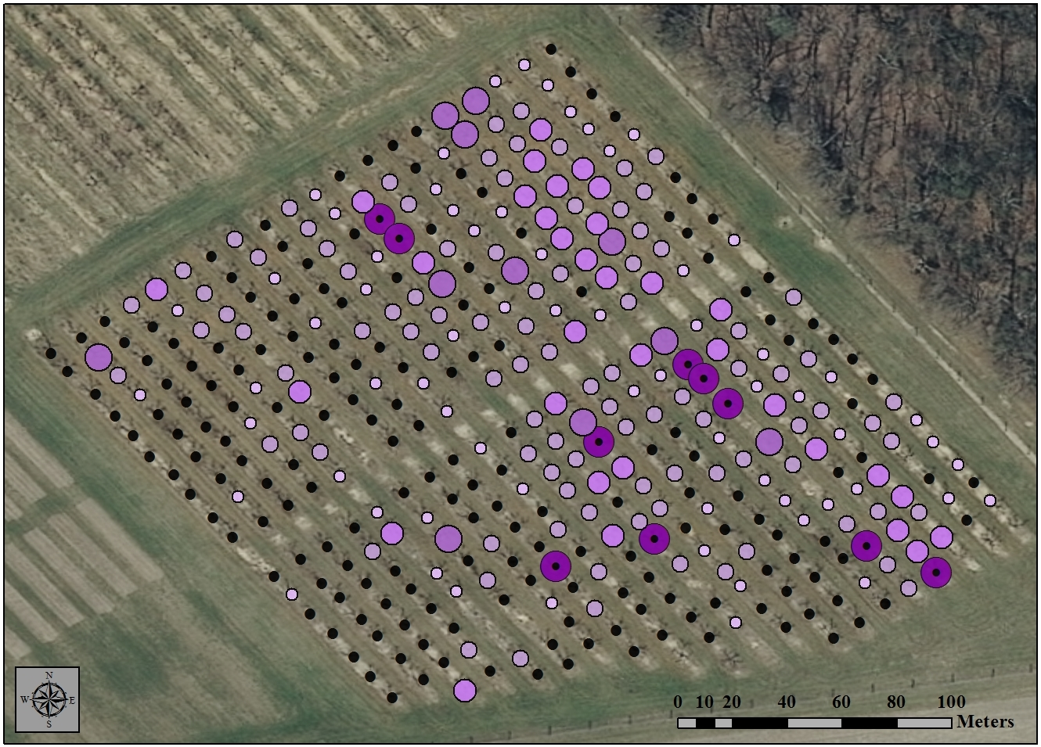
Figure 3. The number of H. halys adults found at a peach orchard in Cream Ridge (a) and RAREC (b) on 8/27/2013.

