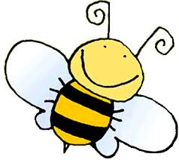
Pollination Name____________________________
Experiment

My bag of Cheetos represents…
My hand represents…
When I touched a flower…

Pollen
Pollen

Pollination

Pollination
Bee
Bee
Pollen

Pollination
Bee

