FARMDATA Record Keeping System
on Thursday afternoon, January 29, 2015, at 2:45 for 45 minutes in the New Equipment session.

Speaker Bios:
Matt Steiman is the production manager at the Dickinson College Farm, a 10 acre certified organic produce operation in Boiling Springs PA. Matt has been raising organic vegetables for over 20 years, and teaching about farming to college students since 2000. He has been instrumental in design, field testing, and public outreach for the FARMDATA project.
Dr. Tim Wahls, raised on an Iowa dairy farm, is now Associate Professor of Computer Science at Dickinson College. His teaching specializations are programming languages and software engineering. Tim and his students developed the database and have written and continuously improved the code for FARMDATA since 2010.

Summary for Proceedings:
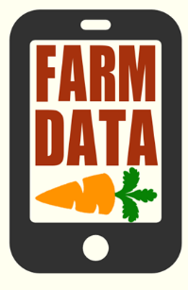
FARMDATA: An internet-based smartphone compatible records management system for produce farms – free and open source to the public.
The Digital Clipboard: All produce farms can benefit from better record keeping – knowledge is power, and good records improve farm efficiency and profitability. Digital records are highly useful, since they can be easily copied, searched, and analyzed at the touch of a button. Unfortunately, digitizing farm records at the end of a growing season can be painstaking – dealing with lost records, or incompletely logged information only makes the task even more difficult. A five year partnership between the Dickinson College Farm and the Dickinson College Department of Mathematics and Computer Science has resulted in an exciting, effective solution, a project we call FARMDATA.
FARMDATA is a smartphone enabled internet based record keeping system designed and field tested by produce farmers. Focus areas include field and greenhouse plantings, harvest, pack, inventory, distribution, e-invoicing, labor tracking, fertilizers, compost, cover crops, tillage, irrigation, scouting, spraying, and seed orders. The goals of FARMDATA are to replace clipboards and paper records across the produce farm, from the field to the packing house and beyond. More importantly, FARMDATA is designed to save growers valuable time both during the busy growing season and in the winter when planning for the coming year. FARMDATA improves record keeping by using “smart” data entry forms that minimize user errors, perform calculations automatically, and store useful crop production information. Growers and their staff can rapidly input valuable production data from the field. Multiple users can make live updates to the database at the same time, and growers can search their production records from the field, desktop, or any internet connected device. Each growers’ database is password protected and only accessible by registered users that the grower can delete or add at any time.
For organic growers, FARMDATA contains many features designed to facilitate easy annual inspections and reporting. Our project team partnered with Pennsylvania Certified Organic to optimize FARMDATA to meet the needs of certifiers – these special features include easily viewed comprehensive field records, compost accumulation and management logs, and plantings linked to seed orders for verification of organic seed use.
Thanks to public funding from the USDA’s Northeast Sustainable Agriculture Research and Education program (NE-SARE), FARMDATA is available for free public downloads to your farm website. We invite interested users to take a guest tour of the site at http://farmdata.dickinson.edu/guest.php Here are some example features of FARMDATA that make it a speedy, user friendly and powerful records management system:
- Extensive use of drop down menus: drop downs minimize typing and prevent common data entry errors that can foul up a database. Drop downs are also a “smart” feature of the data entry forms – for example, when entering harvest records, crops are only displayed in the fields where they have been registered as “planted”.
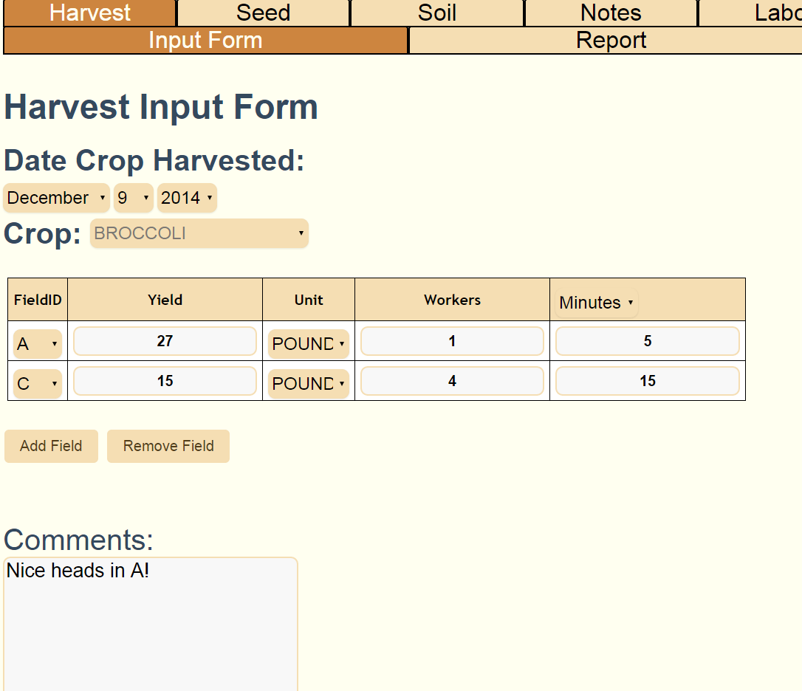
- Forms designed for rapid data entry: through two seasons of on-farm testing, we have refined the FARMADATA input windows to reflect needs in real field conditions. For example, users can log harvest records for crops from multiple fields through one quick action. Date values automatically default to the current day, but can be manually edited for past or future actions. Harvest units can be changed to any unit listed for a particular crop – FARMDATA does the math and automatically converts between units

- All input forms allow user comments. Harvest and planting forms generate labor records automatically, all other labor can be recorded and reported through the Labor tab.

- All stored data can be edited or deleted by the farm manager (also known as the “admin” user) from smartphone or desktop. Admin users can also add and remove new crew members, new fields, crops, harvest units, spray materials and more. The whole database can be backed up to file, flash drive, or CD at any time.

- Users can run reports on stored data from the field or desktop at any time. Reports are designed to be sorted by date range, by crop, by field, or by other specific info. With a simple button push, any report can be easily downloaded to Microsoft Excel for further analysis. FARMDATA does contain some automated graphing functions for harvest and sales figures. Reports also perform some commonly desired calculations, such as total yield, yield per row foot, total labor, and more.
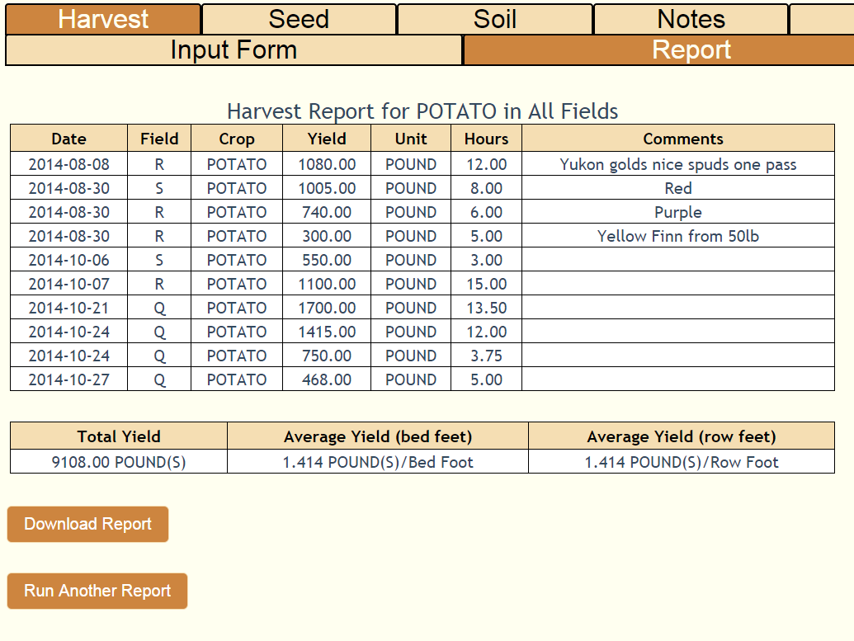
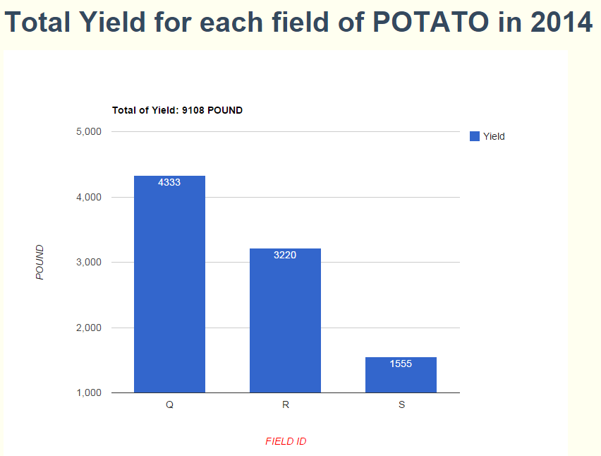

- Paperless digital invoicing: Admin users can rapidly create invoices on both desktop and smartphone. After approval, invoices are sent instantly to email addresses stored for the client and the farm office. Invoice reports can be downloaded to Excel, enabling the grower to analyze units of each crop sold, sales timing, revenue generated and more.

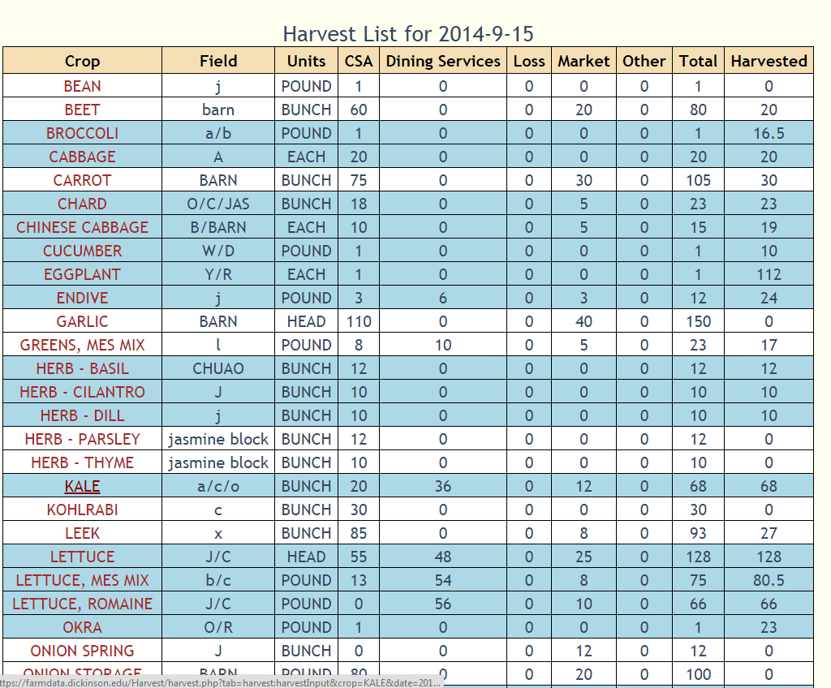
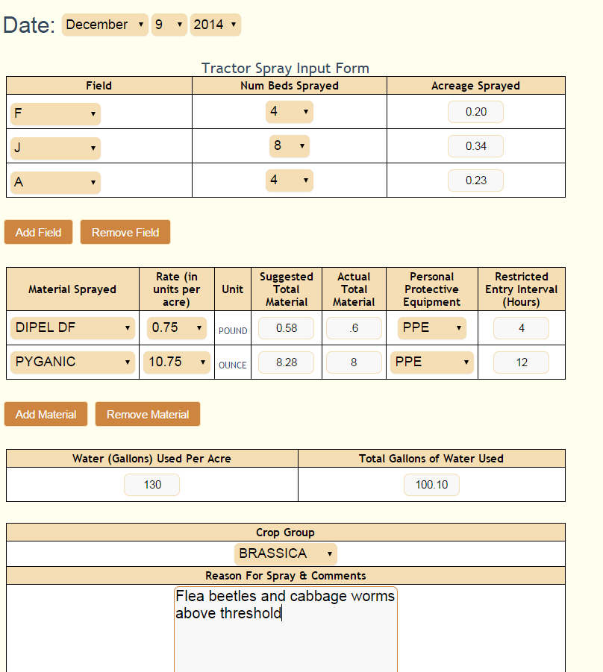
- Stored field sizes, cover crop seeding rates and spray product rates: For the more complicated data entry forms, the design team’s goal was to save the user more time than is spent performing the data entry step. FARMDATA achieves this by performing necessary math functions for the grower using stored information. On the cover crop seeding input window, the grower chooses a field, percentage seeded, and cover crop species. FARMDATA then asks the user to select a seeding rate in pounds per acre from a range that is stored for each species, and does the math to inform the user how much seed to use. Similarly, on the “Tractor Spray” input form, the user chooses fields, number of beds sprayed, and selects from an admin-created list of spray materials and specific spray rates. FARMDATA then does the calculations and displays recommended amounts of spray materials and water to use for this instance. In practice, our field testing team has found that these input forms save valuable time by negating the need to perform calculations or look up field sizes and spray rates in the farm office. Once the data are entered, growers (and certifiers) can query the records for total spray materials user per season or per crop, as well as comparing them with insect or disease scouting information recorded elsewhere on the site.

- Interactive Harvest List: Admin users can create a daily harvest list for multiple crops, with desired harvest quantities for all of the farm’s different sales clients. Any harvest crew member with a smartphone can view the harvest list, and with the touch of a button, enter data for quantity harvested from each field. The harvest list updates itself automatically every minute, so that multiple users harvesting in different parts of the farm can see how much of any crop has been harvested elsewhere. Once the required quantity of a crop has been harvested, its color changes on the list to serve as a digital checkmark

HOW TO GET SET UP WITH YOUR OWN FREE FARMDATA ACCOUNT: To establish your own working copy of FARMDATA, you will need to download the free software and add it to your existing farm website or to a new, dedicated website. The FARMDATA programming team has designed the download and startup process to be easily attainable to any person familiar with website management – for most farmers this will be your web master or another contact who is handy with computer programming. Downloads, technical information, and the user’s manual can be found at http://sourceforge.net/projects/farmdata/ and http://sourceforge.net/p/farmdata/wiki/Home/
After downloading, to get started the grower must input basic field and crop info, and choose which FARMDATA features to use in a configuration step. Crop names, harvest units, cover crops, and spray materials used by the Dickinson College Farm are pre-loaded into FARMDATA – new users can easily edit or delete this information as needed. The setup phase is designed to be as quick and easy as possible, but it is suggested that growers plan to spend a few hours on setup during the off season. In practice, we have found the following contribute to farmer success with FARMDATA:
- Starting early – performing site setup and getting familiar in the off season
- Setting realistic expectations for data collection and improving over time
- Delegating data entry to as many people as possible (especially harvest data)
- Field checking and updating planting records once a month
- Creating habits – creating a culture of data entry as recordable activities occur among the entire farm crew
- Reap the benefits – use collected data for crop planning and business analytics
OPENSOURCE: FARMDATA was designed by a small handful of farmers and computer programmers. While we are very pleased with the state of the software package and find it incredibly useful and rewarding, it is natural that all growers will see something in the site that could be improved to suit their own needs or systems. The sourceforge project page includes a discussion forum and a place to report any software bugs that may arise. Because the code for FARMDATA is opensource, growers who desire new features or substantial improvements to the site should consider working with a programmer to write new code specific to their needs. We encourage such users to offer these improvements back to the opensource community via the sourceforge portal.
FARMDATA users can always post help requests to the sourceforge site. For growers starting new accounts, limited free technical support is also available by emailing Matt Steiman at steimanm@dickinson.edu

