Case Study: Delaney Farms

Delaney Farms is a direct farm market operation in central New York. Their primary crops are sweet corn, tomatoes, and geraniums. The farm markets primarily through an on-farm farm stand and farmers markets. They have been in business for 31 years and now that both sons have left the owners are beginning to scale back.

Going through the Marketing for Profit: Tools for Success series has helped them think more clearly about the bigger picture of their business and marketing efforts.

In the context of customer assessment, the program got them to think more about the demographics of their area and market, and how they might attract and sell to other customer bases. They used several tools and information sources suggested in the webinar to research the demographics of their area and how the demographics impacted their customer base. They began informally surveying their customers to find out who they are, where they came from, and to get some sense of customer loyalty. They were quite surprised to discover how far customers were willing to drive to buy at their farm stand. The information they gained in terms of customer loyalty proved to be useful, along with other information, in making their decision to drop one of their farmers markets.

The sessions that dealt with branding were by far the most useful to the Delaney’s. While they had business cards, logos, tee shirts, shopping bags, and signage prior to participating in these sessions, nothing matched, coordinated or blended together in terms of their branded image and look. Now they see the importance of consistency and uniformity in their image and branding efforts. As a result of participating in the program they have:
- Gone to a uniform type face across all documents, shopping bags, imprinted items, and signage
- Developed a new, updated business card
- Adopted a consistent, uniform message across all materials
- Provided uniform tee shirts for all employees with the consistent logo, colors, and type face
- Adopted a consistent logo and color scheme across all materials
- Improved their web site using the same consistent logo, colors, and design scheme
Customers have commented that they are now easier to find at the farmers market. They are also consistently using their name associated with their products, Delaney Farms Sweet Corn and Delaney Farms Tomatoes. A new customer came to them one day and said a friend told her she had to try the Delaney Corn. Which she easily found, because it wasn’t try the sweet corn from this market or from that farm, it was you need to try the “Delaney Corn”. Tying the product, the quality, and the customer service to the name, in the mind of your customers, is what branding is all about.

As a result of the webinar presentation on product display, the Delaney’s switched their layout and display of products. They made these changes at both their farm stand as well as their farmer’s market display. They are now using a combination of color, texture, and layout to create a more interesting and attractive display. While they made no attempt to collect data to document if the changes resulted in increased sales, the display did catch the eye of a newspaper photographer as he walked through the market. He stopped, talked and took a series of pictures of the Delaney’s product display and the people working there. The next day the Sunday paper contained several full color photos of both the Delaney’s and their produce at their farmer’s market booth.

As a result of participating in the webinar series the Delaney’s are now making greater use of social media. They routinely post messages on their Facebook page about what is happening on the farm, what they have at the farm stand, and what they will have at the next farmer’s market. On the days of the farmer’s markets they post what they have fresh that day. They also tell their customers they will be in the market at a particular time and invite them to stop by early for the best selection and freshest vegetables.

One of the webinar presenters talked about getting free publicity in the local media. Following up on that, at the beginning of each season Mrs. Delaney contacts reporters at the local newspapers and radio and TV stations, introducing herself, telling them that she is a local vegetable farmer, and that if they ever need an expert to help them or provide input to a vegetable or farmers market story she is available and willing to help them. As a result Delaney Farms was featured in two newspaper articles and one TV interview last year. This media exposure resulted in lots of positive feedback from customers. It probably also lead to new customers as well but the Delaney’s have no way of tracking that.

Since both of the Delaney’s sons have left the business, and they have difficulty finding new high quality employees, they have decided to gradually scale back their operation so that it can be managed with their available labor pool. In scaling back they decided to eliminate one of their market outlets. Remembering the market channel assessment tool presented in one of the first webinars, Mrs. Delaney used that tool to assess the costs and returns for their three market outlets. This assessment showed them that one of their two farmers markets should go first as opposed to their farm stand. In addition to the cost and returns of the farmers markets, and based on what was learned from a combination of several webinar sessions, they went further and looked at the customer base at the markets as well, along with their perception of customer loyalty. One of the farmers markets was physically easier set up and sell at, but looking at the demographics for that market the customers were more price sensitive and less brand loyal. Through the analysis they ultimately decided to drop the easier market in favor of another farmers market which required significantly more physical effort to set up. However, they felt the brand loyalty and value of the customers at this market made it worth the extra effort.

Mrs. Delaney spoke very highly of the entire webinar series and thought it would be valuable for anyone involved in direct farm marketing. “If I can pick up just one idea from a presentation that I can adapt and use in my business, then it was well worth my time”, she said.

Over the last several years the Delaney’s have seen an increase in both customers and sales volume, especially at their farm stand. While they are convinced that the changes they made as a result of the webinar series have resulted in these increases in customers and sales, they unfortunately do not have an accounting or recordkeeping system that will allow them to definitively say that they are a direct consequence of the changes.

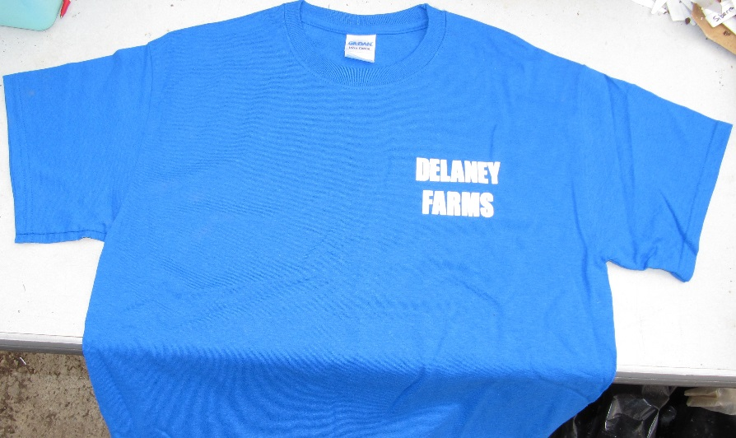
All employees now wear the same color blue shirt at both the farmers markets and the farm stand. Customers have commented that the bright blue shits help them find the Delaney booth more easily at the farmers markets. Mrs. Delaney says, “Even if the forget the name they know to look for the bright blue shirts.”

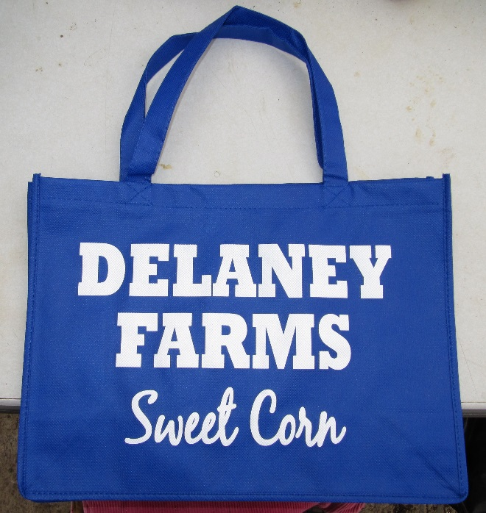
Previously the Delaney’s bags were tan with a different type face. Now the several different sized bags are all the same bright blue as their tee shirts and the type face for the Delaney Farms name is the same as well. Mrs. Delaney says she now knows that uniformity helps customers with recognizing and remembering the farm.

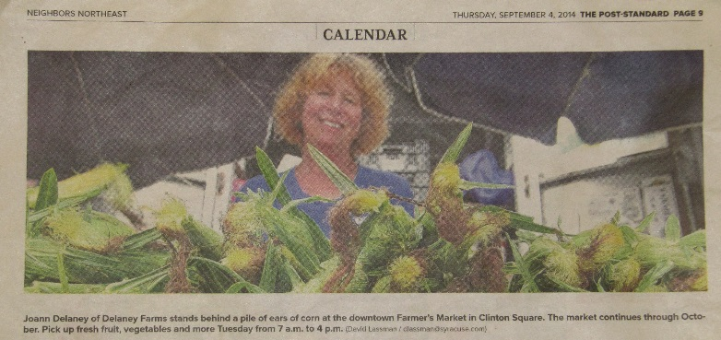

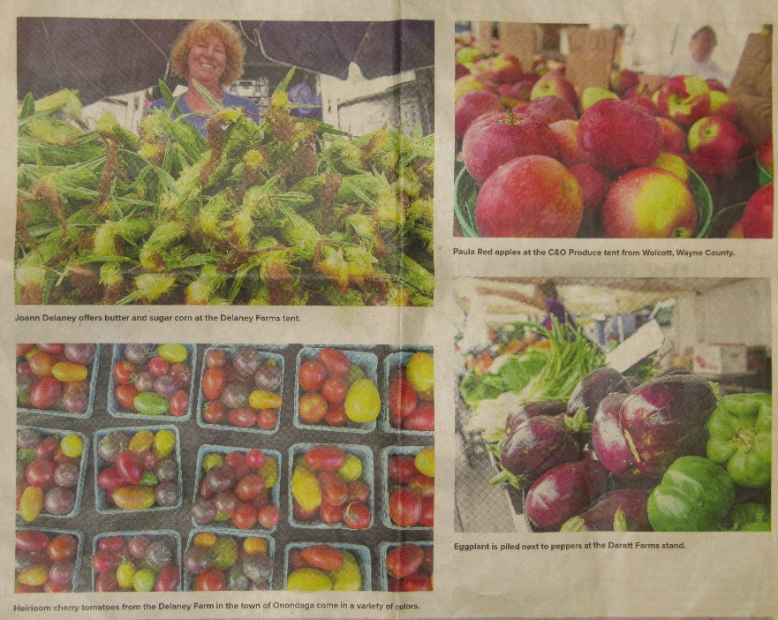
The colorful display and large pile of sweetcorn attracted the attention of a newspaper photographer and made a nice spread in the Sunday paper (right). Once the paper has these file photos they are likely to show up again when they need a nice photo for another purpose. Such as the calendar section above.

