Marketing for Profit: Tools for Success Case Studies
Name: Jarmila Haseler
Title: Farmers’ Market Specialist
Project: Merchandising for Improved Performance at Farmers’ Markets
Region: Total or 11 counties (9 counties of Genesee Valley Region and Seneca and Cayuga County)
Scope of work: Building a robust farmers’ market network through market managers’ and vendors education, connecting public and local authorities with their markets in vicinity, promoting local farmers in order to improve the economics of local agriculture.

Did you conduct any farmer trainings using materials or lessons learned from a Marketing for Profit: Tools for Success presentation?
Yes, I attended all the webinars and used mostly the ones listed below. My focus was on marketing thought visuals such as displays, branding and social media. The increase visibility would lead to increased customer base.
If yes, what materials, lessons did you use?

Learning to Look Around or Getting Your Head in the Game, Bob Buccieri

Bogos, Bounce backs, and the Cost of Freebies, Lindsay Ott-Wilcox

Every Silver Lining Has a Cloud!, Marty Butts

Communications Assessment: How to Say What We Mean and Mean Something!, Dave and Michelle Bellso

You Are What You Look Like: Preparing the Product, Marty Butts
What was the attendance of your workshop(s)?
The format of the application of learned facts was delivered by a Power Point Presentation, with the focus on meat vendors. There were 17 meat vendors that I interacted with in my project region. Unlike the produce vendors or crafters, most of the meat vendors were standing at their little, non-descriptive tables, in a shade of their tent canopy, having one or two boring coolers sitting on the ground by their feet. Quickly I recognized the disadvantage that they had due to the fact that they couldn’t display the meats in the open air, especially not on a hot, summer day. To increase their visibility I created the PPT of display tips so the customers wouldn’t have to do a guess work as what they are and what they sell. The simple fact is that the majority of shoppers don’t feel comfortable and will not approach a vague vendor. So, the most of meat vendors were passed by with very little sales.
- Number of farmers 17 vendors attended the presentation
- Number of market managers about 65 who were asked to forward the presentation on to their vendors.
Please provide us with details of the workshop evaluation results. – There was no evaluation or feedback collected as this was an on-line PPT presentation.
Did you follow up with any of the workshop attendees to determine any changes they may have made to their marketing plans, techniques, or strategies as a result of the lessons learned through your workshop. What impacts did these changes have on the farm?
I helped two vendors: Sweet Haven Pastures and Gal-a-Tin Farm.
- Sweet Haven Pastures did not know how to display their cuts, they had a hint of a display but it was small and unclear. I convinced them that the customers would surely appreciate a clear message without asking about the meaning of these vendors being at the market. The appreciative vendors were open to suggestions; we figured a black board with an outline of an animal (pig) with each cut marked would work. The picture (below) did the trick. Vendors established a serious customer base with a strong line of followers as soon as they brought out the black board. The board became a routine part of the display in other markets too.

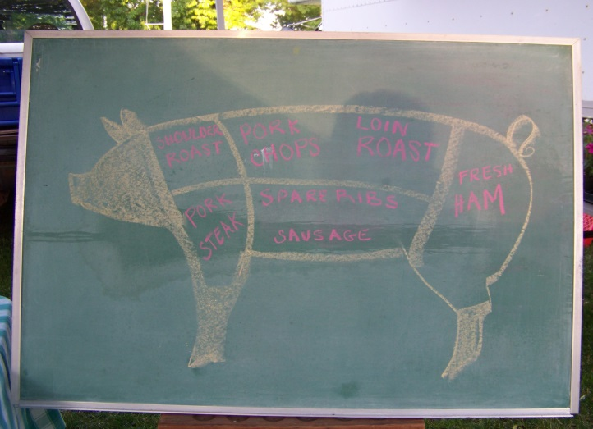

- Gal-a-Tin Farm: The farmer works full time job outside of his home. Since he would like to transition in to the full time farming he needed to start a serious marketing campaign for his farm to boost the sales.

Did you work one-on-one with any farmers to assist with their marketing and using the lessons learned through the Marketing for Profit: Tools for Success presentation?
Gal-a-Tin Farm: A small, three generation family farm. All of their meat animals are raised the old-fashioned way, on pasture, and are free from all growth hormones and antibiotics. Currently they farm 90 acres, have 200 laying chickens, 3000 meat chickens, 22 pigs, and 30 cows (5-6 for beef, the rest are mothers). They would like to increase their pork production from 22 to 50 pigs. They attend 3 farmers’ markets during the summer.
If yes, did you work with the farmer to conduct a review of their farm’s marketing practices, strategies or tactics? Yes
Did you review:
  - Your customer base; i.e. - restaurants, retail bakery (eggs), retail shop i.e. Lori’s Natural Food, Rochester, NY, Public hours for selling directly at the farm.
  - Are you targeting the right customer base for your farm products?-
  - Where are you reaching your customers? – Since a lot of visibility happens at the farmers’ markets, it was important to build a brand and advertise the business
  - Customer tracking – via email list through a sign-up sheet at the market. The farm send out a general email for the farm or updates to the targeted customers for each market
- Marketing channels being used -
  - Marketing message - The message is: Natural/free range/old-fashioned
  - Signage –Delivery of your message – through the logo that contains a clover leaf imbedded in a grass with three animals (chicken, pig and cow) in each tri-leaf of the clover.
- Branding
  - Logo – as above
  - marketing materials – attire (T-shirts for adults and toddlers and baby one-sees), website, FaceBook, flyers, tri-fold describing farming practices and addressing frequently asked questions
- Marketing plan
  - Data collection and management – none
  - SWOT – Strengths – adjusting the time spent at the market vs. farming by selecting the most profitable farmers’ markets to move the product out as fast and efficiently as they can. A high quality product needs a farmer to be there to have a good product
  - 3 fms – Scottsville $100/day, N. Chili
Geneseo $240
Weakness – predicting finicky markets – the vendor brings lots of one of a kind things and less of something else and then he sells out and is short of the less things and the product he thought would be popular will come back home.
Preorders don’t work since people are not reliable in picking them up.
Buyers’ club is in the process of formation
- Pricing strategies – since most of his customers go to Wegman’s the farmer decided to adjust the price according to them. But he knows his meats are better quality so he marked up his product by 15%
- Display techniques- the pictures, story of the family farm, list of pricing, items indicating the sold product are displayed on the table, attire (apron, T-shirt)
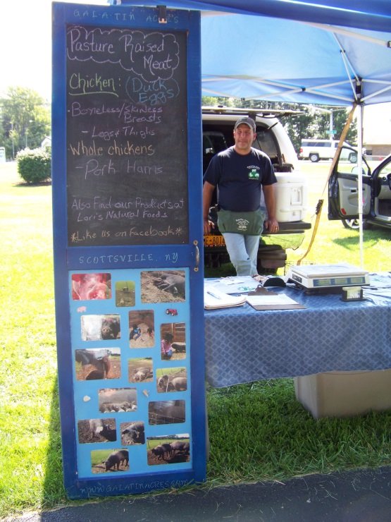
- Product positioning-
- Any others? Frequent monitoring the social media activity – likes on the FaceBook and analytics on the website. Continuous communication with the customers – updates and news.
What were the results of the review? In what marketing areas did the farm excel and in what marketing areas did you find need to be addressed?
Over the two market seasons the visibility of the farm improved and the customer base grew. At the beginning of our collaboration the farmer would make about $100 per market day. Through the improved marketing strategies, he was able to bring home about $250, hence more than a double of his profit.
What new plans, processes, strategies, tactics, were employed as a result of the farm review and the lessons learned through the Marketing for Profit: Tools for Success workshops?
- Logo Creation and message to convey to the customers
- Tag line – ‘Pleased To Feed You’
- Improved Displays
- Continuous communication with the customers
- Customer service
What were the impacts of these changes on the farm? (Please elaborate on how your changes brought about these impacts?)
- Sales – For example the farm increased sales at the markets by more than double.
They realized a positive trend in their revenue from the market season 2013 and 2014. The farm’s annual income was about $1300 in 2013 and $1500 in 2014 (13%) due to improved marketing strategies.
Due to the improved display the farmer was able to attract significantly more customers to his stall. Since this farmer is of a quiet nature, he needed to come out of his comfort zone and learn to be more talkative while promoting his goods. This was hard especially at the Geneseo Farmers’ Market that is visited mainly by young students. Since he was able to attract them to his stall through clear display and a smile on his face he was able gradually to double the sales. He was at this market for two seasons. The first year he averaged about $125 per market day but doubled his sale last season to about $300.
- New customer base/ increased customer base – yes, the farm has something like 200 likes on their FB page since last February. The number of ‘hits’ are expected to grow with upcoming season.
- Increased product line
- Added/changed marketing venues
- Added acreage to the farm – the farmer invested his doubled profit back in to the farm by purchasing about 20% feed for his animals and the rest in to general maintenance upgrades.
- Changed from part time to full time farming – The farmer was able to scale his full time job down to part time to attend the farmers’ markets. The goal is to transit to a full time farming.
- Spouse able to leave outside employment

