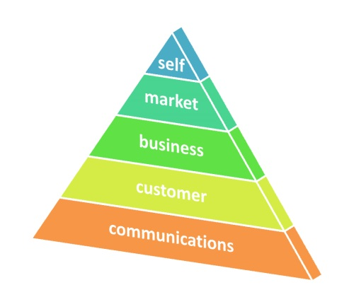
Marketing for Profit: Tools For Success
Free online learning for farmers

Learn essential marketing skills to determine optimal marketing channels, build your customer base and increase sales and profits.
The full curriculum is online and can be accessed anytime, day or night. Curriculum includes 5 components with 3 sessions per component:
Each session includes:
- Video of each live presentation
- Q & A documents
- Glossary of terms
- Links to additional resources
- Online discussion forum
- Homework assignment
- Quiz

Marketing Tools Components:

Self-Assessment
Market Assessment
Customer Assessment
Communications Assessment
Business Assessment

With the completion of each assignment you should have a completed all the pieces necessary to create your farm business and marketing plan. The completion of all sessions within each of the 5 components will earn the participant a Certificate of Achievement. In addition, by completing each session, including the assignments and quizzes, you will be eligible for borrower training credits through the Farm Credit Agency.
To register for this FREE online curriculum to help farmers increase their marketing skills and grow their business, go to:
http://www.nyfarmersmarket.com/work-shop-programs/online-marketing-for-profit-course/

