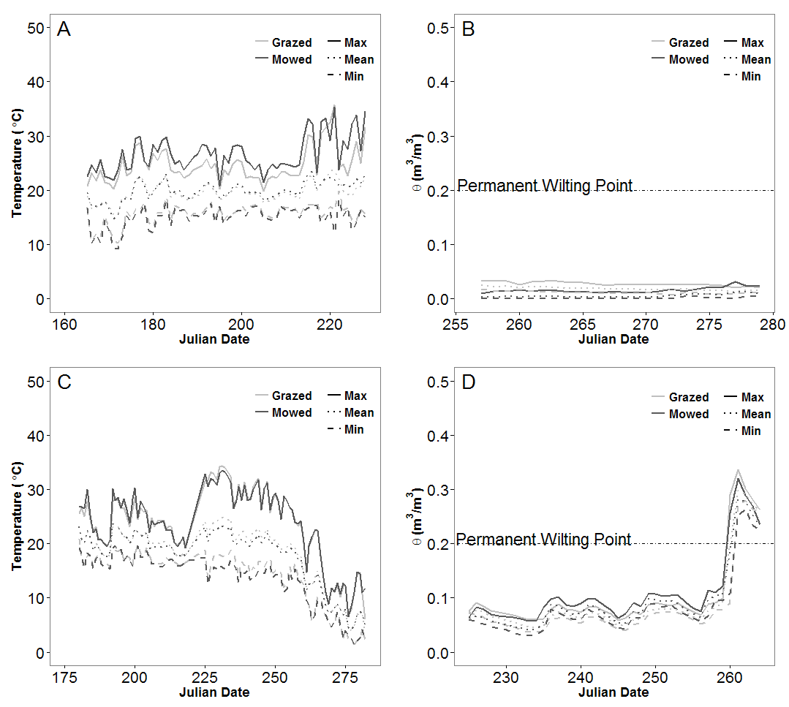

Figure 2.1. Effects of sheep grazing and mowing on (A) soil temperature in 2012, (B) soil moisture in 2012, (C) soil temperature in 2013 and (D) soil moisture in 2013 during the cover-crop phase at Townes Harvest Farm, Bozeman, MT United States.

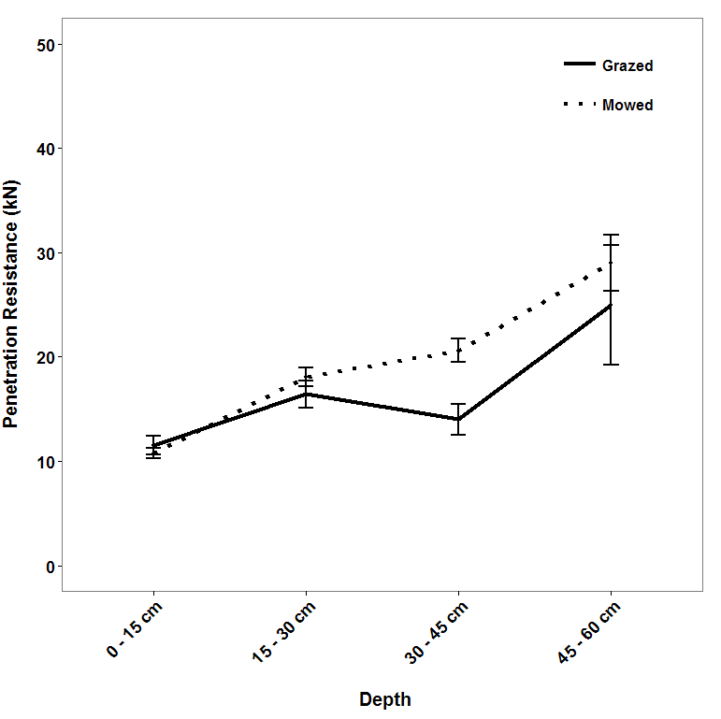

Figure 2.2. Effects of sheep grazing and mowing on soil compaction at Townes Harvest Farm, Bozeman, MT, United States. Values are reported as mean ± SE.

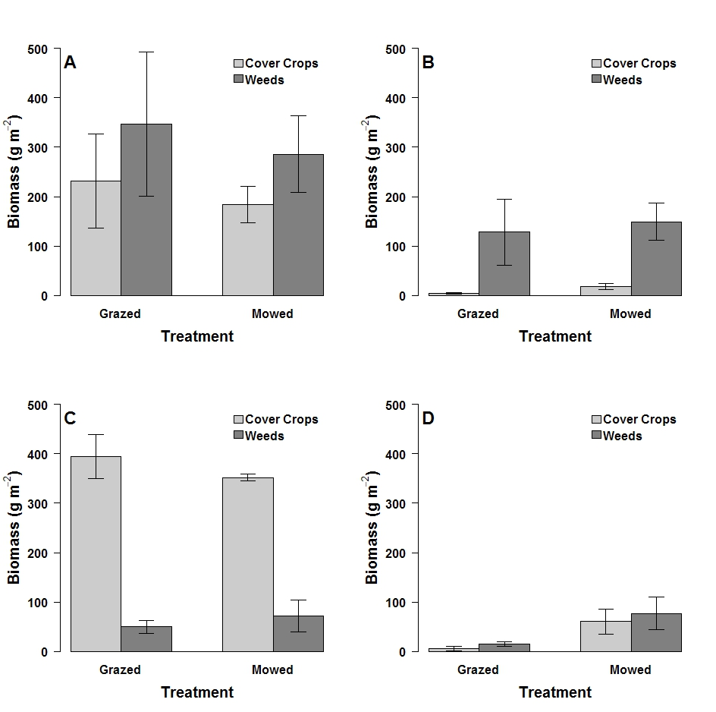

Figure 2.3. Impacts of termination approach (sheep grazing or mowing) on cover crop and weed biomass in (A) 2012 pretreatment (B) 2012 post-treatment, (C) 2013 pretreatment and (D) 2013 post-treatment at Townes Harvest Farm, Bozeman, MT, United States. Error bar are ± SE.

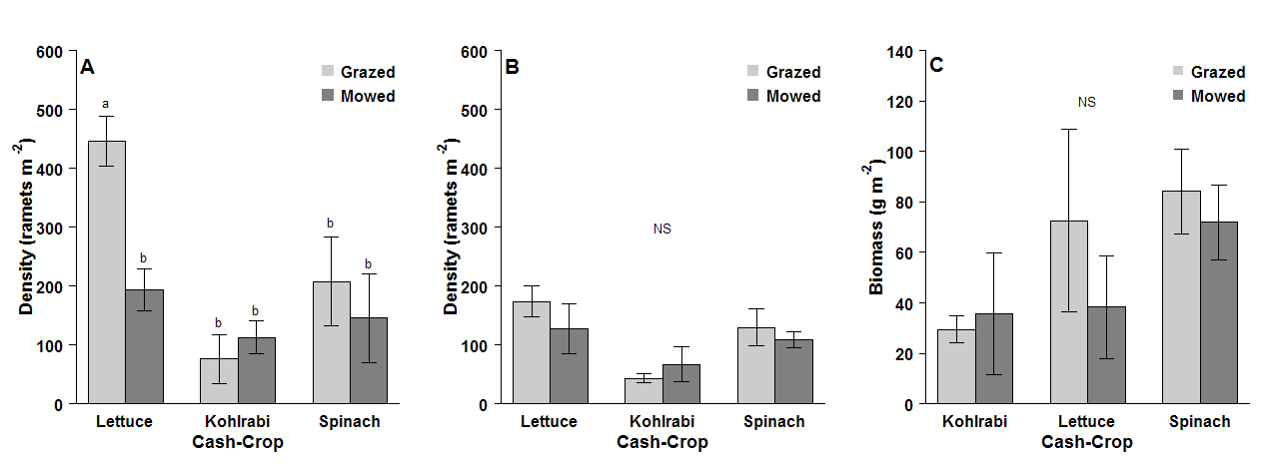

Figure 2.4. Impacts of sheep-grazing and mowing on (A) density of weeds at emergence, (B) density of weeds at anthesis, and (C) biomass of weeds at anthesis in the 2013 cash-crop phase at Townes Harvest Farm, Bozeman, MT, United States. Values are shown as mean ± SE. Lower case letters denote significantly different means (P < 0.05). Groups that share the same lower case letter are not significantly different (P > 0.05). “NS” indicates that no groups were significantly different (P > 0.05).

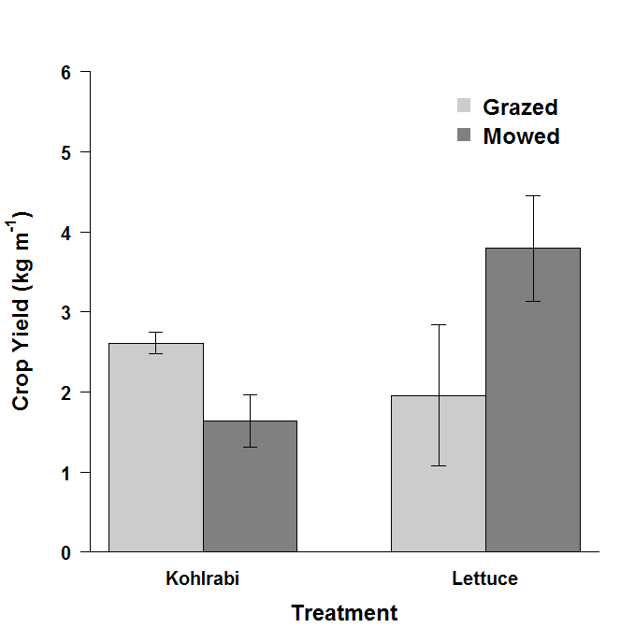

Figure 2.5. Impacts of sheep-grazing and mowing on subsequent cash-crop yields in 2013 at Townes Harvest Farm, Bozeman, MT, United States. Values are reported as mean ± SE.

Table 3.1. Impacts of sheep grazing and mowing on weed density, biomass and species richness during the cover-crop phase in 2012 and in 2013 at Townes Harvest Farm, Bozeman, MT, United States. Results are reported as mean ± SE.



Table 3.2. Legacy impacts of sheep grazing and mowing for cover-crop termination on weed biomass, density, α-diversity, and species richness in the cash-crop phase at Townes Harvest Farm, Bozeman, MT, United States. Values are reported mean ± SE.



Table 3.3. Impacts of sheep-grazing and mowing on carabid beetle activity-density, species richness, α-diversity during the cover-crop phase in 2012 and 2013 at Townes Harvest Farm, Bozeman, MT, United States.



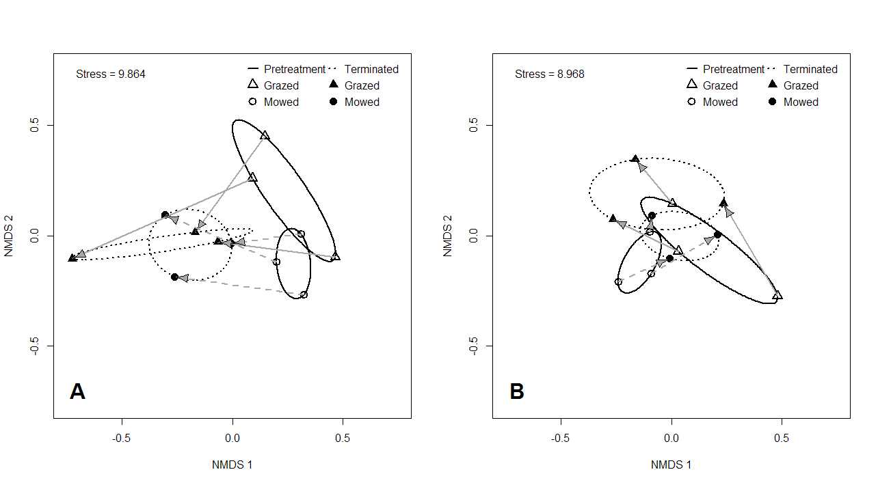

Figure 3.1. Non-metric multidimensional scaling (NMDS) ordination of weed community structure in sheep grazed and mowed plots during the cover-crop phase (A) in 2012 and (B) in 2013 at Townes Harvest Farm, Bozeman, MT, United States. Solid ellipses denote the community structure in the pretreatment period and dotted ellipses denote the community structure in the terminated period. Solid arrows denote the shift in community structure for grazed plots and dashed arrows denote the shift in community structure for mowed plots.

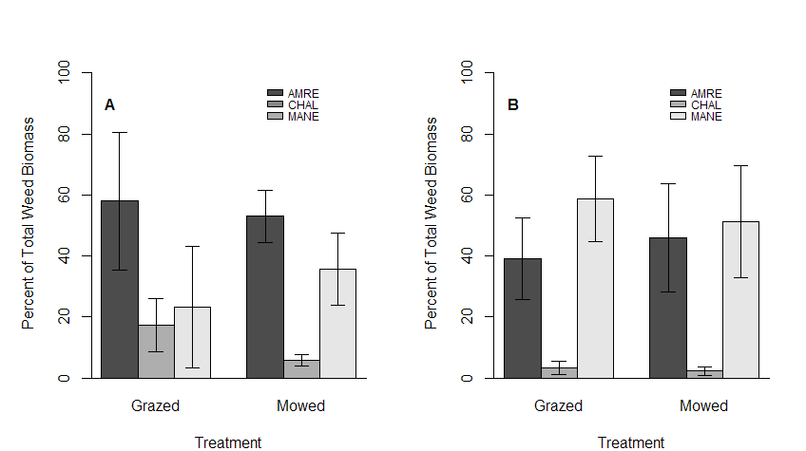

Figure 3.2. Impact of sheep grazing and mowing on relative abundance of the most dominant weeds (A) prior to cover-crop termination and (B) after cover-crop termination in 2012 at Townes Harvest Farm, Bozeman, MT, United States. Species codes are as follows: AMRE = *Amaranthus retroflexus* (L.), CHAL = *Chenopodium album* (L.) and MANE = *Malva neglecta* (Wallr.).

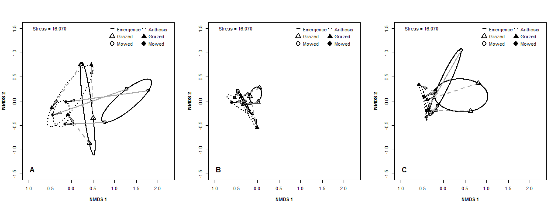

Figure 3.3. Non-metric multidimensional scaling (NMDS) ordination of weed community structure in sheep grazed and mowed plots during the 2013 cash-crop phase (A) in kohlrabi (B) lettuce, and (C) spinach rows at Townes Harvest Farm, Bozeman, MT, United States. Solid ellipses denote communities at emergence and dotted ellipses denote the community structure at anthesis. Solid arrows denote the shift in community structure for grazed plots and dashed arrows denote the shift in community structure for mowed plots.

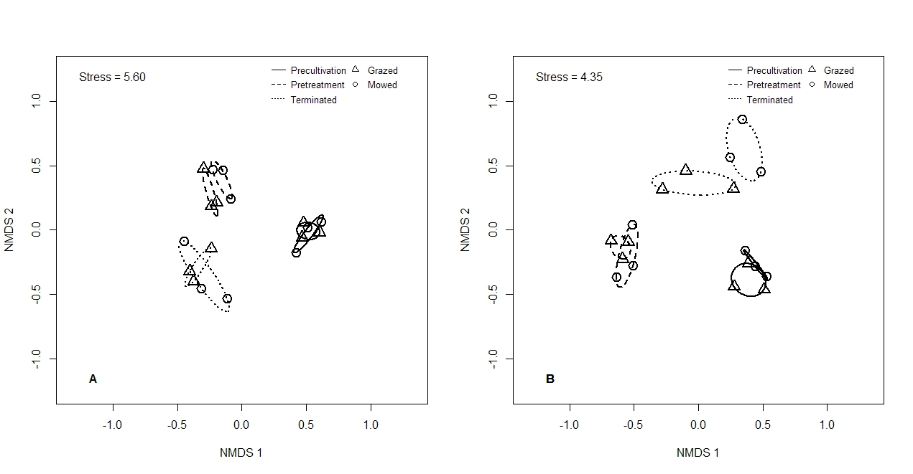Figure 3.4. NMDS ordination of the impacts of sheep grazing and mowing during cover-crop phase on carabid beetle community structure in (A) 2012 and (B) 2013 at Townes Harvest Farm, Bozeman, MT, United States. Solid ellipses inscribe beetle communities in the precultivation period, dashed ellipses inscribe those in the pretreatment period, and dotted ellipses inscribe those in the terminated period.

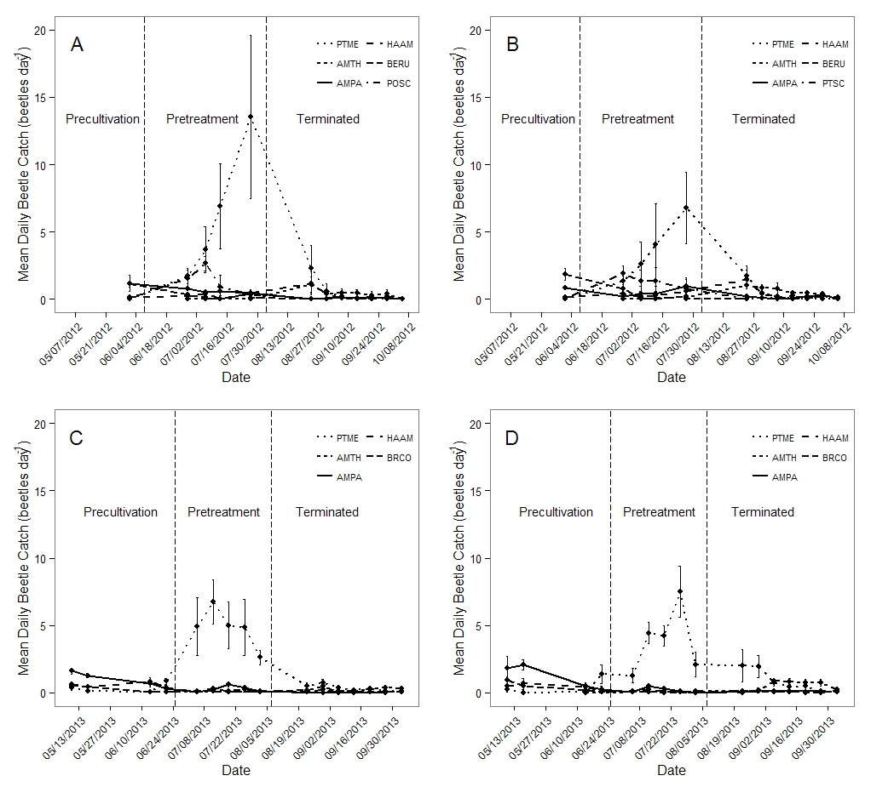Figure 3.5.Dynamics of activity-density of dominant carabid beetle species during the cover-crop phase in (A) 2012 grazed plots (B) 2012 mowed plots, (C) 2013 grazed plots and (D) 2013 mowed plots at Townes Harvest Farm, Bozeman, MT, United States. Species codes are as follows: PTME = *Pterostichus melanarius* (Illiger); AMTH = *Amara thoracica* (Hayward); AMPA = *Amara patruelis* (Dejean); HAAM = *Harpalus amputatus* (Say); POSC= *Poecilius scitulus* (LeConte); BRCO = *Bradycellus congener* (LeConte); BERU = *Bembidion rupicola* (Kirby).

Table 4.1. Vegetation cover and plant community structure in uncultivated refuge systems at in 2012 and 2013 Sieban Ranch, Helena, MT, United States.



Table 4.2. Mean weekly carabid beetle captures from May 2012 – August 2012 and from May 2013 – August 2013 in monoculture alfalfa, barley nurse-crop and uncultivated refuge fields at Sieban Ranch, Helena, MT, United States.

Table 4.3. ANOVA table of impact of vegetation systems on carabid beetle communities at Sieban Ranch, Helena, MT, United States. 

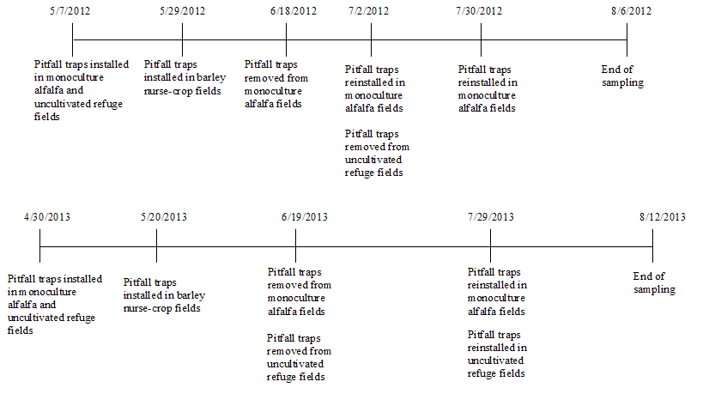Figure 4.1. Pitfall trap installation and removal dates for carabid beetle sampling in 2012 and 2013 at Sieban Ranch, Helena, MT, United States.

C:\Users\hgoosey\Documents\Hayes\Publications\Helena Carabids\Version 2\High Quality Figures for publication\Fig2.tiff

Figure 4.2. Influence of canopy height, date of the growing season, and percent bare ground on carabid beetle community dynamics in monoculture alfalfa, barley nurse-crop and uncultivated refuge fields between (A) May 2012 and August 2012 and (B) May 2013 and August 2013 at Sieban Ranch, Helena, MT, United States

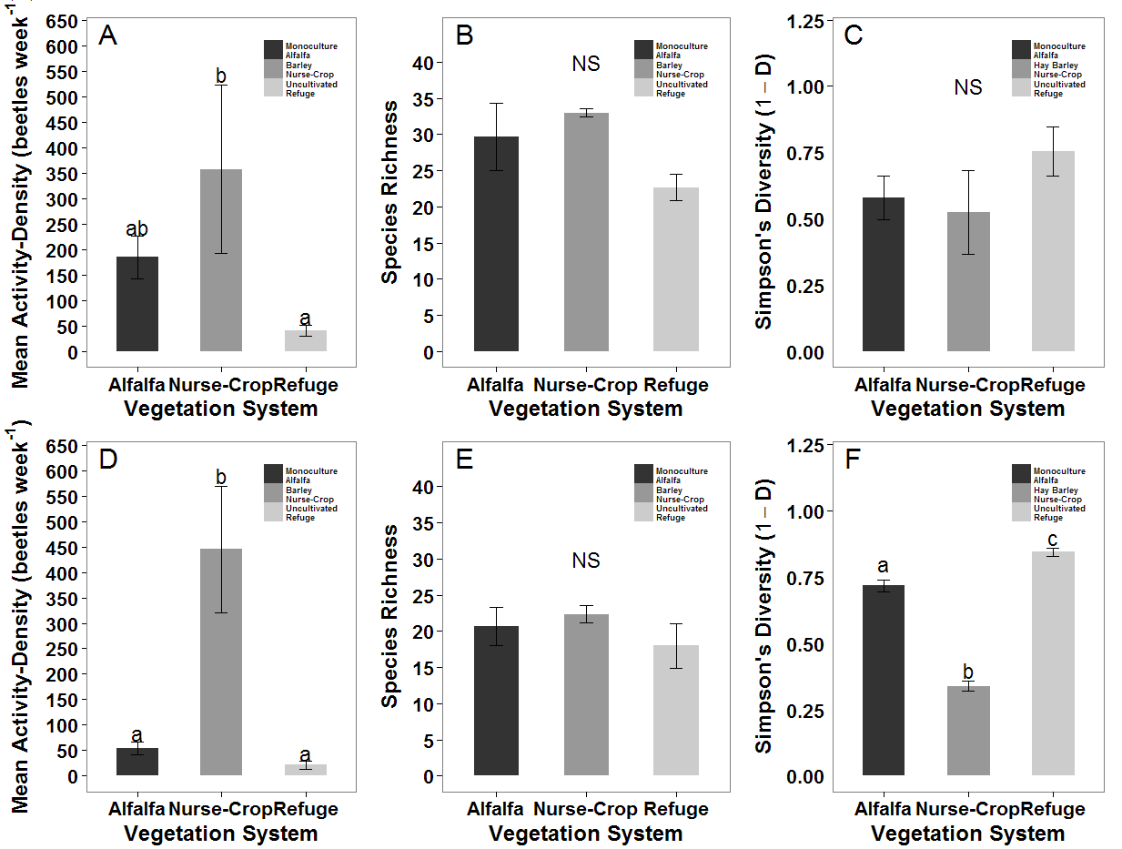Figure 4.3. Impacts of vegetation system on carabid beetle (A) activity-density in 2012 (B) species richness in 2012 (C) α-diversity indexed by Simpson's Diversity (1 – D) in 2012, (D) activity-density in 2013, (E) species richness in 2013, and (F) α-diversity in 2013 among monoculture alfalfa, barley nurse-crop and uncultivated refuge areas at Sieban Ranch Helena, MT, United States. Lower case letters indicate means comparisons. Bars with the same lower case letters are not significantly different (P > 0.05). “NS” indicates that none of the means differed significantly (P > 0.05) from each other.

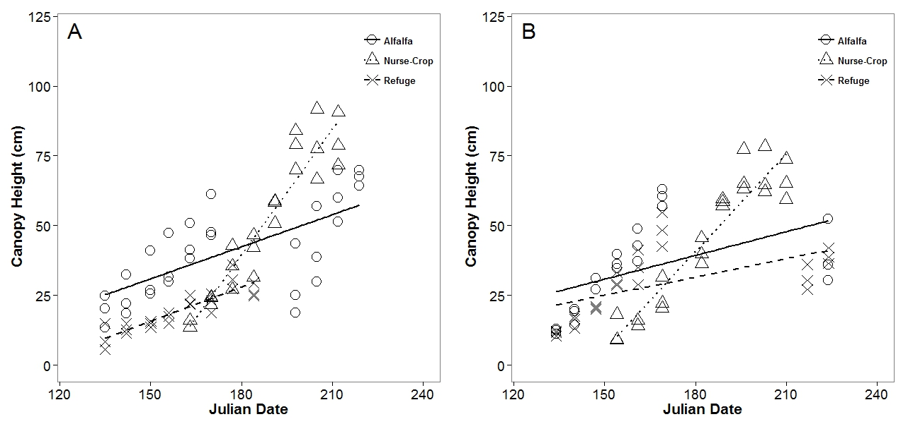

Figure 4.4. Comparison of canopy growth during the (A) 2012 and (B) 2013 growing seasons among monoculture alfalfa, barley nurse-crop and uncultivated refuge systems at Sieban Ranch, Helena, MT United States.

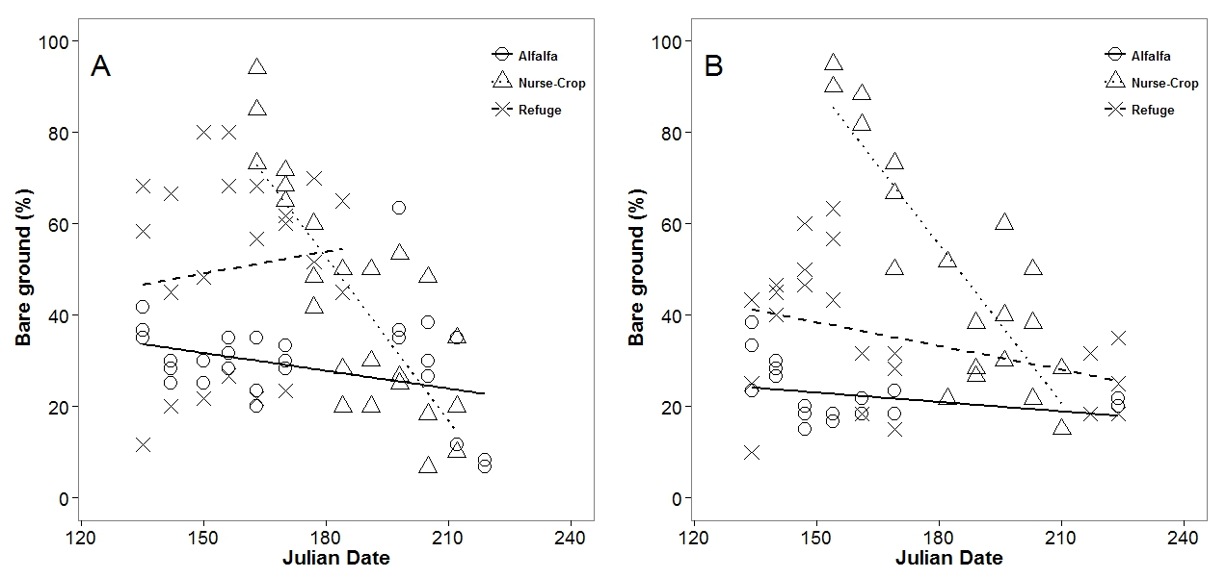

Figure 4.5: Comparison of percent bare ground during the (A) 2012 and (B) 2013 growing seasons among monoculture alfalfa, barley nurse-crop and uncultivated refuge fields at Sieban Ranch, Helena, MT United States.

Table 5.1. Results of T-Test comparisons between f Pre- and Post-surveys given to public school Life Science students.

|  |  |  |  |  |
| --- | --- | --- | --- | --- |
| No. | Question | Level of  knowledge  before | Level of  knowledge  after | P-Value for  difference |
|  |  |  |  |  |
| 1 | Plants are necessary for ALL animal life on earth? | 4.53 | 4.97 | <0.01 |
| 2 | Sustainable agriculture is beneficial to humans? | 2.03 | 4.95 | <0.01 |
| 3 | Sustainable agriculture incorporates many ways to produce food and fiber? | 2.96 | 4.97 | <0.01 |
| 4 | Sustainable agriculture and Organic are the same? | 4.15 | 1.36 | <0.01 |
| 5 | Montana residents do not need to care about sustainable food production? | 3.84 | 1.69 | <0.01 |
| 6 | A plant’s ability to convert sunlight energy into chemical energy is enhanced in a greenhouse? | 2.56 | 4.97 | <0.01 |
| 7 | Healthy soils reduce the acres needed for sustainable food and fiber production? | 2.96 | 4.96 | <0.01 |
| 8 | Pest insects can be managed using beneficial insects, livestock grazing, and crop rotations? | 1.69 | 4.52 | <0.01 |
| 9 | I would like to learn more about sustainable agriculture? | 2.36 | 3.65 | 0.02 |
| 10 | I am considering a Science Fair project about a sustainable agriculture topic? | 2.21 | 3.79 | 0.03 |

Mean value; level of knowledge self-reported as strongly disagree (1), disagree (2), no opinion (3), agree (4), strongly agree (5).