Figure 1. The virulence of entomopathogenic fungi against clover root borers. Mortality (%) of adult clover root borers exposed to spores of field-isolated and commercial strains. (C) = Commercial product; (F) = Field collected.

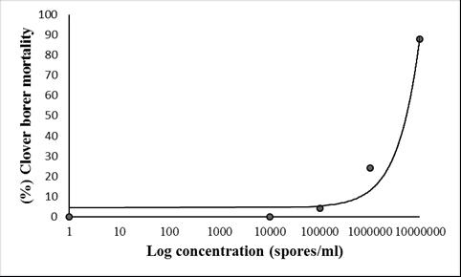

Figure 2. Clover root borer mortality after two weeks of exposure to field collected soil inoculated with Metarhizium anisopliae var anisopliae (A4-MA).

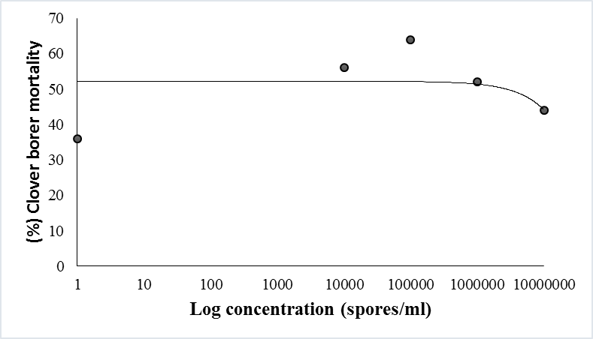

Figure 3. Clover root borer mortality after two weeks of exposure to field collected soil inoculated with Beauveria bassiana (FD).

Ta Table 1. Entomopathogenic fungi isolated from from red clover seed production fields in western Oregon.

Fields | County | Beauveria | Metarhizium | Isaria | Lecanicillium | Grand total
Field 1 | Polk | 10 | 0 | 3 | 0 | 13
Field 2 | Benton | 36 | 8 | 0 | 0 | 44
Field 3 | Benton | 30 | 15 | 0 | 0 | 45
Field 4 | Polk | 15 | 0 | 1 | 0 | 16
Field 5 | Linn | 37 | 6 | 0 | 3 | 46
Total |  | 128 | 29 | 4 | 3 | 165

Table 2. Molecular identification of field isolated fungi isolated from 5 red clover seed production fields in western OR.
No. | Isolat code | Identification | Percentage of similarity |  | e-value |  | Accession number of reference strains
 |  |  | ITS-1F | ITS4 | ITS-1F | ITS4
1. | FD | Beauveria bassiana | 100% | 99% | 0.0 | 0.0 | KM249042
2. | W1 | B. bassiana | 100% | 100% | 0.0 | 0.0 | EU334677
3. | P1SlpC | B.bassiana | 100% | 99% | 0.0 | 0.0 | KC753391
4. | WH3LA | B.bassiana | 99% | 99% | 0.0 | 0.0 | KC753398
5. | Fx-SlpC | B.pseudobassiana | 100% | 84% | 0.0 | 3e-99 | NR111598
6. | A4-MA | Metarhizium anisopliae var anisopliae | 100% | 100% | 0.0 | 0.0 | EU307929
7. | 1 SlpA | M. robertsii | 100% | 96% | 0.0 | 0.0 | NR132011
8. | G2LB | M.quizhouense | 100% | 89% | 0.0 | 1e-142 | HQ331465
9. | 14 Slpc | M. brunneum | 99% | 87% | 0.0 | 4e-118 | KM371261
10. | W4 | Isaria fumosorosea | 100% | 100% | 0.0 | 0.0 | GU354345
11. | 21-RC | I.farinosa | 100% | 91% | 0.0 | 6e-121 | HQ880828
12. | C5 | Lecanicillium muscarium | 99% | 99% | 0.0 | 0.0 | NR111096

Table 3. Impacts of B.bassiana (isolate FD) concentration on horizontal transfer of spores between clover root borer adults*.
Concentration (spores/ml) | Number (%) of clover root borer showing dead with mycosis by Beauveria | Number of clover root borer dead without mycosis
Control | 12 (26.67) | 3 (6.67)
Low concentration (10⁵) | 12 (26.67) | 1 (2.22)
High concentration (9.7 x 10⁷) | 30 (75.56) | 1 (2.22)

* n = 45.

