For all figures, treatments not sharing letters or an * are different according to Student’s t-test if normal, or Wilcoxon each pair means separation test if not normal.

Figure 1: MBB eggs on various beans [Objective 1: 2013]

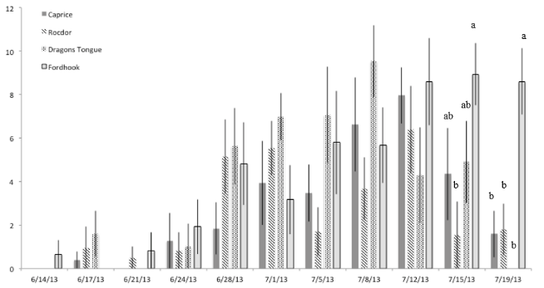
Average number of MBB eggs per 10 Plants (Square root transformed)

Figure 2: MBB late instars on various beans [Objective 1: 2013]

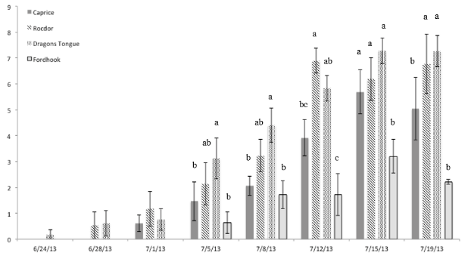
Average number of MBB late instars per 10 Plants (Square root transformed)

Figure 3: MBB eggs on various beans [Objective 1: 2014]

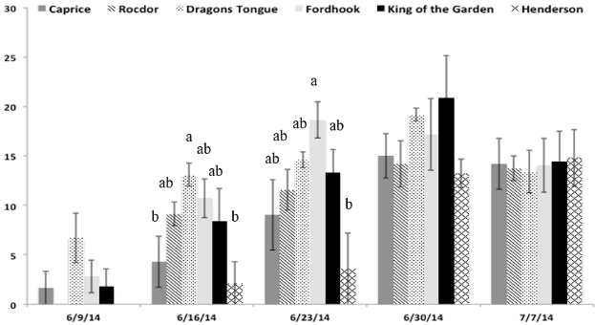
Average number of MBB eggs per 10 Plants (Square root transformed)

Figure 4: MBB late instars on various beans [Objective 1: 2014]

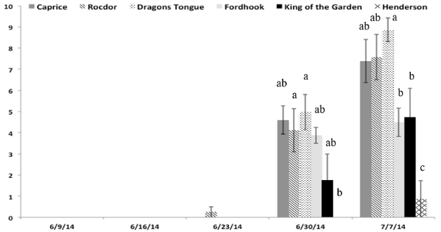
Average number of MBB late instars per 10 Plants (Square root transformed)

Figure 5: MBB eggs on various beans [Objective 1: 2015]
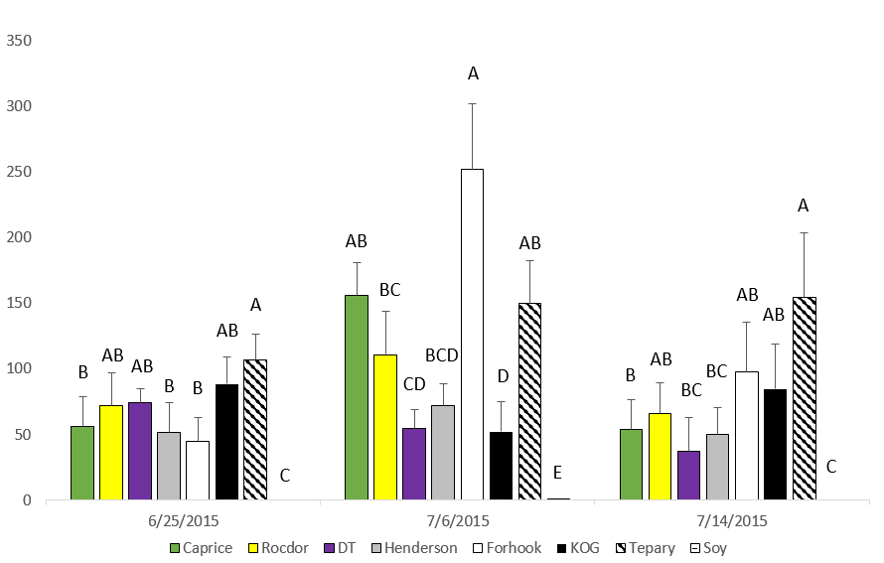
Average number of MBB eggs per 10 Plants

Figure 6: MBB late instars on various beans [Objective 1: 2015]

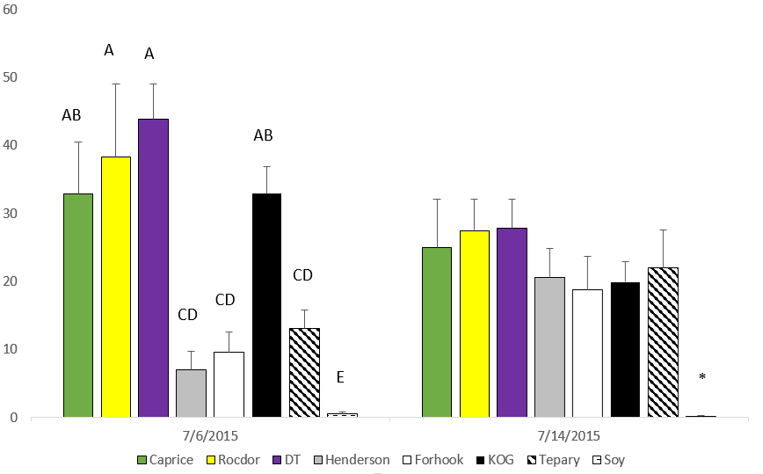
Average number of MBB late instars per 10 Plants

Figure 7: Pod damage from MBB to snap bean varieties [Objective 1: 2015]
Percent of pods damaged out of 50
C
A
B

Figure 8: Foliar damage from MBB on various beans [Objective 1: 2015]

Average foliar damage rating of 10 plants

Figure 9: Immigrated to a new variety [Objective 2: 2013 cage plot]

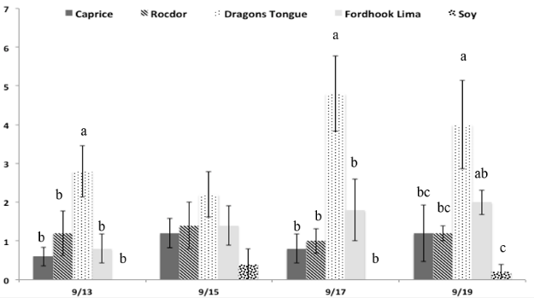
Average number of MBB found within a plot that came from a different variety

Figure 10: Remained in original variety [Objective 2: 2013 cage plot]

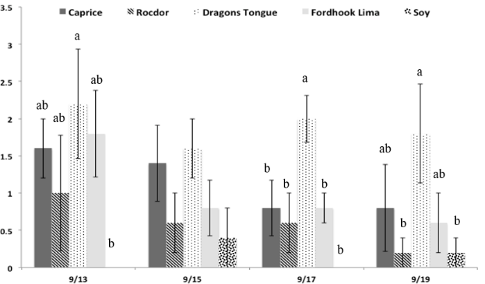
Average number of MBB found within a plot that came from the same variety

Figure 11: Immigrated to a new variety [Objective 2: 2014 cage plot]

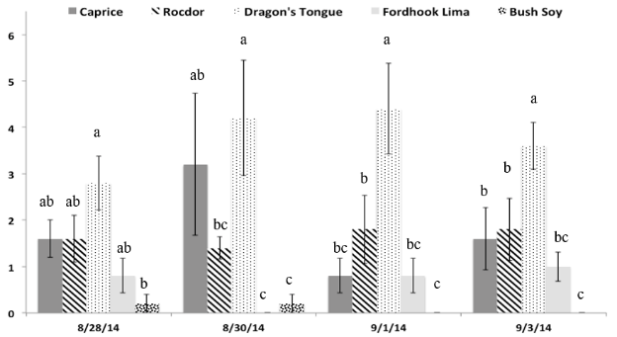
Average number of MBB found within a plot that came from a different variety

Figure 12: Remained in original variety [Objective 2: 2014 cage plot]

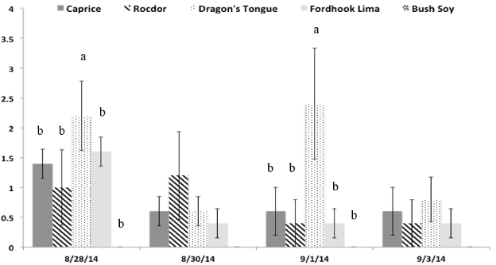
Average number of MBB found within a plot that came from the same variety

Figure 13 a & b: MBB late instars [Objective 3: 2013]

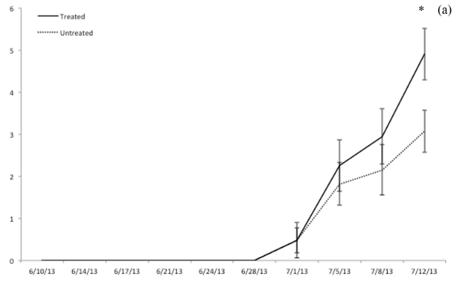
Average number of MBB late instars in 10 plants (square root transformed)
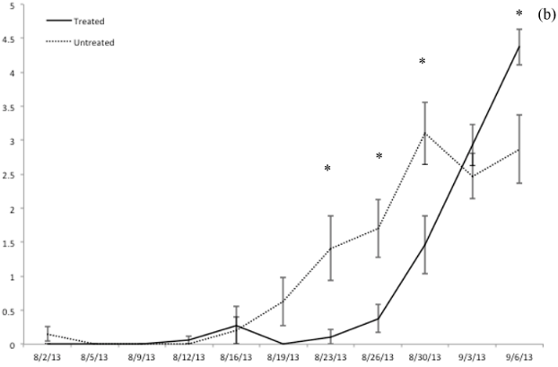
Average number of MBB late instars in 10 plants (square root transformed)
a. PD: 5/3/13. Average number of MBB late instars per replicate (10 plants). Square root transformation.
b. PD: 7/16/13. Average number of MBB late instars per replicate (10 plants). Square root transformation.

Figure 14 a & b: Harvest stand count [Objective 3: 2013]

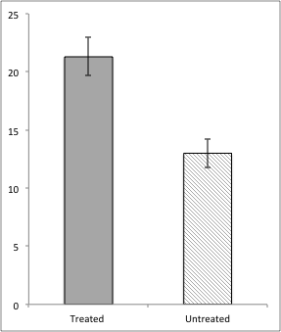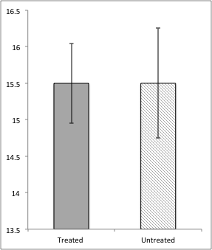
(a)
(b)
Average number of plants per replicate (two, 1m samples) at maturity
*
(a) Planting date: 5/3/13. (b). Planting date: 7/16/13.

Figure 15 a & b: Pod yield (g) by plot [Objective 3: 2013]

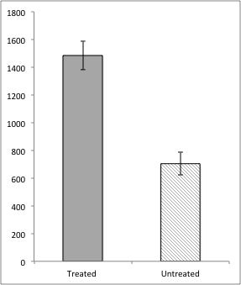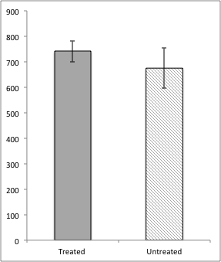
Average weight (g) of pods per plot (two, 1m samples) at maturity
(b)
(a)
*
(a) Planting date: 5/3/13. (b). Planting date: 7/16/13.

Figure 16: Total pod yield (g) [Objective 3: 2014]

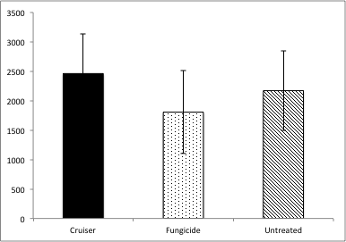
Average weight (g) of pods per plot (two, 3m samples) at maturity
a
b
ab
Average weight (g) of pods per replicate (two, 3m sections of row) at plant maturity, 7/14/2014. Treatments not sharing letters are different according to Tukey’s HSC means separation. *p= .0396

Figure 16: Thrips [Objective 3: 2015]

Average number of Thrips on 10 plants (square root transformed)

Figure 17: MBB Eggs on plastic mulches [Objective 5: 2014]

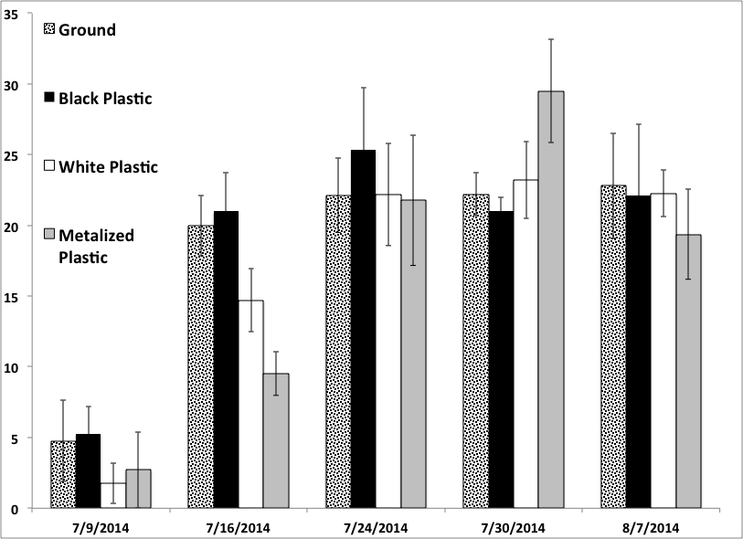
b
c
a
a
Average number of MBB eggs on 10 plant clusters (Square root transformed)

Figure 18: MBB Late instars on plastic mulches [Objective 5: 2014]

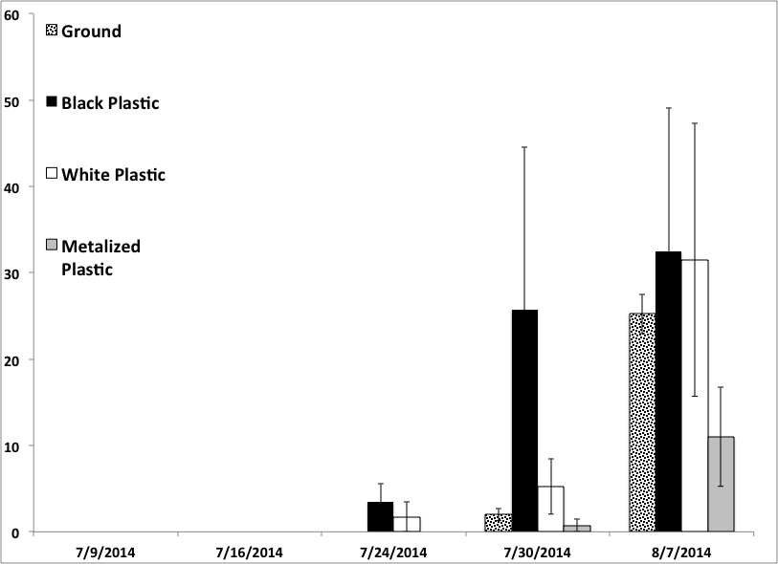
Average number of MBB late instars on 10 plant clusters (Square root transformed)

Figure 19: MBB Pupae on plastic mulches [Objective 5: 2014]

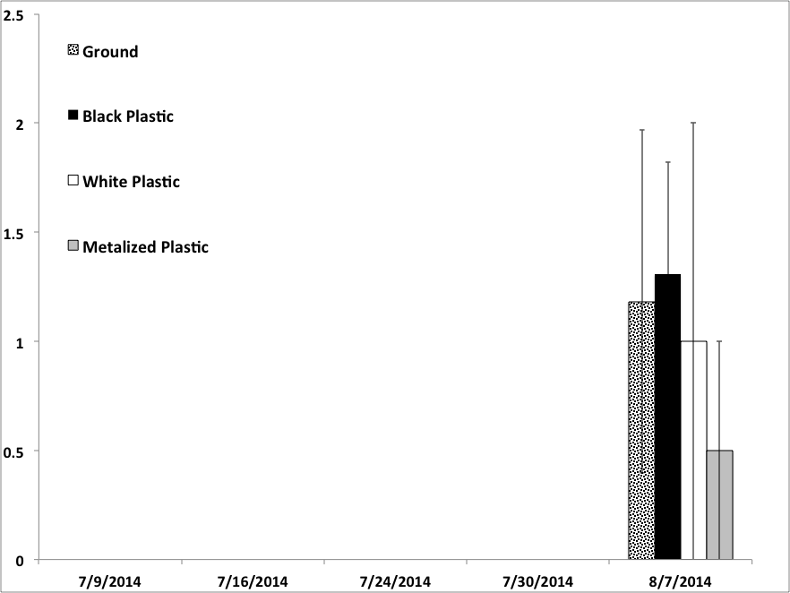
Average number of MBB pupae on 10 plant clusters (Square root transformed)

Figure 20: Predators on plastic mulches [Objective 5: 2014]

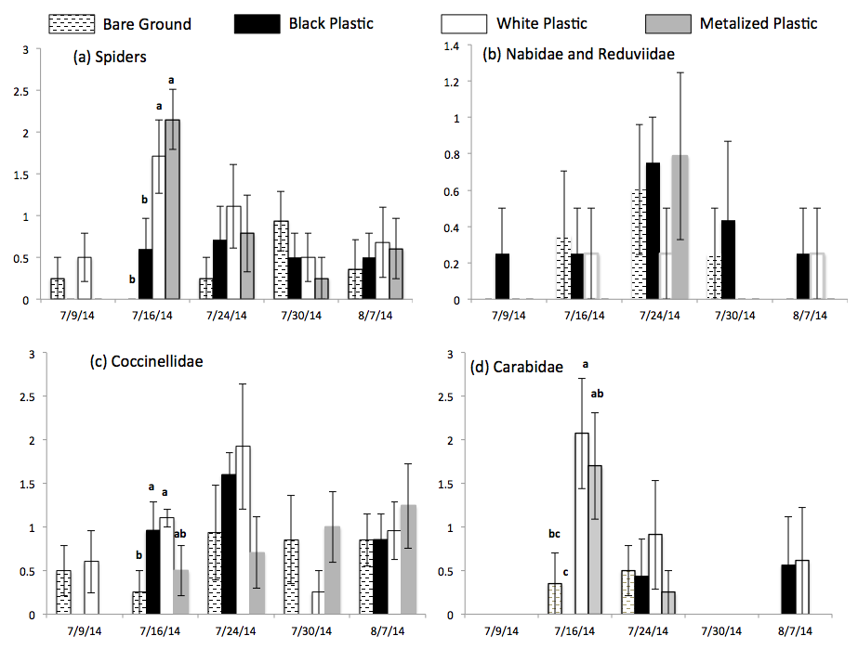
Average number of individuals on 10 plant clusters (Square root transformed)

Figure 21: Pod Yield from plastic mulches [Objective 5: 2014]

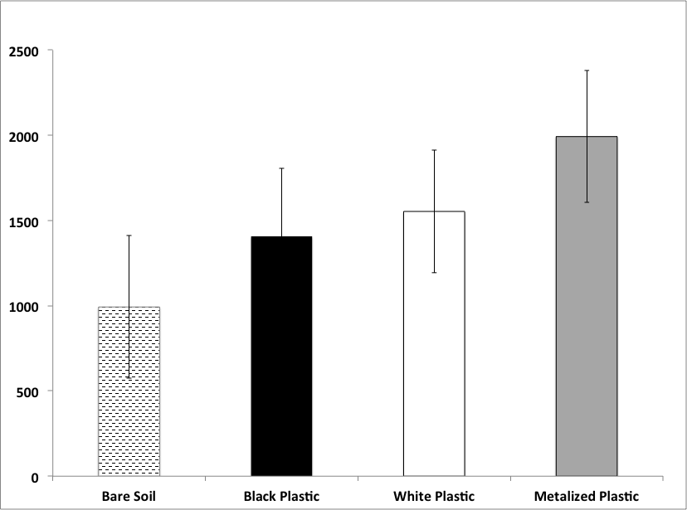
Total weight (g) of bean pods from 20 plant clusters
a
b
b
c

Figure 22: Light sensor readings [Objective 5: 2015]

Average PAR µmol/m²s per day from sunrise to sunset (readings taken ever 10 minutes)

Figure 23: MBB eggs on plastic mulches [Objective 5: 2015]
Average number of MBB eggs on 10 plant clusters (Square root transformed)
ab
b
ab
a
a
a
b
b
b
b
ab
a
*

Figure 24: MBB early instars on plastic mulches [Objective 5: 2015]

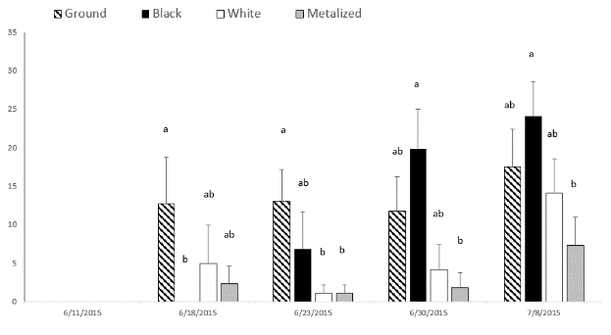
Average number of MBB early instars on 10 plant clusters (Square root transformed)

Figure 25: MBB late instars on plastic mulches [Objective 5: 2015]

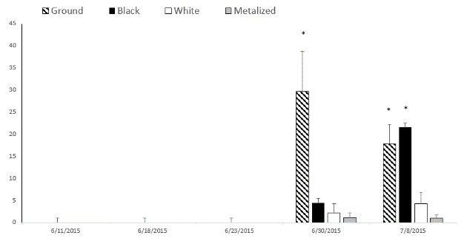
Average number of MBB late instars on 10 plant clusters (Square root transformed)

Figure 26: MBB pupae on plastic mulches [Objective 5: 2015]

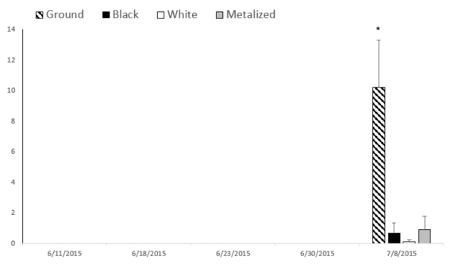
Average number of MBB pupae on 10 plant clusters (Square root transformed)

Figure 27: Foliar Injury to bean plants on plastic mulches [Objective 5: 2015]

Average foliar injury rating from 10 plant clusters (Square root transformed)

Figure 28: Bean pod damage on plastic mulches [Objective 5: 2015]

Average proportion of damaged bean pods of 50 pods (arcsine square root transformed)

Figure 29: Bean pod yield on plastic mulches [Objective 5: 2015]

Total weight (g) of bean pods from 10 plant clusters
b
b
b
c

Figure 30: Double cropped lettuce yield on plastic mulches [Objective 5: 2015]

b
a
a
Total weight (g) of 20 lettuce heads
c

