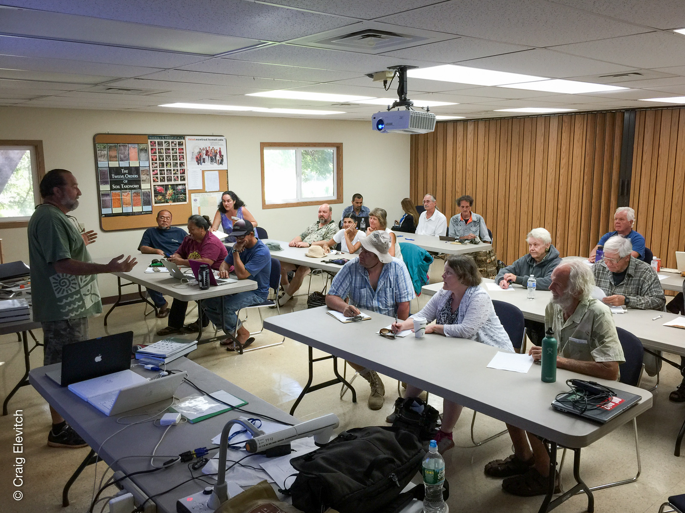IMG_5063–CElevitch.jpg, Glenn Teves opens the workshop on Moloka'i.

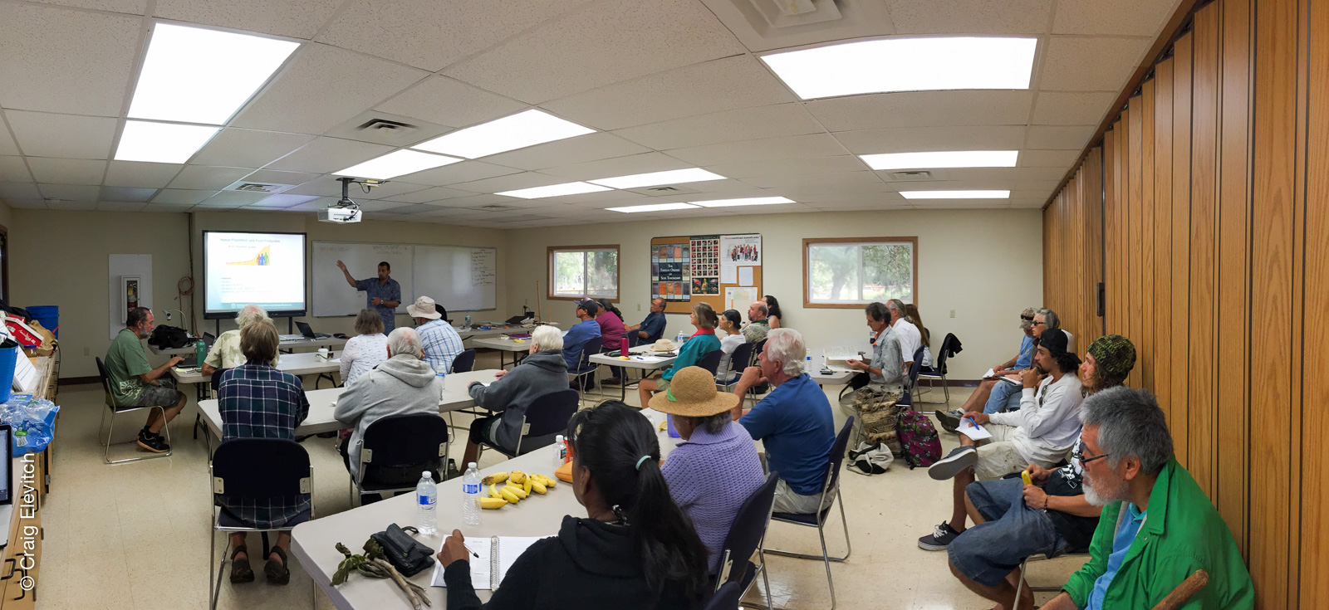IMG_5067–CElevitch.jpg, Amjad Ahmad presents on local sources of soil fertility on Moloka'i.

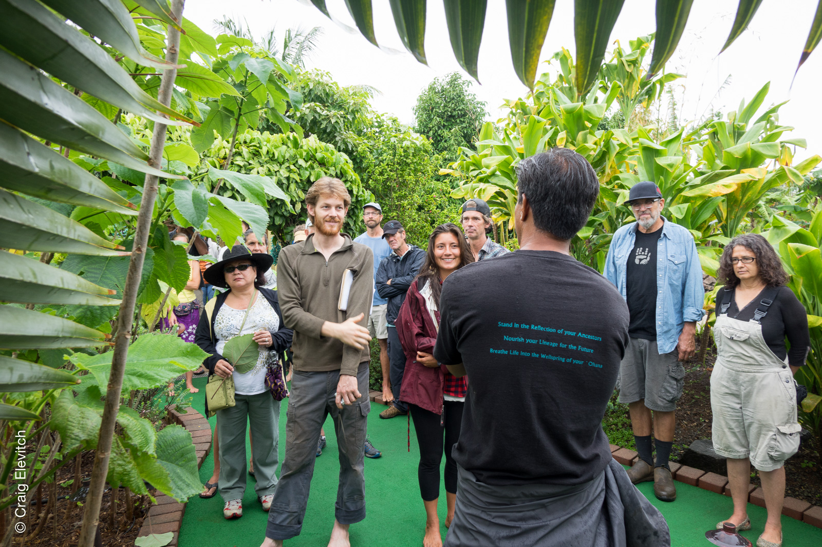DSC07260–CElevitch.jpg, Bino Castello leads tour of Kaua'i Mini Golf's agroforestry landscaping.

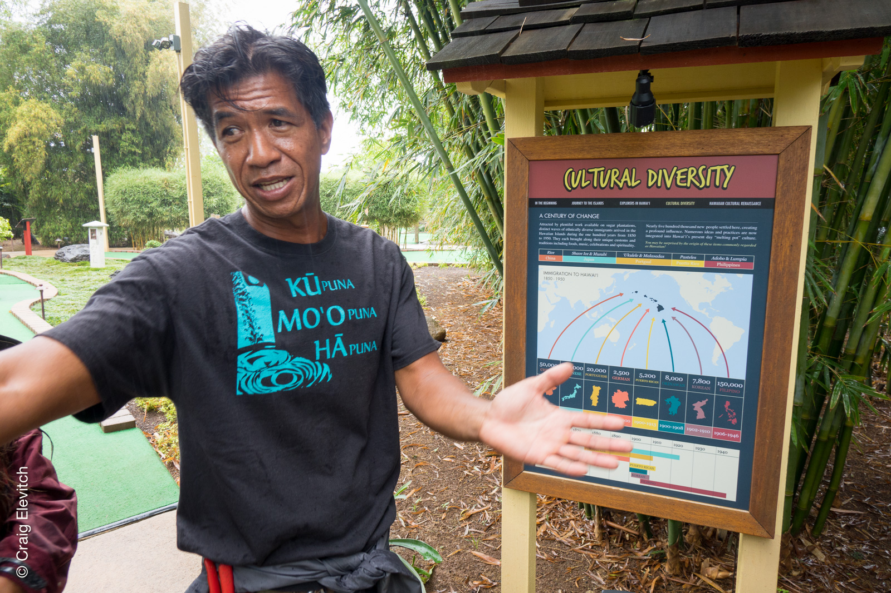DSC07284–CElevitch.jpg, Bino Castello leads tour of Kaua'i Mini Golf's agroforestry landscaping.

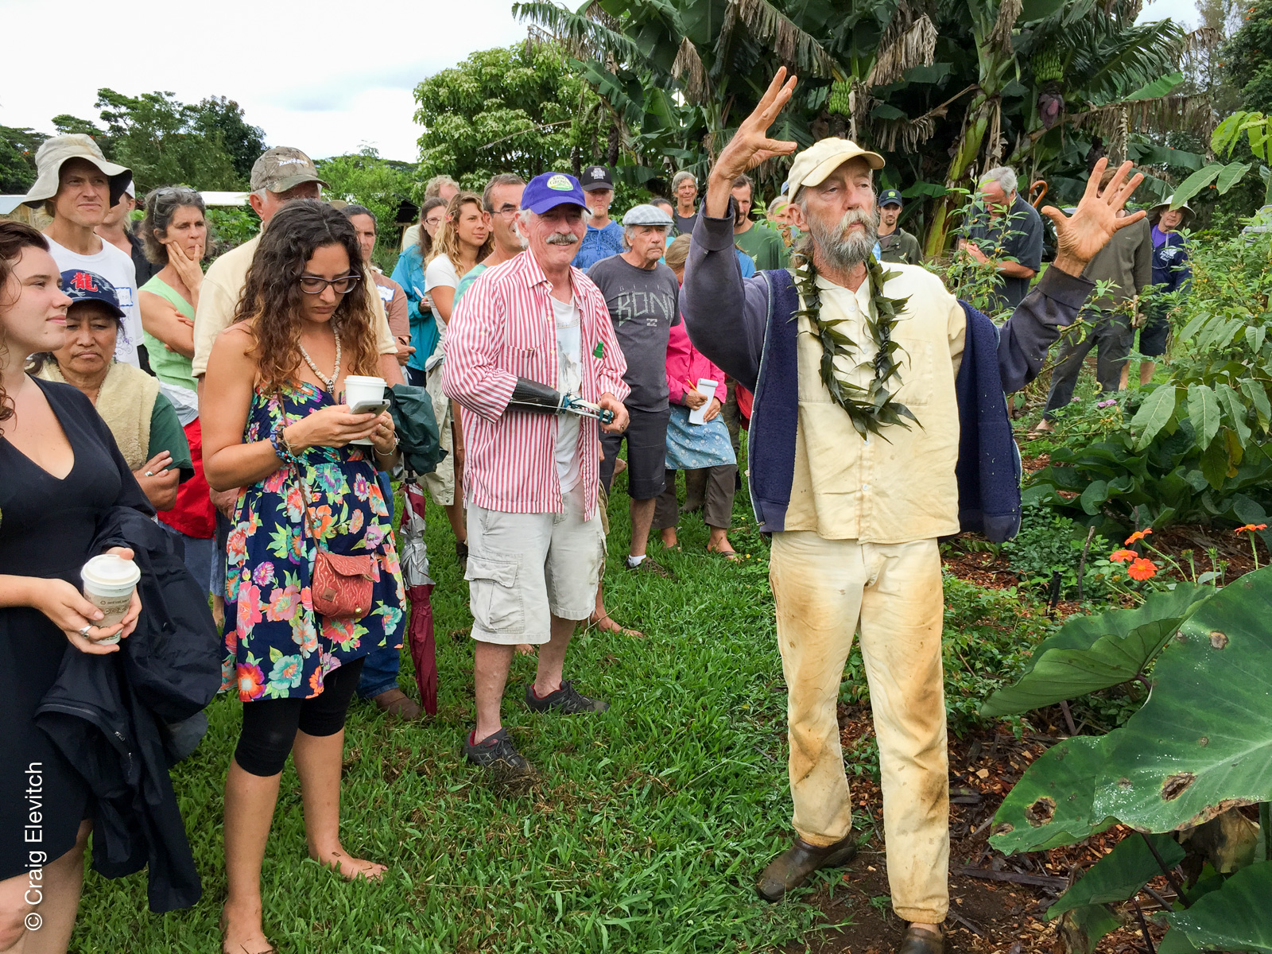IMG_5276–CElevitch.jpg, Sun Hadley describes the work he has been doing for decades in community food self-sufficiency.

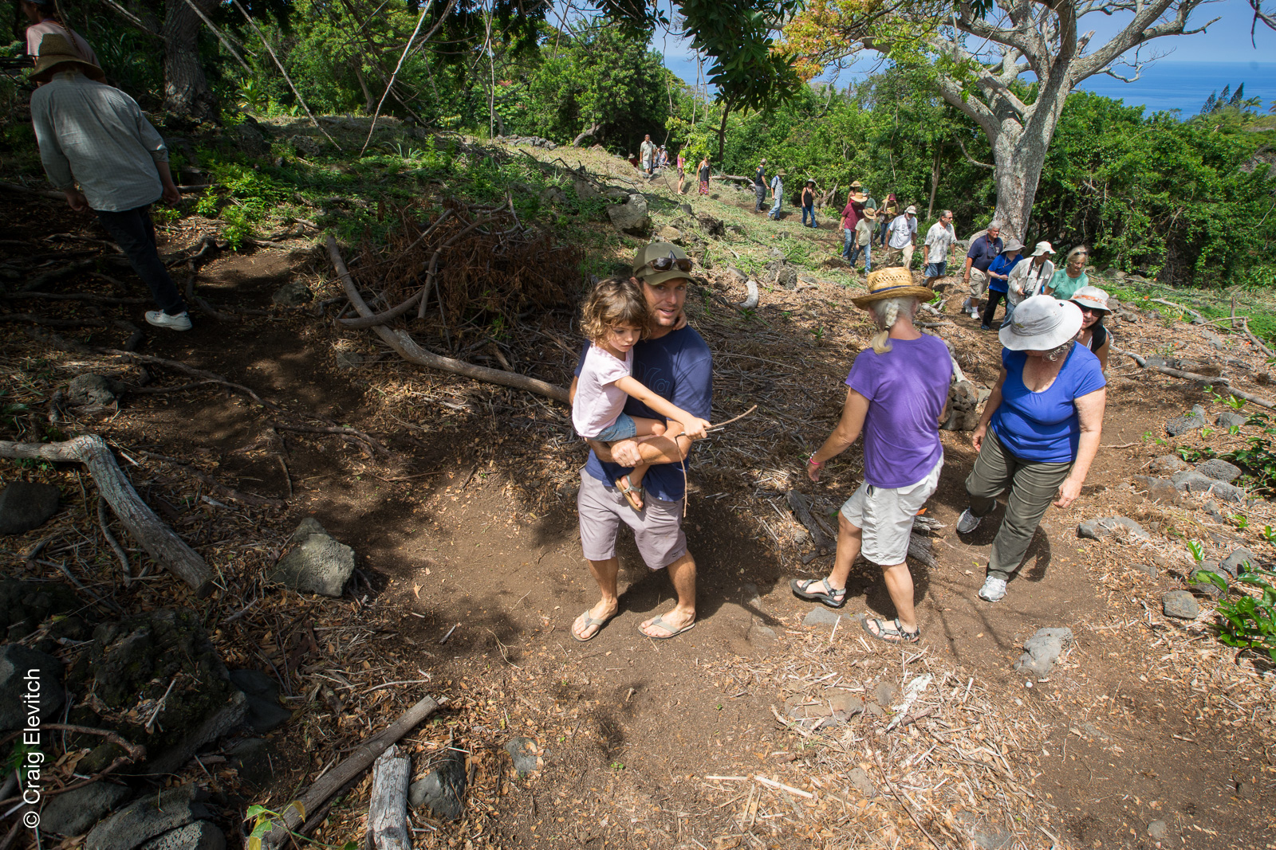DSC03930–CElevitch.jpg, Angelica and Richard Stevens guided a tour of their farm that is being converted to agroforestry integrated with native Hawaiian plants.

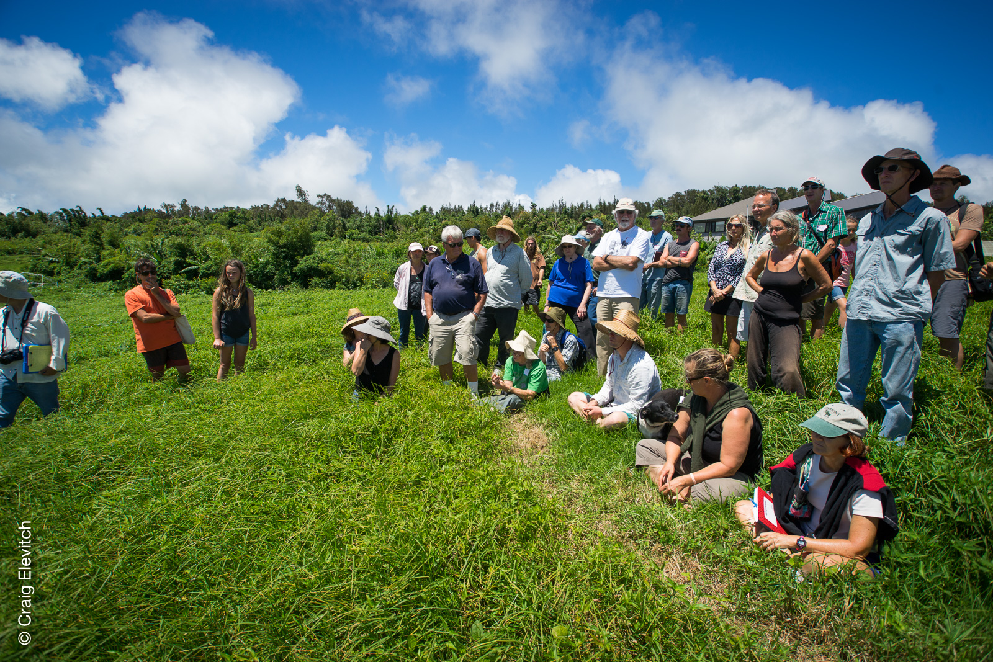DSC03963–CElevitch.jpg, Open pasture at Mohala Farm, North Kohala.

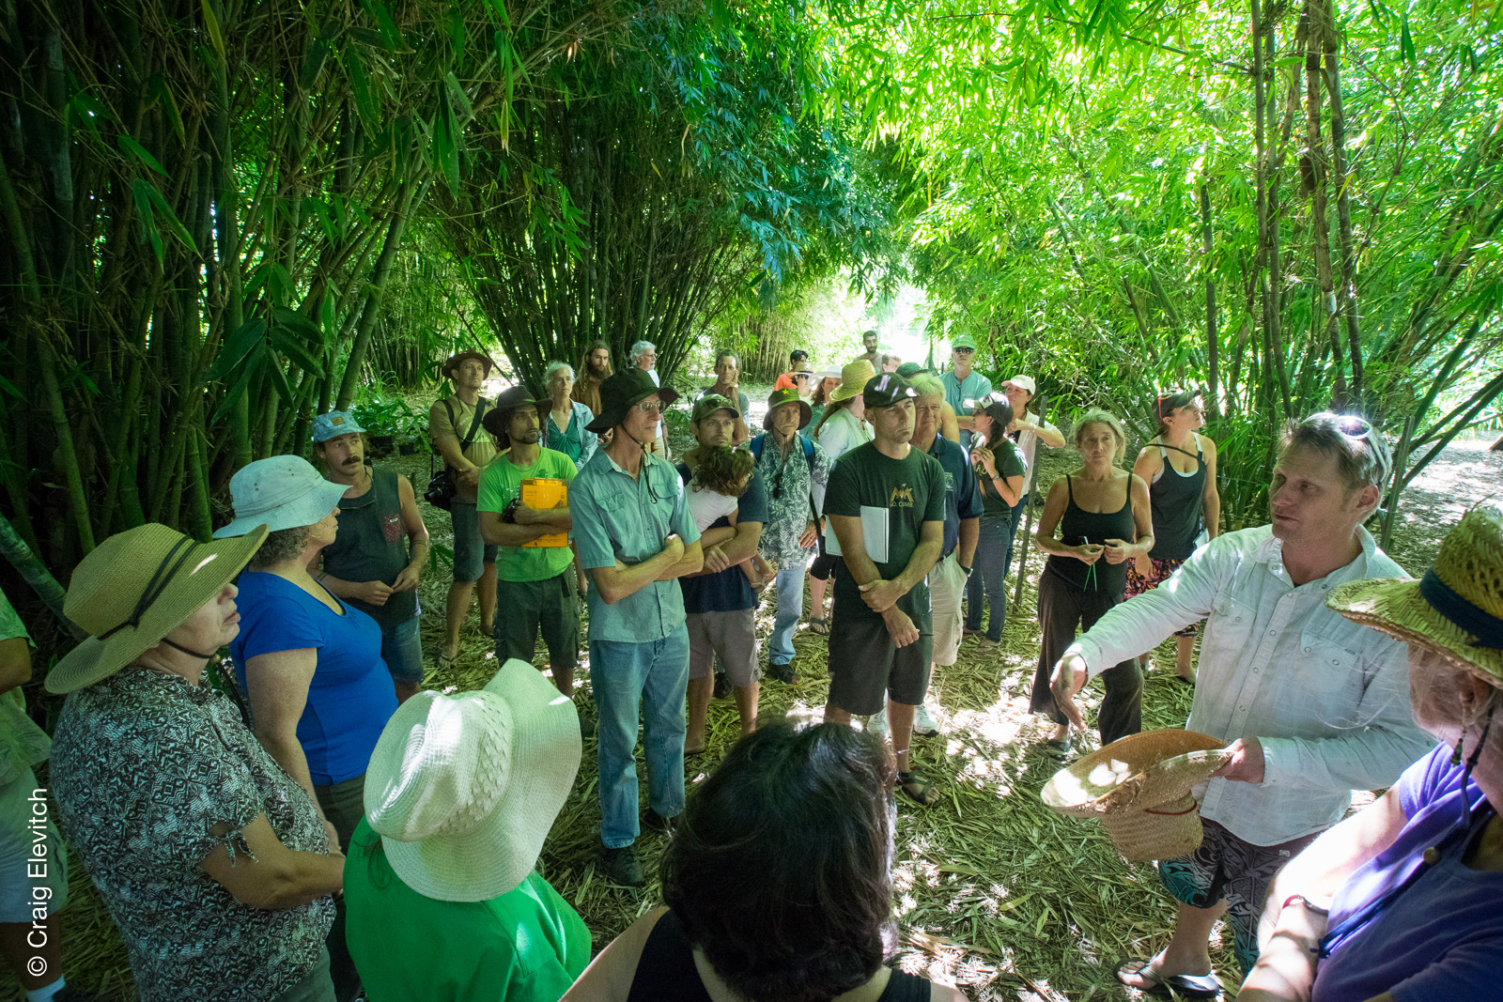DSC04045–CElevitch.jpg, Neil Logan of Mohala Farm shows how open pasture can be converted to productive agroforest.

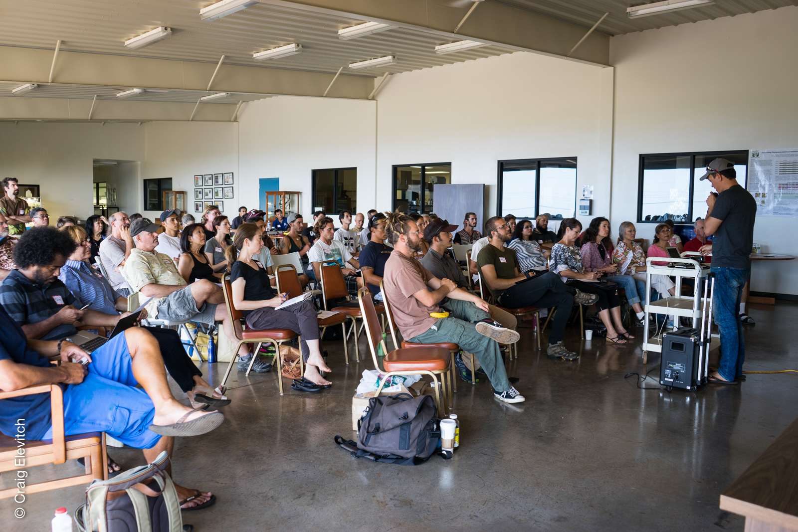DSC00063–CElevitch.jpg, Matthew Lynch presents at the Oahu workshop, hosted by the Hawaii Agricultural Research Center.

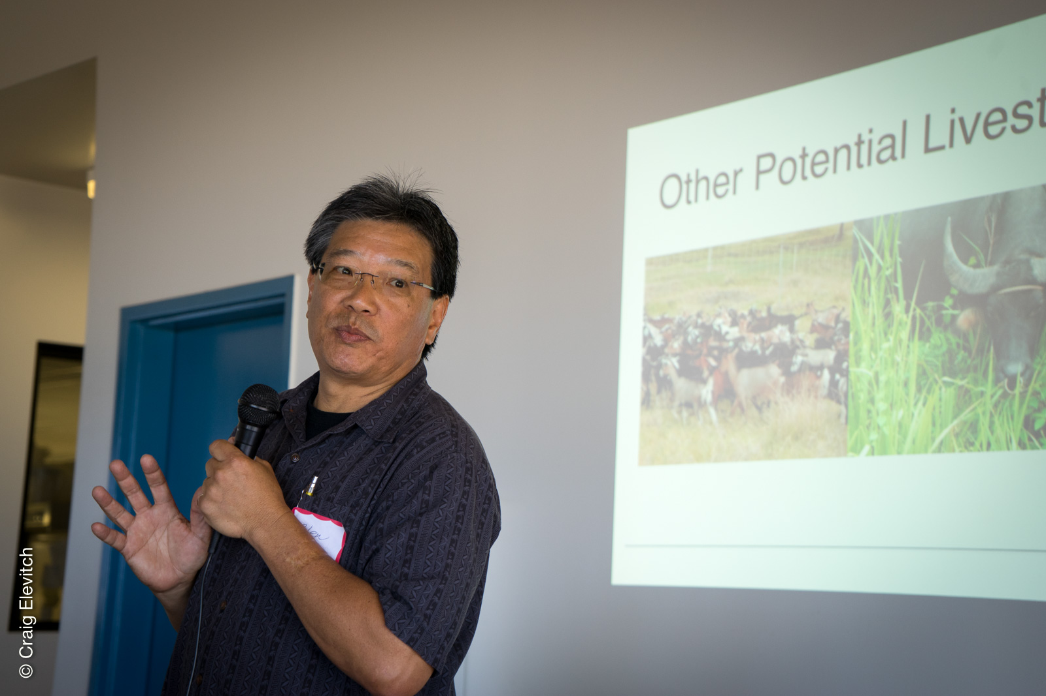DSC00072–CElevitch.jpg, Glen Fukumoto presented his work on integrating livestock into agroforestry.

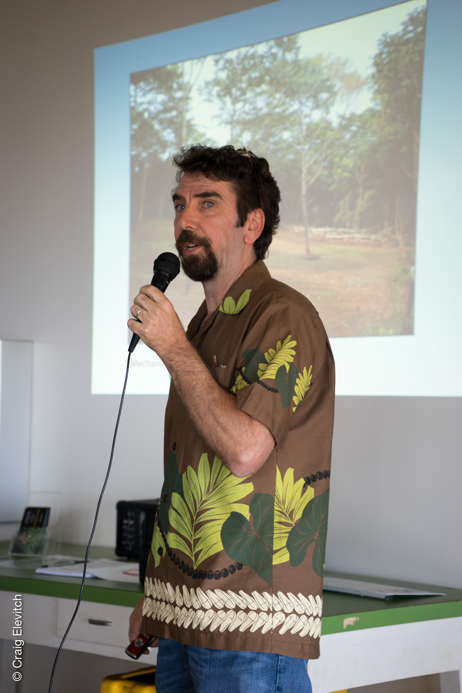

DSC00088–CElevitch.jpg, Michael Constantinides showed how agroforestry can be integrated into NRCS conservation plans.

