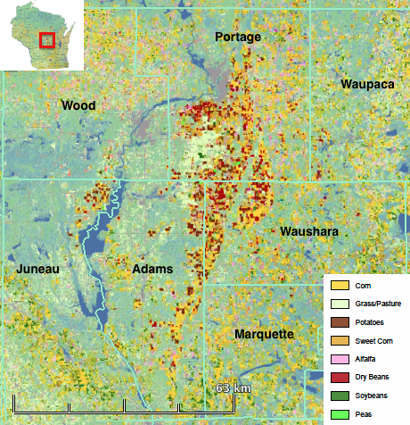

Figure 1. Wisconsin Central Sands location and prevalent crop types depicted by National Agricultural Statistics Service 2013 Cropland Data Layer.