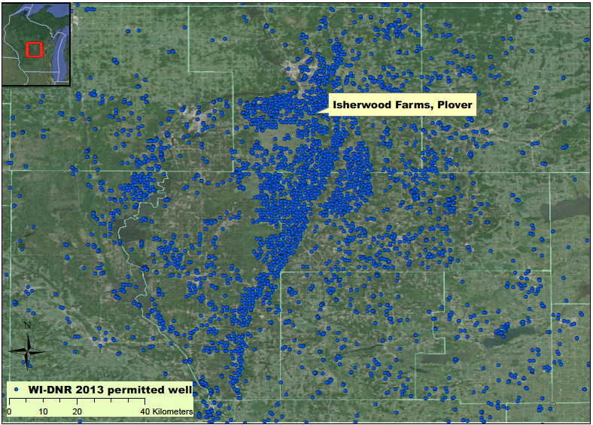

Figure 2. Isherwood Farms, Plover, WI with permitted 2013 high-capacity wells in the Wisconsin Central Sands