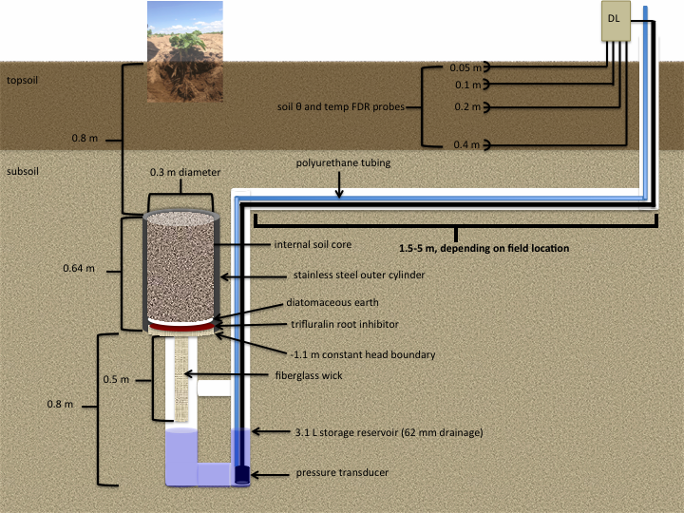
Figure 3. Lysimeter and soil moisture/temperature probe experimental design before (top) and after (bottom) 2015 reconfiguration for weekly access to pressure transducer and polypropylene tubing.

