Table 1. Cumulative water budgets from November 10, 2013 through November 9, 2014. All components of the water budget (Precipitation, Irrigation, Potential Recharge, Net Recharge) are reported in mm.
Cropping system (field name, soil subtype) | Precip | Irrigation | Potential recharge | Potential recharge  CV | ET | ET  CV | Net Recharge | Net Recharge CV
Potato (Gilman, Richford) | 888 | 196 | 407 | 0.37 | 677 | 0.22 | 211 | 0.72
Peas-Pearl Millet (Homefield, Richford) | 888 | 119 | 427 | 0.50 | 580 | 0.37 | 307 | 0.70
Sweet Corn (East Alt, Rosholt) | 932 | 193 | 735 | 0.79 | 390 | 1.50 | 542 | 1.07
Sweet Corn (East Alt, Rosholt, without low outlier) | 932 | 193 | 447 | 0.24 | 678 | 0.16 | 254 | 0.44
Sweet Corn (Louis, Richford) | 927 | 142 | 486 | 0.79 | 583 | 0.66 | 343 | 1.11
Sweet Corn (Louis, Richford, without low outlier) | 927 | 142 | 313 | 0.65 | 756 | 0.27 | 171 | 1.19
Field Corn (West Alt, Rosholt) | 932 | 151 | 752 | 0.57 | 331 | 1.29 | 601 | 0.71
Field Corn (West Alt, Rosholt without low outlier) | 932 | 151 | 556 | 0.64 | 567 | 0.40 | 405 | 0.52
Field Corn (Poznek, Richford) | 927 | 169 | 530 | 0.65 | 565 | 0.61 | 362 | 0.95

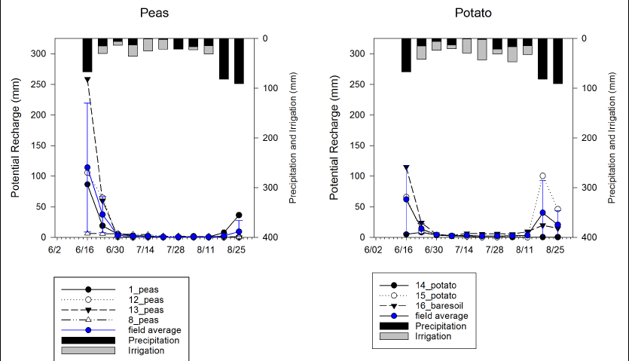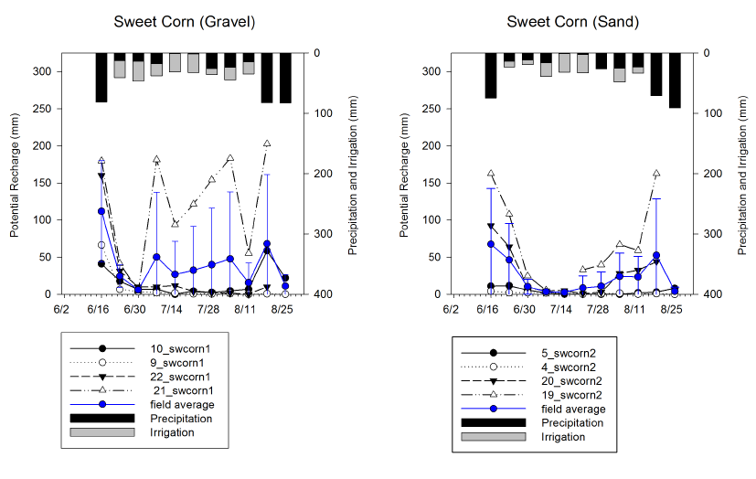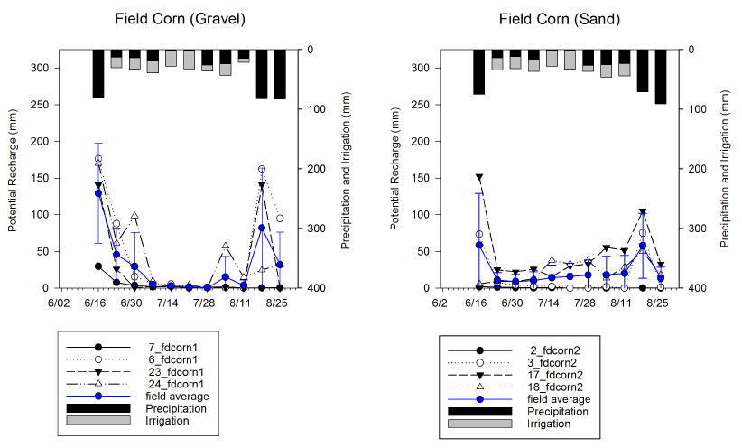
Figure 4. Weekly potential recharge measured by lysimeters (mm, left axes) along with precipitation and irrigation (mm, right axes) for six fields on Isherwood Farms during the 2014 growing season.

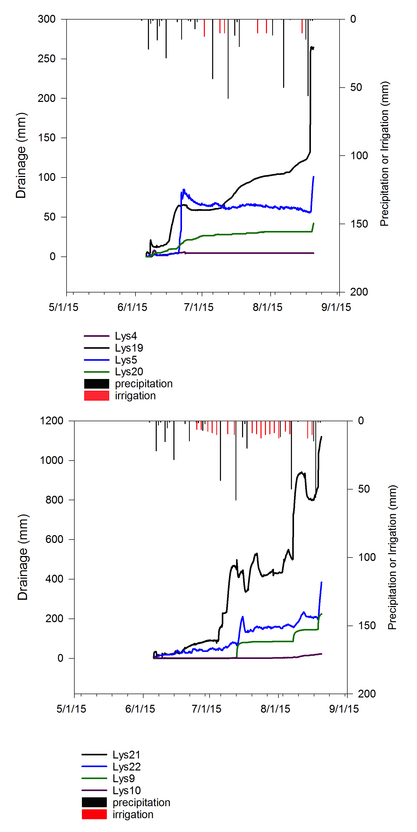
Figure 5. Potential recharge (mm, left axes, 5-minute flux from lysimeters) measured by pressure transducers during the 2015 growing season in sweet corn (top, Louis, sand) and potato (bottom, East Alt, gravel). Precipitation and irrigation (mm) are indicated by the right axes for each field.

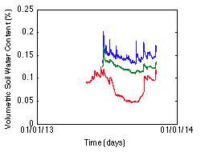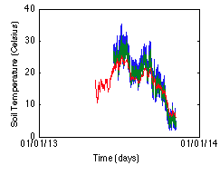
Figure 6. Soil moisture (left) and temperature (right) for 2013 growing season in irrigated maize treatment. Blue, green, and red lines represent soil moisture and temperature at 10, 20, and 40 cm depths, respectively.

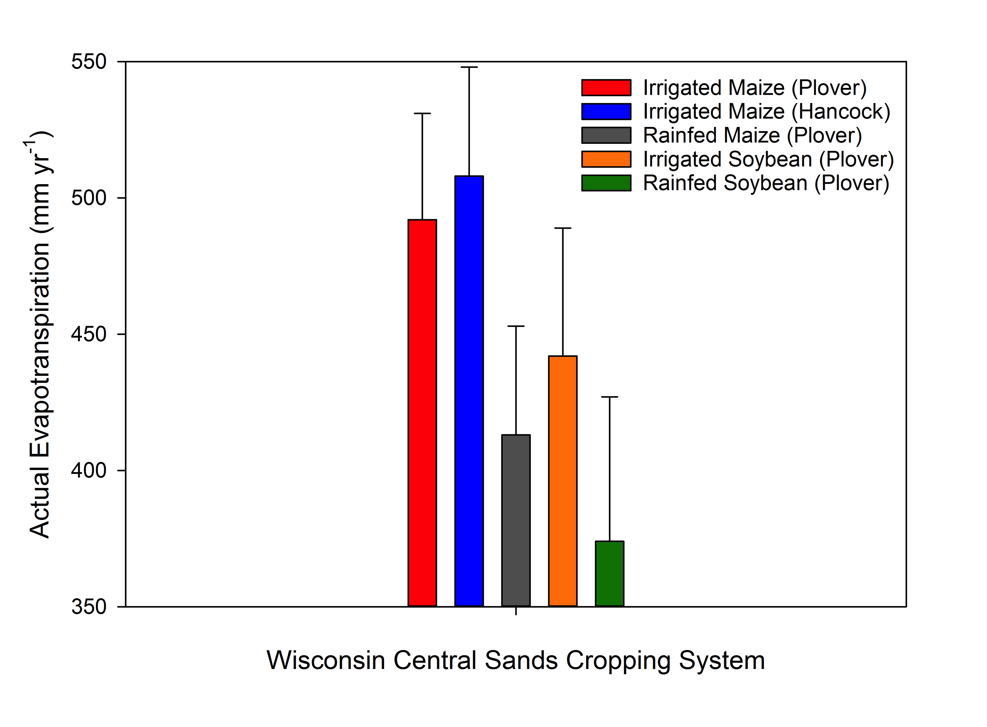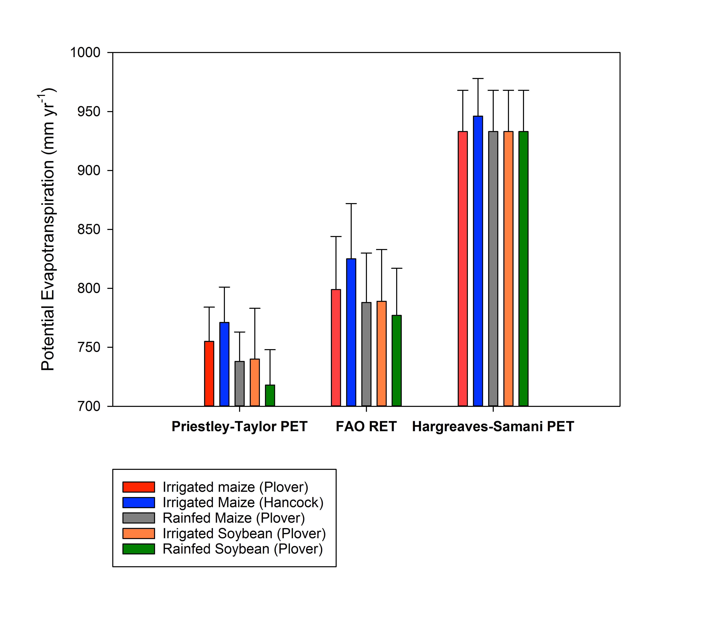
Figure 7. Modeled actual (top) and potential (bottom) annual evapotranspiration rates simulated by Agro-IBIS for 1948-2007

