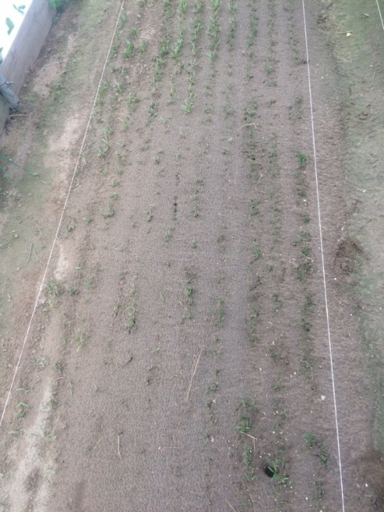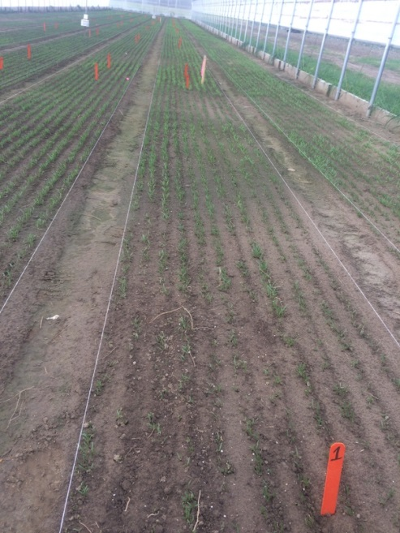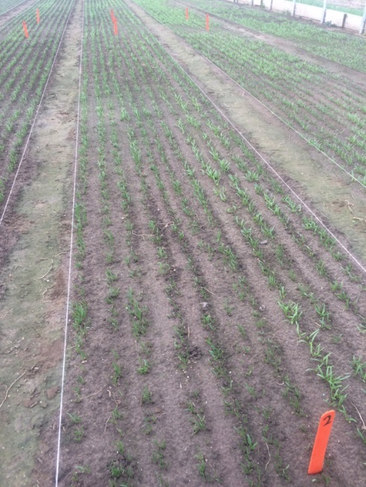
3
2
1
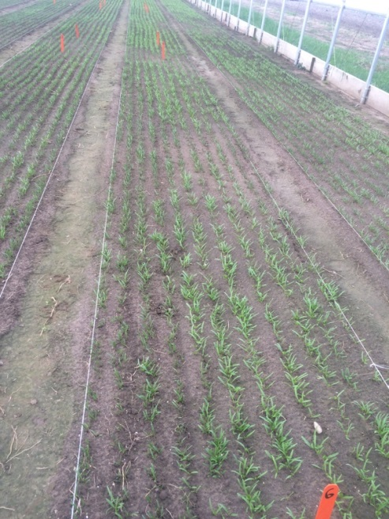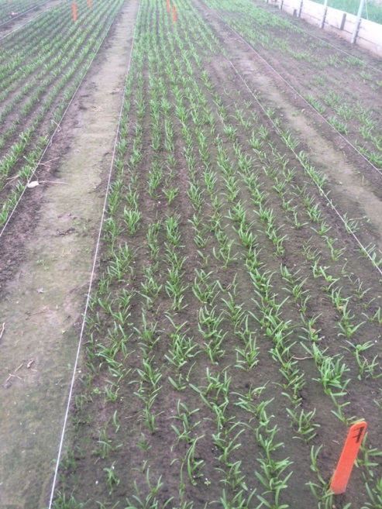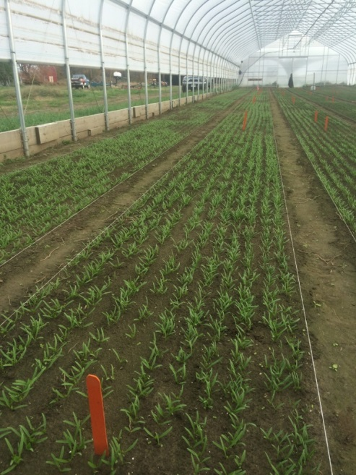
6
5
4
Figure 1. The following ordered categorical scale was developed in order to asses differences in germination and stand establishment from 1-6, where: 1 represents small plants with large patches where plants did not germinate or germinated very slowly; 2 represents small plants with small patches; 3 represents small plants with no patches; 4 represents large plants that germinated as expected but the plot has large patches present; 5 represents large plants but small patches; and 6 represents large plants and no patches, with good plant stand and vigor (see photos 1-6).

