WSARE Onion Project 2015 Annual Report
Onion Systems Management Strategies for Crop Nutrition, Weeds, Thrips, and Iris Yellow Spot Virus

Fig. 1. The influence of weed border treatments on thrips population densities in adjacent onions, 2014.
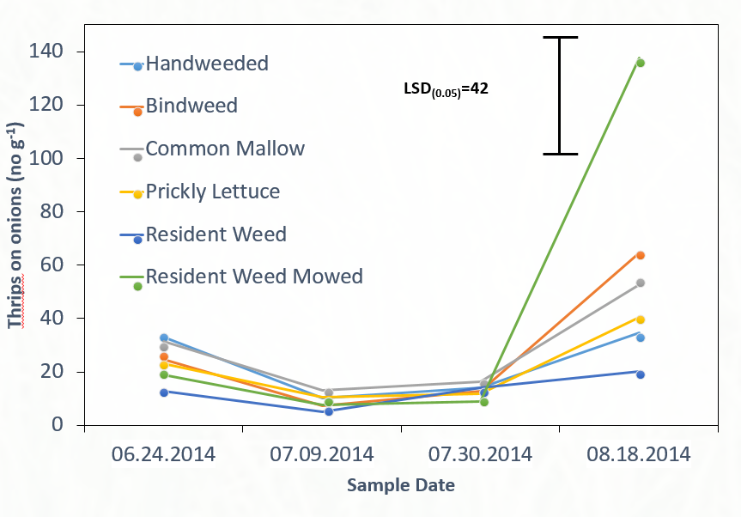
Fig. 2. Adult thrips population densities on weeds in monoculture borders, 2014.
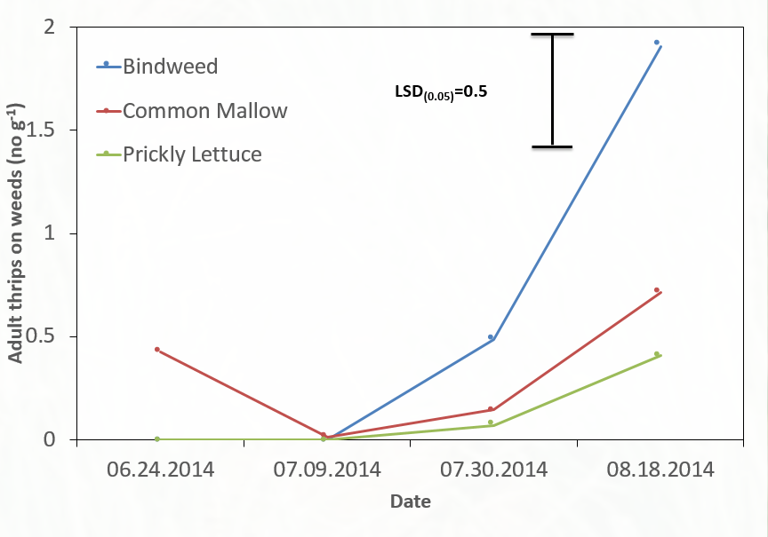
Fig. 3. Larval thrips abundance on weed species in monoculture borders, 2014.
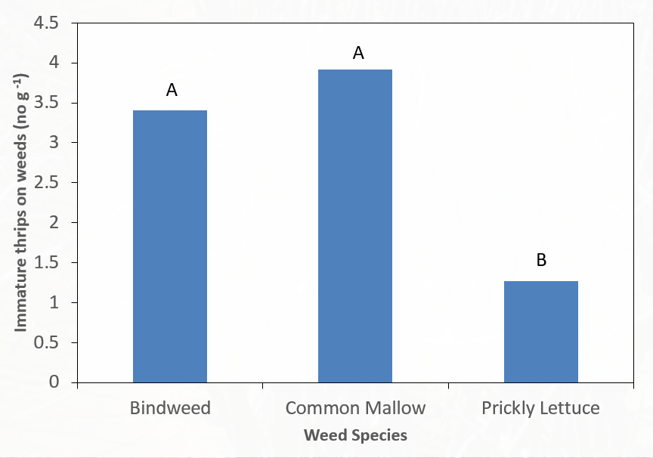

Fig. 4. Comparison of 2014 and 2015 onion thrips abundance on onion averaged over all treatments.
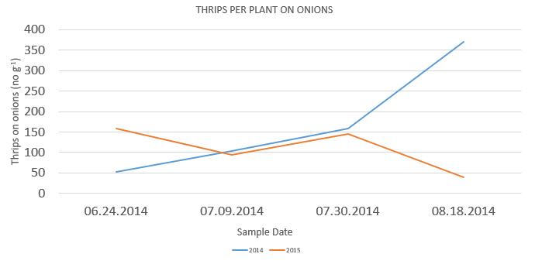

Fig. 5. The influence of weed border treatments on thrips population densities in onion during 2015.
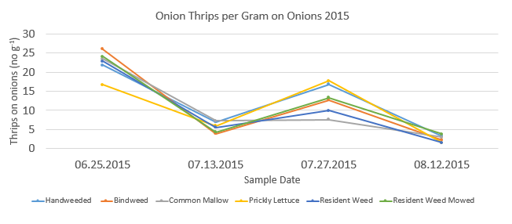

Table 1. IYSV incidence rates in weed species (% of plants infected) during 2015.
Month | Weed species | Mean IYSV infection rate (%)
June | Black medic  Common mallow  Field bindweed  Lambsquarters  Prickly lettuce | 1-3%
 | Witchgrass | 0%
July | Black medic | 8.5%
 | Lambsquarters  Prickly lettuce | 7.5%
 | Nightshade | 0%
 | Witchgrass | 17.5%
August | Black medic  Common mallow  Prickly lettuce | 0%
 | Nightshade | 6%
 | Witchgrass | 4%

Table 2. IYSV incidence rates in onions (% infection) grown next to different weed border treatments.
Treatment | June | July | August
Hand-weeded | 0% | 2.5% | 5%
Common mallow | 2.5% | 2.5% | 20%
Field bindweed | 0% | 10% | 7.5%
Prickly lettuce | 2.5% | 2.5% | 12.5%
Resident weeds | 5% | 7.5% | 7.5%
Resident weeds - mowed | 5% | 2.5% | 0%

Fig. 6. Soil nitrate concentration in reduced (low) and standard (high) nitrogen application treatments in 2014.

Fig. 7. Readily mineralized carbon concentration in soils treated with reduced (low) and standard (high) rates of nitrogen fertilizer.

Fig. 8. Soil microbial biomass in soils treated with reduced (low) and standard (high) rates of nitrogen fertilizer.

