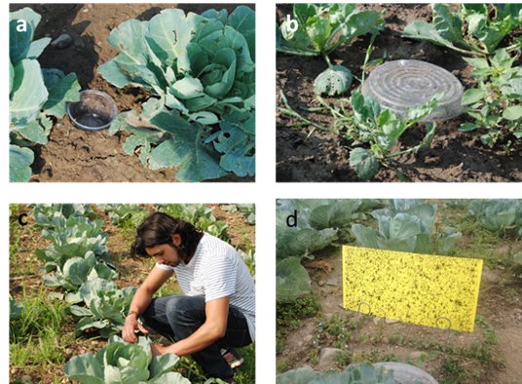
Fig. 1. Arthropod sampling. (a) Pitfall trap. (b) Pitfall trap protected with a plastic plate. (c) Visual inspection of plants. (d) Yellow sticky cards.

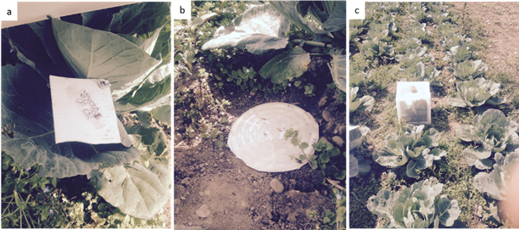
Fig 2. Field set-up to determine predation levels on sentinel prey and predatory activity. (a) Sentinel egg platforms. (b) Sentinel prey arena for ground-dwelling predators. (c) Enclosure cage that served as a control.

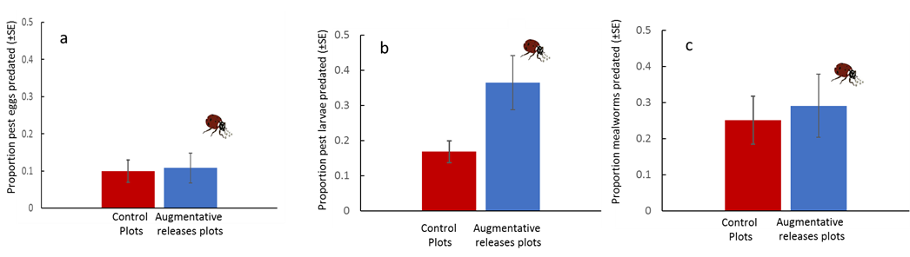
Fig 3. Predation on sentinel prey. Predation on T. ni eggs (a), predation on T.ni larvae (b) and predation on mealworms (c).Error bars are mean ±1 SE.

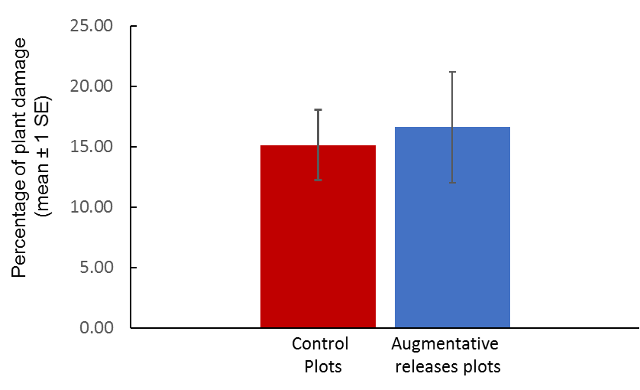
Fig. 4. Percentage of plant damage in experimental plots with or without augmentative releases of predators. Sample size = 10 plants per plot.

