Garlic: Start with Great Seed and Don’t Ruin it
It’s nearing time to plant, which means fine-tuning the fertility program, making sure the site is optimized, and keeping seed cool and dry until it’s time to crack and plant. This sounds like a pretty easy plan, and one really short article! But, for the sake of fun, let’s go through what each of these pieces of the puzzle might look like.
Site Optimization: It is possible to grow garlic very well in a tremendous variety of soils, from heavy clay to coarse sand. One key is to provide enough water for ample growth but not so much that the roots are stressed and diseases are favored. On clay soils this might mean using raised beds, planting shallower and mulching, and using ample cover crops and compost to gradually improve the soil. On sandy soils it might be better to plant a little deeper, forego raised beds and focus on moisture retention (again, through the use of mulch, cover crops, and compost). Pay close attention to your soil types and your field characteristics, and plan accordingly. If you have questions about your site, feel free to call.
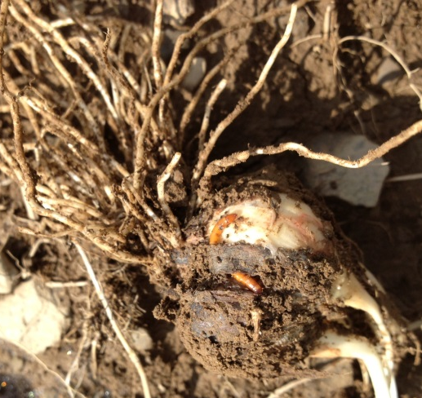
Think carefully about the history of a field before choosing your planting site. One pitfall is planting into fresh killed sod, which can harbor significant wireworms. By the time I get a call about wireworms in garlic, it’s far too late to do anything. The time to deal with wireworms is before the garlic goes in the ground. Wireworms are the larval form of the click beetle, and persist in the soil for up to 6-7 years. Populations are highest in recently turned under sod and gradually decrease over time. I recommend waiting at least 2 years if possible before planting into ground that has been sod for an extended period of time. If you have to go in sooner, using multiple plantings of buckwheat and incorporating the green matter the summer before planting might help break up the wireworms and more quickly reduce populations. It probably won’t completely solve the problem, if there is one. This is an issue better avoided than combatted.
Garlic infested with wireworms. Wrapper leaves have been eaten off. Image: CLS
A final consideration which can be addressed prior to planting is perennial weed control. Pay particular attention to quack grass, which can actually grow into the forming garlic heads. It will be harder to fully control perennial weeds organically this late in the season, since they already have some reserves built up, but you can at least set them back. Conventional growers can use a well-timed herbicide application (after the first frost is ideal) to take care of many perennial weeds. Look for a complete article on fall weed control in next week’s newsletter.
Fall Fertility Recommendations:
Phosphorus and potassium should be optimized in the fall using a soil test. The guidelines are listed in the table below. Based on what we know so far we can say that the crop doesn’t need more nitrogen in the fall than is available in the actual clove, but this doesn’t mean that you can’t apply a slow-release nitrogen form such as alfalfa or peanut meal, or composted poultry manure in the furrow at planting, with the expectation that nitrogen will be available in the spring. It simply means that synthetic and quick-release nitrogen fertilizers will be wasted in a fall application. Many organic growers are shooting for 75% of their nitrogen being applied in the fall, when it is easiest, and 25% quick-release forms like Chilean Nitrate being applied in the spring. Some organic growers are opting to put down all N in the fall, particularly in mulched systems. This can be tricky in a cool spring when N doesn’t become available quickly, but otherwise seems to be a good strategy.
Garlic | Nitrogen (N) Lbs/A | Phosphorus (P2O5) Lbs/A |  |  |  |  | Potassium (K2O) Lbs/A
Soil Test Results |  | Very low <3lbs/A | Low 3-6 | Medium 7-13 | High 14-40 | Very High >40 | Very low <50 | Low 51-100 | Medium 101-200 | High 201-300 | Very High >300
Incorporate at planting | 0 | 200 | 150 | 100 | 50 | 0 | 200 | 150 | 100 | 50 | 0
Sidedress before emergence | 25-50 | 0 | 0 | 0 | 0 | 0 | 0 | 0 | 0 | 0 | 0
Sidedress 2-3 times, 3-4 weeks apart | 25-50 divided among sidedressings | 0 | 0 | 0 | 0 | 0 | 0 | 0 | 0 | 0 | 0
TOTAL | 50-100 | 150 | 100 | 75 | 50 | 0 | 150 | 100 | 75 | 50 | 0

Seed Storage and Preparation
In these last few weeks before planting, make sure garlic is kept as close to 70 percent humidity and 70 degrees (or lower) as possible. Keep garlic heads intact to reduce weight loss and exposure of each clove to aerial fungal spores. Even beautiful, healthy garlic will break down if storage conditions are poor.
When it’s time to crack the garlic and plant, consider a few more ideas:
- Cull bulbs or cloves with symptoms or damage when cracking: Carefully feel and look at each clove during this process, and remove anything that looks suspect. Discard cloves with unhealthy looking basal plates, with dents or lesions on or under the wrapper leaf, and any cloves that feel unusually light. Do not compost these cloves---either bury them away from the field or throw them away.
- Treat all seed with a surface sterilizer: Sterilizing the surface of the cloves will NOT control GBN! However, it will reduce issues with surface molds such as aspergillus and will kill surface penicillium. This is a best practice for all garlic. You can either use a 10% commercial bleach solution (1 part bleach and 9 parts water) or you can use an OxiDate dip (32 oz per 25 gallons water-check labels on different formulations for rates). Remember to test bleach and OxiDate dips for activity if treating large amounts of seed, and replace solution when activity decreases. Otherwise you are simply moving diseases around in water. Plant cloves immediately after dipping, not after they have dried back out. -CLS

