Adding Brassicas to Northeast Grazing Swards for Nutrition and Remediating Soil Health Damage
Fay Benson

ABSTRACT: NE SARE and NIFA Organic Research Extension Initiative funded a 2 year project to explore methods to introduce different species of brassicas into existing grazing swards. The intended outcome was to establish methods of planting that would provide farmers with reliable ways to include brassicas to their pastures for the late grazing season nutrition benefit and remediation of compaction in their soils.
Keywords: Brassica, Grazing, Soil Health

Introduction
This project was built on previous work that incorporated brassicas with the use of no-till drills into existing sods. The goal was to allow farmers to benefit from the high nutritional value of brassicas during the later grazing season when nutrition from cool season grasses decline. In previous work the no-till method was not reliable in providing a consistent stand of brassicas in grazing swards.
The no-till planting done in July 2015 was at the author’s custom grazing farm in Groton, NY. To improve the consistency of brassicas in the sward the project added organic fertilizer at the time of planting to increase the population of brassicas in the existing grazing sward. Three different species of brassicas and two types of organic fertilizer were used in the trial.
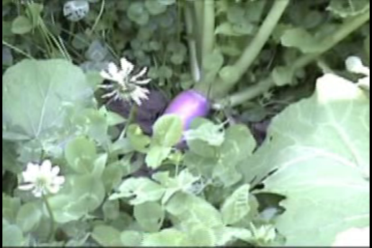
Figure 1. A fodder turnip planted into the grazing sward.
Nutritional Benefits of Grazing Brassicas
It is common to see brassicas included in pasture rotations in Northern European countries and New Zealand. Their high protein and energy, along with their low fiber content, make them a good fit for cooler season grazing. When Northeastern grazing farmers were asked about whether they used brassicas the response was that many had used them as a catch crop when reseeding a pasture back to a pasture sward. Farmers were impressed by the forage quality yet they did not use them regularly. Many of the farmers questioned had only used them once. The reason given was that the cost of tilling and planting did not justify the one season of feeding the brassicas provided.
The idea of introducing brassicas into existing stands through no-till methods would allow a cheaper way to capture brassicas’ nutritional benefits without the cost of establishing them through tilling. Initial field studies completed by the author in 2012 showed spotty, random establishment within the pasture planted through this method. The areas that were successful included “cow paths” where the pasture sward was reduced. In 2013, the practice of burning the pasture sward with 20% acetic acid in 3 inch bands at the time of planting would help reduce pasture sward competition and produce a more uniform population. Results were still spotty. In 2014 the SARE and NIFA funded project sought to include the planting of Daikon Radish as one of the brassicas. It was theorized that pasture soil compaction could be addressed at the same time as the benefit of higher nutritional forage. To improve the competition of the brassicas, fertilizer would be banded along with the no-till seeding of three different types of brassicas: “Graza”, a turnip - kale cross. “Winifred ‘, a leafy turnip, and the Daikon or “Bio-drill Radish”.
Figure 2. “Winifred” Leaf Turnip left of measuring tape and “Graza” Turnip/Kale cross on right.
Results of No-tilling into Existing Pasture
The field studies completed in 2015 included the most extensive measures to improve the populations of brassicas in the grazing sward through no-till planting: Precise seeding depth of ¼ to ½ inch. Planting rates varied from 5 lbs/ac for the smaller seed varieties (Graza and Winifred) and 10 lbs/ac for the larger seed (Daikon). Banding of either Chilean Nitrate (donated by Allganic) or organic poultry compost (donated by Kreher Poultry) was done to provide 10% of their required Nitrogen, and burn-down of the sward was administered with 10% acetic acid at 20 gallons/acre. The populations and uniformity results were better than other tests but still did not provide a uniform population that could be recommended to farmers.
The plots were distributed over a 6 acre paddock area. The area had seen 3 previous grazings and received up to 3 additional grazings after planting. During the three grazings prior to the planting the soil was soaked with unseasonable high rainfall to the point that the cows left hoof prints any place they stood for long, such as around the feeder or water tank. The grazing sward was killed in these areas. Without the brassica planting these areas would have remained bare for the rest of the season and most of the next season
Daikon Radish for Soil Compaction Remediation
The author’s custom grazing operation is home to 80 bred dairy heifers during the grazing season. As mentioned, the 2015 season included a wetter than average spring and an early summer followed by dry periods in the early fall. Pasture is the only feed during this time so daily grazing is mandatory. The herd is moved to a new paddock each day to reduce compaction and improve grazing efficiency. A mobile feeder is moved to each new 1 acre paddock with the heifers. It contained 2 molasses mineral lick tubs, salt blocks and fly control rubs. Even with the daily and sometimes twice daily moves of the feeder, the animals’ compaction during the wet times created bare spots in the paddock. In the 6 acres of the brassica trial fields there were 6 bare areas. The brassicas grew uniform and robust. The brassica planting provided forage during the rest of the grazing season and in the case of the daikon it also helped reduce compaction through the growth of its tuber.
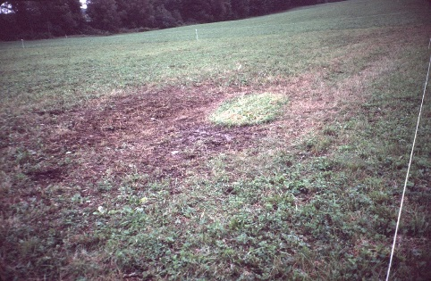
Figure 3. Compacted area after mobile feeder was moved.
The daikon radish grew well either with fertilizer or without, probably due to the increased amount of animal waste deposited from the time the animals spent in the compacted area. The largest daikon turnip grew in an unfertilized area close to a water tank. This is another area where compaction killed the existing pasture sward. (Figure 4) The radish was dug up to determine how far into the compacted area it grew. The tap root broke off at 24 inches. (Figure 5)

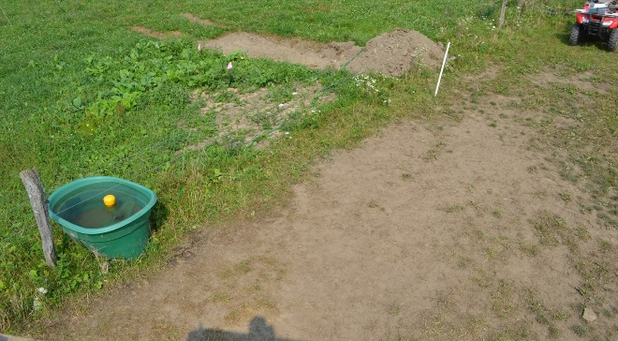
Figure 4. Compacted area around water tanks are another place Daikon Radish can improve soil health.

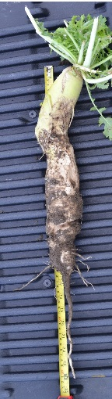
Figure 5. This 24+ inch Daikon Radish grew in the unfertilized portion of a highly compacted area next to the water tank above.

Conclusion
Establishment of brassicas into existing sod through no-till methods does not provide reliable results. Only if the sod is killed prior to the planting is there a chance at establishing a uniform population in a pasture. From the field studies done by the author, brassicas cannot compete with a healthy cool season grass pasture. They do grow well in areas where the existing sward is killed through prolonged compaction by livestock such as around feeders or water tanks. As a means to improve soil compaction the Daikon turnip is higly effective and should be studied to measure whether a simpler method without the use of a drill could be recommended.

References
- E-Organic Webinar on this project. Recorded 12/4/2014. https://www.youtube.com/watch?v=fOAI5NV-N3I

- Aricom website. Australian seed company, http://agricom.com.au/products/brassicas/forrage-brassicas/winfred-/

- UDSA, NRCS Fact Sheet on Daikon Radish, http://plants.usda.gov/factsheet/pdf/fs_rasa2.pdf

Cornell Cooperative Extension, 60 Central Ave, Cortland, NY, (607)-391-2660, afb3@cornell.edu

