Building a Better Honeybee
Terry Shanor, a beekeeper from Butler County, sports his favorite shirt at the annual picnic of the Pennsylvania State Beekepers Association. A co-op of beekeepers in the region are trying to breed tougher honeybees that can survive cold winters and fight back against parasitic mites. Photo: Lou Blouin
inShare1
August 21, 2015
Beekeepers have plenty of tough days. But urban beekeeper Steve Rapaski is not having one of those today.
“My mouth is full!” Rapaski shouts, barehanding fistfuls of honey from one of his rooftop bee colonies. “We’re eating honey that is fresh from the hive. And it’s so delicious."
Rapaski has about a hundred colonies in and around Pittsburgh, but he actually hasn’t been around to check on this hive in a month. And now, the bees, which should have been storing their honey neatly on wooden frames have instead built a crazy jagged, mini-mountain range of foot-tall honeycomb inside an empty bee box.
“The good news is that it’s what we call fresh cut-comb honey. But it’s what we call a major screw-up by a beekeeper that should have put frames in there a month ago,” Rapaski says, laughing.
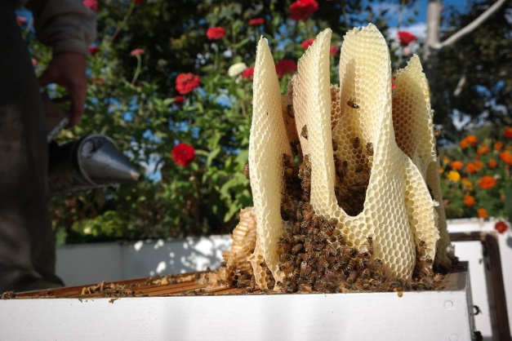
Typically, beekeepers insert rectangular wooden frames into bee hives so that bees will store honeycomb neatly inside the hive. As urban beekeeper Steve Rapaski found out, this is what happens when you forget the frames: The bees will build a free-form comb inside the empty box, much like they would do in the wild in hollow trees. Photo: Lou Blouin
As far as screw-ups go, it’s not really a big deal. But beekeepers aren't really allowed a whole lot of real screw-ups these days. It’s become a very tricky business to keep bees alive. And not because of colony collapse disorder, which scientists haven’t really seen as much of in recent years. In fact, the main thing wiping out honeybees is actually a parasite that’s been a plague since the 1990s.
“In 1997, we had the introduction of varroa mite,” says Penn State bee researcher Maryann Frazier. “It’s a parasitic mite that feeds on the blood of adult bees and on the brood. It also transmits virus and it suppresses the immune system of the bees.”
And it’s basically like having a six-pound house cat attached to your side, sucking the life out of you. These mites wiped out colonies across the world. And treatments were, and still are, pretty limited. In fact, the way most beekeepers treat bees for mites sounds a little crazy: They actually spray bees—which are, of course, insects—with low-dose insecticides. The hope is they’ll kill the mites, but not the bees.
“But you can imagine how difficult it is to control a mite on a bee with a pesticide,” Frazier says.
Still, the strategy has worked well enough to at least give colonies a fighting chance. But a co-op of about a hundred beekeepers stretching from Michigan to Tennessee is trying a different approach. On his farm near Slippery Rock in western Pennsylvania, beekeeper Jeff Berta lights a smoker to check on one of his all-star queens bees—a queen he says could be the future of honeybees in Pennsylvania.
“No. 18, there,” Berta says, pointing to a queen with a little florescent yellow tag on it. “That little disc there with the ‘18’ on it, we call those our NASCAR bees because they have numbers on them.”
No. 18 is bit of a science experiment, funded with money from the USDA. This queen’s mother is from a Vermont colony that survived disease and cold winters. And then Berta had her artificially inseminated by Purdue University scientists who were raising bees that demonstrated a unique, mite-fighting grooming behavior.
“The bees will take the mite and they will bite the legs and will chew on the mite,” Berta says. “And if they bite a leg off of the mite, the mite will bleed to death. So the bees are actually fighting back. That’s the type of genetic line we’re after right now.”
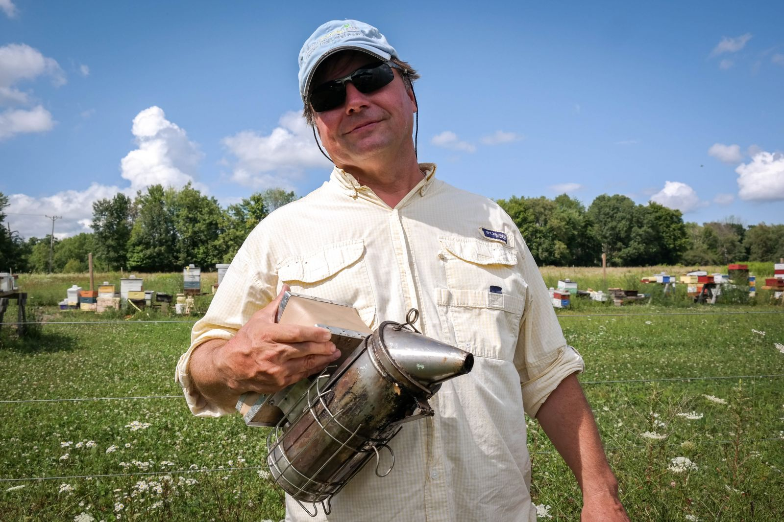
Bucking the paradigm in the beekeeping world, beekeeper and breeder Jeff Berta doesn't use pesticides to control mites on his honeybee colonies near Slippery Rock, Pennsylvania. Instead, he breeds bees that have natural grooming behaviors that keep colonies free of mites.
So now with every egg No. 18 lays, she passes on those leg-biting behaviors—making a colony that can rid itself of mites naturally, with no help from pesticides. It’s a huge breakthrough. But the breeding project can’t end there. Because Berta can’t artificially inseminate every queen, any descendants of No. 18 that turn into queens themselves will likely just fly off and mate with any old drones within a few miles. Meaning, if Berta’s beekeeping neighbors don’t have strong bees too, they can easily dilute his carefully selected lines.
"So, you can’t produce a stock and say, Now I’m done! And that was it! Now we can sell it everywhere!” says Penn State bee geneticist Christina Grozinger, who works with Berta. “You have to constantly reselect and constantly have to have people very interested in working as part of this effort.”
That’s why Jeff Berta and the co-op of beekeepers happily give eggs from their best colonies to their neighbors and swap queens to try out new genetics. It’s all part of shifting the paradigm from a system where beekeepers simply buy new bees every year, to a lasting neighborhood of bees that can slowly create real survivors.
“There really isn’t any bee that laid the golden egg,” Berta says. “Genetics with honeybees is more like a river, and the river is always changing.”

