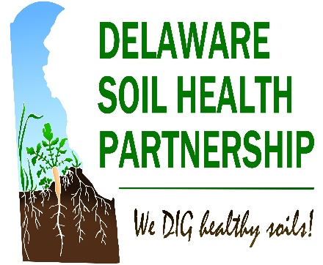
DE Soil Health Partnership

Leadership Workshop
  - November 1, 2017
  - DSU Farm in Smyrna
Goals:
- Educate planners, board supervisors and farmers about soil health management principles & benefits
- Show what farmers are doing and ID their interests/needs in improving their soil health
- Review the structure for the Delaware Soil Health Partnership & develop outreach plan(s) for the three counties for 2018-2019.

Self-Guided Field Tour
Available at breaks throughout the day & lunch
9:00 – 9:15 | Welcome & Introductions  - Brooke Jones & Jason Challandes
9:15 – 10:15 | Soil Health 101 & Demonstration  - Jen Nelson & Jayme Arthurs
10:15 – 10:45 | Compaction: Public Enemy #1  - Phil King
10:45 – 11:00 | Break
11:00 – 11:45 | Farmer Panel  - Brandon Bonk, Chris Wyatt, Aaron Thompson  - Moderator: John Bushey
11:45 – 12:30 | Lunch  Self-guided Field Tour
12:30 – 1:15 | - We Dig Healthy Soils! Building a Successful Program in Your District  - Debbie Absher & Jen Nelson
1:15 – 3:45 | Planning Session  Establishing goals, identifying a partnership structure and drafting an outreach plan for 2018/2019. (Include a 10-minute break around 2:30.)
3:45 – 4:00 | Wrap Up & Next Steps

We would like to know how you use information learned today in your programming and what farmers are implementing. To provide this or for questions about future programing, please contact Jason Challandes, Regional SARE Coordinator, at jchallandes@desu.edu or (302) 388-2241.

