SEED QUALITY HANDBOOK for NORTHEAST SEED PRODUCTION

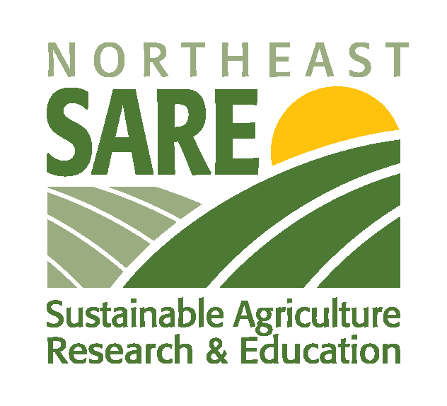
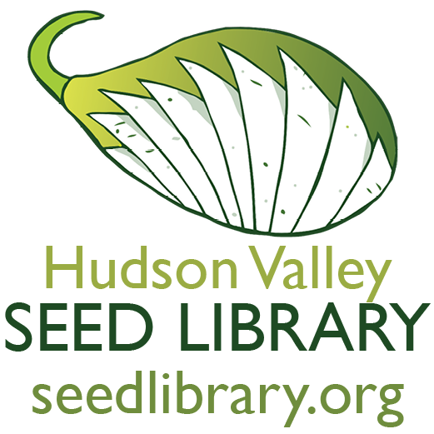

PROJECT SUMMARY

Northeast Grown Seed
Over the past ten years we've seen an incredible resurgence in consumers’ and farmers’ awareness around seeds. Farmers and gardeners are interested in growing with regionally produced and adapted seeds. At the same time, more and more growers of all kinds are experimenting with producing their own seeds. Some are doing it to create a more reliable seed source for themselves, others are getting into seed saving to improve varieties for flavor, disease resistance, or adaptation to their farm, and still other farmers are producing seed to share freely or sell to small regional seed companies. Across the country we've seen hundreds of community seed libraries and dozens of small regional seed companies sharing and selling locally grown seeds. And while anyone with a garden can save seeds—and there are excellent resources to help growers learn the basics of seed-saving—it takes care, knowledge, and experience to produce seed of high quality.

As one of the pioneers of regional seed production in the Northeast and a seed company sharing seeds throughout the Northeast and beyond, we wanted to find out how we were doing. Were we producing the highest quality seeds possible on our farm? Were produce farmers growing one or two varieties of seed for us or themselves sharing high-quality seed? How could we find out? We applied for a SARE grant as part of our efforts to ensure that we are producing high-quality seed as well as to help other growers in the Northeast become more aware of the importance of seed health and gain the skills necessary to produce healthy seed.

Grant Summary
This SARE-funded research and education project is part of the Hudson Valley Seed Library’s greater mission to increase the sustainability, independence, interdependence, and profitability of farms by developing a regional seed economy in the Northeast. Seed health and quality is one of the most challenging concerns facing small-scale diversified farmers trying to produce seed to save, share, or sell. Many diseases and other plant health issues are regionally based; here in the Northeast, we have a particularly challenging climate for growing seeds. Additionally, with proximity to lucrative local and regional markets of sophisticated eaters, many local growers interested in producing seed struggle to incorporate seed production into their growing plans in a way that does not disrupt their normal farm business activities. More research and education is needed to ensure that anyone interested growing seed in the Northeast does so with the skills required to produce quality seed. Ultimately, the goal of the SARE grant was to increase the availability of regionally grown and adapted seed while ensuring that small-scale seed growers are producing the healthiest seed possible.

Project Methods and Participants
Eight farms participated in this grant including the Hudson Valley Seed Library seed farm. We focused on varieties that were currently commercially unavailable as regionally grown and/or unavailable certified organic. Participating farmers came to the Hudson Valley Seed Library farm for monthly trainings and sent in reports on their seed crops. All seed crops were evaluated and tested for health and disease during the Growth Stage. The harvested seeds were also tested for seed coat and seed-borne diseases. Based on the participating farmers’ experiences, questions, and the results of the tested seeds, we've created this brief handbook as an introduction to managing seed health in the Northeast.

Results
The most important result that came out of the grant was the discovery that there were actually very few seed quality issues when growers followed the training protocols. That's good news for Northeast-grown seed! There were a few crop failures unrelated to seed health including a deer break-in and feast, an overworked farmer, and focus on income-producing crop over seed crop. Despite a challenging damp growing season and some plant health issues at the Growth Stage, 16 out of the 17 plantings produced high-quality seeds. In the rest of this handbook, we'll cover the basics of the conditions that can lead to poor-quality seed and what you can do about them.

SEED QUALITY

What is High Quality Seed?
When we conceptualized this grant, one of the main questions we wanted to answer was whether or not seed grown in the Northeast is high-quality compared to seed grown in regions with fewer moisture and disease pressures. Additionally, we wanted to know if there was a difference between seed produced on diversified vegetable farm operations and seed grown on dedicated seed farms.

To answer these questions we first had to define what makes seed high-quality. High quality seed is seed that has a high viability, good vigor, and has no seed-borne diseases.

Terms that Define High-Quality Seed

Viability: The ability of seeds to germinate under normal conditions.
Testing: Germ Rate. This can easily be done on the farm.

Vigor: Properties such as root growth, leaf set and more which determine the potential for rapid uniform emergence and development of normal seedlings under a wide range of field conditions.
Testing: Evaluate root set and size, leaf set and timing. No one test determines vigor. Some of these tests can be performed on farm but most are done by labs.

Disease: Bacteria, fungi, and viruses that cause damage to or kill plants where the primary vector is insect, soil, wind or other external factor.
Testing: Plant materials can be tested by any plant pathology lab during the course of the growing season. Pathologists examine the plant matter using plain sight and microscopes and make diagnoses based on these observations.

Seed-Borne Disease: Bacteria, fungi, and viruses on the seed coat or in the seed where the primary vector is the seed itself.
Testing: Seed testing is done by only a handful of labs throughout the country. These tests are very expensive, as the labs must germinate and grow out the seedlings in sterile environments in order to test for symptoms of disease in the seedlings (the sterile environment ensures that any disease found must have arrived by way of infected seed).

What can Affect Seed Quality?
The next factor we needed to define was what can affect seed quality. We focused on two main vectors: seed production knowledge and plant health.

Seed Production Knowledge
A big part of producing high-quality seed is knowing the basics of seed saving. As part of the SARE grant, participating farmers received monthly trainings on all aspects of seed growing. See the reference section for a list of resources to learn about good seed-growing practices, as this handbook will focus primarily on seed quality and is not meant as a comprehensive seed-growing guide.

Plant Health
There are two main interrelated categories to think about when it comes to plant health as it affects seed quality: Growth Stage issues and Seed Stage issues. Although most farmers are able to recognize unhealthy plants during the seedling to harvest stages, growing for seed means caring for the plant through its entire life-cycle, often well beyond the harvestable stage. The number one rule to follow for producing high-quality seed is to always save seeds from the healthiest plants. Healthy, vibrant, vigorous plants are able to transfer the most energy and nutrition into their seeds. These well-fed seeds last longer in storage, have a high germ rate, and produce healthier plants the next season. Beyond this, the causes of poor seed quality can occur at any stage of seed growing, harvest, and storage.

Growth Stage
Growth Stage concerns occur during the seedling and initial growth stages of a plant, which sometimes includes the flowering and edible harvest part of the plant's life-cycle. How you manage the environmental growing conditions including weather, pests, humidity, and endemic diseases affects the seeds. Most of the practices for growing high-quality seed during this stage are the same as best practices for food production. Good agricultural practices including seed starting, timing, watering, plant spacing, soil nutrients, pest management, weeding, and protection from the elements will help produce good seed.

Practices during the Growth Stage that ensure healthy, high-quality seed include:
- Rogueing out off-types and/or plants that perform poorly in your conditions.
- Increasing plant spacing to ensure enough soil nutrition for their longer life-cycles and larger size—and ensuring plenty of air-flow around each plant, important in our usually wet and humid Northeast growing season.
- Paying close attention to the necessary minimum population size for a given variety.
- Isolating varieties to prevent cross-pollination.

Seed Stage
Seed Stage issues refer to the practices involved after the Growth Stage. In some cases, this is in a fruiting plant (like summer squash), which has already flowered and has ripe fruits, and in other cases this starts just before the flowering stage that comes after the normal harvest time (like lettuce). The final parts of the seed stage that can affect seed health are cleaning, drying and storage. If you are saving seeds from the healthiest plants, using good management practices at the Growth Stage, and have the basics of seed saving under your belt, you're in good shape.

Practices during the Seed Stage that ensure healthy, high-quality seed include:
- Leaving seeds to mature on plants as long as possible (in the field or drying under cover).
- Cleaning harvested seeds of all organic matter.
- Drying seeds in well ventilated area.
- Waiting until seeds have dried completely before putting into containers for storage.

No matter the management or environmental challenges, with increased awareness of seed health indicators before, during, and after growing, high-quality seed can be produced in the Northeast. However, there are factors that can cause plants that look healthy at the Food and Seed Stages to produce poor-quality seeds. In order to understand these signs and risk factors, it's important to understand how diseases affect plants.

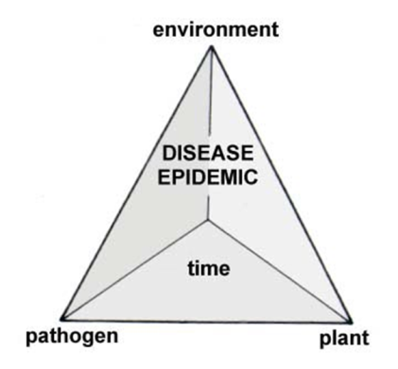
PLANT DISEASES

Disease Basics
Growing healthy, disease-free seed crops begins with a basic understanding of plant diseases, how plants become infected with disease, and what other factors play a role in disease development. There are three main sources of plant disease: bacteria, fungi, and viruses. The presence of one or more of these pathogens is obviously necessary for plants to develop disease, but three other factors—the environment, a susceptible host plant, and time—play an important role in the degree to which disease develops. Taken together, these factors are often called the disease pyramid. Successful growers use management practices at all points of this pyramid to prevent disease epidemics.

Bacterial, fungal and viral pathogens are all around us in the farm environment: in the soil and air; carried by insects; hosted by weedy plants. Many of the same strategies for growing healthy food crops such as good crop rotation, growing in tunnels and greenhouses, and quickly incorporating or removing infected plant debris. All work to reduce the number of pathogens in the environment and therefore also contribute to healthy seed production. Plant susceptibility to pathogen infection increases when plants are under stress. Maintaining good plant nutrition, adequate irrigation, preventing plant injury (where pathogens could gain entry) and controlling insect pests are all ways to increase plant resistance to pathogens. Abiotic factors—such as airflow, cold soils, and weather stress—also play an important role in plant health, and efforts to promote a low-stress temperature and exposure environment for the plant can impede disease development.

Once a disease has developed on a crop, the concern for seed growers is whether the pathogen will affect the seeds. The first step is to correctly identify the disease on the crop (we will discuss plant sampling later) and determine if the pathogen can be harbored in or on the seed.

How Disease Affects Seed Health
Non-Seed Borne Disease
Sometimes you hear about "crop failures" from seed companies as the reason a seed is not available. "Failure" is such a strong word and can make it sound like there's a hard and fast line to know when a seed crop has failed. But this subjective line between a sharable seed crop and a failed crop depends on the situation. The main factor in the determination of a failure is the reason why you are growing the seed.

Growth Stage seed crop failures include some obvious situations, like the deer break-in at Thresh and Winnow farm. If your plants are eaten, ravaged by pest or disease, trampled, frozen, or otherwise compromised before the Seed Stage—to the point where they can't complete their full reproductive lifecycle—then that's a pretty good indication you've got a crop failure. Or is it? Seed production is an adventure, especially here in the Northeast. If all of your squash plants were wiped out by Downy Mildew, except two, you might consider that a very successful seed crop if you're interested in breeding a more Downy Mildew resistant squash.

Seed-Borne Disease
Pathogens have three main ways to infect the seeds themselves: systemic infection occurs when a disease enters the vascular system of the plant (through roots or injury to plant tissue), penetration of floral parts, or through the wall of the ovary. Pathogens then either remain within the first few layers of the seed coat or make their way inside the seed to the developing plant embryo. Infected seed may or may not have a low germination rate. Seedlings may be infected or disease symptoms may not appear until seedlings have been planted out in fields resulting in widespread loss and possible introduction of the pathogen into the soil where it can exist for many years.

Seed Stage crop failures often involve moldy seed, seed that is not germ testing successfully, or seeds with serious seed-borne diseases. Again, you might want to toss all of these seeds into the failure category. If this is a non-commercially available seed, a rare family heirloom, or a breeding project, it is possible to use these seeds even though they are not saleable. Moldy or low-germ seeds can be re-cleaned and a few good seeds recovered, and seeds carrying certain diseases can be treated before planting.

DEALING WITH DISEASES ON ORGANIC SEED CROPS
Good Foundations Are Key
As part of this grant process we mentally prepared ourselves to see a range of seed quality issues. Our hope was that by focusing attention on seed production in our region, we would be able to expose any practices or diseases that lead to low-quality seed and find solutions to ensure high-quality regionally produced seed. The fact that there were almost no seed quality issues led us to the conclusion that with proper farmer training and responsible practices most seed quality challenges in our region can be overcome. Feedback from the grant participants highlighted that inspecting plants throughout the season for signs of disease, knowing about rouging, selection, and cross-pollination, and being aware of the weather conditions at the time of seed development is essential. In particular, recording these observations using forms available online from Organic Seed Alliance proved helpful when predicting potential seed health issues and determining if and when testing was necessary. (See Organic Seed Alliance resources.)

Plant Disease Identification
For seed production, it is particularly important to know if a disease can lead to poor quality seeds and especially if it can be seed-borne. Correct identification of the disease affecting a crop is essential for determining how to manage it—and for knowing whether it presents a risk to the seed crop. Many resources are available to aid in the identification of plant diseases, including local extension offices. For hard-to-identify diseases, sending in a plant sample to a diagnostic laboratory may be the only way to accurately diagnose a disease (see resource section for a listing of state diagnostic clinics).

Taking a Plant Sample: Each diagnostic laboratory may have different procedures to follow, but general sampling rules include:

  - Time sampling to avoid having the sample sit unopened over the weekend. Mondays and Tuesdays are a great time to sample!
  - Sample a plant that has early symptoms of the problem. A specimen with advanced symptoms may harbor secondary organisms that will obscure the primary pathogen.
  - The sample should contain all parts of the plant at its current stage: roots, shoots, leaves and fruit.
  - To pack: Wrap the sample loosely in an unsealed plastic bag and place it in a sturdy shipping container. Roots should be packaged separately. If sending material to a lab out of state, place plant material in paper or cloth bags first, then in two heavy sealable plastic bags (ex. Ziploc freezer bags).
  - Fill out submission form in as much detail as possible.
Seed-Borne Disease Testing and Treatment
Based on the results of our grant project, 10+ years experience growing seeds in the Northeast, and informal survey of other seed companies, we've found that most seeds do not harbor seed-borne diseases and not all seeds with disease present will transmit disease to the field. Because of this, not all seeds are tested for all diseases. The two factors that suggest a seed crop may need a seed-borne disease test are the presence of potentially seed-borne diseases at the Growth or Seed Stage and problems during the germination testing process.

Testing Seed
All seeds should be germ tested after processing and drying. Germ rates can help determine if a seed lot has been adequately cleaned of dead or low-germ seeds. This is a simple test to do on-farm (see resource page). If there are concerns about the health of the plants during any stage of their lifecycle, a combination of germ testing and vigor testing is called for.

If there are concerns based on field conditions during Growth Stage or Seed Stage about diseases that could be seed-borne, testing and treatment is recommended. If fresh, well-cleaned seed exhibits unexpectedly low germination or high volumes of mold during the germ test, this is another clue that a disease may be affecting the seed. (That said, seed that is fresh may not yet be damaged by a seed-borne disease it is carrying, so its germ rate may be just as high as any other seed lot. This is why monitoring at the Growth and Seed Stage is so important.)

Vegetable seed can be tested in a laboratory for pathogens. It can be expensive and require a large amount of seeds depending on what you are testing for. However, sample size and price can be less if you are not looking for official documentation of seed purity. A good place to start if you are interested in vegetable seed testing is the USDA Seed Regulatory and Testing Division. Private companies, such as Eurofin, also test for seed pathogens. (See Resource Page)

When contacting a seed testing laboratory you will need to provide them with the following information:

- Type and variety of seed
- Common and scientific name of the pathogen(s) for which you want to test. There are hundreds of pathogens that labs test for, so make sure to narrow down what you are looking for to the most prevalent and probable diseases that can significantly affect other growers you share seeds with.
- Available amount of seed (seed quantity or weight in grams)

Treating Seed Coat Diseases
This first step to preventing seed-borne diseases is proper processing, which for many crop types, such as tomatoes and most cucurbits, includes fermentation. Fermenting seeds is a foundational seed-saving practice for many crop types and kills a high percentage of any seed coat pathogens. The fermenting process is easy (though smelly) and can be done on-farm following instruction from the seed-saving and seed-production resources listed on the resource page.

Disease pathogens that are on the seed coat are treatable by application of anti-microbial commercial products. While this method can greatly reduce pathogens, it is rarely 100% effective, and these products are not OMRI listed.

Chlorine treatment will eliminate fungal and bacterial pathogens on the seed surface. It can be used on both large and small seed that will not be treated in any other way, and is in most cases acceptable to Organic Certification bodies (be sure to seek pre-approval beforehand).

Hot water baths can also be effective; these also treat interior seed diseases and are described in the section after next.

Treating Seed Coat Diseases with Bleach
Using a weak bleach solution to treat seed coat diseases is one of the few treatments allowed for organic seeds. It is easy to do and requires no specialized equipment. The process will reduce the prevalence of seed coat diseases but will not completely eradicate diseases. Use this method when hot water treatment is not available or for seeds that don’t respond to hot water bath treatment. If the solution is too strong or if seeds are left to soak for too long, this method can damage the seed coat and compromise seed quality.

Dry seed: Soak seed in a 5-10% bleach solution for 5-10 minutes then re-dry on screens.

Wet seed: Add bleach to final wash during wet seed cleaning or soak after cleaning before drying.

Treating Interior Seed Diseases
Disease pathogens that are inside the seed can cause infection as soon as the seed germinates and starts to grow. The primary treatment that is approved for certified organic farms that is effective for eradicating disease inside the seed is heat. If you are beginning with commercial seed, check with the company to see if the seed has been treated already—double treatment may kill the seed. It is important to note that seed company guarantees are nullified if you treat the seed. If you produced your own seed, keep in mind that seed will need to be retested for germination after hot water treatment, as some seeds may be killed by the process.

Hot Water Seed Treatment
This treatment will kill pathogens inside the seed as well as on the seed coat; however it requires precise temperature and time procedures and cannot be used for all crop seed. Ohio State offers specific protocol for chlorine and hot water bath treatments. Large seed, such as cucurbits, corn, peas, and beans, should not be treated in hot water. Most small seeds—tomato, eggplant, brassicas—can be hot water treated. Pelleted seed cannot be treated. While hot-water seed treatment can be done effectively on a stovetop, it is much better to use a precision water bath. Equipment and supplies needed for hot water bath treatment are listed in Chart 3. The temperature of water for treating seed varies from 118º to 125º F, depending on the crop, and the treatment period likewise varies from 15 to 30 minutes. Pre-heating seed at 100 F is recommended. (See Ohio State Factsheet in resources for full instructions.)

GUIDE TO PREVALENT PLANT DISEASES IN THE NORTHEAST
From Cornell Cornell Cooperative Extension of Ulster County

Non-Seed-Borne Diseases
There are more diseases in this category than we have space to list, so we have just included a few of the most damaging non-seed-borne diseases of the Northeast. Non-seed borne diseases on plants can affect overall seed quality. If the plant is not healthy during its lifecycle, it is less likely to produce fully mature, healthy seeds. When seeds don't get enough nutrients from a weakened parent plant they can have low germ rate or low vigor. Additionally, seeds harvested from disease-affected plants—especially fungal diseases that can cause rot—can become moldy when drying down. Use preventative disease control techniques while monitoring and caring for your plants as you normally would during the Growth Stage. Rogue out or don't save seeds from the most affected plants while saving seeds from the healthiest plants in the population. Here are ID photos of potential Northeast plant diseases to watch out for.

Downy Mildew (Pseudoperonospora) on Cucurbits  Yellow, angular leaf spots that are delineated by leaf veins develop on leaf surface; purplish/gray fungal growth will be found on underside of leaf. | 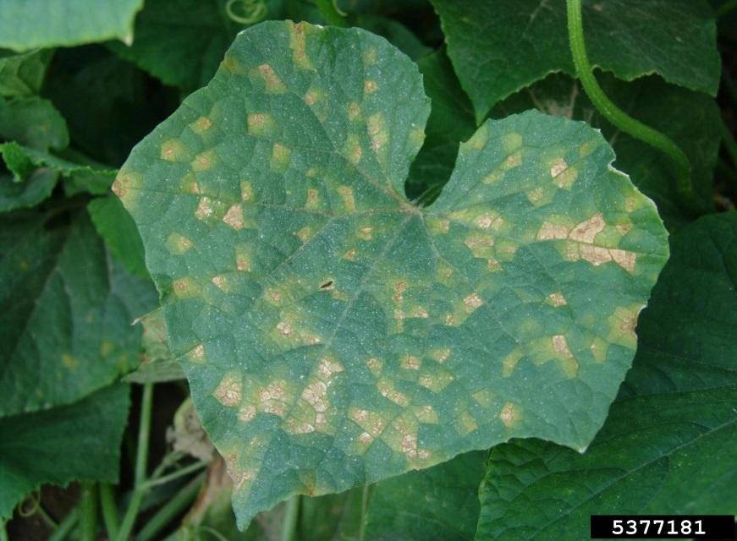
Phytopthora on Cucurbits  Fruit rot on summer squash characterized by concentric rings and white, yeasty fungal growth. | 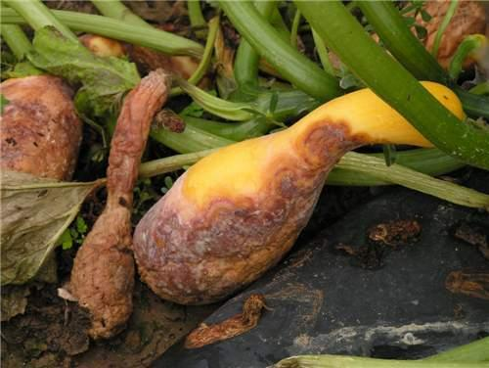
Powdery Mildew on Cucurbits  White, powdery growth may form on upper and lower leaf surfaces, petioles, and stems. Yellow spots may also develop on leaf surfaces opposite white fungal colonies on lower surface. | 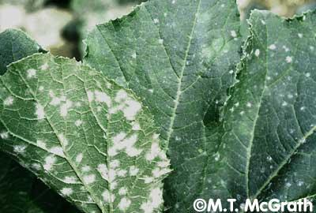
Cucumber Mosaic Virus  on Tomato  Shoestring-like leaf blades are the most common symptom; plants may also develop a mottled appearance. | 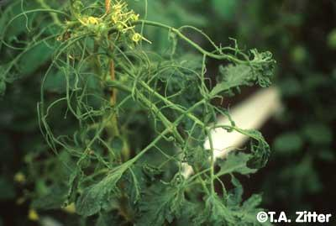
Aster Yellows on  Lettuce  Carried by leafhoppers, symptoms include yellowing of leaves, rosetting or abnormal, bushy growth, and veins that turn pale. | 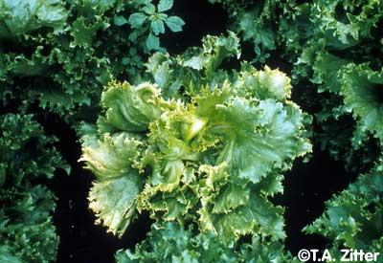
Late Blight (Phytophthora infestans) of Tomato  Photo: North Carolina State University  Late blight is spread by airborne spores during dry, windy breaks of wet seasons. Distinguished from Early Blight and Septoria by the uniformity of the water-soaked lesions that appear all over the plant. Cannot be cured but can be slowed by applications of organic or conventional fungicide. | 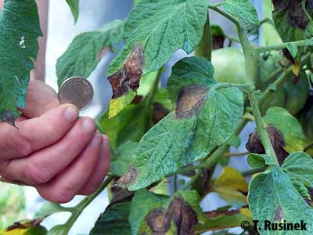

Seed-Borne Diseases
Unlike non-seed-borne diseases, when you have diseases with the potential to become seed-borne, you need to make a choice about the value of the seed crop and whether or not it is worth continuing seed production or treating harvested seeds. If only certain plants are affected by the disease, you can rogue out those plants, saving seeds from the unaffected plants. If the entire population is affected, you'll need to determine if it is a crop failure or if the plants are healthy enough to still produce seeds with high viability and vigor, and then test the seeds to treat them to reduce the chances of passing on the disease from year to year on your own farm or other farms.

Select Seed-Borne Diseases:
Here are select ID photos of Northeast seed-borne plant diseases to watch out for provided by Cornell Cooperative Extension of Ulster County. For a full list of seed-borne diseases, including if they are severe, intermediate, or minor, and what organic treatments are available, see the resource page at the end of this handbook for the excellent book The Organic Seed Grower.

Bacterial Spot (Xanthomonas) and Speck (Pseudomonas) on Tomatoes  Leaf symptoms of bacterial spot and speck are very similar: small lesions with a discrete yellow halo. Both diseases affect stems, petioles, flowers and fruit. Fruit symptoms are easier to distinguish- speck lesions are usually smaller and slightly raised, and do not crack or become scaly as with spot fruit lesions. | 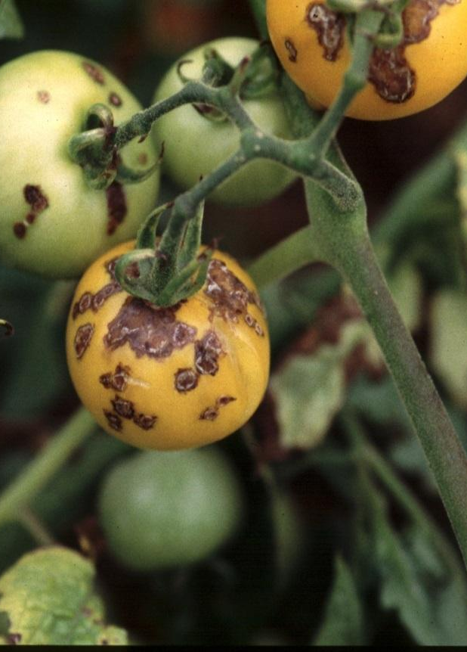  Bacterial Speck on Tomato  Photo: OMAFRA  Bacterial Spot on Tomato  Photo: JB Jones, Univ. of Florida
Bacterial Canker (Corynebacterium) on Tomato  Early symptoms of canker include curling of leaflets and browning of leaves, often only on one side of the plant. The vascular tissue of the plant shows yellowish/ brown discoloration. Fruit develops white, raised lesions with a dark center surrounded by a white halo. | 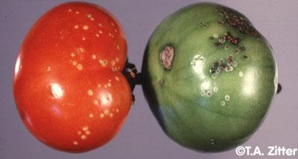
Septoria Leaf Spot on Tomatoes  Leaf lesions are gray or tan with a dark brown margin. Dark brown/black spots will be visible in the center of lesions when the fungus is sporulation. Lesions lack the target-like appearance characteristic of early blight. | 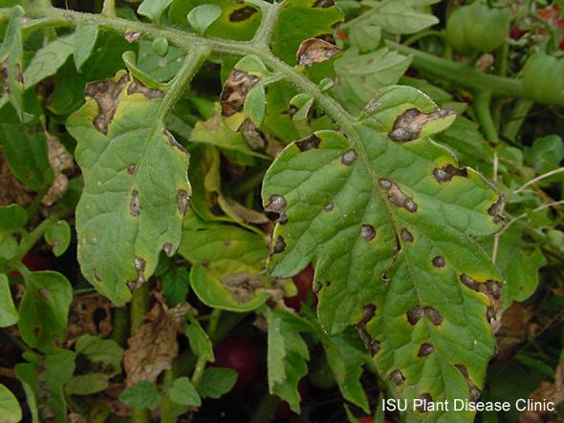
Leaf Spot (Cercospora) on beets, carrot, and celery  Small, circular leaf spots appear with tan to off-white centers and red borders. Lesions will enlarge, merge and turn gray as fungus sporulates. Symptoms may also occur on petioles, flower bracts, seed pods and seeds. | 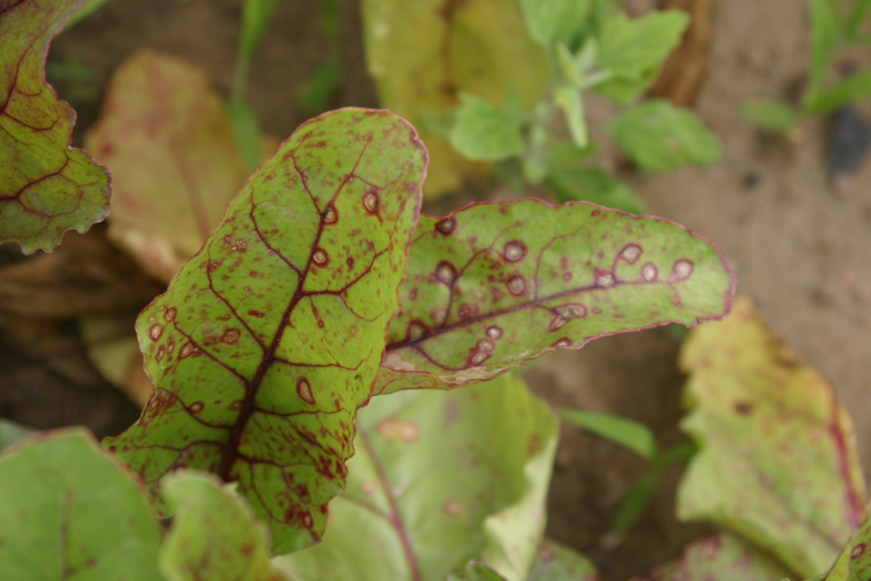  Photo: UMASS Anherst
Black Rot (Xanthomonas campestris) on crucifers  Infected tissue is first wilted and pale green, becomes yellow, then brown. Lesions are typically ‘V’ shaped and begin at the leaf margin. Blackened veins in stems and petioles can sometimes be seen when cut crosswise. | 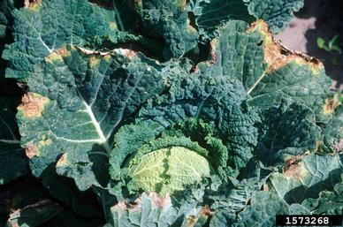  Photo: Gerald Holmes, Cal Polytechnic
Bacterial Leaf Spot (Xanthomonas sp.) on peppers  Leaf symptoms initially appear on the underside of leaves as small, water-soaked lesions. On upper surfaces, spots are depressed with a brown border and beige center. Eventually leaves yellow and fall off. Fruit symptoms are raised scab-like areas. | 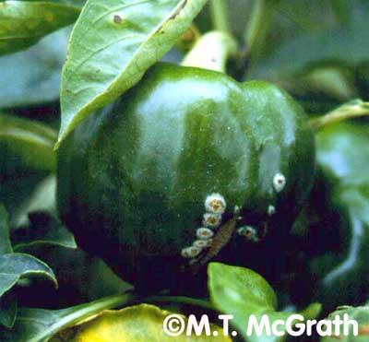
Early Blight (Alternaria solani) on Tomato  In the Northeast, it is a rare tomato patch that makes it through the season without contracting Alternaria. The fungus sporulates and spreads in warm, moist weather. Symptoms include concentric-circle lesions with yellowing on leaves. Dry weather halts disease progression. | 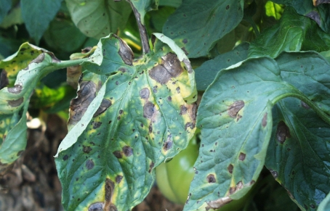

Participating SARE Grant Farms

Lineage Farm, Mixed Vegetable Production, Hudson, NY
Great Song Farm, CSA, Mixed Herb and Vegetables, Red Hook, NY
Poughkeepsie Farm Project, CSA, Poughkeepsie, NY
Long Season Farm, Winter CSA and Seed Production, Kerhonkson, NY
Thresh & Winnow, Seed Production and Education, South Salem, NY
Bonfire Farm, Mixed Vegetable and Herb, Troy, NY
Moon in the Pond Farm, Mixed Vegetable Production, Sheffield, MA
Hudson Valley Seed Library, Seed COmpany and Seed Farm, Accord, NY

RESOURCES:

Seed Production How-To

Organic Seed Alliance: seedalliance.org
OSA's website has an incredible diversity of resources for farmers interested in producing seed including seed production information by type, wet and dry seed processing instructions, and seed crop records to help evaluate and track seed health.

eOrganic: eorganic.info
eOrganic is the organic agriculture community of practice with eXtension. Our mission is to foster a research and outreach community, engage farmers and ag professionals through trainings and publications, and support research and outreach projects.

Breeding Organic Vegetables: A Step-by-Step Guide for Growers
by Elizabeth Dyck (Editor), Stacy Wakefield (Illustrator), Rowen White (Author), Bryan Connolly (Author)
This NOFA-NY / SARE book is a practical approach to plant breeding for farmers and gardeners. In addition to explaining basic plant breeding theory and methods, the authors cover all the necessary steps in a breeding project, from deciding on a breeding goal and finding suitable germplasm to performing selections and evaluations.

The Seed Garden: The Art and Practice of Seed Saving
by Jared Zystro (Author), Micaela Colley (Author), Lee Buttala (Editor), Shanyn Siegel (Editor)
Filled with advice for the home gardener and the more seasoned horticulturist alike, The Seed Garden: The Art and Practice of Seed Saving provides straightforward instruction on collecting seed that is true-to-type and ready for sowing in next year’s garden. In this comprehensive book, Seed Savers Exchange, one of the foremost American authorities on the subject, and the Organic Seed Alliance bring together decades of knowledge to demystify the time-honored tradition of saving the seed of more than seventy-five coveted vegetable and herb crops―from heirloom tomatoes and long-favored varieties of beans, lettuces, and cabbages to centuries-old varieties of peppers and grains.

Breed Your Own Vegetable Varieties: The Gardener's and Farmer's Guide to Plant Breeding and Seed Saving, by Carol Deppe (Author)
All gardeners and farmers should be plant breeders, says author Carol Deppe. Developing new vegetable varieties doesn't require a specialized education, a lot of land, or even a lot of time. It can be done on any scale. It's enjoyable. It's deeply rewarding. You can get useful new varieties much faster than you might suppose. And you can eat your mistakes.

The Organic Seed Grower: A Farmer's Guide to Vegetable Seed Production
by John Navazio (Author)
The Organic Seed Grower is a comprehensive manual for the serious vegetable grower who is interested in growing high-quality seeds using organic farming practices. It is written for both serious home seed savers and diversified small-scale farmers who want to learn the necessary steps involved in successfully producing a commercial seed crop organically.
Focus on disease Chapter 16

Hudson Valley Seed Library: seedlibrary.org
Northeast grown and adapted seeds, workshops, trainings, farm tours.

Disease Identification:
Cornell Vegetable MD Online http://vegetablemdonline.ppath.cornell.edu/
UMASS Disease ID Factsheets https://extension.umass.edu/vegetable/soil-crop-pest-management/diseases
State Cooperative Extension Educators are available to help identify crop diseases and interpret plant disease test results. Below are some contacts in the Northeast:
New York: Cornell Cooperative Extension:
Eastern New York Horticulture Team http://cdvsfp.cce.cornell.edu/
Western Vegetable Team http://cvp.cce.cornell.edu/
New Jersey Rutgers Cooperative Extension http://njaes.rutgers.edu/county/
UMASS Amherst Vegetable Program https://extension.umass.edu/vegetable/
Penn State Cooperative Extension Extension http://extension.psu.edu/counties

University of Connecticut Extension http://www.extension.uconn.edu/pa_foodSystems/

University of Vermont Cooperative Extension http://www.uvm.edu/extension/agriculture/

University of New Hampshire Cooperative Extension http://extension.unh.edu/Fruit-Vegetable-Production/Meet-Team

University of Maine Cooperative Extension http://umaine.edu/agriculture/

Plant Disease Diagnostic Labs in the Northeast:
New York http://plantclinic.cornell.edu/index.html
Plant Disease Diagnostic Clinic
Cornell University
334 Plant Science Building
Tower Road
Ithaca, NY 14853
(607) 255-7850
Connecticut www.ct.gov/caes
The Plant Disease Information Office
The Connecticut Agricultural Experiment Station
123 Huntington Street, P.O. Box 1106
New Haven, CT 06504
(203) 974-8601; (877)855-2237 toll-free outside New Haven area (toll free) 1-877-486-6271

University of Massachusettes http://ag.umass.edu/services/plant-problem-diagnostics
UMass Extension Plant Diagnostic Lab
101 University Drive, Suite A-7
Amherst, MA 01002
(413) 545-3208 fax: (413) 545-4385
University of New Hampshire
Plant Diagnostic Lab
Department of Biological Sciences
G37 Spaulding Hall
38 Academic Way
Durham, NH 03824
603-862-3200
http://extension.unh.edu/Problem-Diagnosis-and-Testing-Services/Plant-Diagnostic-Lab-Plant-Health-Program

University of Vermont http://pss.uvm.edu/pd/pdc/
Plant Diagnostic Clinic
201 Jeffords Hall
63 Carrigan Drive
University of Vermont
Burlington, VT 05405
(802) 656-0493
University of Maine http://extension.umaine.edu/ipm/ipddl/
UMaine Cooperative Extension: Insect Pests, Ticks and Plant Diseases
491 College Avenue
Orono, Maine 04473-1295
(207) 581- 3880

Penn State University http://plantpath.psu.edu/facilities/plant-disease-clinic
Plant Disease Clinic
Buckhout Lab
University Park, PA 16802
New Jersey: Rutgers University http://njaes.rutgers.edu/plantdiagnosticlab/
Plant Diagnostic Laboratory
Rutgers NJAES
P.O. Box 550
Milltown, NJ 08850-0550
(732) 932-9140

Contact information for USDA Seed Testing Division:
Sandra Walker, Plant Pathologist
Seed Regulatory and Testing Division
801 Summit Crossing Place, Suite C
Gastonia, North Carolina 28054-2193
704-810-7268 - lab 8887
sandra.walker@ams.usda.gov

Contact information for Eurofin Labs:
Eurofins STA Laboratories California
7240 Holsclaw Road
Gilroy, CA 95020
Tel: +1 408 846 9964
Fax: +1 408 846 9954
stacalinfo@stalabs.com www.stalabs.com

Hot Water Bath Guidelines: Ohio State Fact Sheet:
http://ohioline.osu.edu/hyg-fact/3000/3085.html

