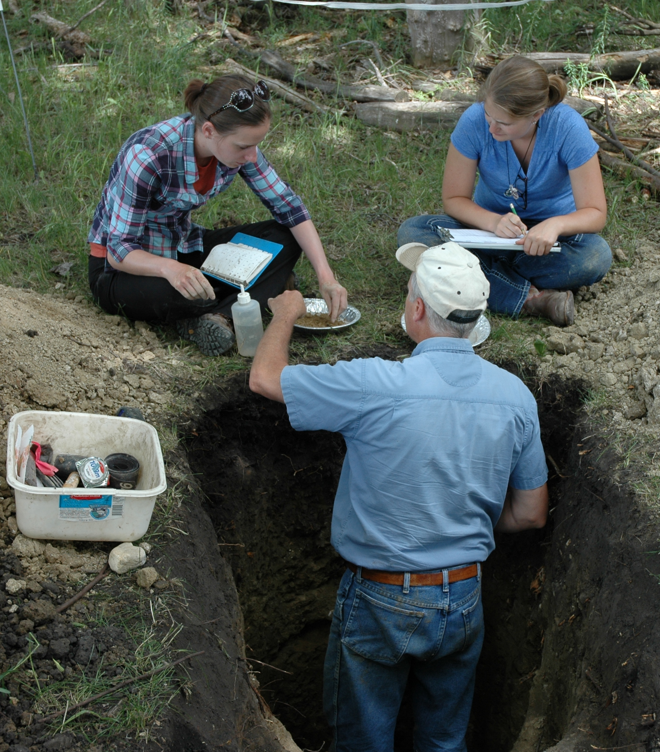

Figure 1. Soil profile in osage orange hedgerow near McPherson, KS (left), NRCS soil scientist and students preparing a soil profile description near Milnor, ND (center), and soil profile in pasture showing former badger burrow near Corsica, SD. Depths are in cm.

