2017 Cover Crop Survey - Schoharie Valley Farms
October 19th 2017, 9:57 am MDT
Q1 - What is the main type of cash crop on your farm? (if growing more than one, please indicate within your circle a 1 for greatest acreage, 2 for second most and so on)
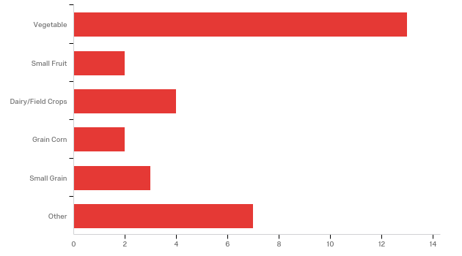

# | Answer | % | Count
1 | Vegetable | 41.94% | 13
2 | Small Fruit | 6.45% | 2
3 | Dairy/Field Crops | 12.90% | 4
4 | Grain Corn | 6.45% | 2
5 | Small Grain | 9.68% | 3
6 | Other | 22.58% | 7
 | Total | 100% | 31

Other
Other
no farm
pasture
tree fruit
beef/rotational grazing
garlic
garlic
3 acres veg, 1/4 acre flowers

Q2 - Please indicate the size of your current farming operation?
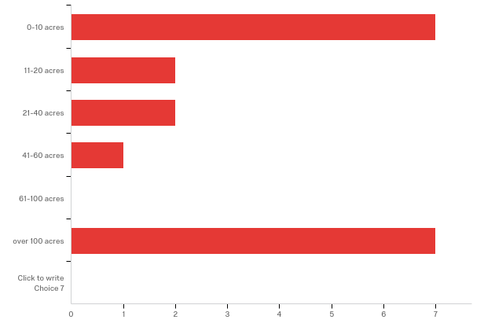

# | Answer | % | Count
1 | 0-10 acres | 36.84% | 7
2 | 11-20 acres | 10.53% | 2
3 | 21-40 acres | 10.53% | 2
4 | 41-60 acres | 5.26% | 1
5 | 61-100 acres | 0.00% | 0
6 | over 100 acres | 36.84% | 7
7 | Click to write Choice 7 | 0.00% | 0
 | Total | 100% | 19

Q3 - How often would you say you cover crop?
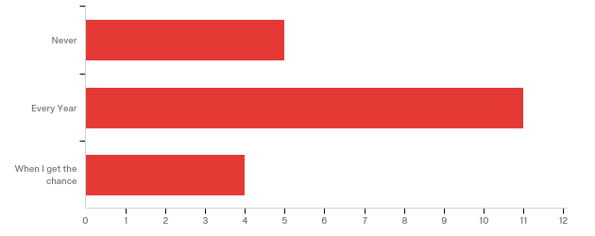

# | Answer | % | Count
1 | Never | 25.00% | 5
2 | Every Year | 55.00% | 11
3 | When I get the chance | 20.00% | 4
 | Total | 100% | 20

Q4 - How often would you like to cover crop?
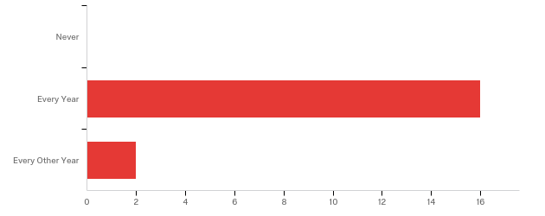

# | Answer | % | Count
1 | Never | 0.00% | 0
2 | Every Year | 88.89% | 16
3 | Every Other Year | 11.11% | 2
 | Total | 100% | 18

Q5 - What percentage of acreage mentioned in question 2 do you try to cover crop?
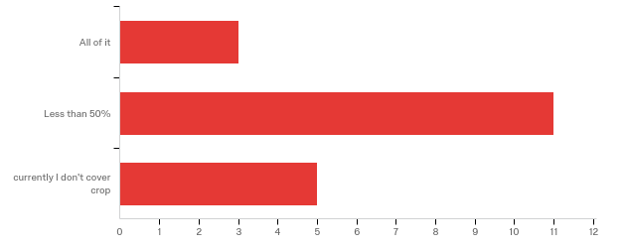

# | Answer | % | Count
1 | All of it | 15.79% | 3
2 | Less than 50% | 57.89% | 11
3 | currently I don't cover crop | 26.32% | 5
 | Total | 100% | 19

Q6 - If you currently are cover cropping, which season do you plant most of your cover crop?
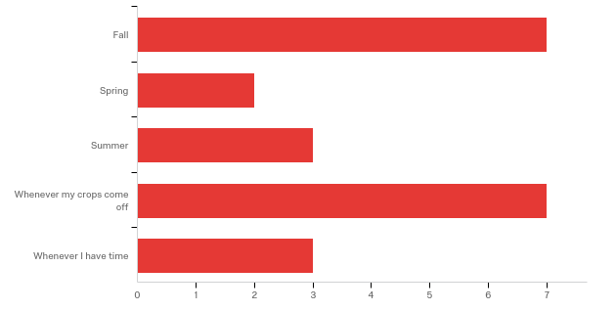

# | Answer | % | Count
1 | Fall | 31.82% | 7
2 | Spring | 9.09% | 2
3 | Summer | 13.64% | 3
4 | Whenever my crops come off | 31.82% | 7
5 | Whenever I have time | 13.64% | 3
 | Total | 100% | 22

Q7 - If you had to pick one reason why you don't cover crop what would it be?
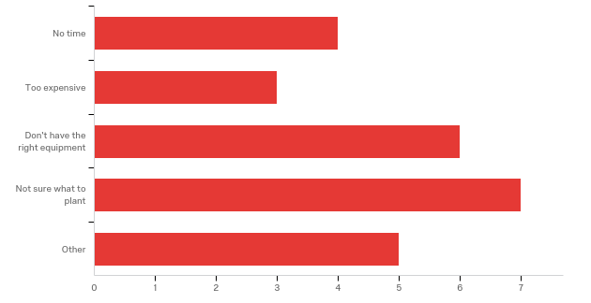

# | Answer | % | Count
1 | No time | 16.00% | 4
2 | Too expensive | 12.00% | 3
3 | Don't have the right equipment | 24.00% | 6
4 | Not sure what to plant | 28.00% | 7
5 | Other | 20.00% | 5
 | Total | 100% | 25

Other
Other
start up farm
not enough land to give to it
no till seeder - timing enough time in fall for cover crops to establish well
we harvest garlic in july & august - i would like more direction in how to cover crop in this system
wireworm issues in potatoes, white cabbage butterfly population big enough with more, Brassicas

Q8 - How satisfied were you with the information provided at this meeting?
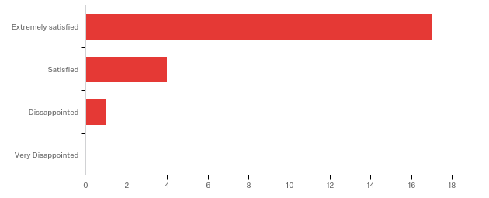

# | Answer | % | Count
1 | Extremely satisfied | 77.27% | 17
2 | Satisfied | 18.18% | 4
3 | Disappointed | 4.55% | 1
4 | Very Disappointed | 0.00% | 0
 | Total | 100% | 22

Q9 - Which part of today’s meeting did you gain the most knowledge from?
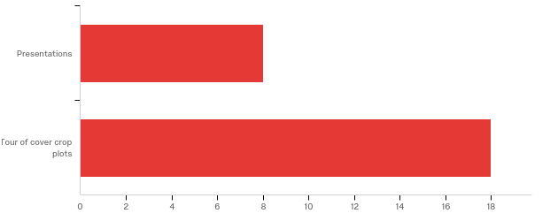

# | Answer | % | Count
1 | Presentations | 30.77% | 8
2 | Tour of cover crop plots | 69.23% | 18
 | Total | 100% | 26

Q10 - From the information presented at this meeting what changes might you try:
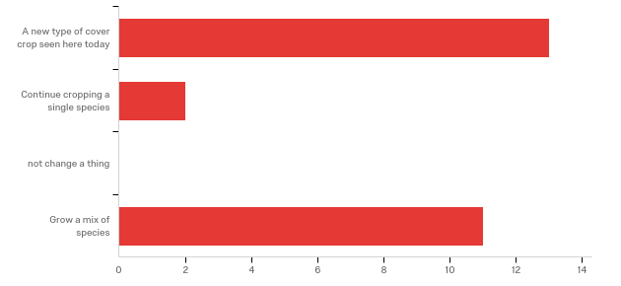

# | Answer | % | Count
1 | A new type of cover crop seen here today | 50.00% | 13
2 | Continue cropping a single species | 7.69% | 2
3 | not change a thing | 0.00% | 0
4 | Grow a mix of species | 42.31% | 11
 | Total | 100% | 26

Q11 - Will you try to increase the amount of cover cropping on your farm based on some of today’s information?
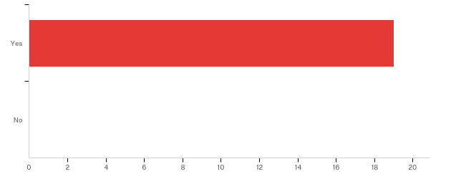

# | Answer | % | Count
1 | Yes | 100.00% | 19
2 | No | 0.00% | 0
 | Total | 100% | 19

Q12 - Was there information missing that you would have liked to have seen? If so, what is it?

Was there information missing that you would have liked to have seen? If s...
no
more for animal ag
mixes for different systems
using cover crops in organic min till systems (roll&crimp)
more on effects of compost tea on crops
sources of cheap seed
can you use these cover crops for grazing or early harvest forage?
more specific options (and reasoning) of cover crop mixes, when specifics were just mentioned off hand it wasnt helpful
radish, ryegrass
we need to connect with a cover crop specialist
more on cover crop plantings after fall crop, not just fall, summer timing and performance. more on actual feasibility of reducing (no) tillage of veggies- what research is being done, what current barriers are, which cover crops work with it? (emphasis is on reducing tillage in the workshop)
The perspective of a small organic veg operation would have useful
Tissue test to see which crop picked up micro's better

Q13 - Which cover crop(s) did you find the most interesting and would like to see more information on?

Which cover crop(s) did you find the most interesting and would like to see...
tillage radish mix with grasses
cool season
ones that could be grazed
canolas, barley mixed with vetch
interseeding corn
soil pit, soil compaction probs
clover, rye, radish mixes
fall mixes where some crops are winter hardy & some are not. intercropping for more than just corn
Daikon radish, medium red clover - a cover crop needed for our garlic situation. Probably need more info on buckwheat
no till/ winter kill
More ideas on what the best cover crop mixes include
clovers
sweet clover/radish

Q14 - Was this meeting what you expected?
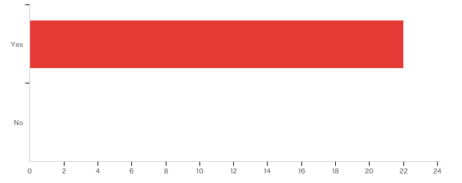

# | Answer | % | Count
1 | Yes | 100.00% | 22
2 | No | 0.00% | 0
 | Total | 100% | 22

Q15 - Would you attend a similar meeting in the future?

# | Answer | % | Count
1 | Yes | 100.00% | 22
2 | No | 0.00% | 0
 | Total | 100% | 22

Q16 - Did this meeting impact your operation at home?
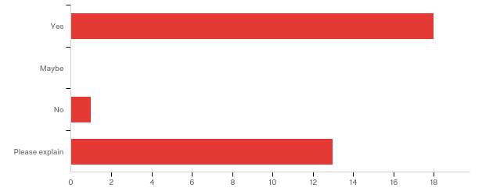

# | Answer | % | Count
1 | Yes | 56.25% | 18
2 | Maybe | 0.00% | 0
3 | No | 3.13% | 1
4 | Please explain | 40.63% | 13
 | Total | 100% | 32

Please explain
Please explain
more soil heath considerations
work paid
meeting was even better than expected!
increase different varieties
i will use cover crops to break soil pan rather than subsoil
near mixes of cover crops to try
i now have slightly more info on which to bare my cover crop decisions at home
more likely to cover crop!
Recognize the need for a cover crop and was intrigued by the interseeding
Im an ag educator in CCE & want to do no till workshop with dairy in our area. EXCELLENT farmer panel!
encourage soil health practices
I will try to move from singe species cover crops to mixes and try interseeding
I think you could pay for a radish seeding by picking some of the crop for sale

