Table 1. Biomass of sunn hemp generated for each trial.

Trial (Location) | Planting period | Wet weight (tons/acre) | Dry weight (tons/acre)
I (Kunia – Khamphout Farm) | 8/15/08-10/7/08 | - | 2.51
II (Lanai) | 7/22/08-10/15/08 | 9.45 | 6.76
III (Poamoho Station) | 5/7/07-7/23/07 | - | 4.65
III (Hawaii Kai-Otsuji Farm) | 4/16 /09- 6/17/09 | 10.67 | 2.67
IV (Kunia – Aloun Farm) | 5/19 /09 - 7/31/09 | 9.48 | 2.26

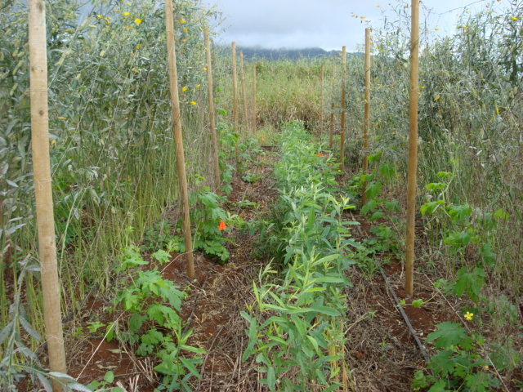 | 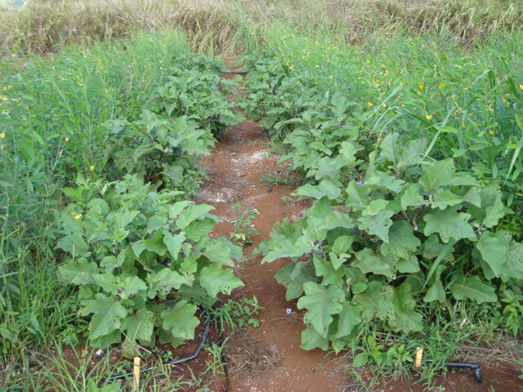
Fig. 1. A) Bitter melon and B) eggplant in sunn hemp strip-till living mulch system in Trial I at Kunia.
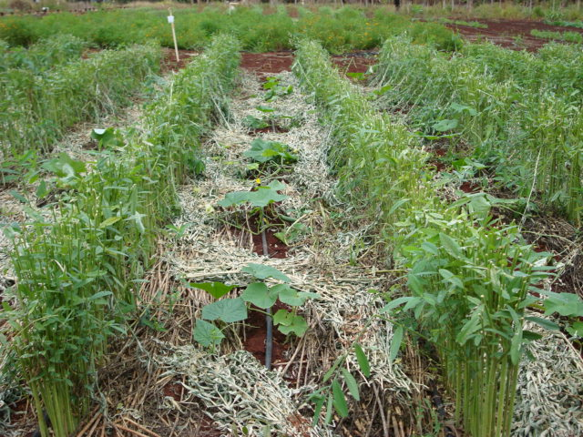 |  | 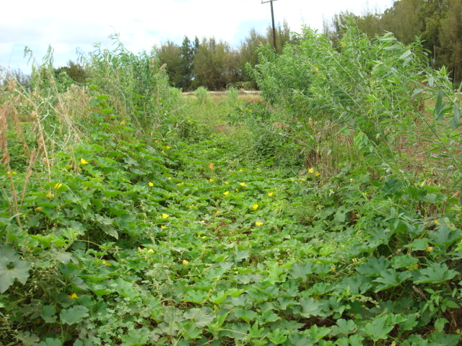
Fig. 2. A) Cucumber and B) winter gourd in sunn hemp strip-till living mulch system in Trial III at Poamoho.

