Lesson 2
Seeds - What they are and how do they grow?
Developed by Mike Bartolo, Colorado State University Extension

Objectives: The purpose of this lesson will be to introduce students to how seeds develop and eventually grow into a variety of different crops plants.

Students will:
- learn about the different components of seeds
- learn how weather and nature effect seed germination and development
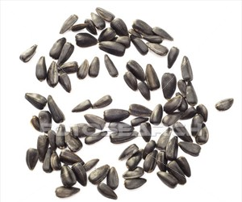
- learn to identify different types of seeds

Curriculum Connections:
- Language Arts
- Science/Biology/Botany
Student Skills Developed:
- Listening Comprehension
- Thinking skills – categorizing
Materials Needed:
- Seeds and “Seed Game” template (provided by instructor)
- Self-Discovery Packets – information about seed structure, planting instructions, seed diagrams (provided by instructor)
- Crayons or colored pencils for younger students
- Bean seeds for older students (provided by instructor)
Individual Student Activity:
- Younger students will color a diagram of a seed (cross section) comprised of its different components
- Older students will dissect (by hand) a bean seed and try to identify its different components

Group Activity:
- The “Seed Game” . Students work in groups to match the seeds to their respective names. Each group of students is given a mixed bag of seeds containing 10-15 types of crop seeds. The students must place an example of each type of seed on the paper template provided. The group getting the most correct matches in the time allotted will receive a small prize (seed packets).

