Sunflower Research Trials
2009

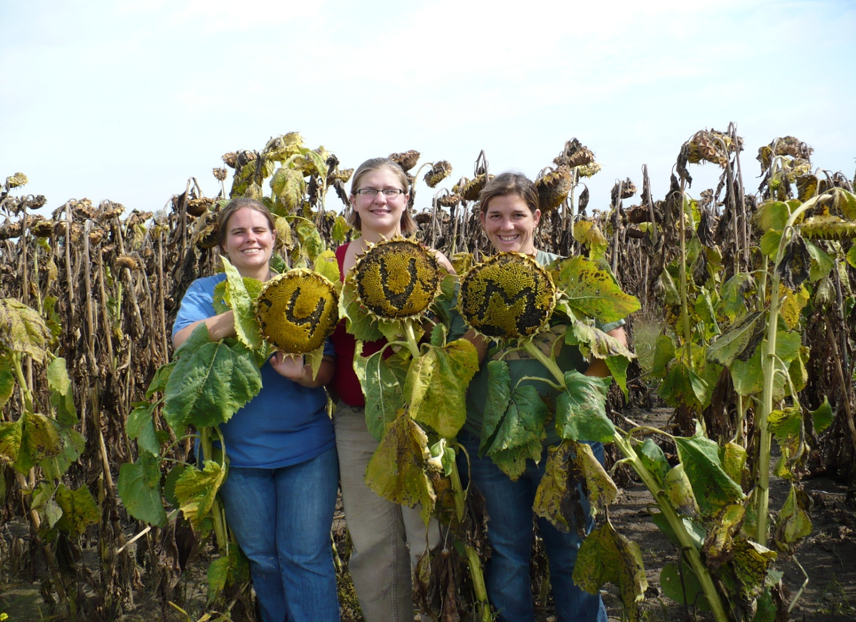
Dr. Heather Darby
Rosalie Madden, Amanda Gervais, and Erica Cummings
UVM Extension
802-524-6501

In 2009, the University of Vermont Extension Crops and Soils Team conducted several canola and sunflower research projects. A number of agronomic topics were investigated including pest control strategies,. Many farmers are engaged in on-farm fuel production endeavors. In order for on-farm fuel production to be feasible farmers must be able to reliably produce a high yielding crop. Therefore the overall goal of this research is to develop best agronomic practices for sunflower production in New England. In 2009, sunflowers trials were conducted in Alburgh at Borderview Farm.

WEATHER DATA
Seasonal precipitation and temperatures recorded at weather stations in close proximity to the 2009 research sites are shown in Table 1. This growing season brought cooler temperatures and higher than normal rainfall resulting in fewer Growing Degree Days (GDD) than usual. Excess moisture and low soil temperatures resulted in poor germination, loss of plant available nutrients, and a slowed crop dry down prior to harvest. Several fields were also impacted by white mold (Sclerotinia sclerotium) a fungi that can be devastating to sunflower fields. White mold prevalence was primarily due to weather conditions (Figure 1).
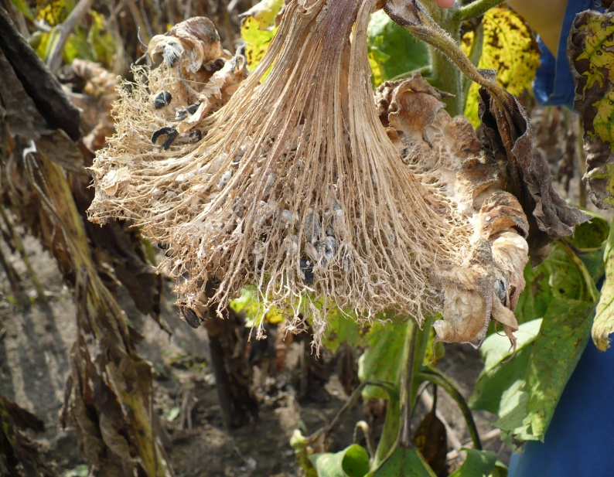
Figure 1. White mold resulting in shredded head skeleton. Note black sclerotia in the sunflower head. These black rock-like structures are the over-wintering structure of the fungi. These sclerotia will germinate in the spring and release spores.

Table 1. Temperature and precipitation summary – 2009.
Alburgh, VT | April | May | June | July | August | September | October
Average Temperature | 44.9 | 53.9 | 62.8 | 65.9 | 67.7 | 57.7 | 44.1
Departure from Normal | +1.4 | -2.7 | -3.0 | -5.2 | -1.3 | -2.7 | -4.7
Precipitation | 2.89 | 6.32 | 5.19 | 8.07 | 3.59 | 4.01 | 5.18
Departure from Normal | +0.38 | +3.39 | +1.98 | +4.66 | -0.26 | +0.55 | +0.79
Growing Degree Days | 184.4 | 325.5 | 565.5 | 657.5 | 708.5 | 428 | 113
Departure from Normal | +53.9 | -65.1 | -88.5 | -181.1 | -66.5 | -64.0 | -82.3

Tineweeding: A Weed Control Strategy for Canola & Sunflowers

As with all annual crops, weeds are a primary pest that farmers must adequately control to produce a satisfactory crop yield. Tineweeding is a type of mechanical cultivation that is implemented early on in the field season. A tineweeder is a low cost and simple piece of equipment (Figure 4). They are designed to disturb the root zones of weed seedlings while they are in the very delicate "white thread root" stage, which often results in seedling desiccation and death. The effectiveness of a tineweeder as a weed control tool in oilseed crops was evaluated with replicated plots in Alburgh, VT. The experimental design was a randomized complete block with three replications. Five weed control strategies were tested: tineweeding 6 days after planting (DAP), tineweeding 12 DAP, tineweeding 6 and 12 DAP, herbicide (POAST – sethoxydim), and no weed control.
Figure 4. Tineweeding at Borderview Farm, Alburgh, VT.

The seedbed was prepared with conventional tillage methods. Plots were seeded with a John Deere 1750 corn planter equipped with sunflower cups, and the variety Hysun 521 at a rate of 31,000 seeds per acre. Plots were seeded with a John Deere 750 grain drill and the variety Nex845CL (Mycogen) at 12 lbs/acre. The plots size was 10’ x 30’. Overall plot management is described in Table 2.

Table 2. Plot management for weed control trials.
Borderview Farm, Alburgh, VT
Soil type | Silt loam
Previous crop | Corn
Tillage operations | Plow and disk
Planting date | 5/19/2009
Row width | 30 inches
Fertilizer (starter) | 250 lbs 10-20-20
Fertilizer (sidedress) | 61 lbs N/acre
Cultivation (on selected plots) | Tineweeding 6 and/or 12 DAP
Herbicide (6/11/2009) | 2.5 pts Poast + 2 pts crop oil/acre

Weed and crop populations were measured at 6 and 12 DAP, and again 5 weeks after planting. Weed identification was performed at each interval.

In early September, sunflower height, head width, population, seed size, percent bird damage, and weed subsamples were collected. By September 4, 2009, bird damage was already extensive, and by the time the sunflowers had dried down enough to be harvestable, they were completely decimated. North Dakota State University Extension has developed a formula for inferring yields from seed size, population, head width, and seed set which has allowed us to make a conjecture on yield results from data collected. Percent survival was calculated by dividing the “harvest” population by the seeding rate. The canola crop was harvested on early September with a Almaco SP50 plot combine. Seed yields were measured at the time of harvest. At harvest, bird damage was at an estimated 25%. It is presumed that the more extensive bird damage in the tineweeding plots due to the proximity of plots to sunflower trials, which were particularly hard-hit by avian pests. Taking this into consideration, yields were recalculated. Canola seeds from each plot were then extruded with a Kern Kraft Oil Press KK40, and oil yielded recorded. All data was analyzed using a mixed model analysis where replicates were considered random effects. All data was analyzed using a mixed model analysis where replicates were considered random effects. The LSD procedure was used to separate treatment means when the F-test was significant (P< 0.10).

Sunflower Results:
At 6 DAP, sunflowers had not emerged, and so were not affected by tineweeding. Very few weeds were present at that time, and those that were present were in white thread stage. At 12 DAP, sunflowers were still germinating or at the cotyledon stage. Some seedlings were pulled out by the tineweeding, and some were covered up. Height was measured at 5 weeks after planting, and as no significance was determined between treatments, it demonstrates that tineweeding, and any associated disturbance the crop received in the rooting zone, did not retard plant growth. By harvest, all tineweeded stands had recovered to such an extent that those few that were buried or uprooted caused no significant difference in percent survival compared with the control or the herbicide plot. Foxtail (Setaria spp.), redroot pigweed (Amaranthus retroflexus L.), and common lambsquarters (Chenopodium album L.) were all removed by the 12 DAP tineweeding treatment. No significance was found between tineweeding treatments and height as of 5 weeks after plant, harvest population, percent survival, height, head width, seed size, bird damage, calculated yield, or weed biomass (Table 3).

Table 3. Impact of weed control strategies on sunflower characteristics.

Treatment | Height, 5 weeks AP | Harvest population | Survival | Height | Head width | Bird damage | Sunflower yield |  | Weed biomass
 | in | plants/ acre | % | in | in | % | lbs/ac | bu/ac | lbs/ac
6 Day | 10.0 | 20700 | 66.9 | 63.2 | 7.60 | 73.6 | 2180 | 77.7 | 1130
12 Day | 11.3 | 20400 | 65.9 | 65.5 | 7.53 | 69.1 | 2100 | 75.3 | 1220
6 & 12 Day | 11.0 | 18800 | 60.5 | 65.6 | 7.83 | 79.4 | 2080 | 74.1 | 505
Control | 10.7 | 21900 | 70.7 | 64.6 | 7.33 | 54.1 | 2170 | 77.5 | 1820
Herbicide | 10.2 | 22900 | 73.9 | 67.9 | 7.70 | 79.6 | 2480 | 88.6 | 594
LSD (0.10) | NS | NS | NS | NS | NS | NS | NS | NS | NS
Means | 10.6 | 20900 | 67.6 | 65.4 | 7.60 | 71.2 | 2200 | 78.6 | 1050
NS - None of the treatments were significantly different from one another.

There were no significant differences among weed control methods. However, there were several trends observed in the data. The herbicide weed control treatment tended to higher in yield than other treatments. The 6 & 12 DAP tineweeding treatment was very effective at controlling weeds. From the one season of data, it appears that the tineweeder can be an extremely effective weed control tool in a sunflower crop. However, the tineweeder will cause some plant loss. If a farmer adopts this tool, he or she might consider planting at a higher seeding rate to compensate for plant losses.

Canola Results:
At 6 DAP, canola had emerged in some plots, but not all. Very few weeds were present at that time, and those that were present were in white thread stage. At 12 DAP, canola was in the cotyledon stage. Some seedlings were pulled out by the tineweeding, and many were covered up, but by harvest, the crop seemed to recover as there was no significant affect on yield (Table 4). Foxtail (Setaria spp.), redroot pigweed (Amaranthus retroflexus L.), and common lambsquarters (Chenopodium album L.) were all completely removed by 12 DAP tineweeding. There were few weeds present at 5 weeks after planting, most likely due to canola’s quick tendency to form canopy closure. Height was also measured at 5 weeks after planting, and no significant difference between treatments was determined, demonstrating crop recovery after the disturbance of tineweeding. No significance was found between tineweeding treatments and oilseed and oil yield (Table 4). The percent oil is fairly low for this canola trial, as around 40-42% oil is expected for canola, depending on growing conditions, variety, and efficiency of your press. Our low oil percentage is most likely due to the canola seeds being very dry (~2% moisture) when attempting to press them in combination with the malfunction of the KK40 at time of pressing. The control, with no weed management strategy was the highest yielding out of all the treatments, but not statistically different from other weed control methods. All tineweeded plots recovered from observed damage, showing no significant difference in yield. Based on the data it appears that tineweeding may provide an acceptable method of weed control in canola fields. However, overall if early season weeds are controlled the quick canopy closure of canola can keep weed populations down throughout the growing season.

Table 4. Impact of weed control methods on canola characteristics.
Treatment | Height  5 wks - AP |  | Yield |  |  | Oil
 | in |  | lbs/ac | bu/ac |  | lbs/ac | gal/ac | %
6 Day | 14.0 |  | 1880 | 37.6 |  | 149 | 19.5 | 34.0
12 Day | 12.8 |  | 1620 | 32.4 |  | 114 | 14.9 | 30.3
6 & 12 Day | 13.0 |  | 1520 | 30.4 |  | 113 | 14.9 | 32.5
Control | 14.0 |  | 2050 | 41.0 |  | 149 | 19.5 | 32.7
Herbicide | 12.0 |  | 1430 | 28.6 |  | 111 | 14.5 | 33.5
LSD (0.10) | NS |  | NS | NS |  | NS | NS | NS
Means | 13.2 |  | 1700 | 34.0 |  | 127 | 16.7 | 32.6
NS - None of the treatments were significantly different from one another.

Harvest dates as a means to reduce bird damage

Bird damage is a well documented restriction on sunflower production in Vermont. This year was no exception with migratory birds arriving in early August. A study was conducted at Borderview Farm in Alburgh, VT to determine if harvest date impacted the level of bird damage in sunflower fields. The experimental design was a randomized complete block with three replications. Sunflower variety Hysun 521 (Interstate Seed) was planted with a John Deere 1750 corn planter, equipped with sunflower cups, at a rate of 30,000 seeds/acre. Plot size was 10’ x 20’. Plot management details are contained in Table 5. All data was analyzed using a mixed model analysis where replicates were considered random effects. The LSD procedure was used to separate harvest date means when the F-test was significant (P< 0.10).

Table 5. General plot management for Harvest Date Study.
Borderview Farm - Alburgh, VT
Soil type | Silt loam
Previous crop | Sunflower, rye cover crop
Tillage | No-till
Planting date | 6/8/2009
Row width | 30 inches
Fertilizer (starter) | 200 lbs 10-20-20
Fertilizer (sidedress) | As per soil test
Herbicide (6/8/2009) | 2.5 pts Poast + 2 pts crop oil/acre
Harvest date 1 | 10/1/2009
Harvest date 2 | 10/23/2009
Harvest date 3 | 11/2/2009

Bird damage significantly increased as sunflowers began to dry down. The data indicated that earlier harvest dates would reduce the amount of damage by birds and subsequently increase yields (Table 6).

Table 6. Percent bird damage over three possible harvest dates.
Date of harvest | Bird damage (%)
Oct 1, 2009 | 2.90
Oct 23, 2009 | 36.0
Nov 2, 2009 | 68.8*
LSD (0.10) | 8.01

* Treatments that did not perform significantly lower than the top performing treatment in a particular column are indicated with an asterisk.

Figure 1. Harvest Date Trial, percent bird damage over time.

On October 1, the sunflowers reached physiological maturity (35% moisture). Although at this stage the sunflowers could be theoretically harvested, the moisture content would prohibit the use of a combine. It may make sense for a farmer to apply a dessicant at this stage of growth especially if it has the potential to significantly increase yield by 60-70%. The benefits of a greater yield must be weighed against the price of the desiccant and the increased fuel, time, and compaction resulting from the extra passes with a tractor. If Roundup (or any other desiccant) takes about 12 minutes to apply per acre, uses about a half gallon of gas per acre, and is applied at 2 qts/acre, and you were to calculate a salary of $15/hr, and $2.50/gallon for fuel, then it would cost an additional $22.56/acre to apply a desiccant. However, if this were to save 60-70% of your crop from bird predation, this would make economical sense.

Alternatively, if the combine can handle a wetter sunflower head, the crop could be harvested at higher moisture contents, but then drying cost must be considered and weighed against early harvesting (Table 7).

Table 7. Drying with 47˚F air with a relative humidity of 65% to dry oilseed sunflowers.
Sunflower seed  moisture | Airflow required for drying (cfm/bu) | Drying time required
 |  | Hours | Days
17% | 1.00 | 648 | 27
15% | 1.00 | 480 | 20
 | 0.75 | 720 | 30
 | 0.50 | 960 | 40
13% | 1.00 | 336 | 14
 | 0.75 | 504 | 21
 | 0.50 | 672 | 28
Texas Cooperative Extension, The Texas A&M University System. http://sanangelo.tamu.edu/agronomy/sunflowr/index.htm

Cover Crop Termination Trial for Canola and Sunflower Production

Cover crops are becoming more widely used throughout Vermont as a method of smothering weeds, deterring pests, trapping nutrients, and slowing erosion. However, little has been done to determine the best course of action for terminating the cover crop to maximize crop and soil improvement characteristics. The objective of the project was to determine the cover cropping strategy that resulting in maximum benefits to the crop and soil. The experiment was conducted on a silt loam soil with the previous crop being sunflowers. On October 10, 2008 the winter rye was seeded at a rate of 100 lbs/acre. Plots without cover crops served as controls. The plot design was a randomized complete block with three replications and the plot size measured 10’x 25’. In mid-April the soil was sampled to determine soil quality. Soil was sampled from multiple locations to a 6” depth using a trowel. The subsample of soil was taken from each plot and sent to the Cornell Soil Health Lab for analysis. Soil quality was monitored to determine if a single season of cover cropping would improve soil health.

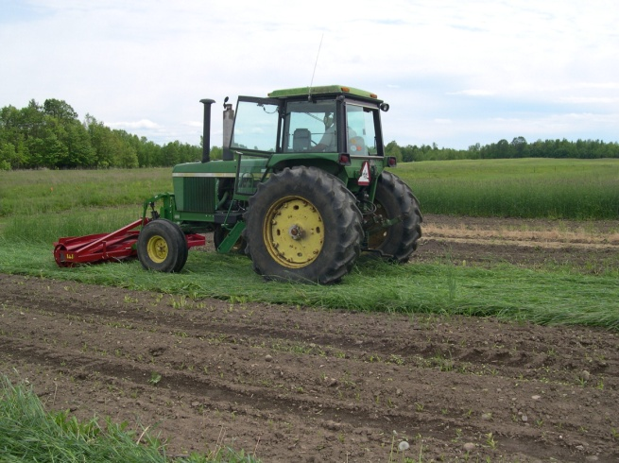
Prior to cover crop termination, a one-meter² sample of cover was taken to determine crop biomass and nitrogen content. In the spring of 2009, the cover crops were terminated with a burn-down herbicide (glyphosate at 2 qts/acre), plowing the cover crop into the soil, or by rolling and crimping the crop (Figure 2). After the cover crop was terminated, canola (var. Mycogen Nex845CL) was planted with a John Deere 750 grain drill at 8 lbs to the acre. Starter fertilizer was broadcast applied prior to seeding at a rate of 100 lbs N, 40 lbs of P, and 40 lbs K to the acre. Plots where the cover crop was terminated with herbicide burn-down were planted with a Great Plains no-till drill. Sunflowers were seeded with a John Deere corn planter equipped with sunflower fingers. The sunflowers were planted at 34,000 seeds to the acre. Unfortunately, the sunflower germination rate was too low to proceed with this aspect of the project (less than 50% stand). Sunflowers in these systems will be tested again in 2010. On September 5th, all plots were harvested with an Almaco SP50 plot combine and seed yield was weighed. Additional trial information is shown in Table 7. Seeds were then pressed with a Kern Kraft Oil Press KK40, and the oil quantity was measured. The percent oil is fairly low for this canola trial, as around 40-42% oil is expected for canola, depending on growing conditions, variety, and efficiency of your press. Our low oil percentage is most likely due to the canola seeds being very dry (~2% moisture) when attempting to press them in combination with the malfunction of the KK40 at time of pressing. All data was analyzed using a mixed model analysis where replicates were considered random effects. The LSD procedure was used to separate treatment means when the F-test was significant (P< 0.10).
Figure 2. Rolling and crimping winter rye cover crop.

Table 8. Cover crop termination trial information.
Cover crop |  | Cover crop | Tillage | Canola planting
termination method |  | termination date | type | date
No cover crop (control) |  |  | Plow & disk | 13-May
Plow under |  | 6-May | Plow & disk | 13-May
Herbicide burn-down |  | 6-May | No-till | 13-May
Rolled & Crimped |  | 6-Jun | No-till | 1-Jun

RESULTS

The amount of cover crop biomass was highest in the roller/crimper treatment (Table 9). This makes sense because the rye cannot be rolled/crimped until the flowering stage. The other cover crop termination strategies were applied when the cover crop was still in the vegetative stages. Essentially the cover crops were worked under as soon as the cooperating farm was ready to start working the soil. Therefore the cover crop biomass was almost half as much as the roller/crimper treatment.

Table 9. Cover crop biomass and nitrogen content
Cover crop | Cover crop
termination method | dry matter
 | tons/acre
No cover crop (Control) | 0
Rolled & crimped | 3.10*
Herbicide burn-down | 1.84
Plow under | 1.73
LSD (0.10) | 0.26
* Treatments that did not perform significantly lower than the top performing
treatment in a particular column is indicated with an asterisk.

Overall, the soil quality was improved by a single season of cover cropping (Table 10). The cover crop improved active carbon and stable aggregate levels. Active carbon is the portion of organic matter that is readily available to soil microorganisms. If a soil has a high level of stable aggregates the physical properties of the soil are improved. Generally, these soils have better drainage capabilities. The level of potential N-mineralization was not statistically increased by cover cropping. The amount of potentially mineralizable nitrogen is an indicator of soil microbial activity. Increased microbial activity can improve nutrient cycling and soil physical properties. It is promising to see that even a single season of cover cropping can provide immediate benefits to the soil.

Table 10. Impact of a single season of cover cropping on soil quality.
Treatment |  | Organic | Active | Stable | Potential
 |  | Matter | carbon | aggregates | N-mineralization
 |  | % | mg kg⁻¹ | % | ug N g⁻¹ d soil
Cover crop |  | 4.42 | 702 | 63.2 | 12.3
No cover crop |  | 4.46 | 676 | 61.4 | 11.1
P-value (0.10) |  | NS | * | * | NS
*Coefficients significanct at the 0.10 probablity levels.
NS - None of the varieties were significantly different from one another.

Canola yields were impacted by the type of cover crop termination (Table 11). First, the rolled/crimped treatment resulted in a crop failure. The canola crop did not emerge from underneath the cover crop. The impact of rolling/crimping on canola growth has not been reported in the scientific literature. It is possible that the no-till grain drill was not heavy enough to cut through the cover crop mat. The Rodale Institute has reported that additional weight added to the planter is often required to plant through the cover crop residue. Next season we will add weights to the drill. The herbicide termination strategy resulted in the lowest canola yields. The control treatment and the plowed under cover crop treatment resulted in statistically similar yields. The herbicide treatment was planted with no-till technology potentially contributing to lower yields.
Overall, cover cropping had positive results on soil quality. There was minimal impact on canola yields as a result of cover cropping. Additional studies need to be conducted to continue to understand how to reap the benefits of each termination strategy.

Table 11. Impact of cover crop termination methods on canola seed and oil yields.
Treatment | Yield |  |  | Oil
 | lbs/acre | bu/acre |  | gal/acre | %
Herbicide burn-down | 576 | 11.5 |  | 17.5 | 25.9
Plow under | 988* | 19.8* |  | 39.4 | 32.5
No cover crop | 1164* | 23.3* |  | 44.9 | 32.5
LSD (0.10) | 322 | 6.40 |  | NS | NS
Trial Mean | 909 | 18.2 |  | 33.9 | 30.3
* Treatments that did not perform significantly lower than the top performing treatment in a particular column are indicated with an asterisk.
NS - None of the treatments were significantly different from one another.

