Way Sweet Corn Fertility Trial in Cooperation with Penn State Cooperative Extension

Brooks Way, Owner of Ways Fruit Farm

Thomas M. Butzler, IPM/Horticulture-PSU Coop. Extension

Craig Altemose, Centre County CED/Agronomy-PSU Coop. Extension

Mark Douglass, Farm Financial Management PSU-Coop. Extension

Funded by USDA Northeast Sustainable Agriculture Research and Education (NESARE) Farmer Grant
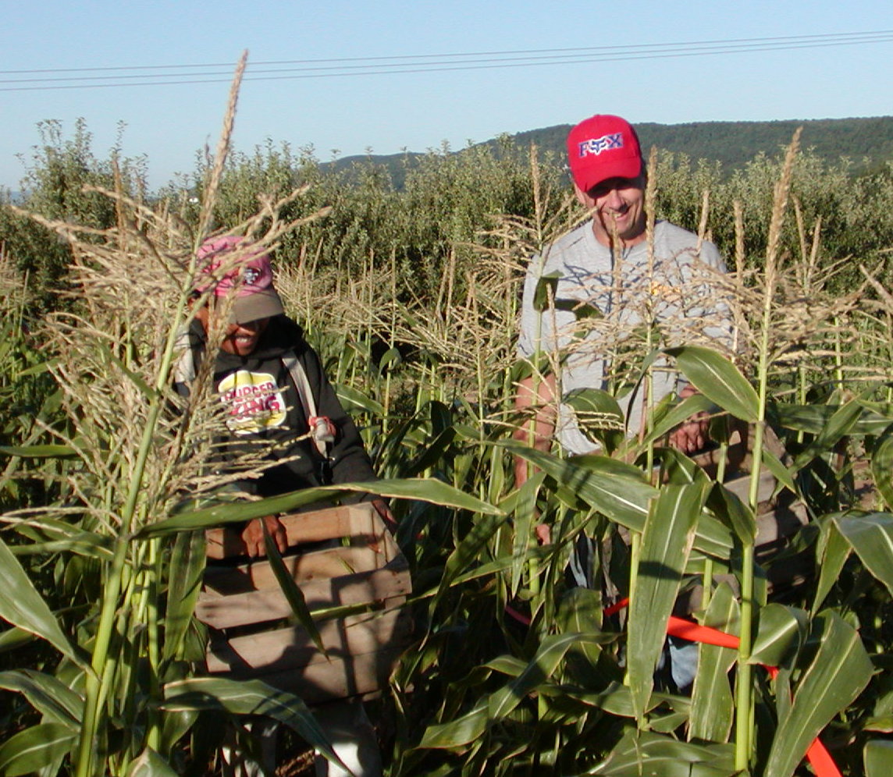
Figure 1. Fidel Castillo (on the left) and Brooks Way harvest marketable ears of sweet corn in test plots.

History & Treatments

Brooks read an article in the October 13, 2001 issue of Lancaster Farming titled “Is It Wise To Use Starter Fertilizer For Corn?” This led him to theorize the elimination of certain fertilization procedures and the incorporation of foliar feeding.

Brooks thought that the foliar fertilizer would give the plant a boost right when it was needed (applied when corn silking) and improve the sugar content. In addition, foliar feeding was convenient in the sense that it could be mixed with insecticide applications. Brooks tried foliar feeding in 2001 and thought he saw some visual difference in a plot where the foliar feed was not reaching the middle rows. This led him to question the effect of various fertilization practices on marketable yield.

This project was conducted to determine the effect:
- of a foliar treatment with Fertileader & Fertileader BMO
- of the use of a Pre-Sidedress Nitrate Soil Test (PSNT) to measure nitrate available to the crop when the crop is 8 to 12 inches tall. A recommendation for nitrogen is made if the test is less than 25 ppm nitrate.
- of preplant incorporate 50 pounds of nitrogen per acre.

The PSNT is a soil sample taken at one foot of depth when the corn plants are eight inches to one foot high to determine the amount of nitrogen available to the plant at the time when it is green and growing and able to take up the nitrogen.

Abstract

On-farm Comparison of Fertility Treatments on Sweet Corn
Mark Douglass, Craig Altemose, Tom Butzler and Brooks Way

An on-farm comparison of fertility treatments to one Sweet Corn variety planted and harvested at two different times during the season was carried out at the Way Fruit Farm in Centre County, Pennsylvania. This was an evaluation of which treatment was most economical, had the best sugar content, and nutrient utilization. The treatments consisted of: 1) 50 pounds of nitrogen applied just prior to planting as a broadcast and incorporated 2) a nitrogen recommendation based on Pre-Sidedress Nitrate Soil Test (PSNT) taken when the corn was 8 to 12 inches tall, and 3). a foliar treatment with Fertileader & Fertileader BMO.
Two replicated trials consisting of these three treatments replicated four times in each trial were planted, one in early May and the second in early June, 2003. All treatments were applied after each trial was soil sampled and brought up to recommended soil test levels for P and K.
PSNT recommendations were made if the test level was less than 25 ppm nitrate. The recommendations were based on a yield goal of 120 bushels of dry shell corn per acre. We used this goal based on field corn because Penn State has no yield goal for sweet corn. Both trials were sprayed with the herbicides: Prowl 3 EC at 1 quart & Bicep Lite II, Magnum at 2 quarts per acre pre-emergence to control weeds. The planting rate was 18,000 seeds/acre.
Harvests were taken August 18 & August 25, 2003 in Trials1 and 2 respectively. Measurements were based on the number and weight of marketable ears from the middle 20 feet of rows 4, 8, 12, and 16 out of each plot. Yields were interpolated to one acre. A Brix test was performed for sugar content of 1 ear selected at random from each row sample harvested in each plot. The 2003 year was a record setting year for rainfall. Irrigation was only needed once to help incorporate the side dress Nitrogen fertilizer recommended in the PSNT treatments. Wire cone traps with appropriate lures were used to trap and monitor Corn Earworm and European Corn Borer. A bucket trap was used to monitor Fall Armyworm. The results of this monitoring did not show a need for increased insecticide spraying.
The cost for treatment 1 was $558.55 per acre, treatment 2 was $548.10 per acre, and treatment 3 was $540.62 per acre. Net return to management for treatment 1 was $2419.16 per acre, treatment 2 was $3088.21 per acre, and treatment 3 was $2416.07 per acre. The results of the Brix test for sugar content were 22.78 for treatment 1, 21.94 for treatment 2, and 22.22 for treatment 3.
Brooks Way plans to use a PSNT test on all sweet corn grown in 2004.

Project participants were Brooks Way of Way Fruit Farm, Thomas Butzler, Craig Altemose, and Mark Douglass, Penn State Cooperative Extension. Responsibilities included experimental design, implementation, data collection, analysis, outreach efforts, and summary report.

Plot plan showing fertility treatments in both trials carried out in 2003
.

Sweet Corn Fertility Trial at Brooks Way

SARE Grant Trial # 1
Block 1
Treatment 1

Block 1
Treatment 2

Block 1
Treatment 3

Block 2
Treatment 2

Block 2
Treatment 1

Block 2
Treatment 3

Block 3
Treatment 3

Block 3
Treatment 1

Block 3
Treatment 2

Block 4
Treatment 1

Block 4
Treatment 3

Block 4
Treatment 2

Treatment 1 – Preplant Inc 50 lbs N/Acre

Treatment 2 – Sidedress PSNT

Treatment 3 – Foliar Fertileader and BMO

Sweet Corn Fertility

Trial at Brooks Way

SARE Grant Trial # 2
Block 1
Treatment 1

Block 1
Treatment 2

Block 1
Treatment 3

Block 2
Treatment 3

Block 2
Treatment 1

Block 2
Treatment 2

Block 3
Treatment 3

Block 3
Treatment 2

Block 3
Treatment 1

Block 4
Treatment 2

Block 4
Treatment 3

Block 4
Treatment 1

Result for Way Sweet Corn Economic Data on a Per Acre Basis Across Both Trials in 2003
 | 50 Nitrogen | PSNT | Foliar
Yield Dozen | 844.77 | 1,038.95 | 850.77
Price Per Dozen | 3.50 | 3.50 | 3.50
Total Income | $2,956.69 | $3,636.31 | $2,977.71
Variable costs
Broadcast 50-30-0 | $20.57 | $20.57 | $20.57
Spreading | $6.15 | $6.15 | $6.15
Broadcast 50 N | $7.88 | $0.00 | $0.00
Spreading | $6.15 | $0.00 | $0.00
BMO + Fertleader | $0.00 | $0.00 | $24.06
Foliar Spray | $0.00 | $0.00 | $7.90
PSNT Test | $0.00 | $6.00 | $0.00
Sidedress N | $0.00 | $11.63 | $0.00
Sidedressing | $0.00 | $6.15 | $0.00
Total variable costs | $40.75 | $50.50 | $58.68
Fixed costs
Herbicides | $23.00 | $23.00 | $23.00
Spray | $7.60 | $7.60 | $7.60
Insecticides | $22.89 | $22.89 | $22.89
Spray | $23.70 | $23.70 | $23.70
Soil test | $6.00 | $6.00 | $6.00
Plow | $14.30 | $14.30 | $14.30
Disk | $27.60 | $27.60 | $27.60
Plant | $13.60 | $13.60 | $13.60
Irrigation Set Up | $50.00 | $50.00 | $50.00
Irrigation | $102.00 | $102.00 | $102.00
Labor | $70.00 | $70.00 | $70.00
Seed | $48.38 | $48.38 | $48.38
Lime | $40.80 | $40.80 | $40.80
Land | $50.00 | $50.00 | $50.00
Total fixed costs | $499.87 | $499.87 | $499.87
Total costs | $540.62 | $550.37 | $558.55
Net Returns to Managment. | $2,416.07 | $3,085.94 | $2,419.16

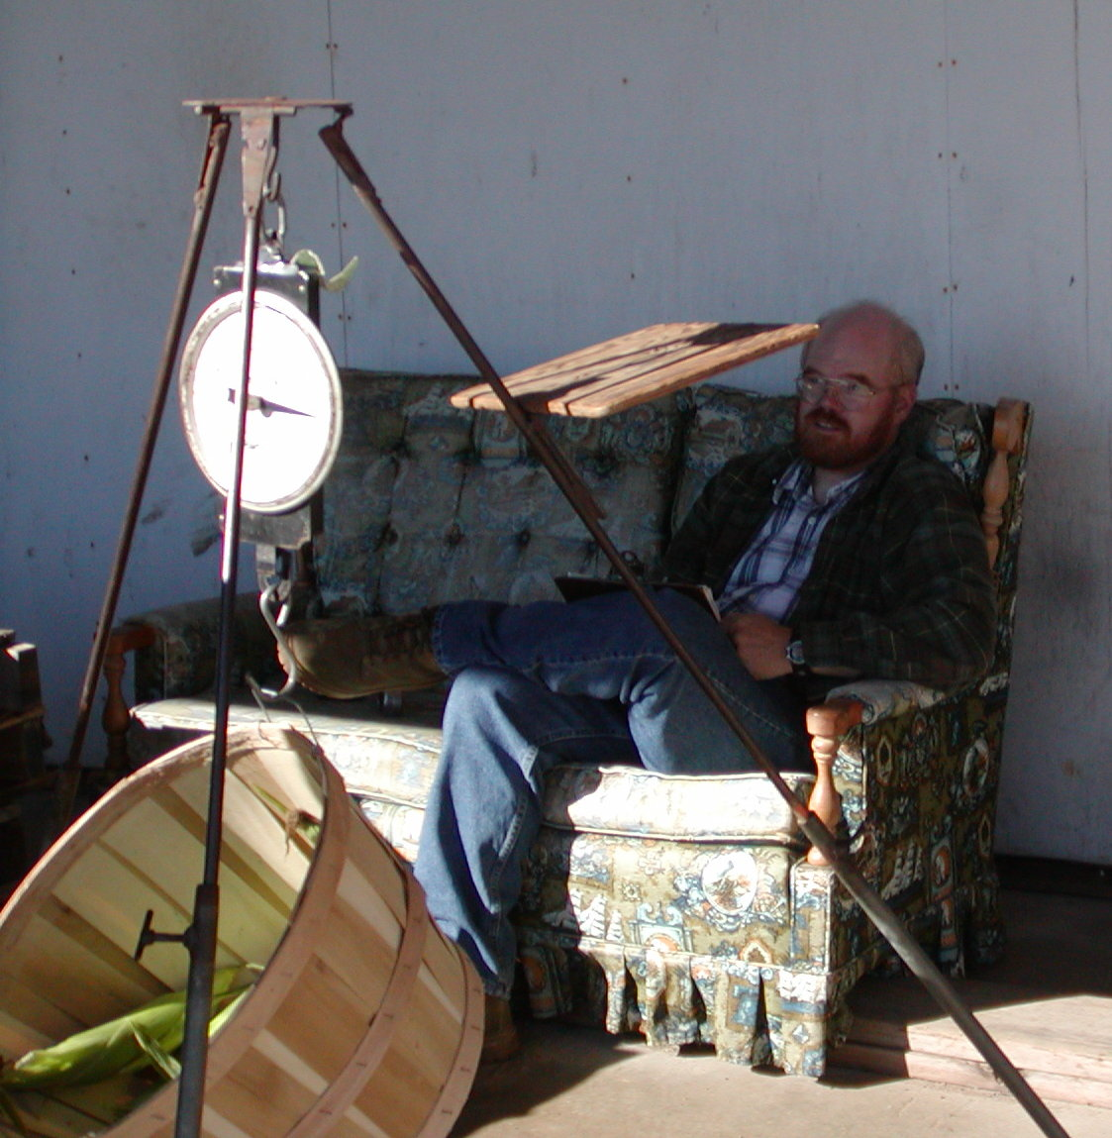
Figure 5. Mark Douglass recording sugar content and yield data on marketable ears harvested that morning.

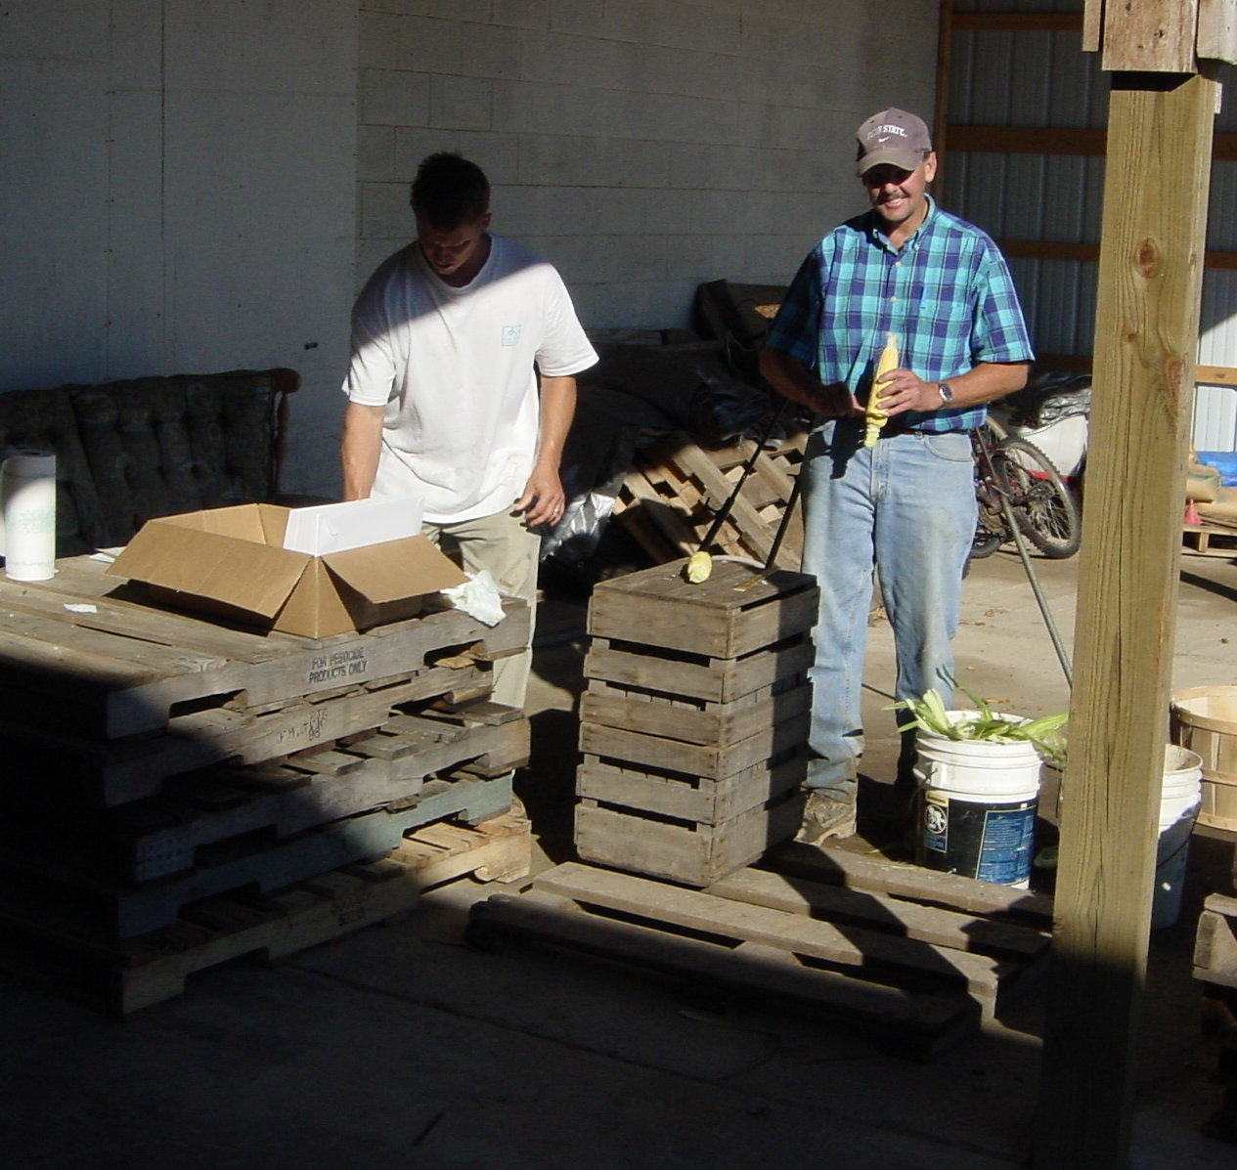
Figure 6. Tom Butzler (left) and Craig Altemose measuring length, diameter, and sugar content of marketable ears.

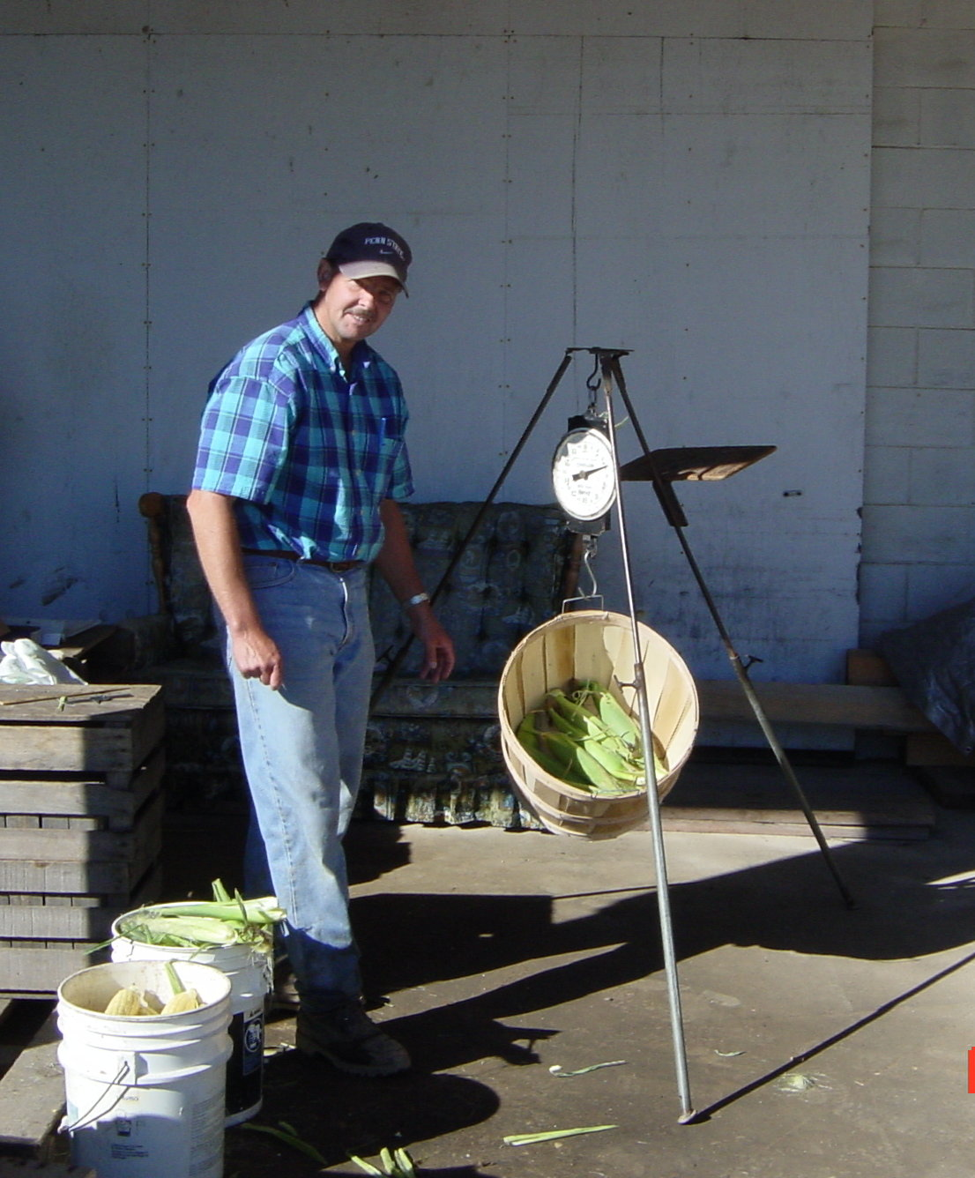
Figure 7. Craig Altemose weighing marketable ears of corn for yield data.

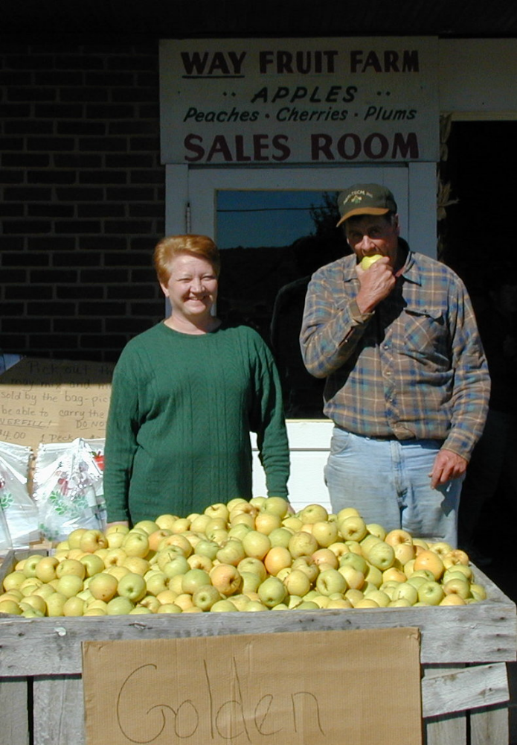
Figure 8. Brooks and Sharon Way enjoying the fruits of their labor. Brooks received the Master Farmer award for his leadership, creativity, and progressiveness in the local and global community

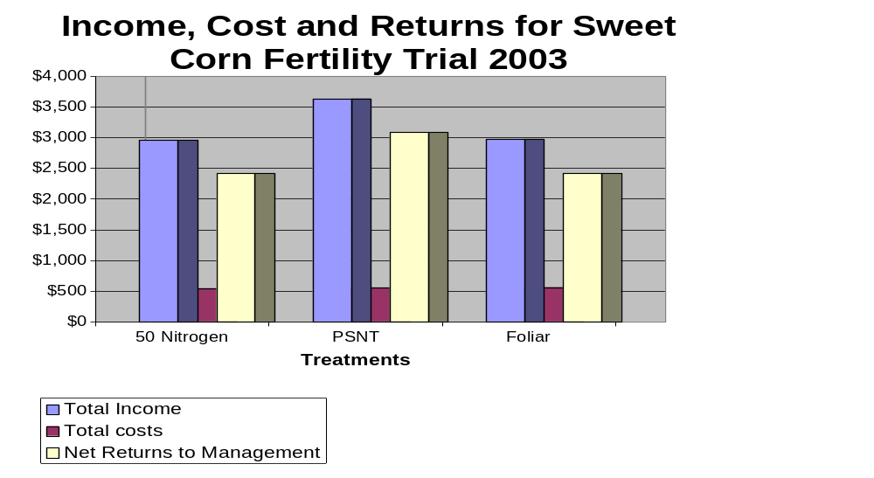
Figure 4. Income and Expenses on Marketable Ears on Both Trials in 2003.

Mother Nature at Work

The project was conducted in 2002 and was adversely affected by the drought, out of 12 plots only 3 plots yielded marketable ears. The data that was collected increased our interest in continuing this research study in 2003. With additional funding received from NESARE we were able to continue our research effort in 2003.

Figure 2. Local newspaper articles from 2002 describing drought conditions throughout central Pennsylvania

