Northeast SARE Farmer Grant Final Report

- Project Name and Contact Information

Determination of the Productive Capacity of the Damariscotta River for Farm-raised Oysters, (Crassostrea virginica)

Christopher V. Davis and Carter R. Newell
Pemaquid Oyster Company, Inc.
PO Box 302
Waldoboro, Maine 04572

Contact: Christopher Davis
(207) 832-6812
cdavis@midcoast.com

- Goals

Nearly half of all Maine oyster farms occur in the Damariscotta River estuary located in mid-coast Maine. Farms in the Damariscotta River lease over 90 acres of the surface and bottom waters, making it the most intensive area for shellfish farming in Maine. Reasons for siting farms in the Damariscotta are numerous, but the high level of primary productivity (phytoplankton production which the oysters feed on) and the warm waters during the summer months are critical to achieving success raising oysters in Maine. Given the growth of the industry, questions are being raised such as "how many farms can the estuary support and how close together can they be placed?" "Is there a maximum number of farms the river can support?" and "what constitutes the best site for bottom culture of shellfish?" The goal of this project is to begin to understand the capacity of the Damariscotta River Estuary (and ultimately, other similar ecological systems) to support shellfish farming activities.

We proposed to address these questions by conducting experiments to determine both the supply of food (production and standing crop of phytoplankton), the demand or consumption of that food (grazing rates by the oysters of various size and growing conditions) and the transport of that food throughout the system by tidal currents. This was done by 1) monitoring the phytoplankton flux near the oyster farm over the course of the growing season; 2) assessing the physical characteristics of the estuary in general and the specific characteristics on the POC growing beds using bathymetric mapping and characterization of the tidal currents and 3) estimating the feeding rates of oysters planted on bottom by both measuring seston depletion upstream, within and downstream of an oyster bed and by measuring the feeding rate of individual oysters in a controlled environment, but utilizing natural plankton assemblages.

In many respects, this SARE Project has spawned several other associated research projects related to the carrying capacity of the Damariscotta River. The first was a Sea Grant funded project ($91,662 in funding and match) under the direction of Drs. Mary Jane Perry and Christopher Davis. This project investigated the seasonal phytoplanktion dynamics of the Damariscotta Estuary and was extremely valuable to this SARE study. A second project, funded by the Maine Technology Institute under the direction of Christopher Davis ($48,000 in funding) allowed for the purchase of research grade oceanographic instrumentation to allow for more precise measurements of chlorophyll a than was previously possible. These instruments were used extensively on this SARE project. Finally, data from this project was used as part of an aquaculture GIS project funded by the Maine Aquaculture Innovation Center ($47,250 in funding and match). Drs. John Richardson of Blue Hill Hydraulics and Carter Newell use the current and bathymetry data to generate flow models for the upper Damariscotta River. So as a result of this modest SARE grant, considerably greater research capacity was leveraged resulting in our better understanding of the Damariscotta ecosystem in general and phytoplankton dynamics on the POC farm in particular.

- Farm Profile

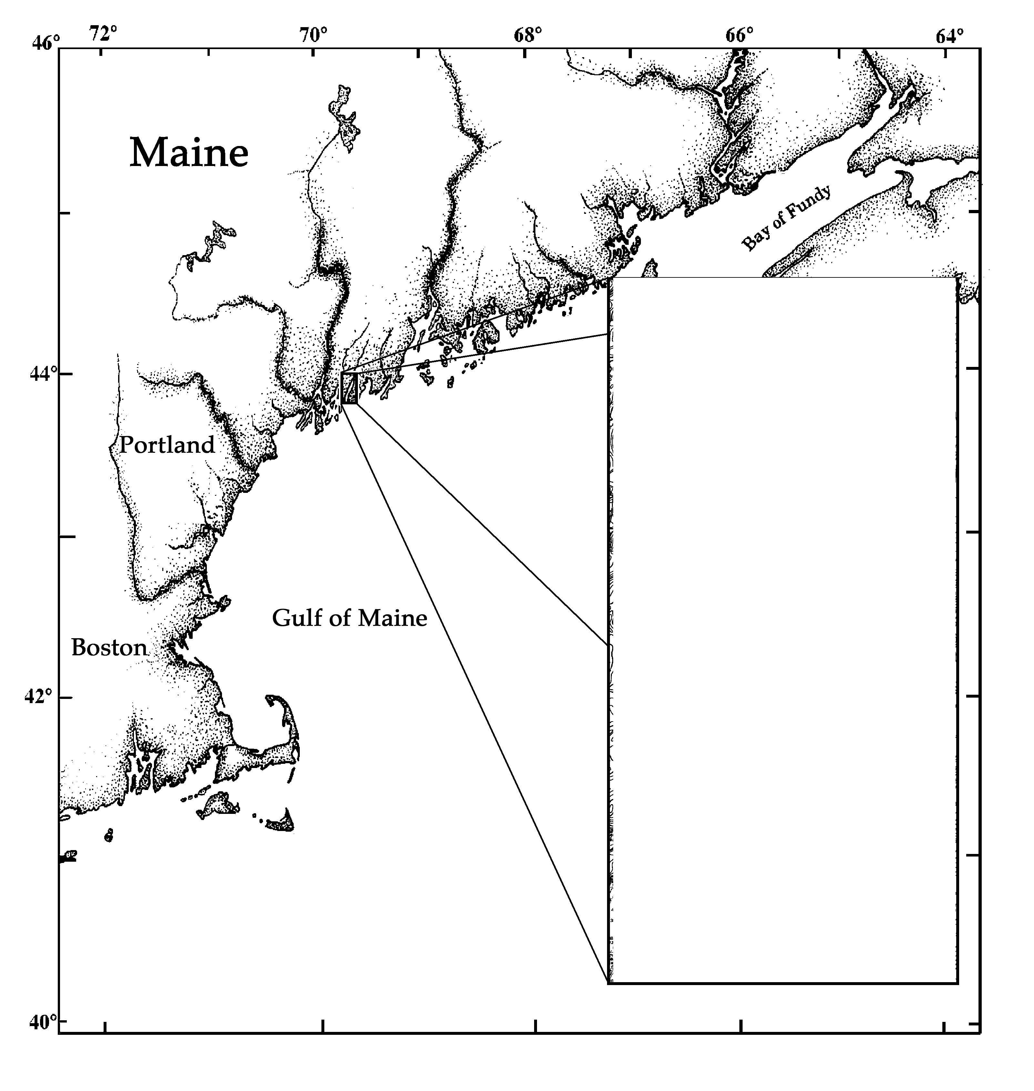
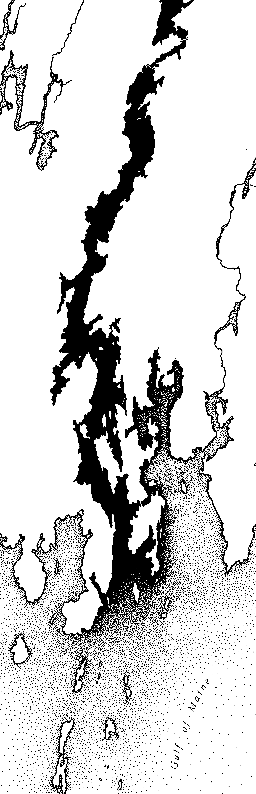
Pemaquid Oyster Company (POC) has been actively farming Eastern oysters (Crassostrea virginica) in the Damariscotta River estuary since 1986 (Figure 1). Current production methods include surface culture of hatchery-reared seed oysters in floating trays during the first growing season (May-October), followed by bottom planting of 45 mm oysters for further growout of 1-2 years. Oysters are then harvested at 75-90 mm and marketed to wholesalers and restaurants under the Pemaquid® trademark. POC owns and operates a shellfish hatchery, nursery upwelling system (for cultivation of 2-10mm oysters), 3 surface nursery sites and 12 acres of bottom. A total of 14 acres of surface and bottom waters are leased from the State of Maine,. POC also owns land on the Damariscotta River used primarily for the storage of growing equipment, a 25 foot fishing boat, a 24 foot work barge, three smaller work skiffs and several rafts designed for wet storage of shellstock. POC also operates a packing and refrigeration facility. Our oyster farm employs two full-time and 3-5 part-time persons depending on the season. Current production exceeds 1 million oysters planted on bottom per year.
Figure 1. Map of the Damariscotta River estuary (arrow in the inset denotes location of POC).

- Participants

This research was conducted by Drs. Christopher Davis and Carter Newell,- two of the principals of Pemaquid Oyster Co. Inc. Davis and Newell are both trained as shellfish biologists. Newell has extensive experience in developing carrying capacity models for shellfish systems. Furthermore, two students, Ms. Karen Stamieszkin (Yale University undergraduate) and Mr. Brian Thompson (University of Maine MS student) conducted research that contributed to this project.

- Project Activities
Pemaquid Oyster Company has 12 acres of suspended and bottom lease sites in the Damariscotta River, Maine (Figures 1 and 2) and performed a series of experiments during 2004 and 2005 to investigate factors which control the supply and demand of food particles to oysters grown in bottom culture. The oysters are planted at densities of approximately 15 per square foot of lease area, and an area which had 670,000 oysters planted in 2003 on the western side of Goose Ledges was investigated to see how much of the food the oyster bed consumed over several tidal cycles, how fast the oysters grew in relation to their location on the lease site, and what the food consumption of oysters was using in-situ feeding chambers. Food supply and demand in bottom cultures of mussel has been studied and modeled in Maine previously (Newell and Shumway, 1991; Muschenheim and Newell, 1992; Newell et al. 1998; Campbell and Newell, 1998) but similar studies have not been performed on native oysters (Crassostrea virginica) in Maine. The study was performed not only to improve oyster cultivation practices, but also to estimate environmental impacts (food depletion) and to provide preliminary information related to the carrying capacity of the Damariscotta River for oyster culture.

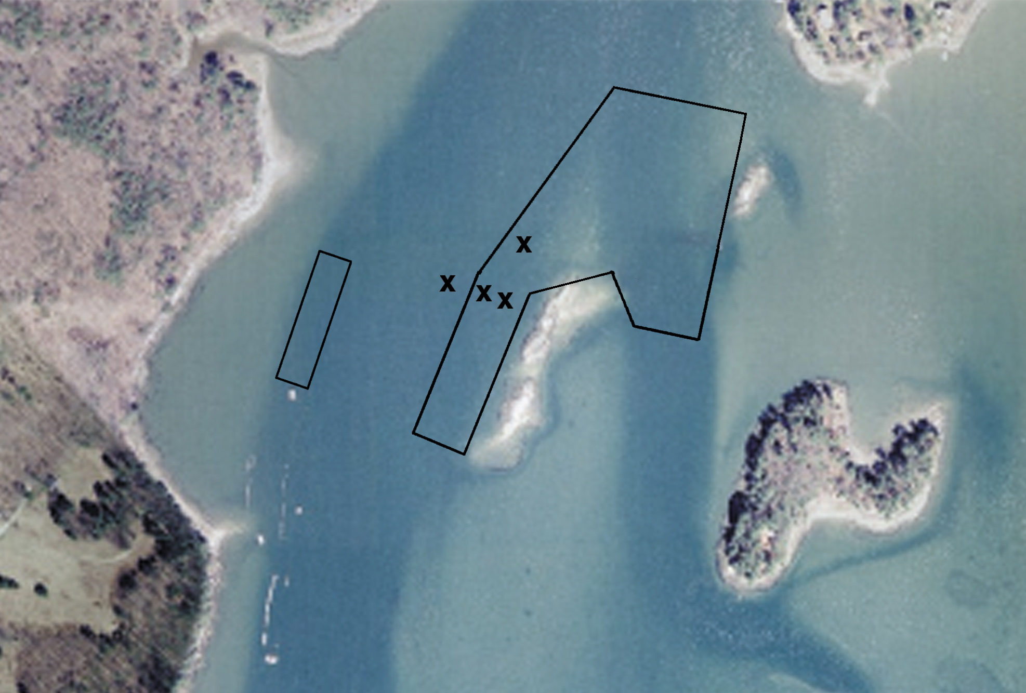
Control CTD’s

Figure 2. Location of Pemaquid Oyster Company lease tracts, with X marking the locations of CTD moorings (see Methods section below) northwest of the Goose Ledges.
Methods

Bathymetric Mapping

A bathymetric map was generated to define the bottom contours on and around the POC growing beds. This was done by interfacing a WASS-based differential GPS with a sonar depth transducer thereby generating depth, time and position data. Parallel transects were run by boat back and forth within the bounds of the mapped area (Figure 3). The result was a dataset of several hundred depths of known position and time. This data was then adjusted to correct for the height of tide during the survey so that all data was referenced to the Mean Lower Low Water Datum used by NOAA in producing charts. All corrections were done in an Excel spreadsheet. The resulting data was then entered into a contour mapping program (Surfer 3.0) to generate the bathymetric map.

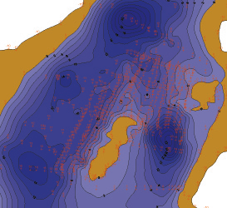

Figure 3. Generation of a bathymetric map of the POC growing beds. Raw depth data (in red) was produced by running transects by boat over the bottom. Depth and position/time data were then used to generate a contour map of the bottom.

Current Velocity

An Inter-Ocean Model S-4 electromagnetic current meter was placed at 1 m off the bottom (Figure 4) at the study site over a 10 day period starting at 13:00 on September 22, 2004. The current meter measured water depth, current speed and current direction at the site, using 12 second average values over a 60 second period every 1 out of 5 minutes to give 60 mean velocity values every hour (= 14,400 samples total).

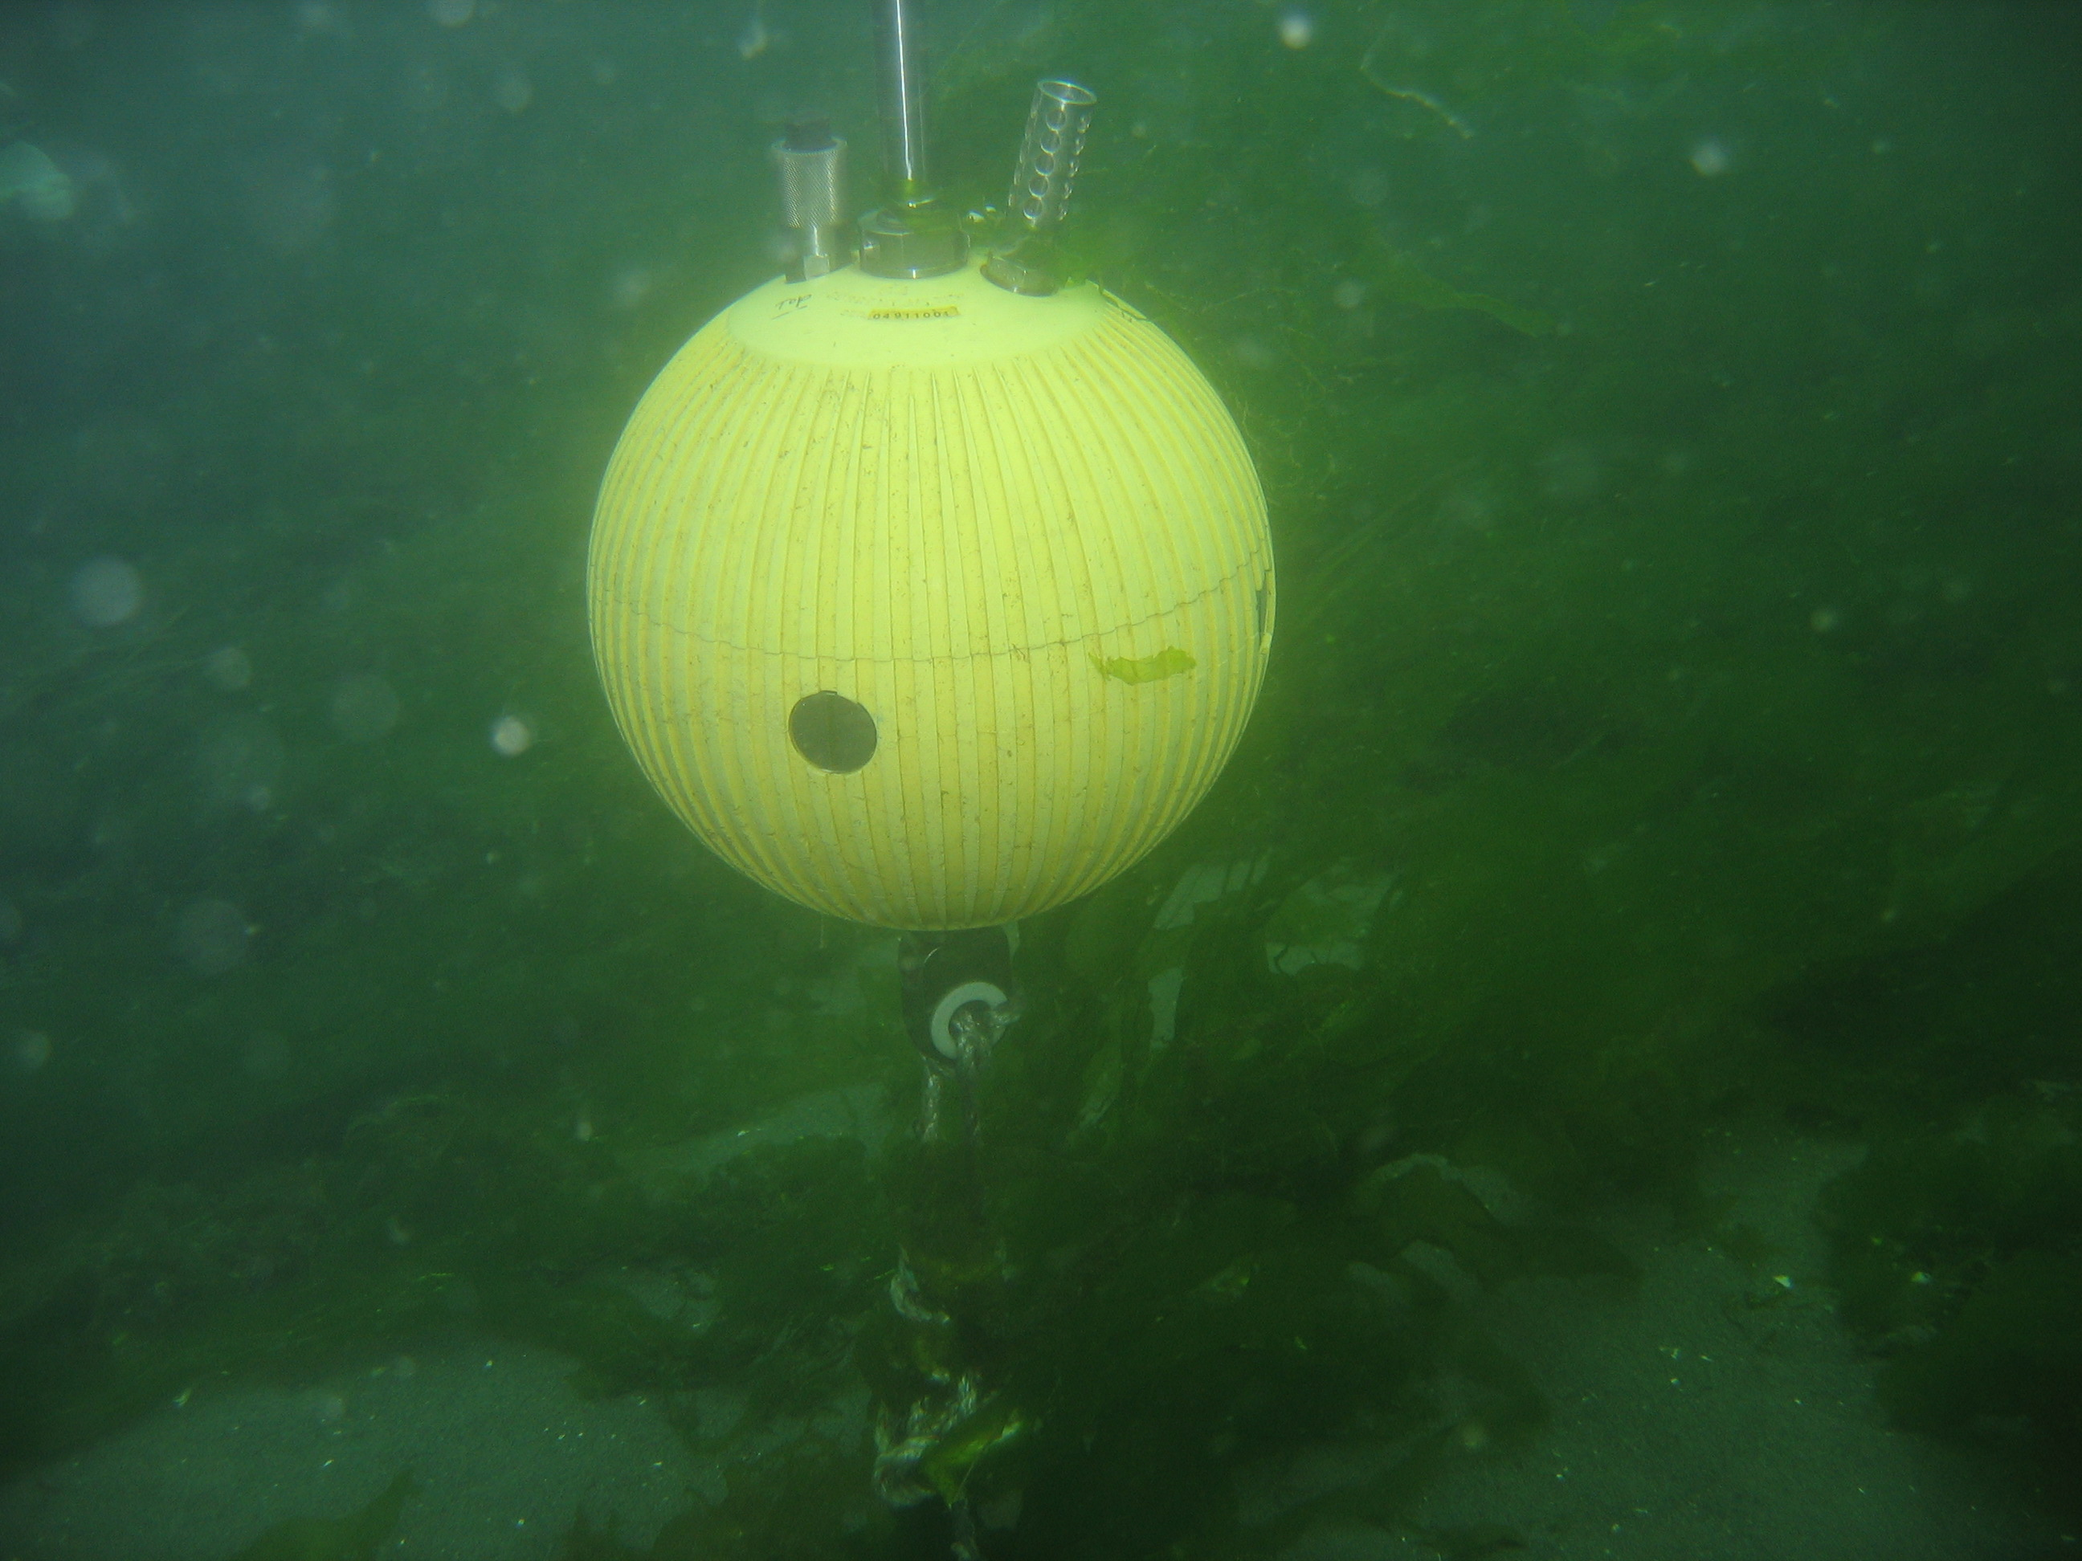

Figure 4. Inter-Ocean Model S-4 current meter deployed 1 m off the bottom.

Sea Bird CTD Deployments

Four Sea Bird Seacat 16 Plus CTD’s (Conductivity – Temperature – Depth instruments) were intercalibrated for Chl a concentration and were set in moored mode to collect periodic averages of water temperature, salinity, depth, and in-vivo fluorescence at 4 locations around the oyster planting starting on September 20, 2004 (Table 1). The instruments were moored from September 20 to October 15, 2004 with the water intake at 0.5 m off the bottom and left for several tidal cycles (Figure 5) at a sampling frequency of 10 samples averaged every 300 seconds (=7,200 samples).

Table 1. September 2004 deployment of SeaBird SeaCat 16-plus units.

Serial No. Position (DD MM.MMM) Location

4662 44 00.921’ west of bed (control) denoted with an arrow in Figure 2.
69 32.771’

4663 44 00.949’ north of bed (control) denoted with an arrow in Figure 2.
69 32.725’

4664 44 00.910’ on bed (Goose Ledge side of bed)
69 32.734’

4665 44 00.915’ on bed (channel side of bed)
69 32.753’

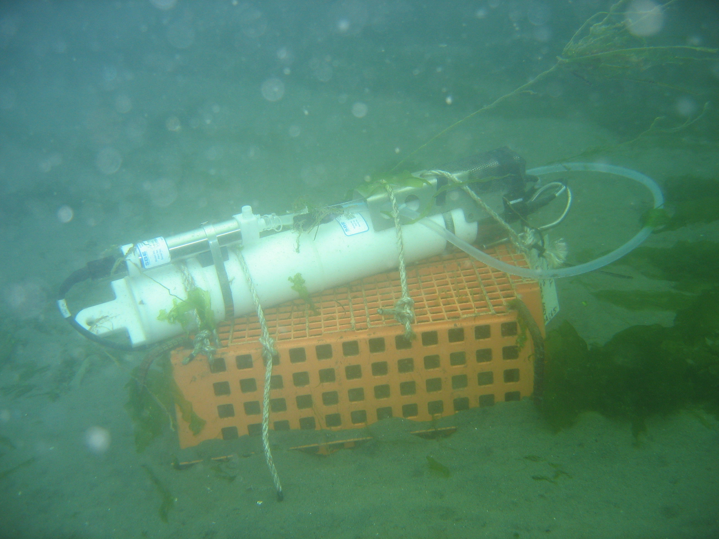

Figure 5. Sea Bird CTD in moored mode on the bottom. Note the position of the water intake tube 0.5 meters off the bottom.

Oyster Growth Experiments

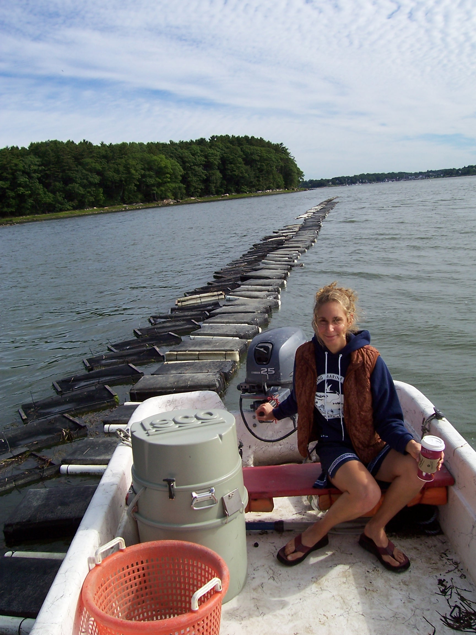
Oyster seed were placed in different locations relative to the oyster bed located along the northwest lease tract of the POC lease to see if there were differences in their growth rates in relation to food supplies and height above the bottom. It is known that food depletion develops near the bottom on shellfish beds (i.e. Muschenheim and Newell, 1992) so there should be an effect of height off the bottom on oyster growth. In addition, oyster higher off the bottom would be exposed to slightly higher current velocities, and therefore a higher food flux. It was also expected that oysters located at the edges of the lease site would have higher food and grow faster, and this “edge effect” has been observed at the Damariscotta POC farms in previous years. A summer intern was recruited to perform the growth experiments and feeding experiments (Figure 6).

Figure 6. Summer intern (Karen Stamieszkin) bringing the autosampler out to the nursery lease for feeding studies.

A group of 50 oyster seed was placed in replicated 3/8 inch mesh oyster bags and placed on the bottom in the middle of the site, on the outside edge, and in treatments on the bottom and 1 m up from the bottom on June 25, 2005. The experiments were retrieved 4 months later on October 28, 2005. While there was sedimentation in the trays and some mortality, the oyster trays were sampled and measured for shell length, total weight, and dry meat weight.

Oyster feeding studies

Using natural seawater supplied with a DC powered pump, oysters in feeding chambers were used to estimate filtration rates with the biodeposition method. Flow rates through the chambers with baffles were at least 10 times the estimated filtration rates of the oysters to minimize refiltration of the seawater within the chambers. Oysters were fixed in flow-through chambers with Velcro® attached to the cupped valve, allowed to feed for 24 hours, and the feces and pseudofeces were collected separately (Figure 7).

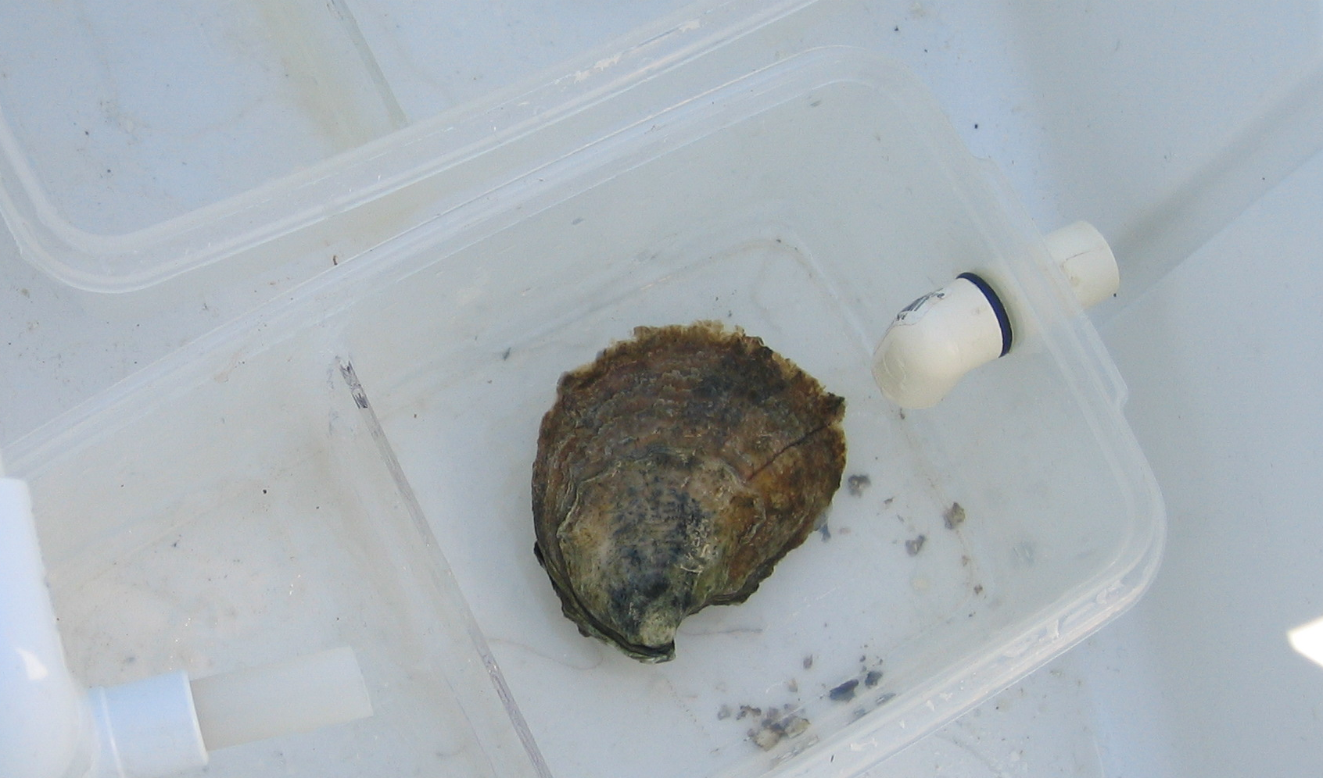

Figure 7. Oyster in flow-through biodeposition chamber.

During the feeding experiments, grab samples of available food were also taken. In some of the experiments, we used an ISCO automated sampler to take a composite sample of the water coming into the chambers every 1/2 hour over the duration of the feeding studies. Using the ash tracer method, the weight of particulate inorganic matter (PIM) in the food available (filtered on pre-weighed GFC filters and ashed at 450˚ C) is compared with the amount of PIM in the feces. For example, if there is 5 mg l⁻¹ PIM in the food and the feces PIM is 250 mg after 24 hours, the oysters have filtered 50 liters of seawater. The feeding studies were performed on July 18-19, 25-26, 28-29 and August 3-4 in 2005. A total of three oysters were used in each experiment. We corrected for natural sedimentation in the chambers during the feeding studies by subtracting the amount of PIM in control chambers without oysters.

- Results

Bathymetry

The bathymetric map of the POC bottom growing beds is illustrated in Figure 8.
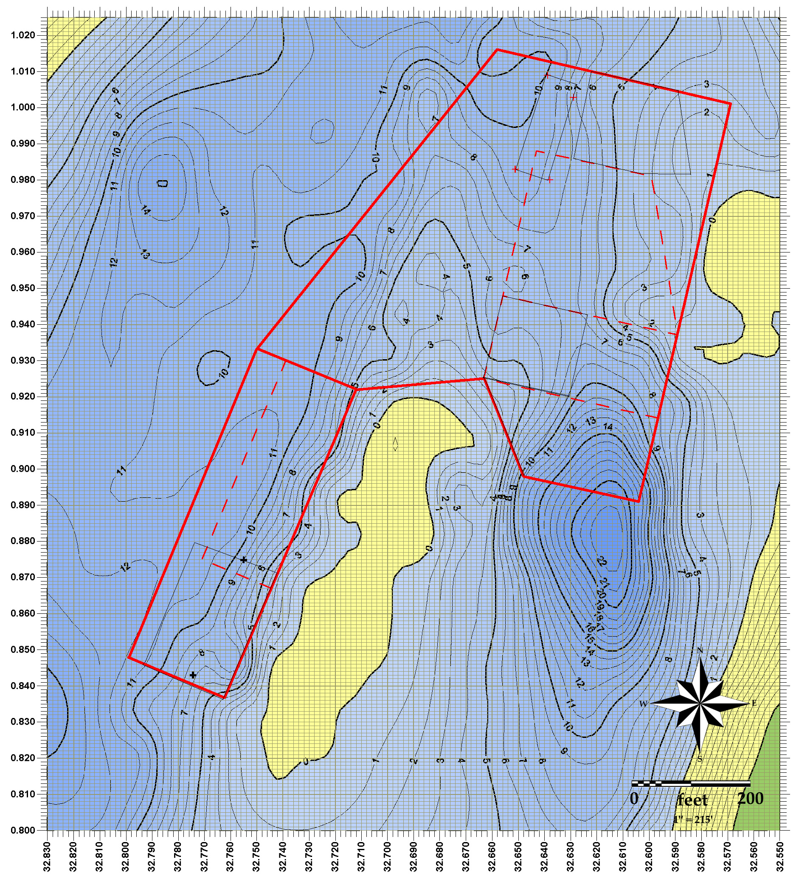

Figure 8. Final bathymetric map of the POC bottom beds. Depths are in feet above mean lower low water (MLLW). The lease boundaries are outlined in red. Dashed lines indicate specific lease tracts. The yellow areas represent the shoreline. The geographic units along the border are in decimal minutes of latitude (44⁰ N) and longitude (69⁰ W).

Current Studies
The current speed, direction and water depth for two tidal cycles is presented in Figure 9. Note that the study site is ebb dominated, with twice the velocity on the ebb tide in relation to the flood tide.

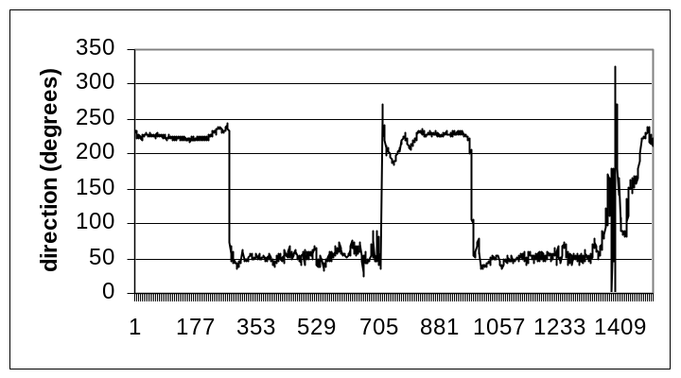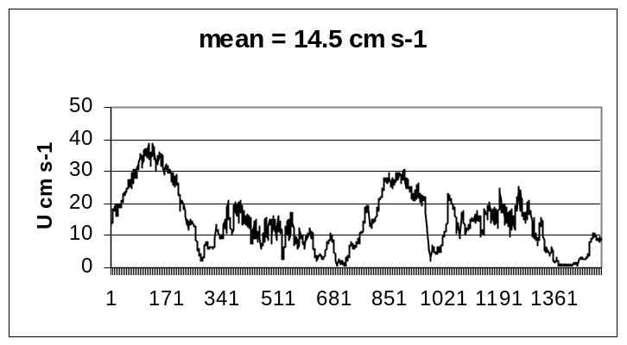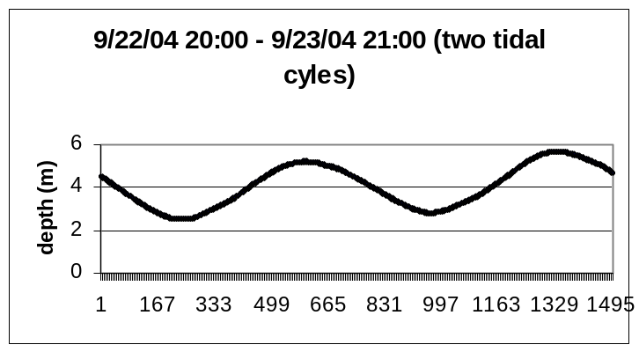

Figure 9. Current speed, direction, and water depth over 2 tidal cycles at the POC west lease site in September, 2004. The Inter-Ocean Model S-4 current meter was moored 1m off the bottom.

The current speed and direction over the entire 9 day deployment is presented in Figure 10. Note that the magnitude of velocity varies over the spring and neap cycle, but the pattern of ebb tide dominance is the same throughout the sample period. Peak spring tide velocities of over 40 cm s⁻¹ were observed on the ebb and 20 cm s⁻¹ on the flood tides. The current data was used to tune the hydrodynamic model and calculate water fluxes across the oyster lease site in relation to the filtration rates of the oysters cultivated there.

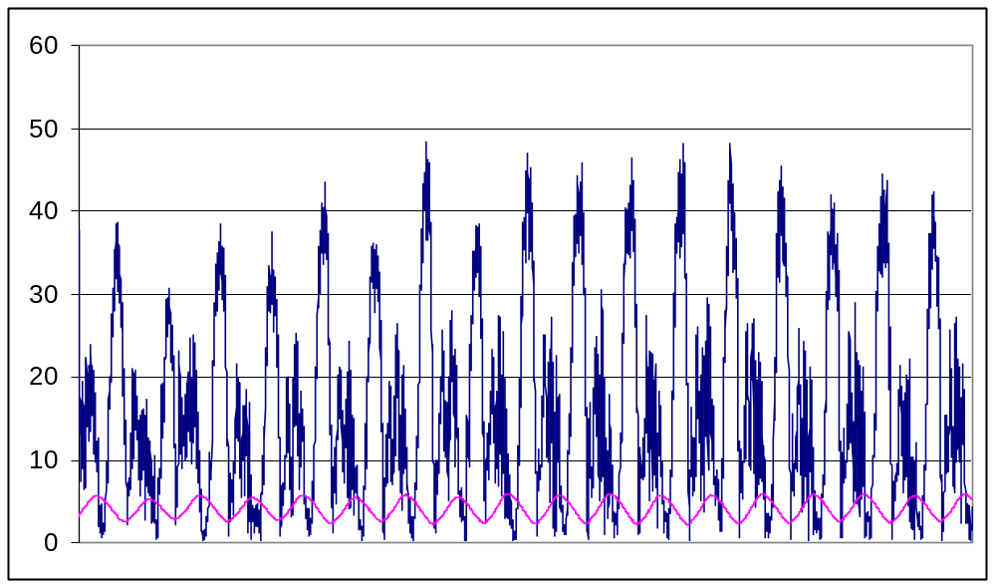

Figure 10. Current speed (cm s⁻¹) and water depth (m) at the POC lease site over 18 tidal cycles in September, 2004.

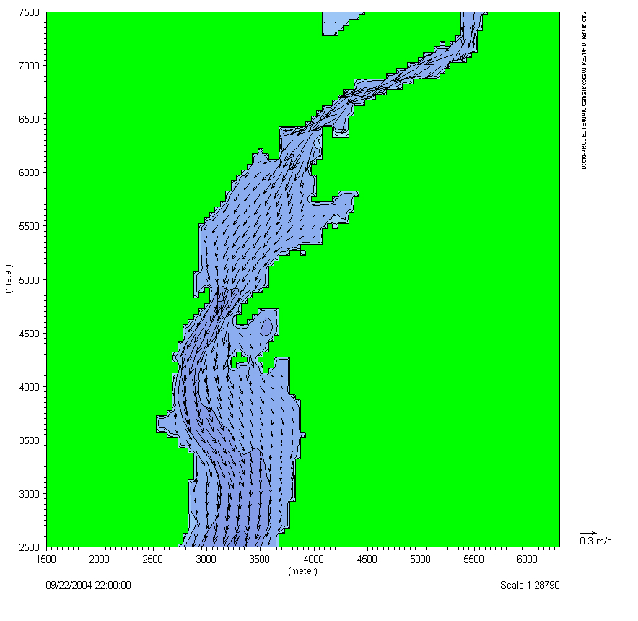
Bathymetric and current data generated by this study was subsequently used as part of an aquaculture GIS (Geographic Information System) project funded by the Maine Aquaculture Innovation Center. This project ($47,250 in funding & match), conducted by Drs. John Richardson (Blue Hill Hydraulics) and Carter Newell included development of a current model for the upper Damariscotta River estuary. A screen shot of the animated graphic display of this model is shown in Figure 11.

Figure 11. Screenshot of the current vector model for the upper Damariscotta River (Developed by Blue Hill Hydraulics for the Maine Aquaculture Innovation Center)

SeaBird CTD deployments

The in-vivo fluorescence (µg.l⁻¹) at the sample sites presented in Figure 1 and Table 1 are plotted in Figures 11 and 12 below.

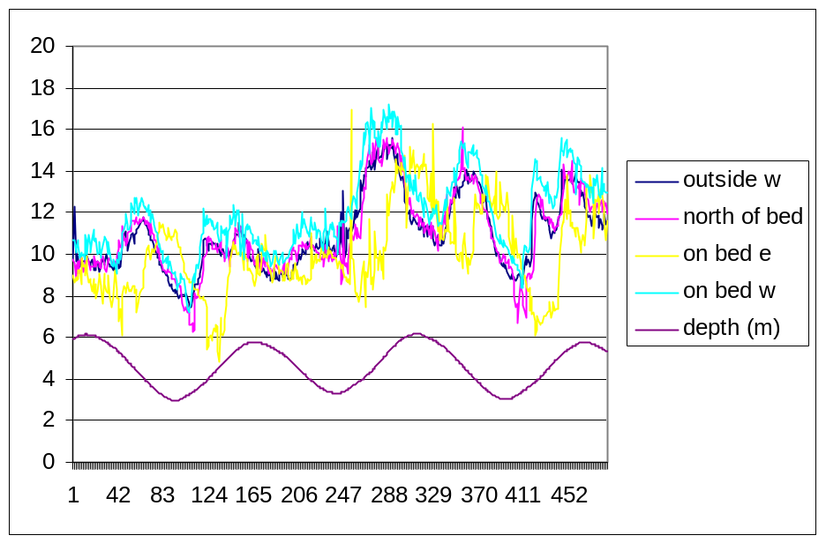

Figure 11. In-vivo fluorescence (µg.l⁻¹) from CTD’s moored around the POC planted lease site (samples 1-490).

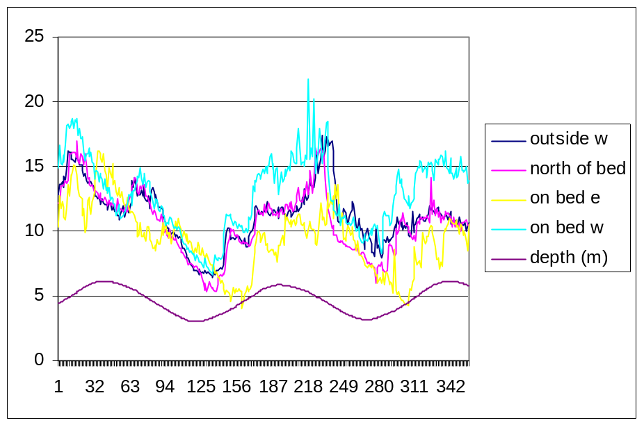

Figure 12. In-vivo fluorescence (µg.l⁻¹) from CTD’s moored around the POC planted lease site (samples 880-1230).

The mean values of chl a from in-vivo fluorescence (µg.l⁻¹) during the two deployments allow a comparison of food availability off the lease site (outside west) and on the bed on the east side (Figure 13). The food was reduced 8.7 and 10.6% for each of the two periods, respectively. Food availability was higher on the western side of the lease site (on bed w) due to higher flows and less oysters upstream than on the east side.

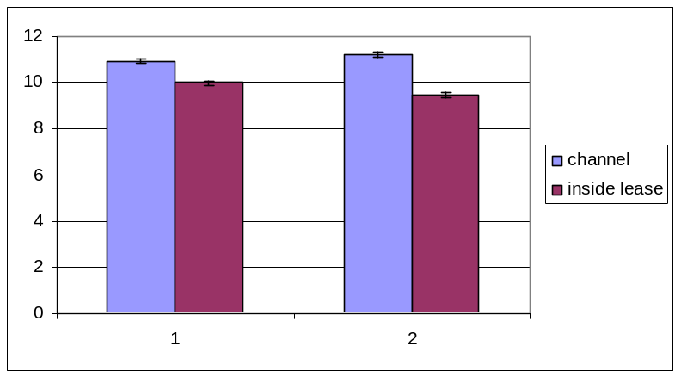

Figure 13. Mean (+/- std. error) chl a in-vivo fluorescence (µg.l⁻¹) on and off the bottom lease site.

CTD Casts
We also performed CTD casts to determine the concentration of chl a (µg.l⁻¹) over the oyster planting, upstream of the oyster planting, and off the lease site. The casts are presented in Figure 14. There were no obvious signs of depletion of chl a over the oysters. The long-term deployments of the moored CTD’s did a better job of estimating food depletion over the oysters than the profiles made at one stage of the tide.

Oyster growth studies

Final oyster dry tissue weight (g) for all the treatments for the four month growth experiments are presented in Figure 15. On the bottom, oysters grew 22% faster off the lease site than on the lease site in the middle of a planting of 500,000 oysters.

Statistical analyses were performed on the growth samples, and the effects of location (on or off the lease) were highly significant. Oysters also grew faster suspended 1 m off the bottom than on the bottom at both locations, indicating that there was more food availability (flow and concentration) at that height than on the bottom. These results may, however, been influenced by sedimentation in the chambers which was higher in the lower (on bottom) treatments.

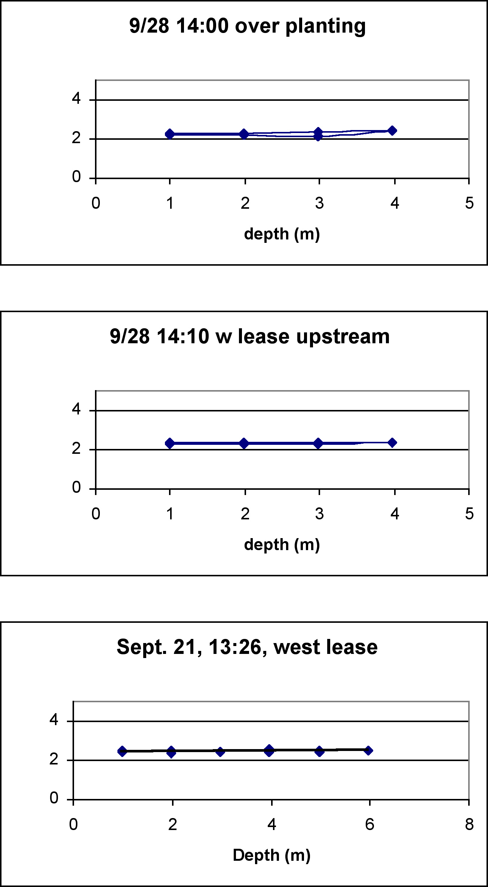

Figure 14. CTD casts for in vivo fluorescence (µg.l⁻¹) using the SeaBird CTD over the lease site.

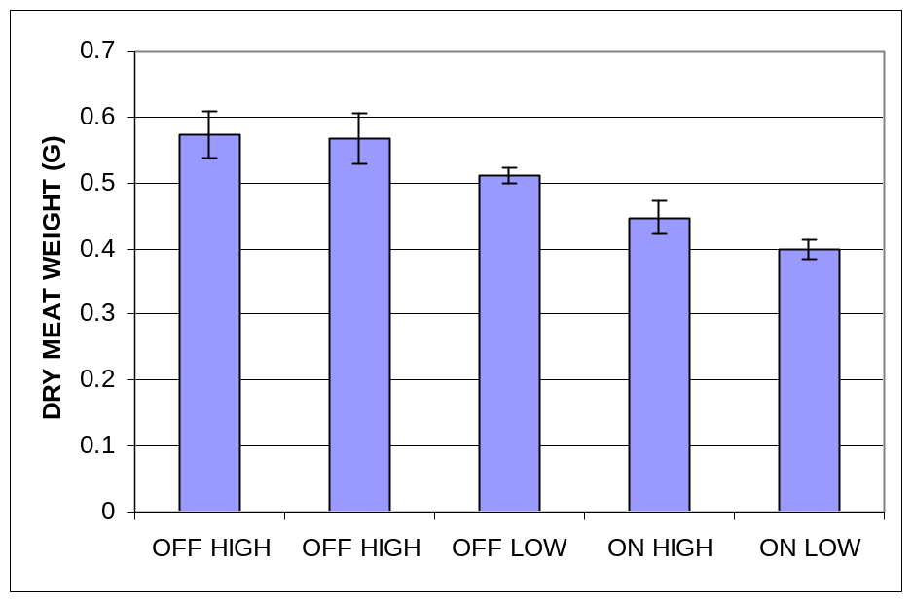

Figure 15. Final dry tissue weight (mean +/- std. error) of oysters after 4 months growth on or off the POC lease site at two different heights off the bottom.

Oyster Feeding Studies

During the July 28-29 feeding studies, fecal inorganic matter and pseudofecal inorganic matter per oyster were .35 and 1.27 g per day, respectively. Therefore, for 500,000 oysters on a lease site, they would remove about 810 kg of inorganic matter from the water column per day. Oyster filtration rates, determined from the PIM in the seawater and that in the feces, averaged 5.4 l h⁻¹ (Figure 16). For 500,000 oysters on the lease site, water filtration would be 2700 m³ d⁻¹. This data can be used to estimate particle depletion using the hydrodynamic model, and to compare with the field observed values of particle depletion above.
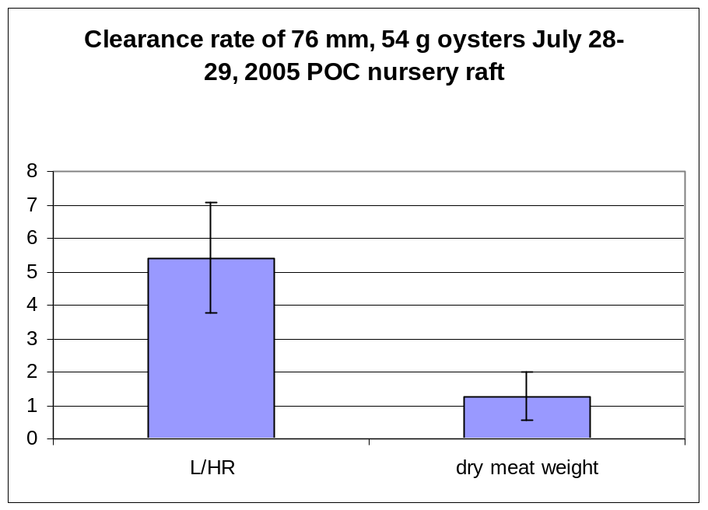

Figure 16. Clearance rates of 76 mm oysters based on the biodeposition method.

- Conditions

It appears that the growing conditions during this study were typical for this site. Temperature, salinity and chlorophyll a levels were within the ranges seen in other years. Dr. Mary Jane Perry and her graduate students have monitored Chl a levels from 2002-2006 at the Darling Marine Center, five miles downriver from the POC growing beds. Summer-time values we observed fell within the ranges observed by Perry and co-workers (Thompson et al. 2006) (Figure 17).

- Economics

The economic impacts from this study are difficult to ascertain. Clearly, the oyster feeding levels observed on and off the growing beds differ due to the density effect of oysters feeding on the bottom. We now know that (under the conditions we were able to measure), a measurable seston depletion effect occurs downstream of the oyster beds. This information will be useful in optimizing planting densities and buffer zones between oyster plantings. Furthermore, expansion of the farm, (or nearby intrusion by other competing farmers) will be influenced by the degree of seston depletion around the farm and so we may need to adjust the buffer zones accordingly. Buffer zones are useful to allow for vertical mixing of deplete bottom waters with more nutrient rich surface waters, thereby minimizing the downstream shadow effect. What is not yet know is the degree of mixing downstream of the beds. In other words, how far downstream from the growing beds does one need to travel to see the seston depletion effects minimized? The answer to his question will influence future farm management and husbandry practices (eg. Planting densities, site selection etc.).

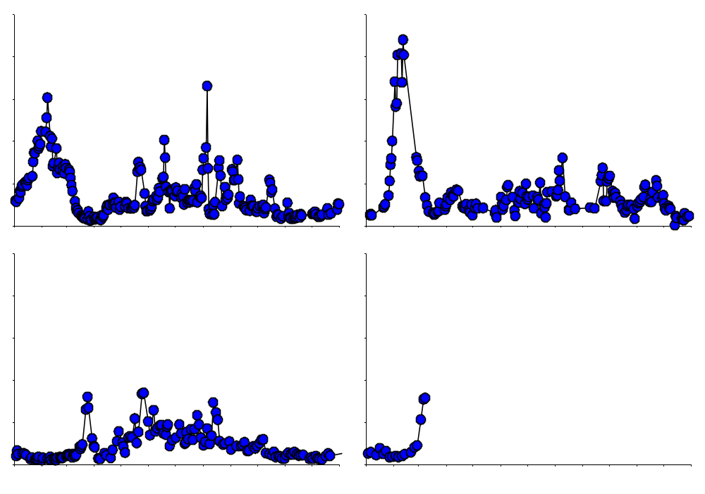
M
M
J
S
J
N
F
A
J
A
O
D
M
M
J
S
J
N
F
A
J
A
O
D
5
20
15
10
5
20
15
10
2003
2004
2005
2006

Figure 17. Inter-annual variability of Chlorophyll a in the Damariscotta River estuary (from Thompson et al. 2006)

- Assessment

This study has illustrated that oyster growth and food availability is determined by site hydrodynamics, oyster planting densities and location within a lease site. Oyster feeding rates may be combined with hydrodynamic field measurements, modeling, and field measurements of particle depletion to improve cultivation practices of the oysters in the Damariscotta River, Maine. The second aspect of this study to estimate particle flux and consumption using the results of a calibrated flow model in cooperation with Dr. John Richardson of Blue Hill Hydraulics and the results from this project.

- Adoption

Results from this study have helped POC in it’s husbandry and general farm management operations. For instance, we now have a better idea of the feed consumption rates of the oysters growing on our farm. The levels of seston depletion downstream from the beds was less than we had expected. This means that the planting densities are suitable given the environmental conditions present. Furthermore, we have a far better understanding of the relationship between current velocity, phytoplankton abundance and oyster feeding rates on our farm.

- Outreach

Results of this work have been reported to other oyster farmers in Maine via dissemination of result to the Maine Aquaculture Association’s shellfish working group. A portion of this research project was incorporated into Karen Stamieszkin’s senior research thesis at Yale University. She gave an oral presentation of her work at Yale. Finally, these results have been disseminated to the Damariscotta River Association (DRA) and the Maine Department of Marine Resources (MEDMR). The DRA is the estuary’s environmental organization with an interest in the shellfish aquaculture activities on the river. The MEDMR is also concerned about husbandry practices and site selection issues and has expressed an interest out results.

- Report Summary

The goal of this study was to elucidate the productive capacity of the Damariscotta River for oyster farming. This was done by studying the temporal dynamics of seston food supply, transport and consumption by oysters on the POC growing beds. This was done by 1) documenting and monitoring the phytoplankton flux using chlorophyll a as a proxy for algal biomass, 2) determining the bathymetric characteristics of the sea bed, 3) estimating the tidal currents in the vicinity of the oyster beds 4) determining the feeding rates of oysters under both natural conditions and in individual feeding chambers using natural phytoplankton assemblages. This project resulted in the production of a bathymetric chart for the POC bottom leases. Tidal currents were determined to be ebb flow dominated with twice the velocity on the ebb versus the flood tides. Observations of seston depletion downstream of the growing beds account for an approximate 10% reduction in levels of food availability. Finally, feeding studies of individual oysters, enabled us to estimate the overall volume of water processed by oysters on our farm. These results will assist us in improving our husbandry practices as well as our overall farm management.

References

Newell, C.R. and S.E. Shumway. 1993. Grazing of natural particulates by bivalve molluscs: a spatial and temporal perspective. In: Bivalve Filter Feeders in Estuarine and Coastal Ecosystem Processes, Ed. R.F. Dame. NATO ASI Series V. G33 p. 85-148.
Newell, C.R. and D.E. Campbell and S.M. Gallagher. 1998. Development of a mussel aquaculture lease site model MUSMOD©: a field program to calibrate model formulations. J. Exp. Mar. Biol. Ecol. 219: 143-169.
Campbell, D. and C.R. Newell. 1998. MUSMOD©, a mussel production model for use on bottom culture lease sites. J. Exp. Mar. Biol. Ecol. 219: 171-203.
Muschenheim, D.K. and C.R. Newell. 1992. Utilization of seston flux over a mussel bed. Mar. Ecol. Prog. Ser. 85: 131-136.
Thompson, B., M.J. Perry and C.V. Davis. 2006. Variability of Phytoplankton Biomass in the Damariscotta River Estuary. J. Shellfish Res. 25(1). Abstract.

Prepared by Christopher Davis
November 21, 2007

