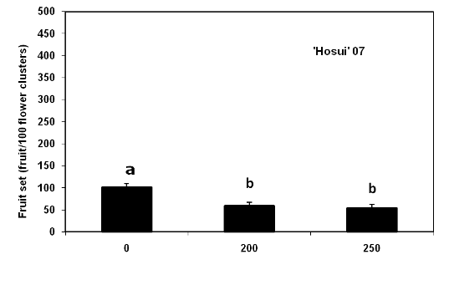
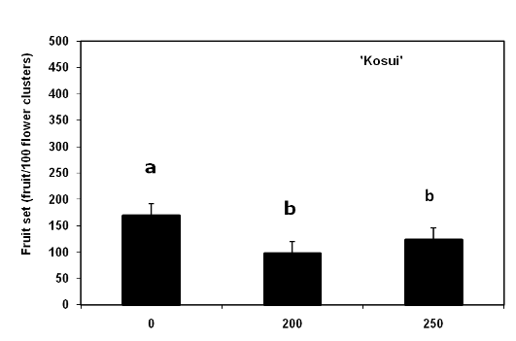
Figure 1. Average fruit set of Asian pears in Northern New Jersey treated with a cytokinin formulation (MaxCel) by cultivar and concentration (ppm).

