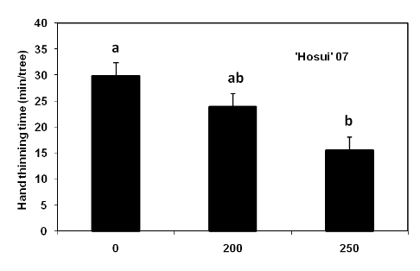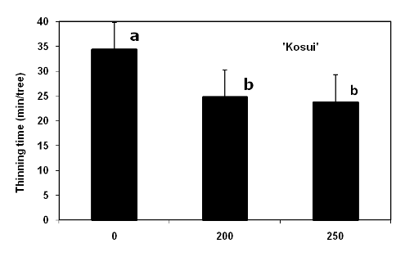
Figure 2. Average time required for hand thinning of Asian pear fruit in Northern New Jersey following treatment with a cytokinin formulation (MaxCel) by cultivar and concentration (ppm).

