1. Project name and contact information

Organic Edible Soybean Variety Trials in Northern VT for Soymilk & Tofu Production
Nicholas Meyer
North Hardwick Dairy
802-472-8889

2. Goals

To determine which edible soybean can be grown in the short growing season of Northern VT on a larger scale to sell as a cash crop for food production.

3. Farm Profile

North Hardwick Dairy is located in the Northeast Kingdom in the town of Hardwick. A family run certified organic dairy operation that produces high quality milk and grows quality forage by means of working the land. The farm has 200 acres of tillable land and pasture. Crops grown are a mix of grasses, peas and oat mix, BMR sorghum grass, tritical, corn for grain, and sunflowers for oil and feed meal. The farm milks 67 Holstein cows and raises all of its own replacements. The long-term goal of the farm is to be 100% self-sufficient; recently adding a wind turbine to produce electricity and future plans of a bio-diesel processing facility.

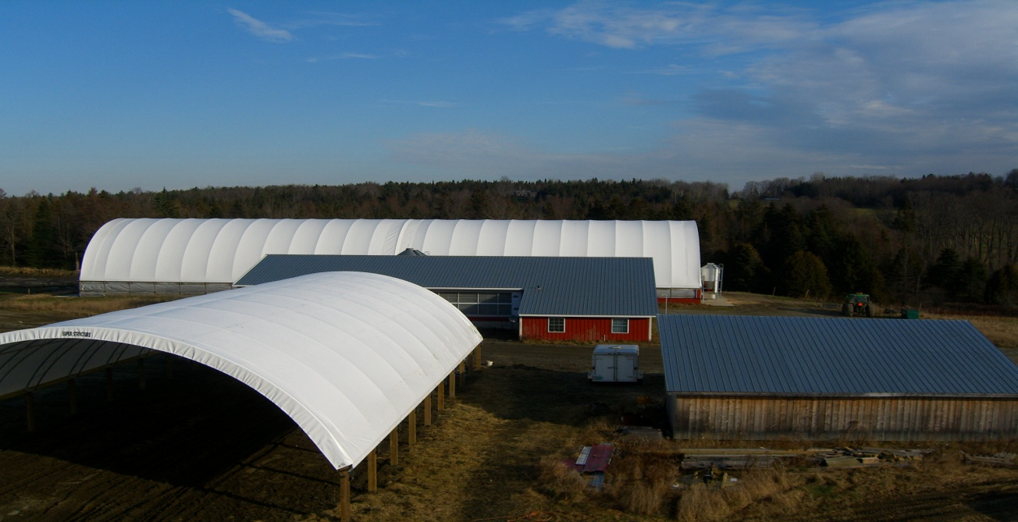

4. Participants

Our technical advisor was UVM extension agent Dr. Heather Darby. Dr. Darby oversaw and advised us on the seed planting, cultivating methods, soil testing and trouble shooting methods and techniques. High Mowing Seeds located in Wolcott, VT provided technical assistance regarding soybean varieties. Vermont Soy collaborated with outreach, networking and market information.
5. Project activities

On May 29th, 2007 we planted 6 acres of soybeans and on June 15th, 2007 we planted 4 acres of soybeans at a different location. At location one the field was divided for two soybean varieties. We planted Blue River Organics #00F84 with a .08 maturity rate. Aimed for 175,000 plants per acre with the seeds planted 7 to 10 beans per foot. The planting was done with a Case International 5100 Soy Bean Special Drill Seeder. The seeding rate was set at 32 with the 14-tooth sprocket and planted 2 inches deep. The drill seeder holes in the hopper were plugged to create 28-inch row spacing. The second variety planted at this location was Lotus I.P. 2500 Canadian heat rating with a .05 maturity rate. The seed came from Pro Grain in Quebec and was untreated. The planting was the same except these beans are slightly larger in size so the drill seeder was set at 36. For both plantings N-Charge Organic Inoculant was mixed with the seed in the hopper along with Vita-Stim to promote growth.

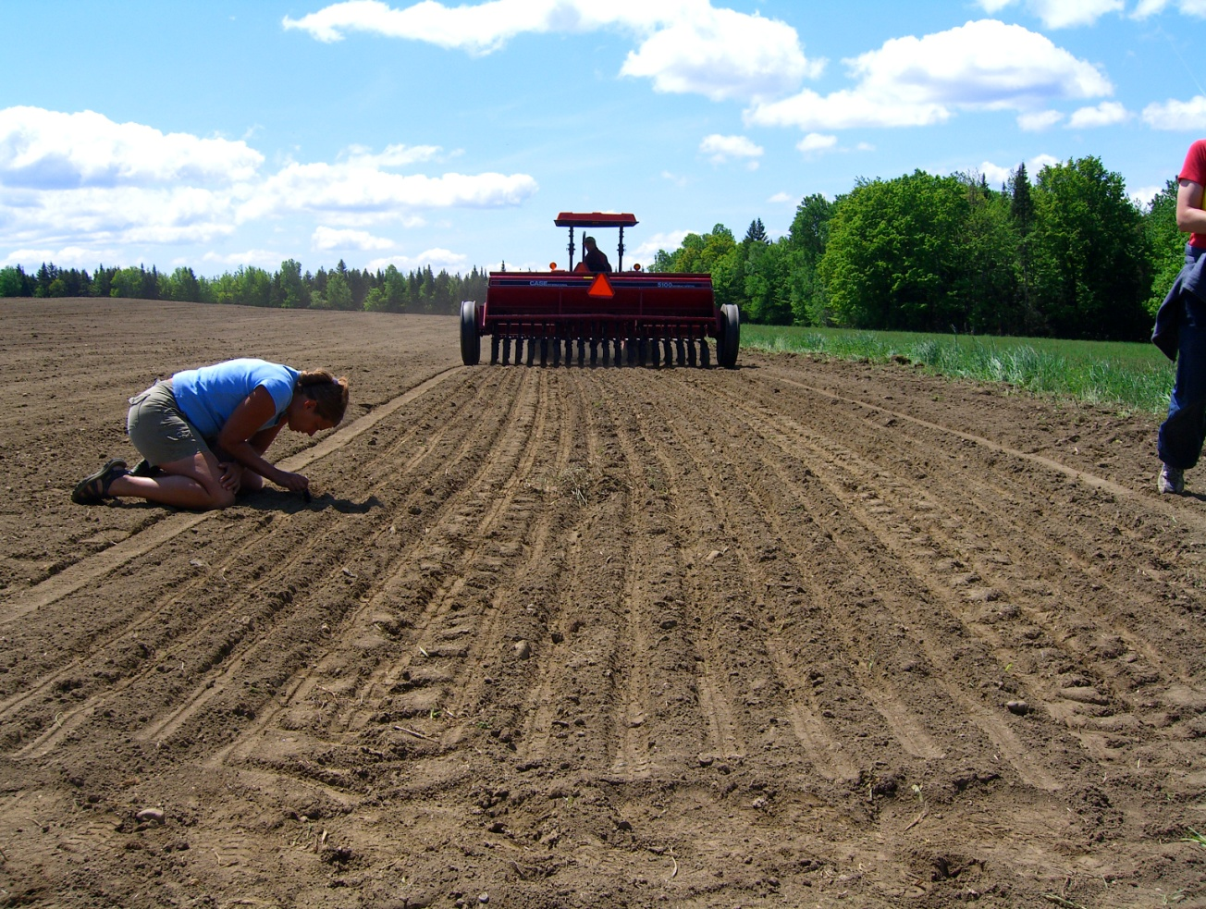

Tine weeding should be done 4 to 5 days after planting to break any cycles of new weeds. The tine weeder is dragged behind the tractor and done ideally at a 45-degree angle of however the field was planted. We could not locate a tine weeder at the 4 to 5 day time because it was in use by other farmers and we also were hit with a lot of rain for a week, which made the field slick and muddy and unable to take on equipment.
Cultivation should be done when the bean is 4 to 6 inches tall. We used a Brillion 4 row cultivator. Small chisel like plows are dragged in between the rows, ripping up any weeds and pushing dirt on the base of the soybean plant so weeds will not choke the plant. Cultivation should be done again when weeds reappear or until the soybean plant has developed a canopy to shade out the weeds.

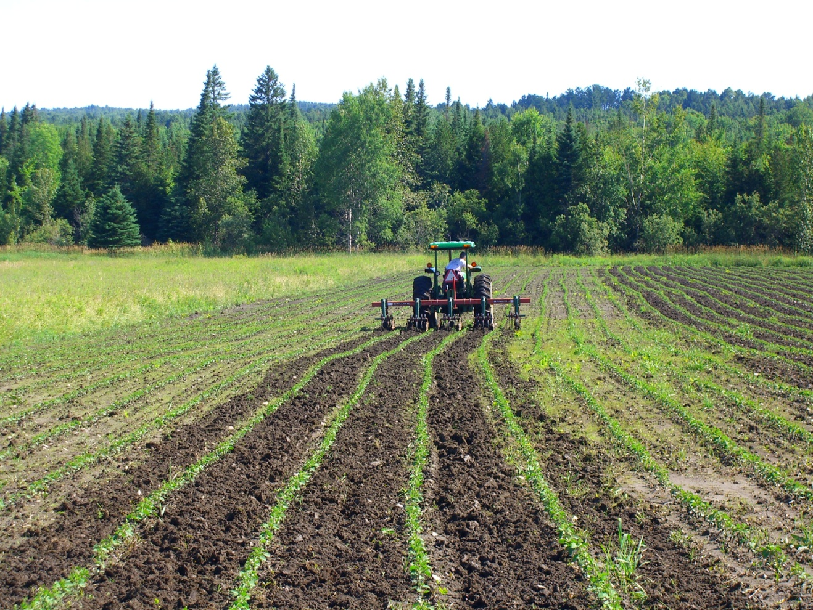

In Location two we planted the Lotus I.P. Soybean. We did everything the same as location one but planted the rows in 36 inch spacing. We did this because the Brillion cultivator will not work with a 28-inch row. The tractor tire and one of the chisel plow type units on the cultivator will run over a row.

6. Results

The results varied from poor to good. In location one the weeds were such a factor that they choked the soybean plant and it did not grow. Critical components include twine weeding at the right time and cultivating to halt any weed growth. Location one was unsuccessful. Location two grew well. The 36-inch row worked excellent for the cultivator and the soybean plant looked healthy and strong. We encountered another problem in location two and that was deer. Deer love soybeans, so such they would walk down the rows and eat the tops off of the plants. This stunted the growth of the plant and because of this the plant produced less pods than normal. Soybean plants normally have 30 to 40 pods per plant; our beans only had 5 to 10 pods. The plants did grow and weeds were not an issue, but the deer devastated this crop for high yield. The beans dried down enough so they rattled in the pod. At the time of harvest a flex head break down on the combine delayed the operation long enough for an early snowstorm to bury the beans. Location two was successful for growing the beans. Deer did lower the yield but learning and discovering that growing soybeans in the Northeast Kingdom can be done is very encouraging.

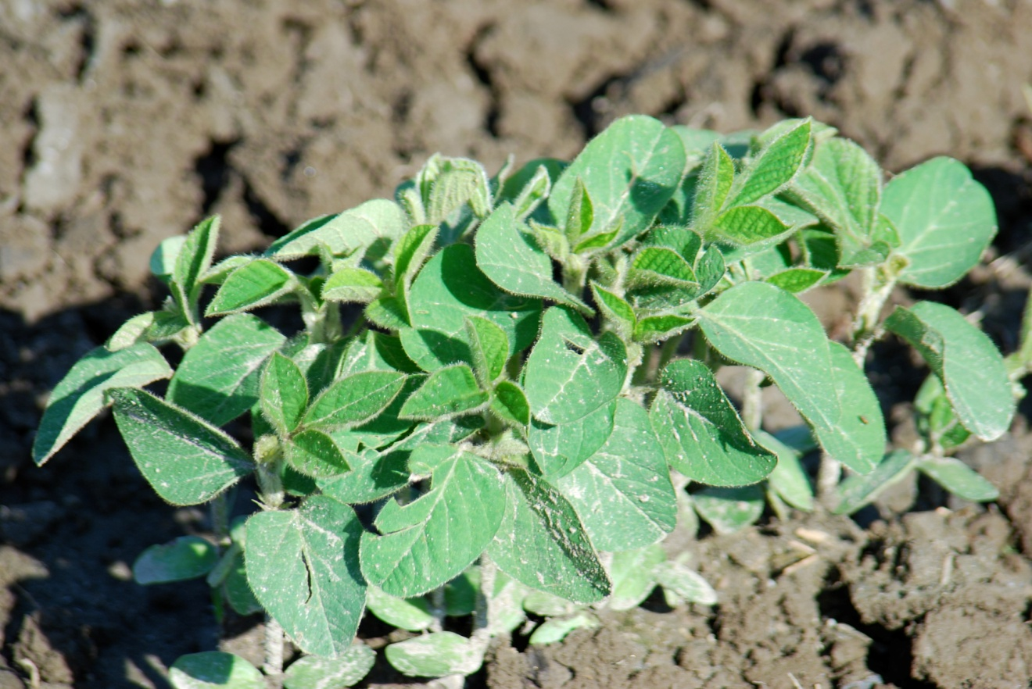

7. Conditions

Early rain and early snow affected our results. Heavy rains after planting made it impossible to tine weed at the correct time. At location two, due to wet conditions, the planting date was pushed to a later date, creating even shorter growing days and increasing the risk of snow during harvest time. We had an early winter and lots of snow.

8. Economics

Knowing that we can grow soybeans creates a great opportunity to plant this crop on a yearly basis. The price of grain for farmers is at an all time high with no end in site. Since beans can be grown and sold at a good price, then yes this will boost net farm income. Also by incorporating a crop rotation program on the farm, then the equipment needed to grow beans can be used for those other crops. Beans can also be grown to offset grain prices by mixing soy with other homegrown grains to feed the animals. It’s a win – win situation. The market for edible beans created by Vermont Soy, located in Hardwick, VT increases our farms interest in producing a high quality crop.

9. Assessment

Learning how to trouble shoot the issues involved with growing high quality soybeans in Northern Vermont is worth the time and energy. Based on our experience under the SARE project, we plan to continue to grow soybeans. To improve our chances of producing a high quality, mature crop, we will use the information attained in our trials and apply it to future plantings.

We will approach new seedings with lessons learned from the trials. We will address the importance of site location by planting a field by the main highway or road may keep deer away. Planting the beans in a 7-inch row may be better because we can grow more beans in less area. Also there is less room for weeds to take over. Spraying the soy plant as it grows with a product that is garlic based will deter the deer and promote growth. Planting as early as possible is key in this short growing season. Fields that will be growing soy should be well drained so one can get on them early in the spring.

10. Adoption

Although this project was based on determining how and why to grow edible soybeans, we have become more aware of the benefits of growing soybeans for additional on farm uses as well. Although our plantings did not get to be harvested we will grow soybeans again. The potential for edible soybeans as a cash crop is notable as well as growing our own grains for animal feed. In addition, our understanding now of incorporating soybeans in crop rotations is very important because it builds the soil to produce high quality forage and feed.

11. Outreach

In effort to share our soybean trial project and information we worked closely with Vermont Soy. Our beans, once harvested were intended to be tested and evaluated in the production of soymilk and tofu by Vermont Soy. Since both plantings were unable to be harvested the results of our beans could not be tested. Fortunately, Vermont Soy, along with the trials conducted on our farm, were conducting similar trials on other farms in conjunction with the University of Vermont’s Agriculture Innovations program through the College of Agriculture and Life Sciences. Other trials around the state were able to provide useful harvest information. A report, which includes evaluations of beans both in the field and the lab was published and is available for interested farmers. Vermont Soy monitored our project closely learning about the issues we faced. As part of this project’s outreach, Vermont Soy included information on their website inviting interested farmers to contact them about growing soybeans. Throughout the growing season Vermont Soy fielded inquires from interested farmers and landowners about growing soybeans. Vermont Soy referred several local interested farmers to our farm. During our trial we invited these and other farmers to visit our test plots. Because of our trial we were able to build a network of resources that we and other farmers can more easily contact and learn from in future crops and plantings.

To inform and educate Vermont farmers about not only the trials conducted on our farm, but also other trials around the state, Vermont Soy hosted a booth at the 2008 Farm Show. Vermont Soy displayed the different edible soybean varieties grow in Vermont during the 2007 crop year, along with information about how farmers could become involved. Vermont Soy also sampled their soymilk to give Farm Show attendees a sense of what fresh soymilk made from Vermont grown soybeans tasted like. In addition to the educational outreach at the Farm Show, Vermont Soy invited interested growers to visit both High Mowing Seeds and the Vermont Soy facility. This tour enabled growers to understand the issues involved with cleaning and storing soybeans as well as the process of converting the raw bean into a finished product.

As the 2007 growing season approaches Vermont Soy continues to share information learned from the trial conducted on our farm.

12. Report Summary

Vermont Soy, producers of fresh organic soy products have created a market for high quality edible soybeans in the state of Vermont. To meet the potential of this market, the project’s goal was to determine which variety of soybean would not only grow best in Northern Vermont’s short growing season, but create a high quality, great tasting soy product. To be successful, soil preparation had to evaluated, planting and cultivating methods had to be timed and determined, bean varieties had to matched to the conditions of the geographic area, and above all the weather conditions, mother nature and predators had to be dealt with. Although our beans were unable to be harvested due to weather and predator damage, several important issues relating to bean variety, cultivating and planting methods were learned and realized. The process of experimenting with a new crop under the expertise and guidance of UVM extension agent Heather Darby enabled us to gain a depth of knowledge and information that gives us the confidence to continue and try again next year.

This project, although it did not meet its goals of harvesting the crop, will prove successful in moving the effort to establish soybeans as a profitable diversified crop forward.

Nicholas Meyer 4/28/08

