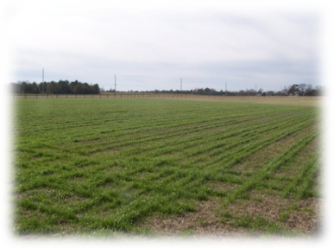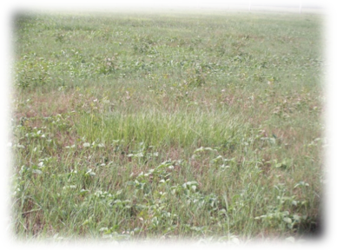
(a) (b)
Figure 2. Winter (a; February, 2010) and summer (b; July 2010) forage fields.

