SEMIOCHEMICAL-BASED TRAPPING METHODS FOR WEEVIL PESTS ON GUAM | 2010
Western Pacific Tropical Research Center
University of Guam
Mangilao, Guam 96923

Table of Contents

Section | Total # of Pages in Section | Starts on  Page #
1. Table of Contents | 1 | this page
2. Major Participants and Acknowledgements | 1 | 2
2. Banana root borer, Cosmopolites sordidus | 4 | 3
3. New Guinea sugarcane weevil, Rhabdoscelus obscurus | 5 | 7
4. Sweetpotato weevil, Cylas formicarius | 4 | 12

Major Participants:
Dr. Gadi V.P. Reddy Chemical Ecologist/Entomologist,
Project coordinator University of Guam

Dr. Robert K. Vander Meer Research Leader and Chemist,
Co-project coordinator USDA-ARS, Gainesville, FL 32608

Dr. Jack Tenorio Entomologist
Major participant Northern Marianas College, Saipan

Mr. Jesse Bamba Extension Associate
Major participant Cooperative Extension Service,
University of Guam

Personnel from Chemical Ecology/Entomology Laboratory, University of Guam:

Rosalie R. Kikuchi, Research Assistant-III
Jenelyn E. Remolona, Research Assistant-I
Mary Rose Canlas, Research Assistant-I
Nicole Kim Reyes, Research Assistant-I
Raymond Gumataotao, Agricultural Technician

ACKNOWLEDGMENTS
This project was supported by USDA-Western SARE, Professional Development Program (PDP) grant#2009-47001-05389, operated at the Utah State University. In accordance with federal law and USDA policy, this institution is prohibited from discrimination on the basis of race, color, national origin, sex, age, or disability.
Any opinions, findings, conclusions, or recommendations expressed in this publication are those of the authors(s) and do not necessarily reflect the view of the U.S. Department of Agriculture.

1. Banana root borer, Cosmopolites sordidus (Germar)
(Insecta: Coleoptera: Curculionidae)
In the past years, most bananas in local markets were imported from other countries. Today, banana growing has become increasingly popular among farmers in Guam and plantations can be seen throughout the island. One of the most serious insect pests of bananas is the banana root borer, Cosmopolites sordidus. The larvae of the banana root borer tunnel in the corm (Figure 1), weakening the stability of the plant and interfering with nutrient uptake. Relatively little damage is caused by adults feeding on plant tissues. Borer attack can lead to poor crop establishment, plant loss due to snapping and toppling, lower bunch weights, mat disappearance (failure to produce suckers) and shortened plantation life (Rukazambuga et al. 1998, McIntyre et al. 2002, Gold et al. 2004). Yield losses increase with time and can exceed 50%. The banana root borer’s host range is restricted to Musa and Ensete (Musaceae). The complete life cycle is from 30 to 40 days; egg five to seven days; larva 15 to 20 days, pupa six to eight days. Adults are long-lived (up to four years), nocturnally active and have low fecundity (< 2 eggs/week) (Figure 2; Gold et al., 2001). The presence of this weevil on Guam and other islands raises concern among growers, consumers, and scientists alike.

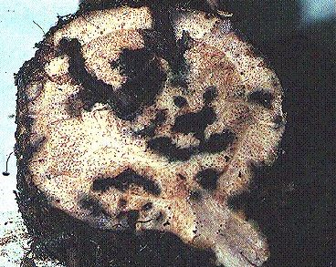

Figure 1: Banana root borer damage to corms

The weevil is native to Malaysia and Indonesia but it has spread to nearly all banana-growing areas of the world, such as, Australia, Africa, Central and South America, Florida, Mexico, some Pacific islands, South and Southeast Asia and the West Indies. It was first reported in Hawaii on the island of Oahu in 1981 and has spread to Hawaii, Kauai, Maui and Molokai. It has been reported from the Marianas since the early 1940s. Recently, this borer has become a very serious problem in commercial banana farms of Guam and the Northern Mariana Islands.
The data from our previous trapping studies indicated that a higher population level (>10/week) was recorded in the northern region while lower (<5 weevils/week) to medium level (5-10 weevils/week) populations were found in the southern parts of the island (Reddy et al. 2008). This weevil can cause a yield loss of up to 100% if it left uncontrolled. Recommendations for the integrated pest management of the banana root borer have emphasized cultural controls, including the use of clean planting material, pseudostem trapping, and crop sanitation (i.e. destruction of crop residues). Trapping with synthetic pheromones (based on the male aggregation pheromone sordidin) has also been promoted (Reddy and Guerrero 2010). While a number of banana root borer predators are reported, and attempts at biological control using predatory beetles throughout the Pacific were made, most were disappointing (Gold et al. 2001).
The number of pseudostem traps a farmer can use in a field is restricted by the number of recently harvested banana plants and the amount of crop residues available. The weevils prefer moist environments and are most commonly found hidden in banana leaf sheaths, in the soil around the base of the mat, or in undercut residues. Flight is uncommon. Dispersal by means of crawling appears to be slow.

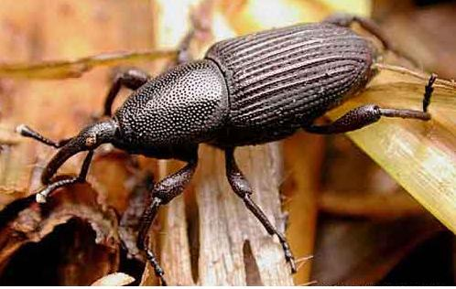

Figure 2: Adult banana root borer, Cosmopolites sordidus

Trapping Technique Developed by the Chemical Ecology and Entomology Laboratory at the Western Pacific Tropical Research Center, University of Guam.

Trap Type: The ground trap (Figure-3) was constructed and developed at the Chemical Ecology and Entomology Laboratory at the Western Pacific Tropical Research Center, University of Guam from a 120- × 60- × 0.5-cm piece of white corrugated plastic board, with a 50- × 8-cm slitted baffle fitted at the top to prevent borers from escaping (Reddy et al. 2005).

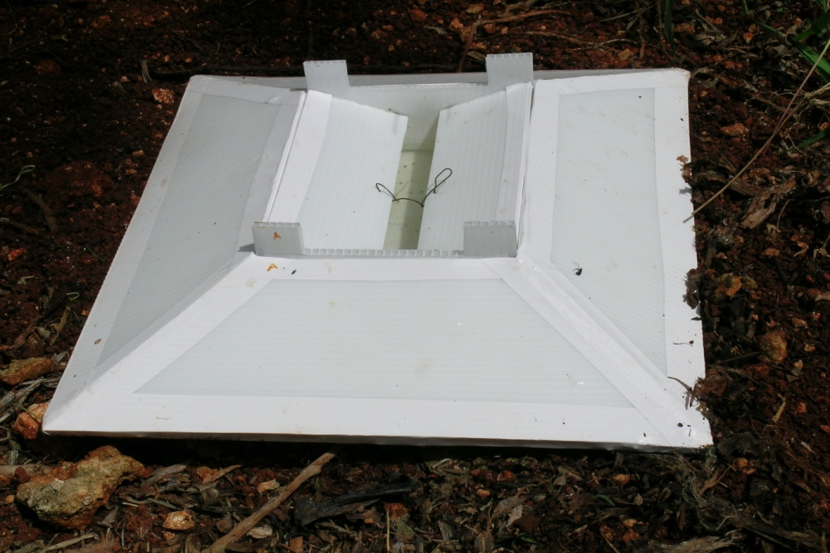
Figure 3: An effective ground trap used for monitoring and control of banana root borer

Size of Trap: Our previous studies indicated that, mahogany-brown ground traps 40 × 25 cm appear to be the most efficient at catching banana root borer adults in the field and have the greatest potential for use in mass trapping and programs for control and eradication of this pest (Reddy et al., 2009).
Pheromone Lures: Pheromone lures (Cosmolure), sealed in a polymer membrane release device and optimized for C. sordidus, can be obtained from ChemTica Internacional S.A. (San José, Costa Rica). The lure packs, each containing 90 mg of pheromone and having a release rate of 3 mg/day, have to be stored at 4°C until use. Lures are hung on 2-cm wires suspended across the tops of the ground traps. The lures have to be changed when the transparent container with the pheromone appears empty, usually once or twice a month, although occasionally more frequent changes are necessary.
Inter-Trap Distance: Pheromone traps are limited by cost: Manufacturer recommendations are to employ four pheromone-baited traps per ha in a single line spaced at 20 m apart.

Placement of Trap: As its name indicates, the trap is placed on the ground. Moreover, pheromone baited ground traps positioned in the shade of the canopy caught significantly more adults than those placed in sunlight (Reddy et al. 2009).

Baiting Traps: Traps were sealed at all four corners and along edges with marine adhesive sealant, and water mixed with a dishwashing liquid detergent (1–3%), was put in the bottom of the container to retain adults. The lower outer edges of the ground traps were covered with earth to prevent weevils from crawling under the traps. Each one-two month interval, the lure has to be replaced and the trap line moved 20 m such that the entire field is systematically covered every 4 months. This assumes (1) that the traps will capture most of the weevils within a 15 m radius of the trap and (2) that there will be limited reinvasion of cleaned areas after removal of the trap. Thus, the benefits of trapping and other management methods may be offset by immigration of adult weevils from neighboring stands or untreated parts of the field (Gold et al. 2001, 2002).

References Cited

Gold, C.S., G.H. Kagezi, G. Night, and P.E. Ragama. 2004. The effects of banana weevil, Cosmopolites sordidus (Germar), damage on highland banana growth, yield and stand duration in Uganda. Ann. Appl. Biol. 145: 263–269.

Gold, C.S., J.E. Peña and E.B. Karamura. 2001. Biology and integrated pest management for the banana weevil, Cosmopolites sordidus (Germar) (Coleoptera:Curculionidae). Integ. Pest Manage. Rev. 6: 79–155.

Gold, C.S., S.H. Okech, and S. Nokoe. 2002. Evaluation of pseudostem trapping as a control of banana weevil, Cosmopolites sordidus (Germar), populations and damage in Ntungamo district, Uganda. Bull. Entomol. Res. 92: 35–44.

McIntyre, B.D., Gold, C.S., Kashaija, I.N., Ssali, H., Night, G. and Bwamiki, D.P. 2002. Effects of legume intercrops on soil-borne pests, biomass, nutrients and soil water in banana. Biol. Fert. Soils 39:74-79.

Reddy, G.V.P., Z.T. Cruz, and A. Guerrero. 2009. Development of an efficient pheromone-based trapping method for the banana root borer Cosmopolites sordidus. J. Chem. Ecol. 35: 111–117.
Reddy, G.V.P., and A. Guerrero. 2010. New pheromones and insect control strategies. Vitam. Horm. 83: 493–519.
Reddy, G.V.P., R. Fettköther, U. Noldt, and K. Dettner. 2005. Capture of female Hylotrupes bajulus as influenced by trap type and pheromone blend. J. Chem. Ecol. 31: 2169–2177.
Reddy, G.V.P., Z.T. Cruz, F. Naz, and R. Muniappan. 2008. A pheromone-based trapping system for monitoring the population of Cosmopolites sordidus (Germar) (Coleoptera: Curculionidae). J. Plant Prot. Res. 48: 515–527.

Rukazambuga, N.D.T.M., C.S. Gold and S.R. Gowen. 1998. Yield loss in East African highland banana (Musa spp., AAA-EA group) caused by the banana weevil, Cosmopolites sordidus Germar. Crop Prot. 17: 581-589.

2. New Guinea sugarcane weevil, Rhabdoscelus obscurus (Boisduval)
(Insecta: Coleoptera: Curculionidae)
The New Guinea sugarcane weevil, Rhabdoscelus obscurus (Boisduval) (Coleoptera: Curculionidae) is a very serious pest of ornamental palms and coconut plantations on the Mariana Islands and other Pacific islands (Muniappan et al. 2004). On Guam, R. obscurus is a major pest of ornamental and other palms such as coconut palm (Cocos nucifera L.), betel nut (Areca catechu L.), champagne palm (Hyophorbe lagenicaulis (Bailey);), pritchardia palm (Pritchardia pacifica Seem. & H. Wendl.), pygmy date palm (Phoenix roebelenii O'Brien), Alexander palm (Archontophoenix alexandrae (F. Muell.) H. Wendl. & Drude), royal palm (Roystonea regia (Kunth) O.F. Cook and date palm (Phoenix canariensis Hort. ex Chabaud) as well as sugarcane (Saccharum officinarum L.) (Reddy et al. 2005b). Incidence is extremely high during the hot and dry season (Timberlake 1927). Even small populations of this weevil can cause severe damage, and they are a year-round pest in warm climates (Sallam et al. 2004).
Adult female borers chew a 3 mm deep cavity into the sugarcane stalk, usually in existing adult feeding scars or cracks and occasionally at internodes or near the base of leaf sheaths (Napompeth et al. 1972). On palms, weevils lay their eggs in the petiole and on the stem (Figure 1). Larvae bore into the living tissue, producing frass filled tunnels that weaken affected parts of the host plant and permit invasion of fungal and bacterial pathogens. Mature larvae pupate in cocoons made of plant fibers close to the exit holes (Halfpapp and Storey 1991). Currently this weevil poses a serious threat to ornamental palms in the nursery industry and to betel nut production in Guam (Figure 2). The withdrawal of the ban on entry of betel nut into the U.S. mainland from Guam by the Food and Drug Administration has encouraged commercial cultivation of betel nut on Guam.
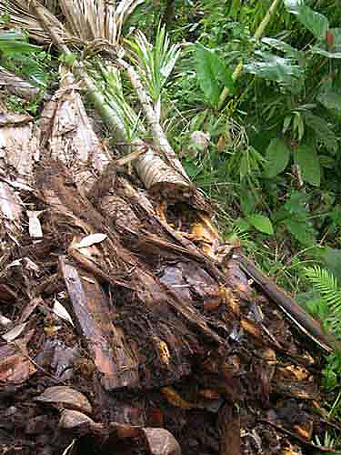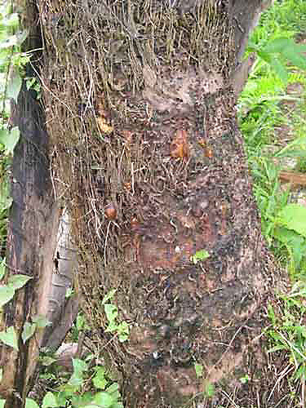
Figure 1: Rhabdoscelus obscurus damage on Sago palm

Because the weather in Micronesia is mostly dry and hot throughout the year, R. obscurus infestation has been very severe (Bianchi and Owen 1965). Guam and other Micronesian islands are therefore in the midst of a decline in nursery and ornamental plant production. According to feedback from local farmers and homeowners in the region, and extension faculty of the University of Guam, thousands of ornamental nursery and betel-nut plants are dying as a result of R. obscurus infestation. Recently, R. obscurus has begun attacking coconut palms on Guam. Although some control methods exist, chemical application is both undesirable and expensive (Robertson and Webster 1995). In the absence of appropriate, effective control, these R. obscurus populations are likely to cause widespread or even complete loss of nursery and betel-nut production in Micronesia and other regions. Although a parasitoid, Lixophaga sphenophori (Villeneuve) (Diptera: Tachinidae), from Maui (Hawaii) was introduced on Guam in 2005 for the control of R. obscurus, it seems not to be established yet. Farmers, homeowners, and commercial firms in this region apply insecticides (Dimethoate, Acephate, Carbaryl, Malathion, Naled, and Lambda-cyhalothrin) up to 20–30 times per cropping period, particularly in ornamental nurseries; these costly measures have been associated with ecological and toxicological hazards. Therefore, ecologically sound and cost-effective semiochemical (pheromone)-based trapping methods developed by the Chemical Ecology and Entomology at the Western Pacific Tropical Research Center are appropriate, and should be required to be implemented, and adopted by growers.
In our previous study, traps baited with lures from the Australian geographical population caught significantly more weevils than traps baited with lures from the Hawaiian R. obscurus population, suggesting that the Guam population is reacting similarly to the Australian population (Muniappan et al. 2004). Moreover, this population is predominantly present in the north because the majority of the commercial nurseries are located there. We also observed in that study that addition of ethyl acetate to the pheromone lures as a synergist significantly increased trap catches of R. obscurus.

Figure 2: Adult New Guinea sugarcane weevil, Rhabdoscelus obscurus

Trapping Technique Developed by the Chemical Ecology and Entomology Laboratory at the Western Pacific Tropical Research Center, University of Guam.

Trap Types: The ground trap (Figure-3A) was constructed and developed at the Chemical Ecology and Entomology Laboratory at the Western Pacific Tropical Research Center, University of Guam from a 120- × 60- × 0.5-cm piece of white corrugated plastic board, with a 50- × 8-cm slitted baffle fitted at the top to prevent borers from escaping (Reddy et al. 2005a). The lower outer edges of the ground traps were covered with earth to prevent weevils from crawling under the traps.
The ramp traps (Figure-3B) are commercially available from ChemTica Internacional S.A. (San José, Costa Rica). They are made of durable yellow Perspex and consist of two box-shaped components, each 14 cm wide by 4 cm high (inside dimensions), one, open side up, forming the floor of the trap and the other, open side down, forming its roof and supported on short pillars at the corners (Reddy 2007). Wide Perspex ramps on all four sides lead up to the rim of the lower box, which can be rested on the ground.
Our previous studies indicated that, ramp and ground traps captured similarly, and both captured significantly more adults than bucket and pitfall traps (Reddy et al. 2010). For economy and ease of handling, the russet brown ground trap (40 × 25 cm and above) is recommended for capturing adults in the field, whereas otherwise identical black -colored traps have to be used in indoors.
Trap Sizes: The ground trap of 120- × 60- × 0.5-cm and ramp trap 14 cm wide by 4 cm high are recommended.
Lures: The pheromone and ethyl acetate lures can be stored in a refrigerator until use. The pheromone lures ((E2)-6-methyl-2-hepten-4-ol and 2-methyl-4-octanol) are sealed in polymer membrane release devices optimized for the Australian population of R. obscurus. Pheromone and ethyl acetate lures have to be changed at 4-month intervals while freshly cut sugarcane sections have to be replaced in the trap once every week (Reddy et al. 2005b).

Placement of Trap: The traps are placed on the ground. Traps have to be strapped to trees to get maximum catches.

Inter-Trap Distance: It is recommended to employ 10 semiochemical-baited traps per ha in a single line spaced at 60 m apart.

Baiting Traps: In the ground trap, the pheromone and ethyl acetate (Rhynchophorus palmarum lure) lures have to be suspended inside the traps on wires hung from the top. Two cut pieces of sugarcane, 12 cm long, are placed directly in the ground trap and replaced with fresh canes weekly. The inside bottom of the trap was treated with a 5-ml spray of permethrin (0.75 ml/1 liter) to kill the attracted R. obscurus. Lures have to be changed at 4-month intervals (Reddy et al. 2005b).
In case of ramp trap, the pheromone lure and ethyl acetate are to be attached to the ceiling of the trap with a piece of vinyl-clad steel wire (the same wire used in all trap types), and two cut pieces of sugarcane are to be placed inside the trap. The floor of the trap has to be treated with a 5-ml spray of permethrin (0.75 ml/l).

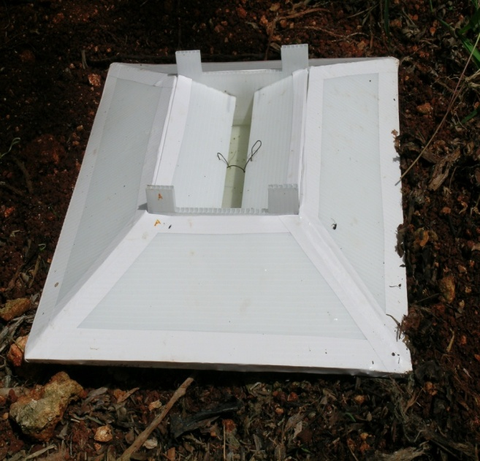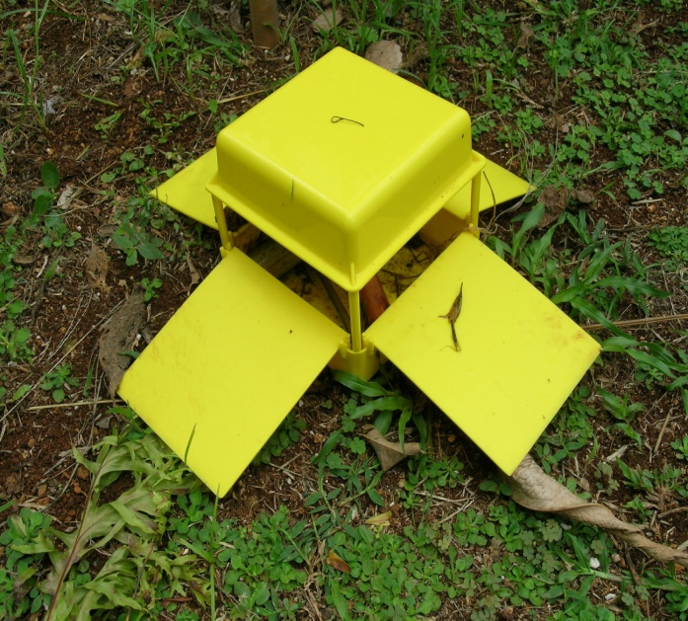
B. Ramp Trap
A. Ground Trap
Figure 3: Effective trap designs used for monitoring and control of New Guinea sugarcane weevil, Rhabdoscelus obscurus

References Cited

Bianchi, F.A., and R.P. Owen. 1965. Observations on Rhabdoscelus obscurus (Boisduval) and Rhabdoscelus asperipennis (Fairmaire) in Micronesia (Coleoptera: Curculionidae). Proc. Hawaiian Entomol. Soc. 19: 77–82.

Halfpapp, K.H., and R.I. Storey. 1991. Cane weevil borer, Rhabdoscelus obscurus
(Coleoptera: Curculionidae), a pest of palms in Northern Queensland, Australia. Principes 35: 199–207.

Muniappan, R, J. Bamba, J. Cruz, and G.V.P. Reddy. 2004. Field response of Guam populations of the New Guinea sugarcane weevil, Rhabdoscelus obscurus (Boisduval) (Coleoptera: Curculionidae), to aggregation pheromones and food volatiles. Micronesica 37: 57–68.

Napompeth, B., T. Nishida, and W.C. Mitchell. 1972. Biology and rearing methods of the New Guinea sugarcane weevil, Rhabdoscelus obscurus. Hawaii Agricultural Experiment Station, Honolulu, Hawaii, Technical Bulletin, No. 85: 51 pp.

Reddy, G.V.P. 2007. Improved semiochemical-based trapping method for old-house borer, Hylotrupes bajulus (Coleoptera: Cerambycidae). Environ. Entomol. 36: 281–286.
Reddy, G.V.P., R. Fettköther, U. Noldt, and K. Dettner. 2005a. Capture of female Hylotrupes bajulus as influenced by trap type and pheromone blend. J. Chem. Ecol. 31: 2169–2177.
Reddy, G.V.P., S. Balakrishnan, J. E. Remolona, R. Kikuchi, and J.P. Bamba. 2010. Influence of trap type, size, color, and trapping location on the capture of the New Guinea sugarcane weevil, Rhabdoscelus obscurus (Coleoptera: Curculionidae). Entomol. Exp. Appl.

Reddy, G.V.P., Z.T. Cruz, J. Bamba, and R. Muniappan. 2005b. Development of a semiochemical-based trapping method for the New Guinea sugarcane weevil, Rhabdoscelus obscurus. J. Appl. Entomol. 129: 65–69.

Robertson, L.N., and D.E. Webster. 1995. Strategies for managing cane weevil borer. Proc. Aus. Soc. Sugarcane Tech. 17: 90–96.

Sallam, M.N., C.A. McAvoy, G.D. Puglisi, and A.M. Hopkins. 2004. Can economic injury levels be derived for sugarcane weevil borer, Rhabdoscelus obscurus (Boisduval) (Coleoptera: Curculionidae), in far-northern Queensland? Aus. J. Entomol. 43: 66–71.

Timberlake, P.H. 1927. Biological control of insect pests in the Hawaiian Islands.
Proc. Hawaiian Entomol. Soc. 6: 529–556.

3. Sweetpotato weevil, Cylas formicarius (F.) (Insecta: Coleoptera: Curculionidae)

Sweetpotato (Ipomoea batatas L., family Convolvulaceae) is considered an important food crop in the Mariana Islands. This crop is being grown continuously throughout the year. However, its total harvested area and productivity indicate that development of the crop is declining due to a high infestation of the sweetpotato weevil, Cylas formicarius (F.) (Coleoptera: Curculionidae). The West Indian sweetpotato weevil Euscepes postfasciates also rarely occurs in Rota but is not a problem in Guam. C. formicarius is the most serious pest of sweetpotato, both in the field and in storage (Chalfant 1990, Sutherland 1986). Adults prefer to live in the canopy of vines and leaves, feeding on all parts of the sweetpotato plant. Females oviposit within cavities excavated either in the stems or the tubers, where the larvae develop. Damage results from adult feeding, from the cavities excavated for oviposition, and from the tunneling of larvae through the tubers (Figure 1). Their tunnels are filled with excrement, which resembles sawdust. This gives the characteristic terpene odor and bitter flavor of infested sweetpotato that renders them unsuitable for human or livestock consumption (Jansson and Raman 1991). A symptom of infestation by sweetpotato weevil is yellowing of the vines, but a heavy infestation is usually necessary before this is apparent. Thus, incipient problems are easily overlooked, and damage not apparent until tubers are harvested. The principal form of damage to sweet potato is mining of the tubers by larvae.

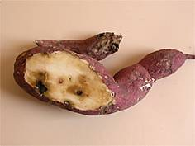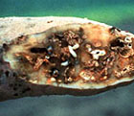
Figure-1: Sweetpotato damage by Cylas formicarius
Many farmers and homeowners spray toxic pesticides such as dimethoate, acephate, malathion, carbaryl, dibrom and warrior to control this weevil. Since the grubs bore inside the tubers, the chemicals do not affect the immature stages of the weevil. Additionally, it is unsafe to use chemicals on tuber crops. The underground feeding habits of the larvae and nocturnal activity of the adults make it necessary for farmers to apply insecticide 15–20 times during the 5 or 6 months of the growing season, which is not only expensive in terms of financial outlay but also is associated with ecological and toxicological hazards. The rate of tuber damage caused by C. formicarius is typically 45%, and sometimes reaches 88% in severely infested fields in Guam. Infestation of sweetpotato farms by C. formicarius can reach 100% in the Commonwealth of the Northern Mariana Islands (CNMI). Pheromone-traps have been developed for monitoring populations of this weevil in the field.
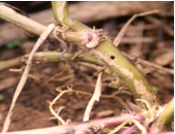
Figure-2: sweet potato weevil entry hole.
A complete life cycle requires one to two months, with 35 to 40 days being common during the summer months (Cockerham et al. 1954). Eggs are deposited in small cavities created by the female with her mouthparts in the sweet potato root or stem. Females apparently produce two to four eggs per day or 75 to 90 eggs during their life span of about 30 days. When the egg hatches the larva usually burrows directly into the tuber or stem of the plant. Duration of each instar is 8 to 16, 12 to 21, and 35 to 56 days, respectively. The mature larva creates a small pupal chamber in the tuber or stem. The pupa is similar to the adult in appearance. Duration of the pupal stage averages 7 to 10 days. Normally the adult emerges from the pupation site by chewing a hole through the exterior of the plant tissue, but sometimes it remains for a considerable period and feeds within the tuber (Figure 2). Under laboratory conditions at 15 C, adults (Figure 3) can live over 200 days if provided with food and about 30 days if starved (Sherman and Tamashiro 1954).
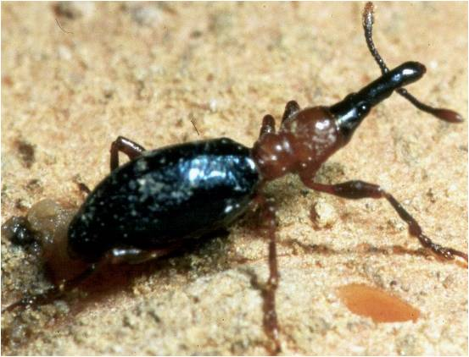
Figure 3: Adult sweetpotato weevil, Cylas formicarius

Trapping Technique Developed by the Chemical Ecology and Entomology Laboratory at the Western Pacific Tropical Research Center, University of Guam.

Trap Type: The field studies at the WPTRC indicated that the Unitrap or Bucket trap (Figure 4) was found to be significantly more effective than other traps in capturing the C. formicarius. The Unitraps are commercially available from Trécé Inc, Adair, OK. Unitraps consist of a funnel-shaped plastic receptacle with a lid and holder for attaching lures mounted over a bucket for retaining captured insects. Bucket traps used at the WPTRC studies had white colored receptacles and yellow lids.
Size of Trap: Based on the field studies at WPTRC, the Unitrap with the size 20.5 cm (height) × 13 cm diameter is recommended for capturing the C. formicarius in the field.
Pheromone Lures: The lures are commercially available from ChemTica Internacional S.A. (San José, Costa Rica). This product consists of the pheromone of C. formicarius Z3-Dodecenyl-E2 butenoate formulated in rubber septa for slow release over 4 - 6 weeks. The devices are further packed in impermeable bag for shipping and storage. The product is intended for use in crops as an attractant for the C. formicarius. The rate of release of pheromone is greatest just after the lure is placed in the field and decreases thereafter.

Baiting Traps: To place lures in Unitraps put the lure in the pheromone cup, and place the cup and top into the hole in the top of the trap. The traps need to be inspected and cleansed weekly for reuse by dumping the insects and wiping the inside of the trap (Jansson et al. 1990).
Placement of Trap: For best results traps should be about 1 meter above ground. Traps should be placed in the field to be monitored on a grid basis at 1 / hectare. Replace lures every 6 weeks. Exhausted lures can be disposed of in household garbage.

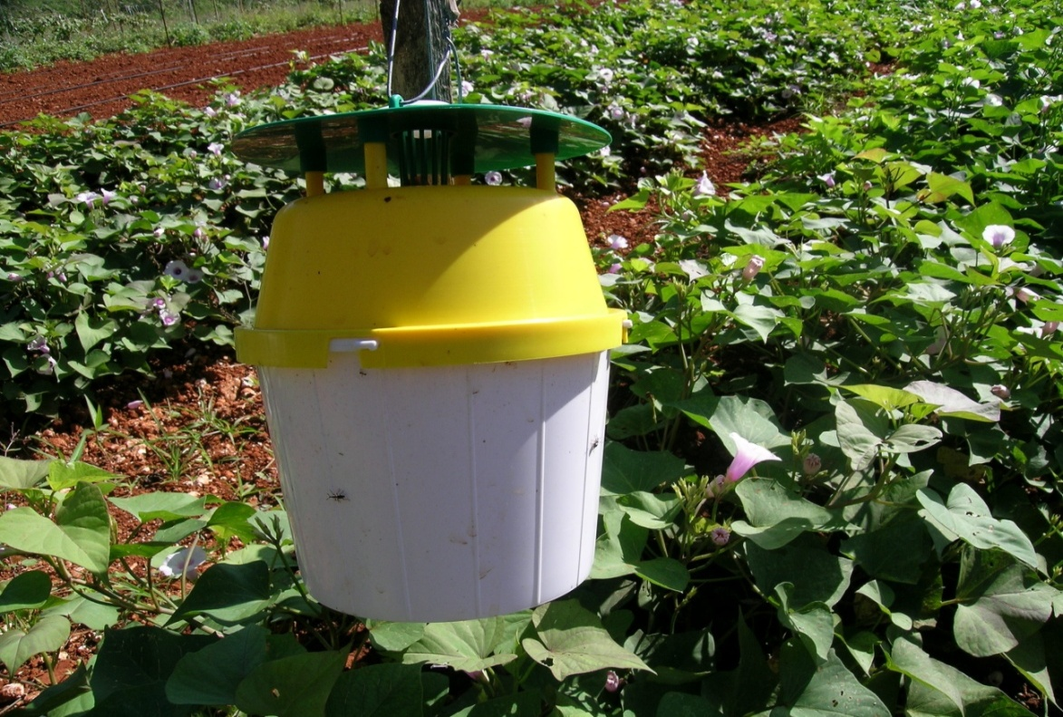
Figure 4: Effective trap design used for monitoring and control of sweetpotato weevil, C. formicarious

References Cited

Chalfant, R.B. 1990. Ecology and management of sweetpotato insects. Ann. Rev. Entomol. 35: 157–180.

Cockerham, K.L., O.T. Deen, M.B. Christian, L.D. Newsom. 1954. The biology of the sweet potato weevil. Louisiana Agricultural Experiment Station Techincal Bulletin 483: 30 pp.

Jansson, R.K., F.I. Proshold, L.J. Mason, R.R. Heath, and S.H. Lecrone. 1990. Monitoring sweetpotato weevil (Coleoptera: Curculionidae) with sex pheromone: effects of dosage and age of septa. Trop. Pest Manag. 36: 263-269.

Jansson, R.K., and K.V. Raman. (ed.). 1991. Sweetpotato Pest Management: A Global Perspective. Westview Press Inc., Boulder, Colorado, USA. 439 pp.

Sherman, M., and M. Tamashiro. 1954. The sweetpotato weevils in Hawaii, their biology and control. University of Hawaii Technical Bulletin 23. 36 pp.
Sutherland, J.A. 1986. A review of the biology and control of the sweetpotato weevil, Cylas formicarius. Trop. Pest Manage 32: 304–315.

