Making Your Compost Product Work for You!

FREE Compost Marketing Workshop/Field Day

Ithaca, New York – Wednesday, January 12, 2011

Whether selling compost is your primary business or a side business, this workshop is for you! The workshop will provide marketing insights and sales techniques, including technical information on compost applications and benefits, feedstocks, quality standards, and marketing principles. Learn tips on developing a marketing plan for your compost operation, how to position your product, the ins-and-outs of compost market segments, bulk sales vs. bagged, distribution strategies, and making money on tipping fees. Sales strategies will also be covered, including sales points, using social media and new media techniques, branding, and customer education tips.

The workshop is free, but all attendees must register by January 4th (late registrants will need to pay their own parking). Lunch/refreshments provided. To register or find out more information, contact Athena Lee Bradley at 802.254.3636 or by email at athena@nerc.org.

When: Wednesday, January 12 from 9:15 am – 4:00 pm
Snow date – Wednesday, January 19
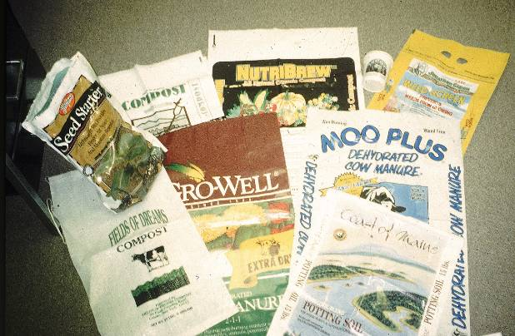
Where: Cornell University
135 Emerson Hall, Tower Rd (campus map)
Ithaca, NY 14853-5601
Presenters:

Jean Bonhotal, Associate Director
Cornell Waste Management Institute
http://cwmi.css.cornell.edu/

Dr. Robert Rynk
SUNY Cobleskill
Agricultural Engineering Dept.
http://www.cobleskill.edu/academics/agnrschool/ageng/

Charles Duprey
Business Development
WeCare Organics, LLC
www.wecareorganics.com

Sponsors

- Northeast Recycling Council, Inc.,
- Cornell Waste Management Institute
- SUNY Cobleskill
- New York State Department of Environmental Conservation

Funding for the workshop is from the Northeast SARE (Sustainable Agriculture, Research, and Education).

