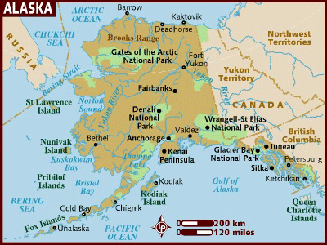 West UAF Campus
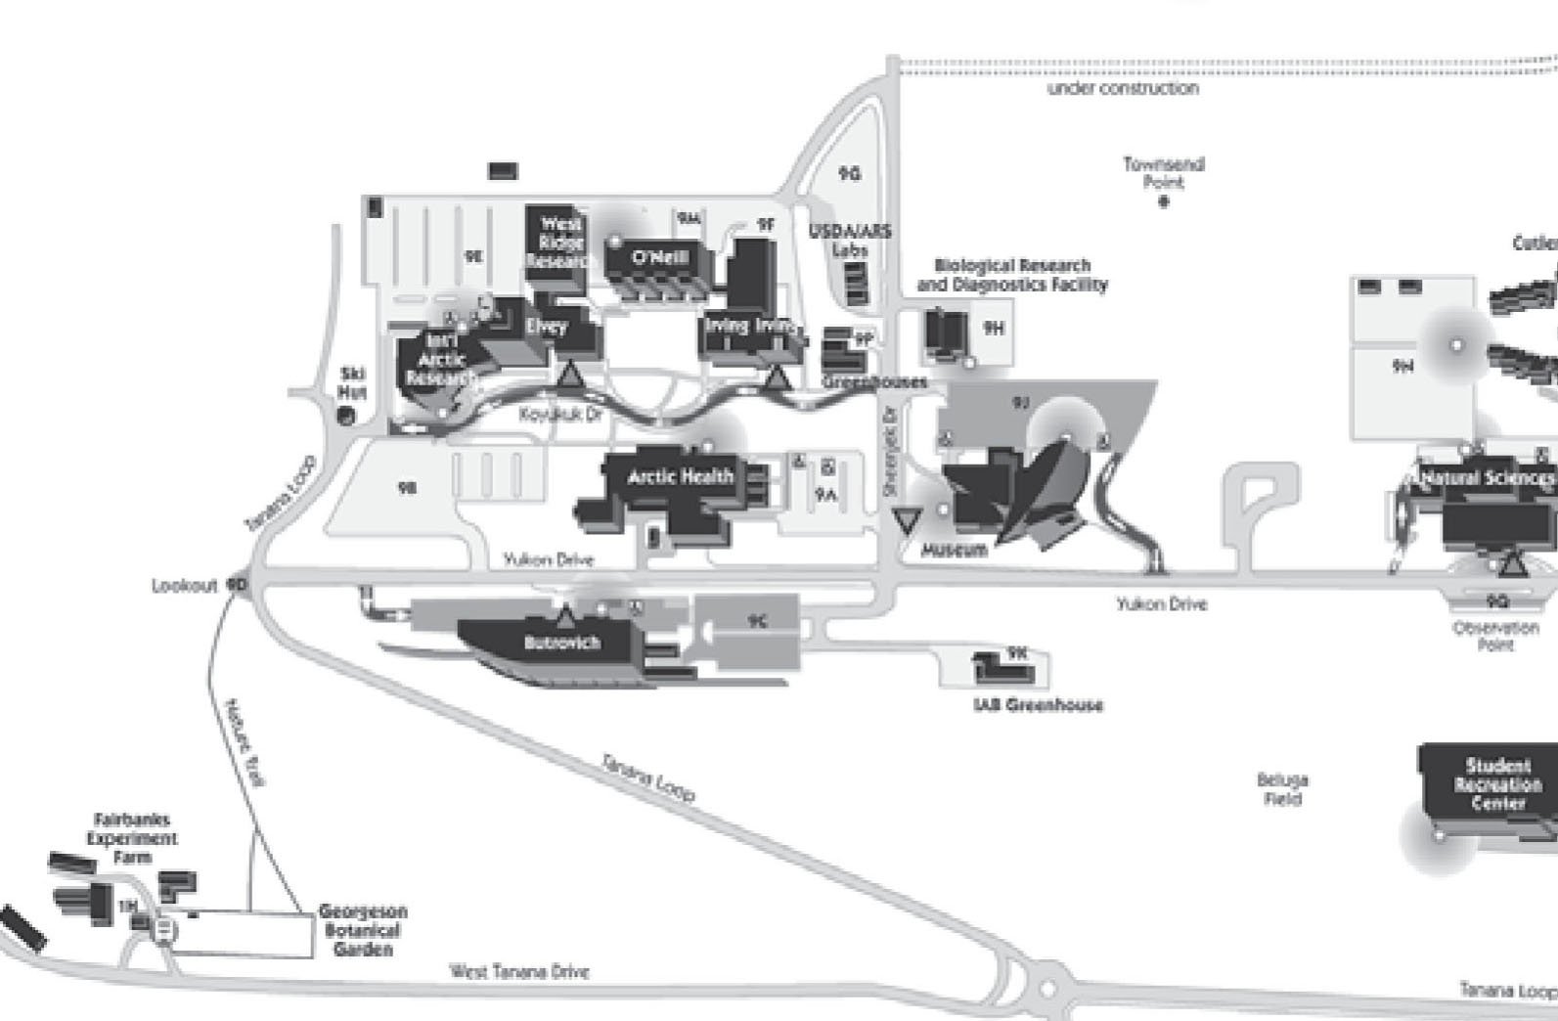
Fruit Tree Trial
Figure 1. Map of Alaska showing Fairbanks and West UAF campus with Fruit Tree Trial location indicated.

Table 1. Minimum and maximum air and soil temperatures collected from Galena, Tanacross, Minto, Nenana, McGrath and Fairbanks in 2008 and 2009.
Village | Dates recorded | Air |  |  |  |  | Soil
 |  | Min | Month | Max | Month |  | Min | Month | Max | Month
Galena | 9/30/08 - 5/07/09 | -52.37 | Jan | 70.97 | April* |  | 9.85 | Jan | 31.79 | April*
Tanacross | 9/17/08 - 9/2/09 | -59.56 | Jan | 89.64 | July |  | 2.24 | Jan | 100.90 | July
Minto | 9/25/09 - 9/30/09 | -49.01 | Jan | 88.76 | July |  | 7.14 | Jan | 88.62 | July
Nenana | 11/3/08 - 9/11/09 | -52.09 | Jan | 87.35 | July |  | 3.94 | Jan | 83.24 | July
McGrath | 10/9/08 - 4/25/09 | -54.89 | Jan | 45.53 | April* |  | 30.23 | Jan | 53.44 | April*
Fairbanks | 9/25/08 - 7/28/09 | -49.76 | Jan | 92.15 | July |  | 21.47 | Jan | 54.90 | July
*Data not available beyond April for Galena and McGrath.

