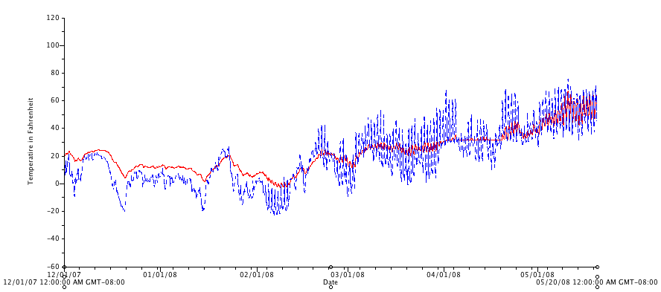
Figure 7. Soil (red) and air (blue) temperatures inside a high tunnel from December 2007 to May 2008.

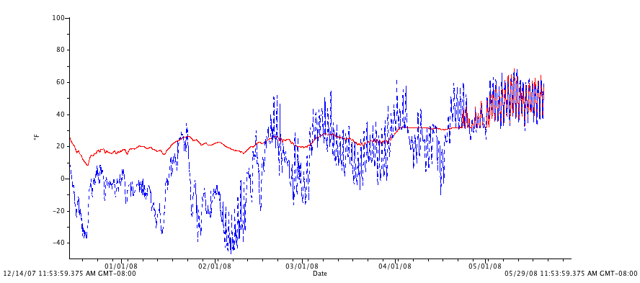
Figure 8. Soil (red) and air (blue) temperatures in exterior plots from December 2007 to May 2008.

