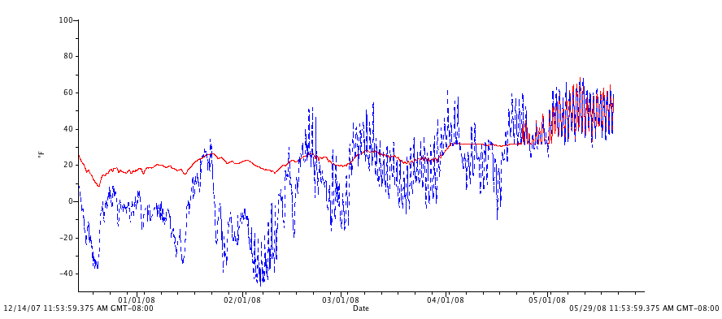
Figure 8. Soil (red) and air (blue) temperatures in exterior plots from December 2007 to May 2008.

